Development Methodology

Approach taken and rationale

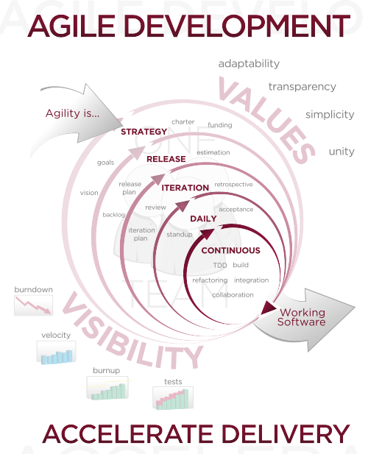
(image from Wikimedia commons, used under a CC-BY-SA 3.0 license)

An Agile approach to software development was taken towards developing this system. This means that we took a focus on

