Charlotte Meola

ECE 5430

Homework 3: Problem 2

2.5) Corresponding Precision Matrix, R:

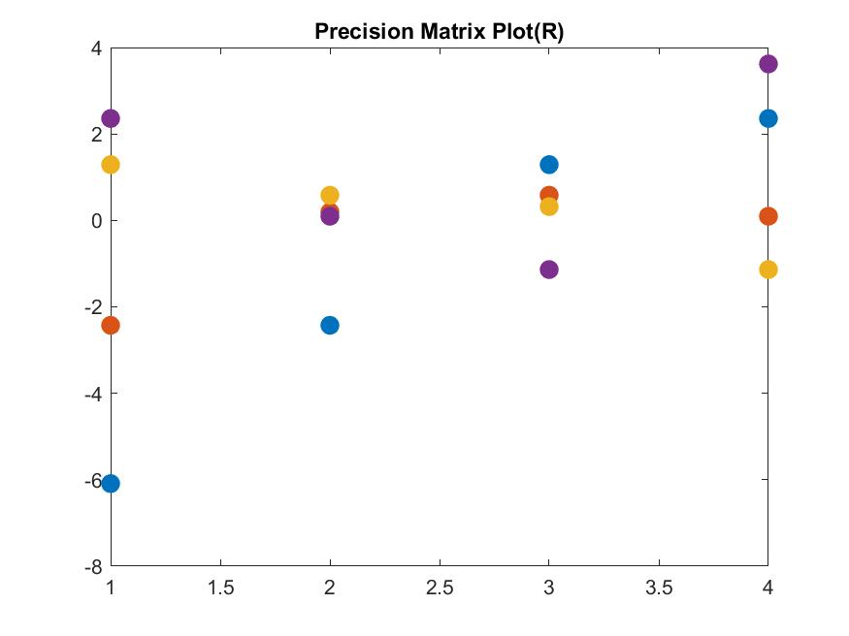

R =

-6.0888 -2.4272 1.2899 2.3578

-2.4272 0.1942 0.5825 0.0971

1.2899 0.5825 0.3190 -1.1373

2.3578 0.0971 -1.1373 3.6200