**Website development brief**

Brief name: The re-development of the McCarthy Nissan and McCarthy Renault websites

Brief date: 20/02/2014

Client lead: Rob Diering

Project start date: **17th February**

Envisaged go live date: **See project plan for full details**

**Brief in 30 seconds:**

**The current McCarthy Nissan and Renault websites feel antiquated especially in terms of the new car content. We are to create new fully responsive websites with an appealing UI and persuasive OEM based new car content.**

**Some quick facts:**

* **New car content is to be supplied by OEM (this has proven to be problematic in the past)**
* **CBR recommends pulling new car prices and spec sheets from Call-a-Car’s new API**
* **The site will be fully responsive**
* **The site will cater for dealers to have their own space**

**Important to note:**

**New car content to align closely as possible to OEM content.**

**Task at hand:**

**Build a modern fully responsive website(s) that utilize a hybrid back-end:**

**CMS:**

* **OEM content**
* **Pics**
* **Banners**

**API:**

* **New car prices**
* **New car spec sheets**
* **Demo cars**
* **Used cars**
* **Dealer info**
* **Feed-based specials**

**Measurable Goal(s):**

**Increase in unique visitor / no. of leads conversion rate**

**Target Audience (TA):**

**Current / potential Nissan / Renault owners**

**Competitor landscape:**

**TBC**

**Stay away from:**

**Referring to McCarthy Nissan as McCarthy Nissan South Africa**

**Mandatories include:**

**Punt the McCarthy brand wherever possible.**

**Deliverables expected from the agency**

* **Project plan**
* **Wireframes**
* **Look and Feel**
* **Front-end**
* **CMS**
* **Back-end Integration**
* **Content population**

**Specific questions relating to a website brief:**

**What platform would you like the website to be built on?**

**PHP, MySQL**

**Where will the platform be hosted?**

**.13**

**How important is mobile capability to you?**

**Fully responsive**

**How often do you foresee content needing to be updated?**

**Dealers:**

* **As per their specials (Liezl to upload)**

**OEM:**

* **As per model / variant changes**

**Do you require any database facilities?**

**Yes – all leads / service requests.**

**Do you require any eCommerce facilities?**

**No**

1. **General website points**

* **Utilise off-canvas menu**
* 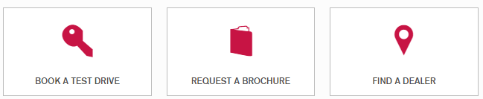**Make use of iconography**
* **SEO style thick footer**
* **Main slider on homepage only (possibly video)**
* **Navigation**
  + **100% opacity navigation**
  + **Sticky nav – fixed to top screen**
  + **Mega menu dropdown with large vehicle images (call to action – explore | book a test drive) << Toyota.co.za (Tabbed by category)**
  + **Clever roll-over states / active states**
  + **Secondary nav directly underneath primary (on scroll) / different colour**



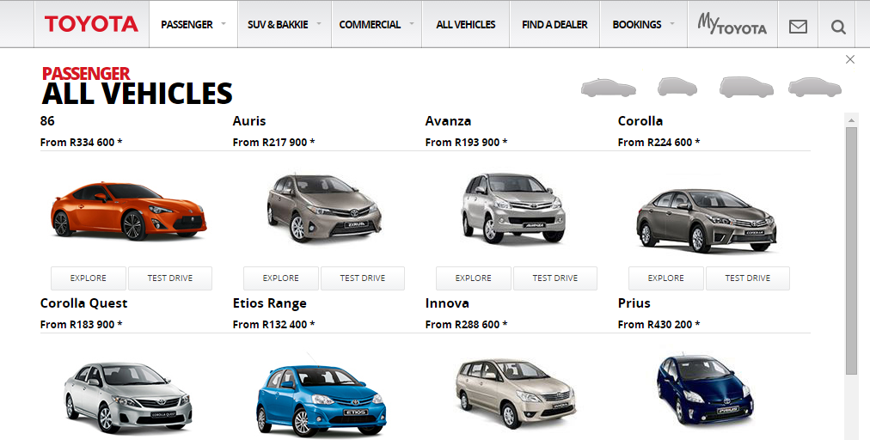

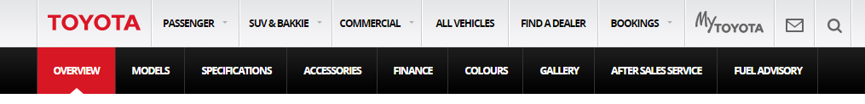

**Actual navigation:**

**Home | New Cars |Demo Cars | Pre-owned Cars | Our Dealerships | Specials | Service | Parts & Accessories | Why McCarthy | Contact**

**Sub-menu for New:**

**Passenger | Electric | Commercial << Tabs within mega menu**

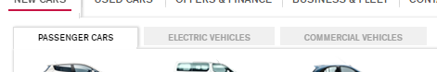

**Sub-menu for Our Dealerships: << recommend utilising secondary nav bar:**

**McCarthy Nissan Woodmead | McCarthy Nissan Randburg | McCarthy Nissan Johannesburg | McCarthy Nissan Germiston | McCarthy Nissan Gateway**

**Sub- Why McCarthy << recommend utilising secondary nav bar:**

**Comprehensive Insurance | Shortfall Protection | Bodyguard | Tyre Guard | Warranties**

1. **Website Search**

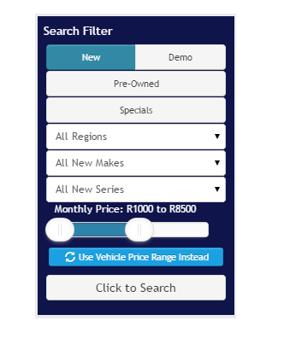**Search module:**

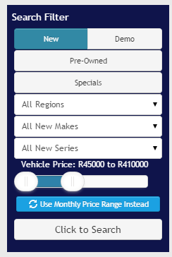

* 1. **Search results**

**Results count with pagination**

**Brand Model Variant Price (from only) Instalment (apply global calculation)**

**View details | Enquire Now**

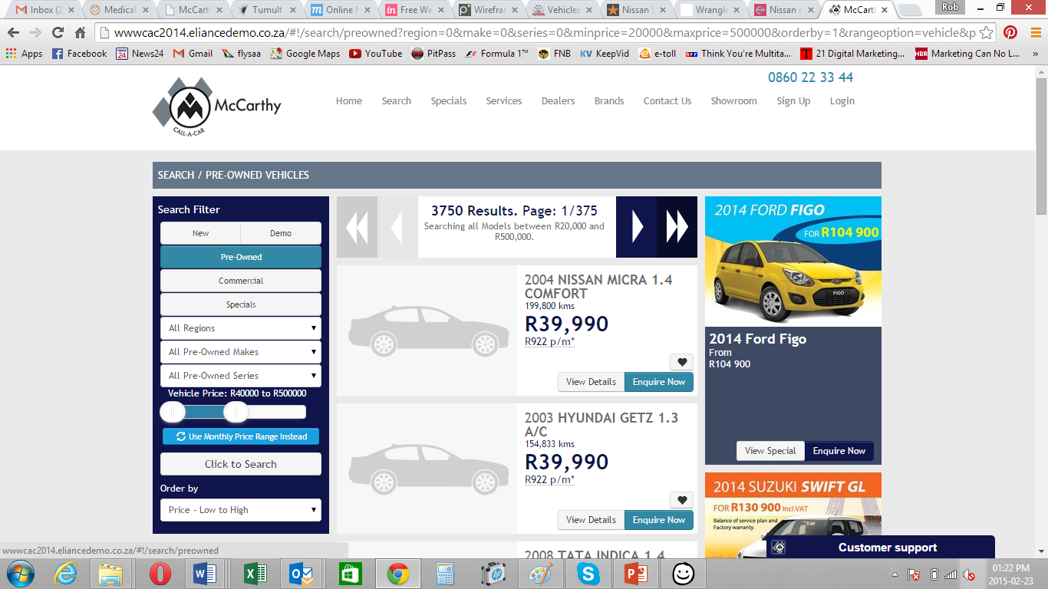

1. **New cars**

**Toyota.co.za << Use as reference**

**Compare cars (max 2) << drop for mobile**

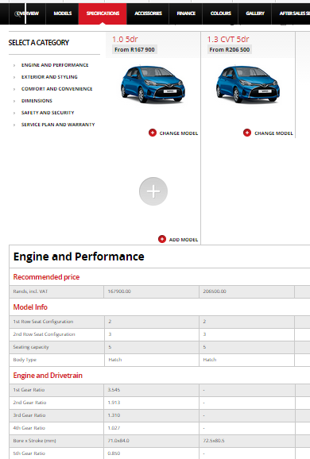

1. **Used cars**

**New CaC / dealer info from current site**



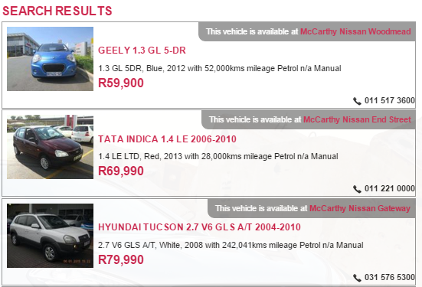

**PC: 3 column incl. special**

**Tablet: drop specials**

**Mobile: Search goes off canvas**

1. **Dealer info**

**Base it on McCarthy Toyota:**

[**http://www.mccarthytoyota.co.za/46/bp/dealer/locale/gauteng/dealerid/55**](http://www.mccarthytoyota.co.za/46/bp/dealer/locale/gauteng/dealerid/55)

**Banner to be static.**

**Banner enquiry:**

[**http://www.mccarthytoyota.co.za/46//bp/specialsenquiry/special/16907/locale/gauteng/dealerid/55/r2**](http://www.mccarthytoyota.co.za/46//bp/specialsenquiry/special/16907/locale/gauteng/dealerid/55/r2)

**Details >> http://ballito.mccarthytoyota.co.za/46/bp/dealer/locale/kwazulunatal/dealerid/7**

**Include active Google Map**

**Also include standard call to action buttons: Book a Test Drive | Book a Service**

1. **Specials**

**Two tabs:**

**On Special: Feed based**

**On Promotion: CMS / graphic banner based**

1. **Lead generation**

**New CaC div pop-up + dealer info**

