Title: Quantifying Limits to Detection of Early Warning for Critical Transitions
Authors: Carl Boettiger* and Alan Hastings,
Center for Population Biology, University of California, Davis
Department of Environmental Science and Policy, University of California, Davis
(Summary paragraph)
Many complex natural systems are known to exhibit critical transitions in which a slow imposed change in conditions leads to a dramatic shift or tipping point such as algal blooms or desertification¹⁻³. Recent work has revealed the potential to detect advanced warning of these sudden transitions through observations of patterns over time in the fluctuations of the system^{4,5}⁠. This search has been motivated by the mathematics of bifurcations, in which sudden shifts result from a slowly changing parameter that impacts the system stability. Research has focused on identifying summary statistics such as variance or autocorrelation^{6,7}⁠ that might indicate when a system is experiencing “critical slowing down,” reflecting a slower return to the desired equilibrium due to this loss of stability⁸⁠. These efforts have provided tantalizing suggestion that detection might be possible, but often lack sufficient power to do so, offering only a false confidence. Here we provide a novel approach to quantify the relative risks of false alarms and missed events for given data. We illustrate that the current approaches, relying on summary statistics such as increases in variance or autocorrelation, have high potential for false alarms. We develop a likelihood-based model approach for single realizations which substantially increases power to detect warning signals relative to summary statistics, while also illustrating the limits of detection faced under even idealized conditions and discuss the kinds of data required for reliable predictions.

The concept of early warning signals for sudden system shifts is motivated by one-dimensional linear stability theory for stochastic systems⁹⁠. As the system approaches a sudden shift, the stability-determining eigenvalue of the linearized deterministic system approaches zero. As this happens, the stabilizing forces decay, which increases the variance and the return times of the system, referred to as critical slowing down (CSD)^{4,8}. A standard approach ^{5-7,10,11}⁠ is to test for a statistically significant positive correlation with time for an indicator statistic (variance, autocorrelation), computed over a sliding window using a common correlation test. Fig. 1a illustrates this approach in four datasets. The first two are simulated data from one, a stable system (Constant), second, the same system approaching a saddle-node bifurcation due to a gradually deteriorating environment (Deteriorating), and the third and forth ones, empirical examples from deuterium concentrations¹²⁠ previously cited as an early warning signal of a critical transition in glaciation (Glaciation)⁷⁠ and Daphnia magna concentrations manipulated in a chemostat towards a critical transition (Daphnia).⁵ A warning signal is expected in the other sets, but even the constant environment shows a significant positive correlation (tau=0.51, p=1.1x10⁻⁷). A large majority of simulations (1604/2000) of constant environment show a false alarm (P<0.05) in autocorrelation, (further examples in Supplemental Information). These examples illustrate that it will be difficult to tell from such simple analyses whether the patterns in summary statistics are indicative of critical slowing down or occur merely by chance (Fig. 1a).

These high error rates arise largely because the approach of summary statistics is derived under the assumption of replicate data instead of a single time-series. If we had access to a collection of replicates, we could compute these summary statistics across replicates instead of over time for a single replicate and look for such a trend. Having access only to a single replicate creates several difficulties. The indicator statistics such as variance or autocorrelation must be computed over a sliding window of time, instead of across replicates. This introduces correlations, resulting in the test finding statistical significance whether or not the critical slowing down is present (see Supplementary Information, Appendix B) . This is typical of the pattern in the literature; examples detecting a warning signal are abundant, whereas examples of plausibly stable systems are largely absent ^{5-7,10,11}⁠.

Results such as in Fig. 1a provide little information to guide decision-makers trying to avoid sudden crashes by advanced warning because they give no indication of the probability the signals could occur by chance. We have seen that the statistical significance of the observed correlation is expected in stable systems when analyzed as single replicates, but might still expect stronger correlations when a system is losing stability. We will focus on estimating the distribution of Kendall’s correlation coefficient, tau, for various summary statistics in the presence and absence of a gradual loss of stability.

We extend approaches for detecting warning signals by estimating both the chance of a false alarm and the chance of a missed detection on a given data-set. We approximate the distribution of Kendall’s correlation coefficient, tau, that we would expect to observe in a warning statistic from the given data under the hypotheses that there is or is not a loss of stability; illustrated in Figure 1b for the same datasets. The null distribution of the correlation coefficient appears in blue, corresponding to the hypothesis that the system is stable. The null distribution covers nearly all values of tau with equal probability, showing that strong positive correlations can be observed in a constant environment, resulting in false alarms (Type I errors). The distribution when there is loss of stability appears in red, showing that the summary statistic approach has little power to distinguish the hypothesis of an impending transition from the alternative hypothesis of a stable system using these data, resulting in either a high rate of missed impending transitions (Type II errors; Supplementary Information, Appendix C).

To generate distributions of correlations expected for the summary statistics under the two alternate hypotheses, we require a technique to generate the distribution of possible data expected under both hypotheses, a stable system (blue distributions) and the alternative hypothesis of a loss of stability (red distributions). For this we use general bifurcation models reflecting the simplest possible bifurcations¹³⁠. Because critical transitions in many dynamical systems can be mapped to a few classes of bifurcations, the approach is a general but not universal description of such crashes^{14⁠}. We derive general linear forms for these common bifurcations as models to be estimated from the data, (Supplementary Information, Appendix D).

Detection of an impending transition amounts to estimating if the parameter that drives the bifurcation is not changing or is approaching a value that would cause a transition. Each simple model is pushed through a critical transition as the bifurcation parameter, denoted r_{t}, changes sign. When the system is stable, r_{t} is constant and both models reduce to an Ornstein-Uhlenbeck process¹⁵⁠. There are three essential features of these models. First, they have been formulated, without loss of generality, under the same assumptions as the originally hypothesized summary-statistics. Second, the models are stochastic; we can generate a distribution of possible outcomes of each by simulation. Third, the models are linear and hence the likelihood of a given outcome is analytically tractable. (Supplementary Information, Appendix E).

These features allow us to perform a Monte Carlo parametric bootstrap¹⁶⁻¹⁸⁠ on the estimates of the correlation coefficient tau for the increase in a warning statistic such as autocorrelation or variance. First, we fit models with and without a gradual change in stability to the original data by maximum likelihood. Second, we simulate replicate datasets under each model. Third, for each dataset, we re-estimate the appropriate value of Kendall’s tau on the summary statistic. Finally, we produce distributions from histograms according to which simulation produced the data. The observed value of tau on the original data (Fig. 1a) is indicated by a black triangle in Fig. 1b. Implementing this approach on a range of empirical and simulated data illustrates that even for generously sampled systems, the detection of a warning signal shows considerable uncertainty around this observation, with either false positives or missed signals. Our likelihood equations allow our frequentist approach to be easily re-framed in the language of Bayesian inference, which can incorporate other sources of uncertainty at the cost of having to formulate reasonable priors. As this approach involves the computationally intensive Monte Carlo simulation and estimation, we provide a simple R package, warningsignals, to illustrate the algorithm and help users apply these analyses to generic data (Supplementary Information, Appendix I).

In contrast to summary statistics, P(f(data) | model), which discard information, direct comparisons of the models by likelihood, P( data | model) ^{19,20}⁠ provides a more powerful and reliable test to detect gradual loss of stability in a given data. Relying directly on the model, we need not assume that the system is evenly sampled, or that the change is slow enough to justify the averaging window. We proceed as with summary statistic bootstrap, but instead calculate the divergence in likelihood between estimated models for each replicate^{17,21,22}⁠ (Supplementary Information, Appendix F). The decreased overlap (Fig. 1c, Supplemental Figure K.6) shows detection with substantial increase in power from Fig. 1b for both the simulated destabilizing system (comparing to original approach of autocorrelation, Type I: 0.5% vs 5%; Type II: 29.9% vs 95.4% ) and the Glaciation data (Type I: < .05% vs 15%; Type II: 0.1% vs 92.5%), while the constant environment shows no detection. With 16 data points the Daphnia system does not have adequate power to detect destabilization even under the likelihood approach, let alone summary statistics. Thus our approach can identify clear cases of warning signals (Glaciation) and cases where the sampling has been too sparse or short an interval for detection (Daphnia). An information-criterion based approach²³⁠ would not quantify the relative risks or power of the test, and additionally may be sensitive to miss-classification when its assumptions are not met (see Supplementary Information, Appendix G).

Not all sudden collapses correspond to the general classes discussed here¹⁴⁠, including examples where variance decreases as a sudden shift approaches^{24,25}⁠. Using the model-driven approach outlined here it will be easier to identify dynamics that do not correspond to the assumptions of the underlying models (Supplemental Information, Appendix I) than it would be by summary statistics alone. Including measurement error and focusing on different bifurcations are other complications we do not address at this time.

Any attempts to implement an early warning strategy for natural systems should use the methods we have outlined to ensure that data collection has adequate power to offer a reasonable chance of detection; i.e. avoid sampling schemes that are too short in duration or too infrequent relative to the system's dynamics. The approach developed here is essential for quantifying the risk of both missed events and false alarms, which must become a central part of early warning signals and management in general.

Methods Summary
Parametric Bootstrap: A parametric bootstrap is performed by fitting stable and deteriorating models by maximum likelihood. (For empirical data, the appropriate bifurcation model was estimated using the likelihood-based approach described below, see Supplementary Information Appendix I). 2000 replicate datasets were simulated under each model, sampled at the same time intervals as the original data. For each replicate, the summary-statistics were computed over a sliding window equal to half the observed time, and a Kendall's correlation test applied to estimate tau. Kernel density estimators for tau under each set of simulations generates the distributions shown in Figure 1b.
Likelihood test: As in parametric bootstrap; but instead of calculating summary-statistics on each simulated dataset, dataset is refit to both stable and deteriorating models to generate a difference in likelihood scores, (Cox's delta,²⁰ see Supplementary Information, Appendix F). Refitting both models on each replicate, rather than estimating the likelihood under the original models, is essential to the power of this approach²²⁠ and is considerably more computationally intensive than estimating the summary-statistic.

1. May, R.M. Thresholds and breakpoints in ecosystems with a multiplicity of stable states. Nature 269, 471-477(1977).
2. Holling, C.S. Resilience and Stability of Ecological Systems. Annual Review of Ecology and Systematics 4, 1-23(1973).
3. Scheffer, M. et al. Catastrophic shifts in ecosystems. Nature 413, 591-6(2001).
4. Scheffer, M. et al. Early-warning signals for critical transitions. Nature 461, 53-9(2009).
5. Drake, J.M. & Griffen, B.D. Early warning signals of extinction in deteriorating environments. Nature 467, 456-459(2010).
6. Carpenter, S.R. & Brock, W.A. Rising variance: a leading indicator of ecological transition. Ecology letters 9, 311-8(2006).
7. Dakos, V. et al. Slowing down as an early warning signal for abrupt climate change. Proceedings of the National Academy of Sciences of the United States of America 105, 14308-12(2008).
8. Wissel, C. A universal law of the characteristic return time near thresholds. Oecologia 65, 101-107(1984).
9. Scheffer, M. Critical Transitions in Nature and Society: (Princeton Studies in Complexity). 400 (Princeton University Press: 2009).
10. Guttal, V. & Jayaprakash, C. Spatial variance and spatial skewness: leading indicators of regime shifts in spatial ecological systems. Theoretical Ecology 2, 3-12 (2008).
11. Bailey, R.M. Spatial and temporal signatures of fragility and threshold proximity in modelled semi-arid vegetation. Proceedings of The Royal Society B (2010).
12. Petit, J.R. et al. Climate and atmospheric history of the past 420,000 years from the Vostok ice core, Antarctica. Nature 399, 429-436 (1999).
13. Guckenheimer, J. & Holmes, P. Nonlinear Oscillations, Dynamical Systems, and Bifurcations of Vector Fields (Applied Mathematical Sciences Vol. 42). 480 (Springer: 1983).
14. Hastings, A. & Wysham, D.B. Regime shifts in ecological systems can occur with no warning. Ecology letters (2010).
15. Gardiner, C. Stochastic Methods: A Handbook for the Natural and Social Sciences (Springer Series in Synergetics). 447 (Springer: 2009).
16. Efron, B. Better bootstrap confidence intervals. Journal of the American Statistical Association 82, 171- 185 (1987).
17. McLachlan, G.J. On Bootstrapping the Likelihood Ratio Test Stastistic for the Number of Components in a Normal Mixture. Applied Statistics 36, 318 (1987).
18. Diciccio, T.J. & Efron, B. Bootstrap Confidence Intervals. Statistical Science 11, 189-212 (1996).
19. Neyman, J. & Pearson, E.S. On the problem of the most efficient tests of statistical hypotheses. Philosophical Transactions of the Royal Society of London. Series A, Containing Papers of a Mathematical or Physical Character 231, 289 (1933).
20. Cox, D.R. Tests of Seperate Families of Hypotheses. Proceedings of the 4th Berkeley Symposium, University of California Press 105 – 123 (1961).
21. Goldman, N. Statistical tests of models of DNA substitution. Journal of Molecular Evolution 36, 182-198(1993).
22. Huelsenbeck, J.P. & Bull, J.J. A Likelihood Ratio Test to Detect Conflicting Phylogenetic Signal. Systematic Biology 45, 92-98(1996).
23. Burnham, K.P. & Anderson, D. Model Selection and Multi-Model Inference. 496 (Springer: 2002).
24. Schreiber, S.J. Allee effects, extinctions, and chaotic transients in simple population models. Theoretical population biology 64, 201-209 (2003).
25. Schreiber, S.J. & Rudolf, V.H.W. Crossing habitat boundaries: coupling dynamics of ecosystems through complex life cycles. Ecology letters 11, 576-87 (2008).

Figure 1
(a)
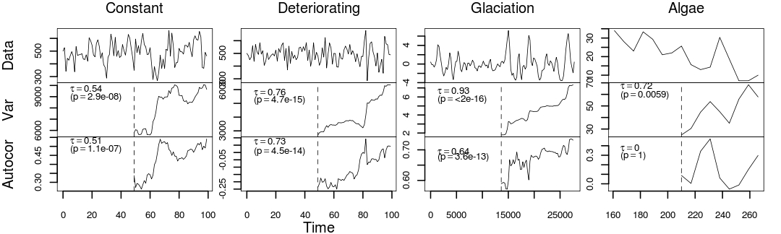
(b)
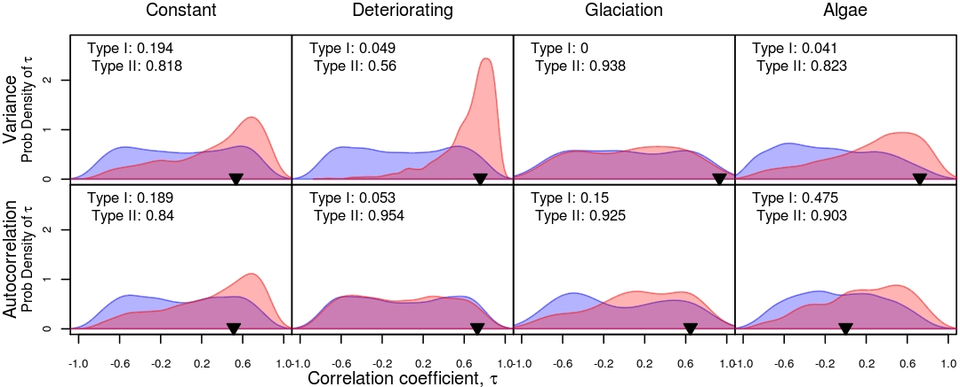
(c)
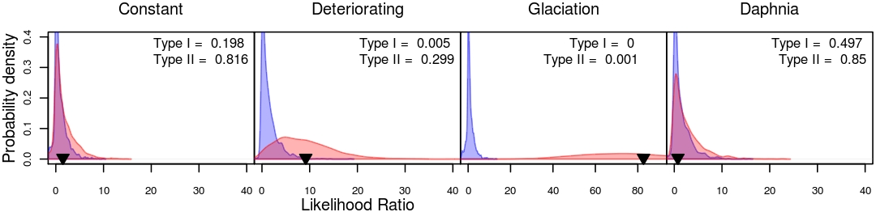
(a) Commonly used warning signals in simulated and empirical data. In each example, variance and autocorrelation show a highly significant positive correlation, even though the first (left-most) example is from a stable system. Number of sample points from left to right: N=100,100, 121,16. (b): Monte Carlo bootstraps of the correlation coefficients, tau, observed in the variance and autocorrelation for the datasets in (a). The value of tau calculated in (a) is shown by a black triangle. The distribution of tau under the null (stable model, estimated from the data) is shown in blue, while the distribution under the deteriorating-stability hypothesis is shown in red. The stable and deteriorating cases are nearly indistinguishable for most indicators. Type I error gives the probability of false alarms for values of tau observed. Type II error, the probability of missed detection, is calculated at a 5% false alarm rate, see Supplementary Information, Appendix C. (c): Distributions of likelihood ratios under the stable (null hypothesis, blue) and deteriorating- environment (alternate hypothesis, red) models. This test is substantially more powerful than the correlations in summary statistic (b), evidenced by the decreased overlap between the distributions. The observed likelihood ratio on the original data is indicated by a black triangle. In each case this likelihood approach provides substantially lower rates of Type I (false alarm) and Type II (failed detection) events than the summary statistics.
Author Contributions
C.B. wrote the software and performed the analysis with advice from A.H. C.B. and A.H. designed the study and wrote the paper.

Acknowledgements
M. Holyoak, A. Perkins and M. Baskett provided comments on the manuscript. This research was supported by funding from NSF Grant EF 0742674 and a Computational Sciences Graduate Fellowship from the Department of Energy grant DE-FG02-97ER25308.

Author Information
Data and code for the analysis are deposited at: https://github.com/cboettig/warningsignals/archives/master.

Reprints and permissions information is available at www.nature.com/reprints.

The authors have no competing interests as defined by Nature Publishing Group, or other interests that might be perceived to influence the results and/or discussion reported in this article.

Correspondence and requests for materials should be addressed to C.B. (cboettig@ucdavis.edu).

* Corresponding Author

