# FIGURES

## Figure 1. Our study areas: the managed forests of Saskatchewan and the Prince Albert Forest Management Area.

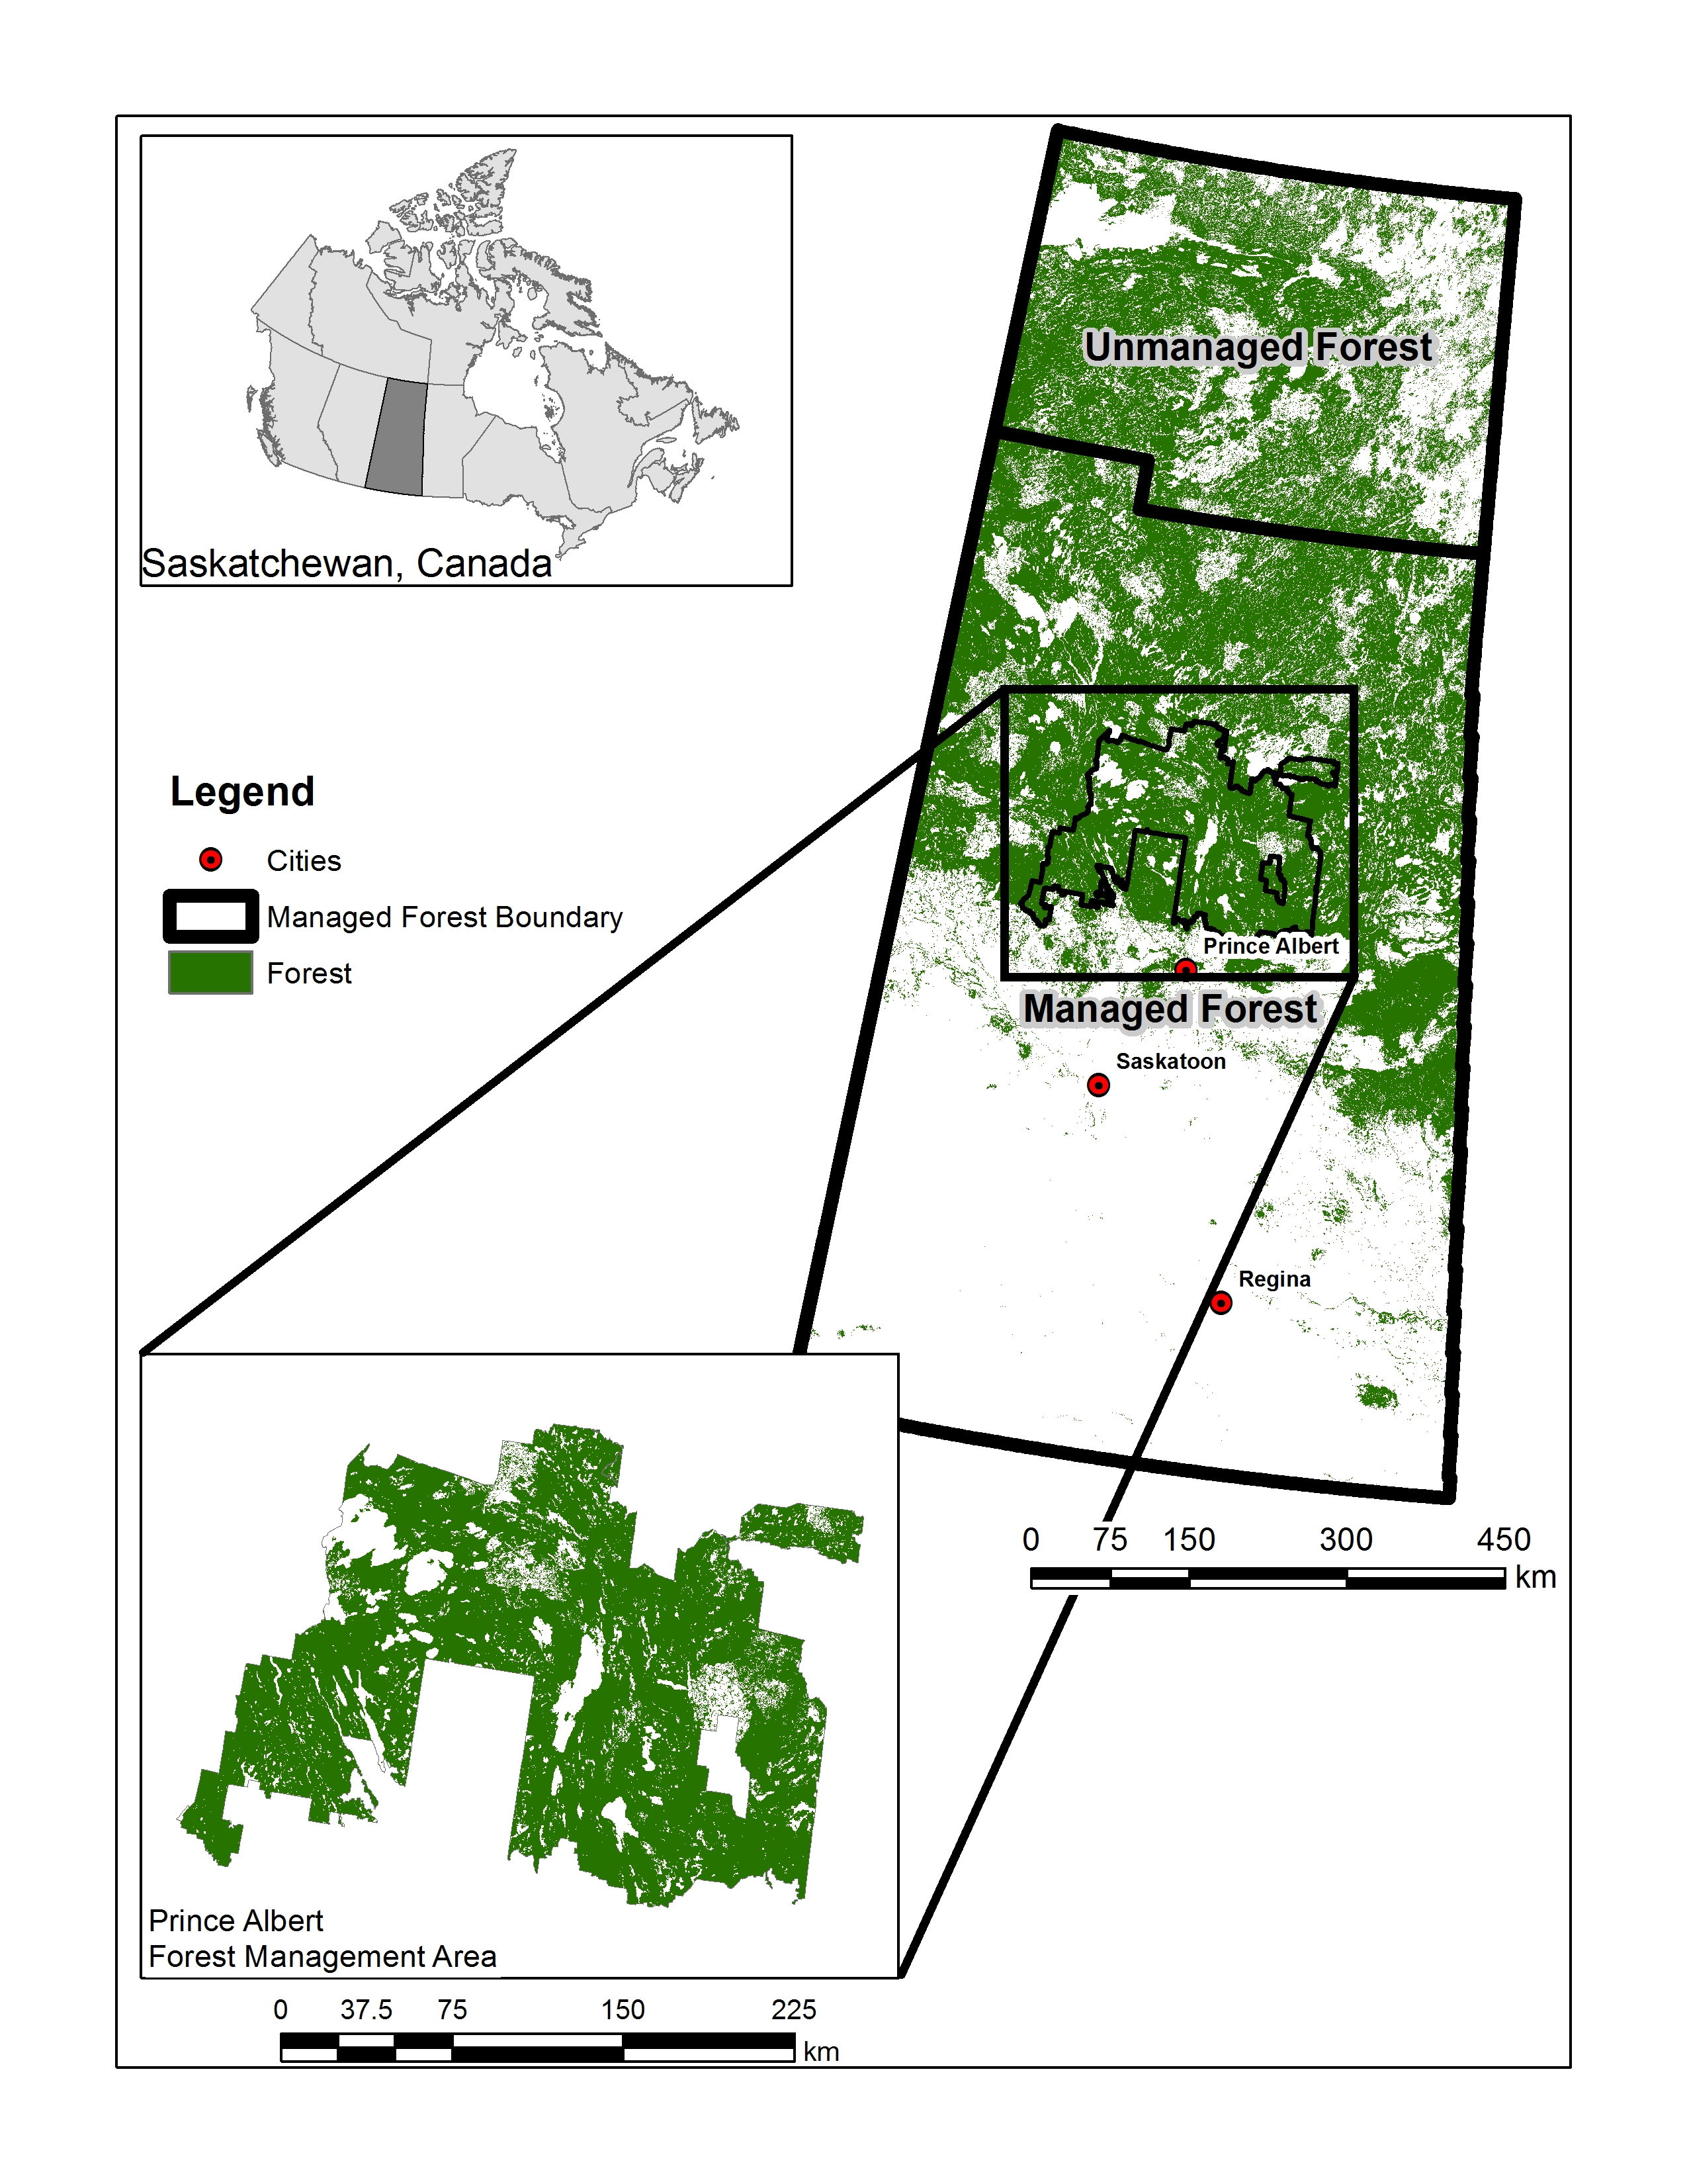

## Figure 2. Analyses inputs and flow.

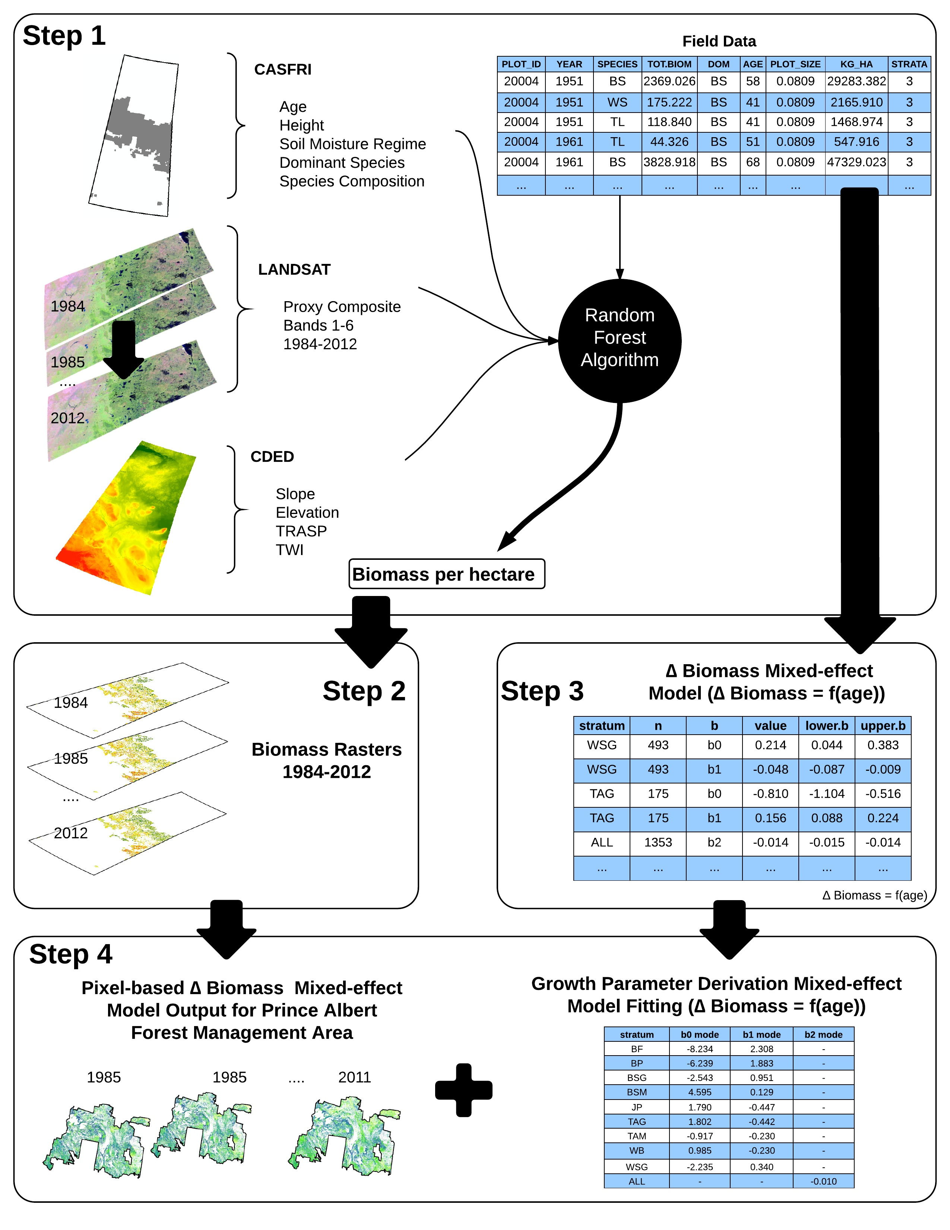

## Figure 3. Tree-level measurements over plot age, by species for plots used for biomass prediction.

##   
Read 92.3% of 574115 rows  
Read 574115 rows and 8 (of 8) columns from 0.022 GB file in 00:00:03

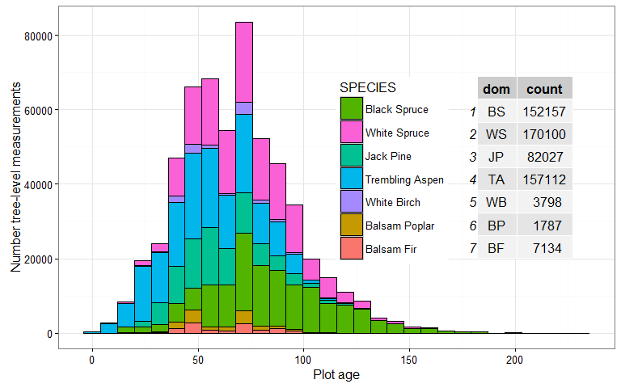

## Figure 4. Average (blue dot) and measurement range (wings) of biomass measured in permanent sample plots in each year that field data were collected. The size of the dot indicates the total number of plots measured in each year.

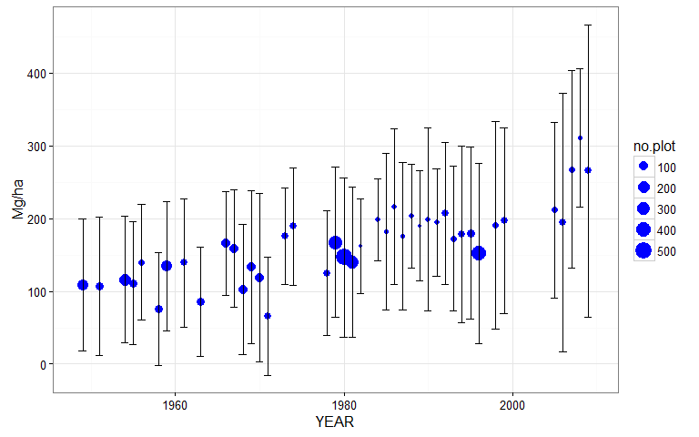

## Figure 5. Average yearly aboveground biomass across pixels (in black) for the pixel-based estimates that remain undisturbed from 1984 to 2012 for each year, and estimates from the field plots (red).

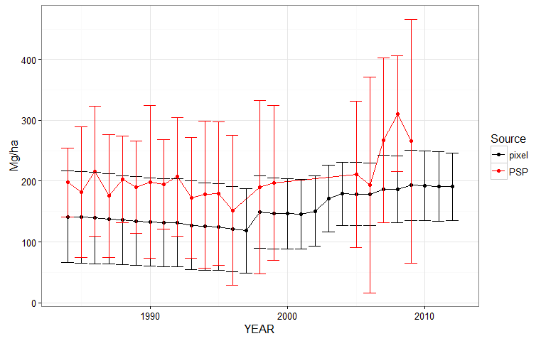

## Figure 6. Predicted biomass per ha increments per year (MgC ha-1 yr-1) from the mixed effect model fit on the field-based for each of nine strata modelled.

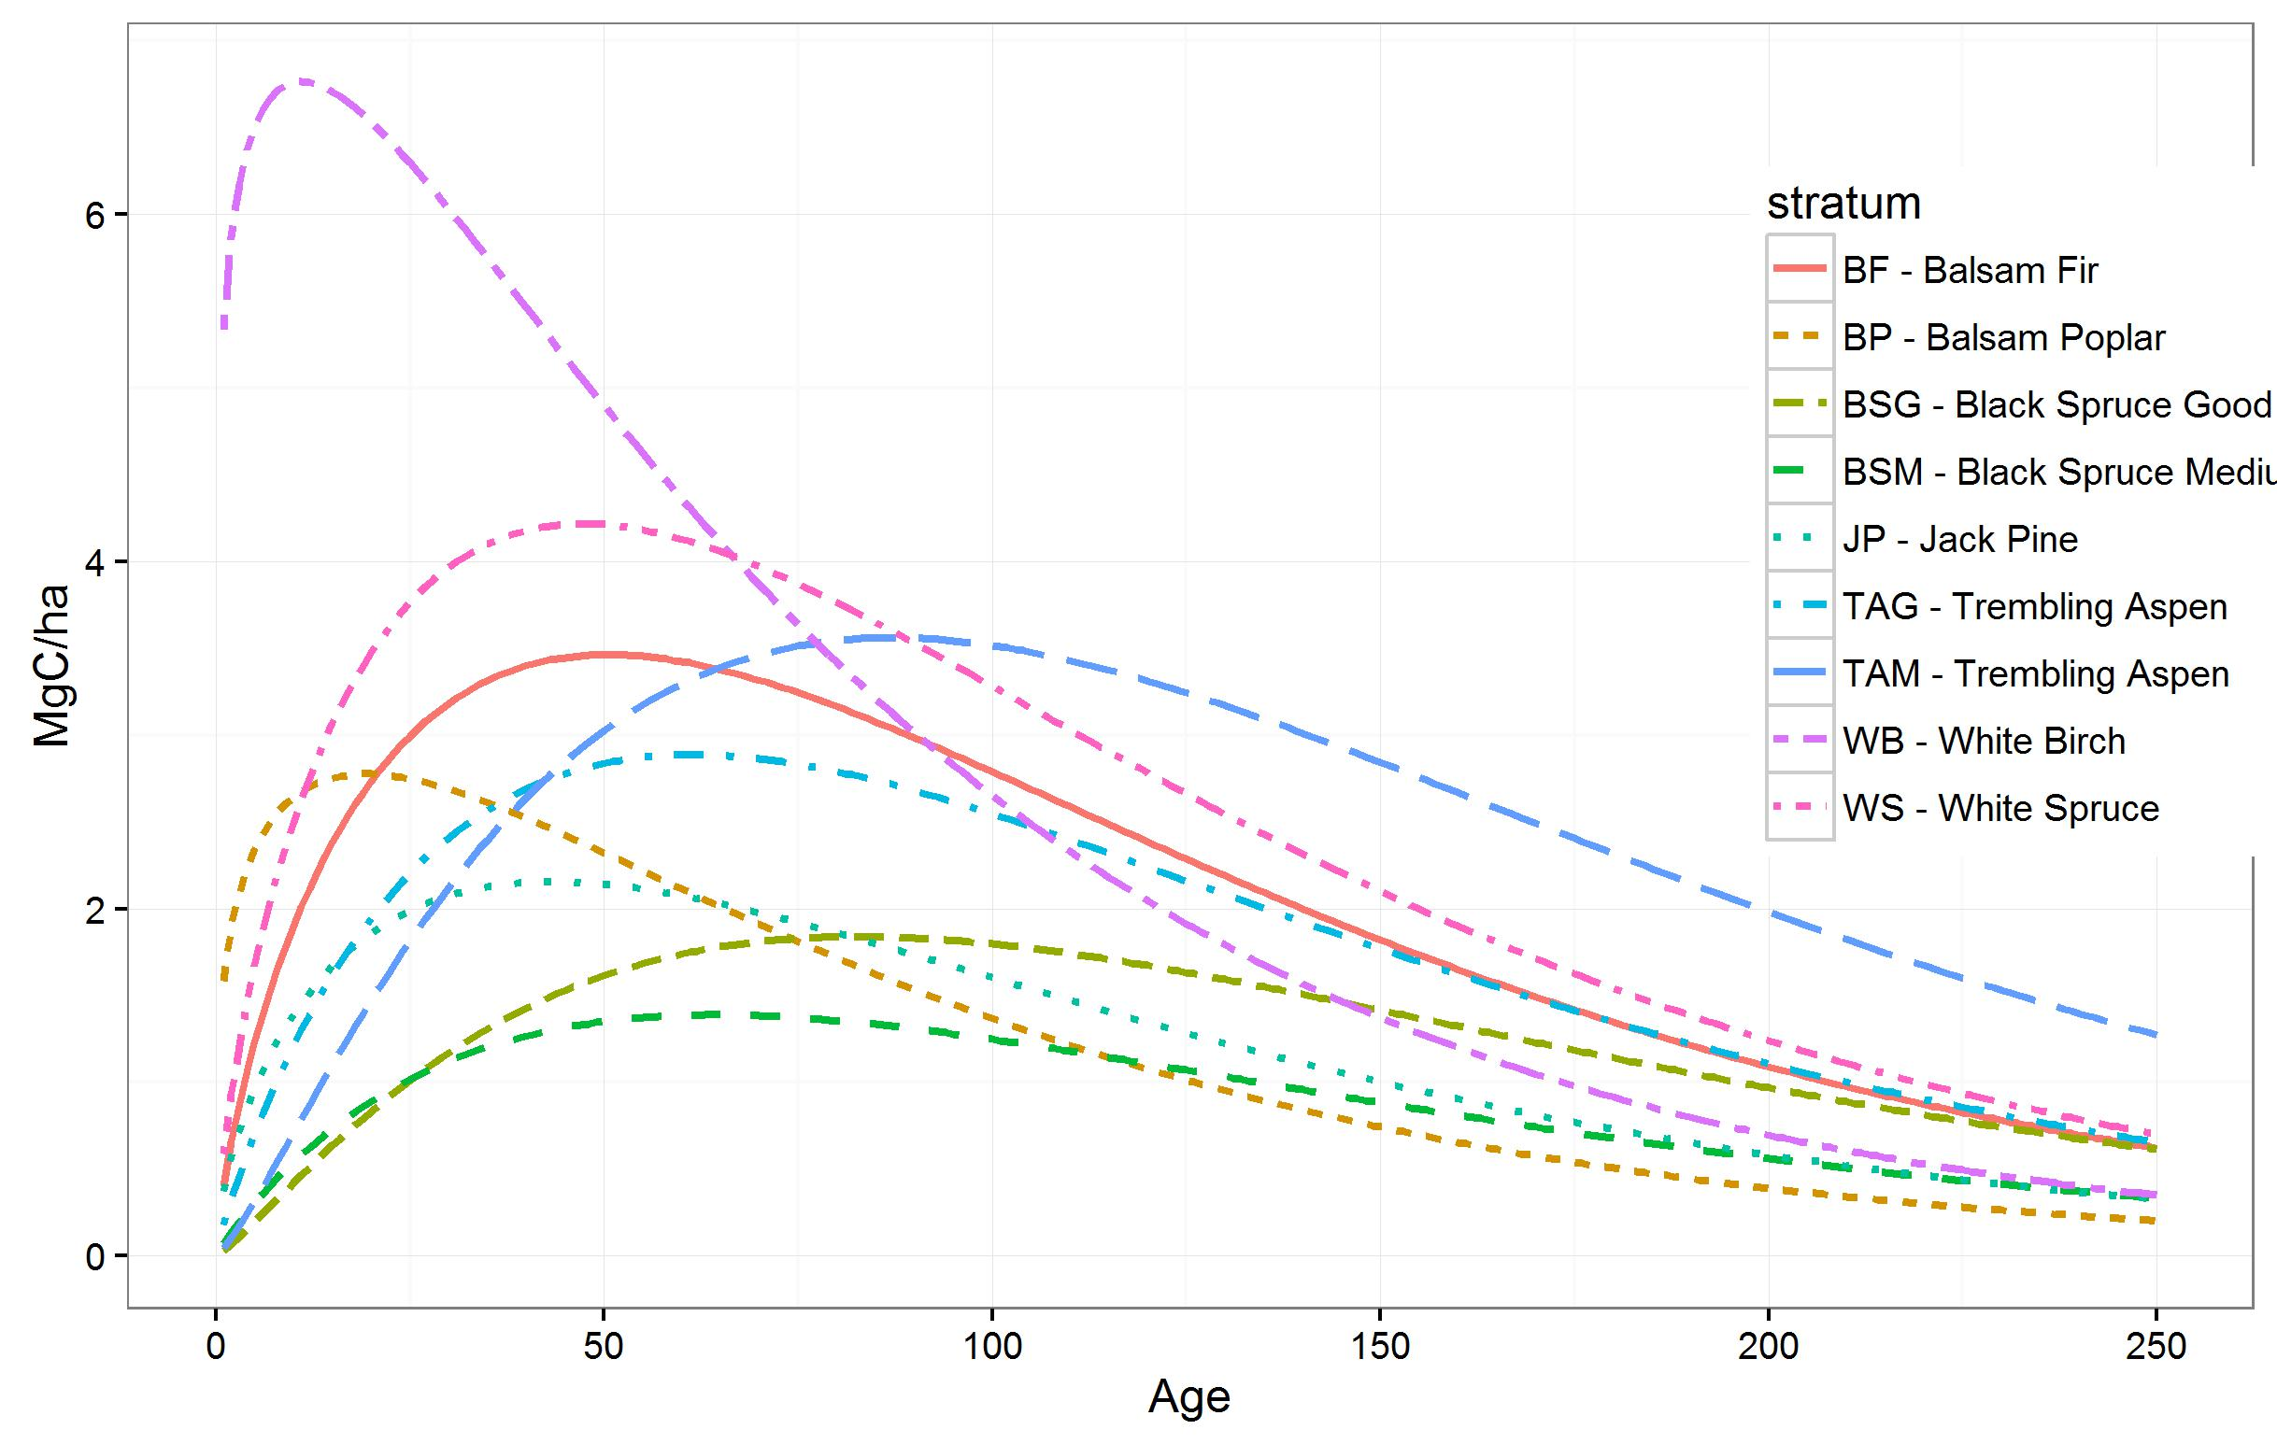

## Figure 7. Parameter values resulting from fitting the log of Hoerl's fucntion to field-based observations (purple) of biomass change for the PAFMA in Saskatchewan Canada compared to the range of parameter values obtained by fitting the log of Hoerl's function to 100 samples of pixel-based estimates of yearly biomass change. The top panel shows the intercept values for each of the nine strata, and the bottom panel shows the parameter values for the slopes, nine for b1 (one per strata) and one for b2 (x-label "ALL").

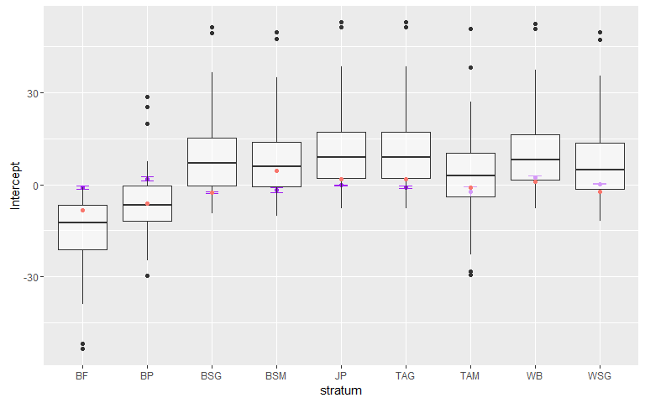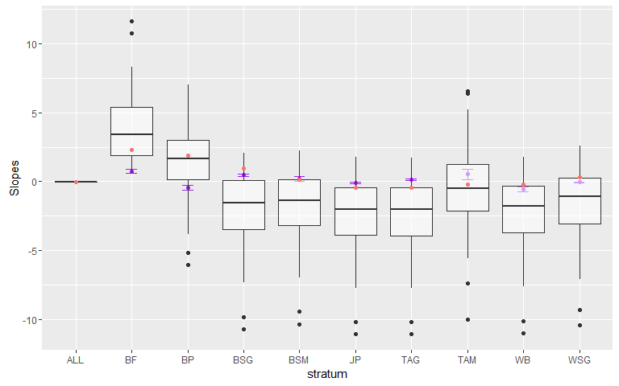

## Figure 8. An example of the range of biomass increment curves for Balsam Poplar (BP) that can be extracted from the range of possible coefficient values fittes to the pixel-estimates of biomass increments.

