Month x year patterns in overall number of crimes

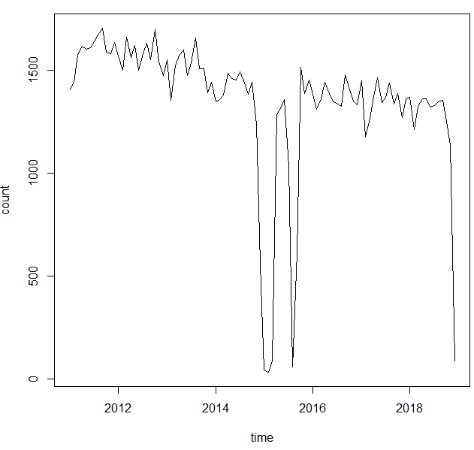

All crimes: hourly patterns

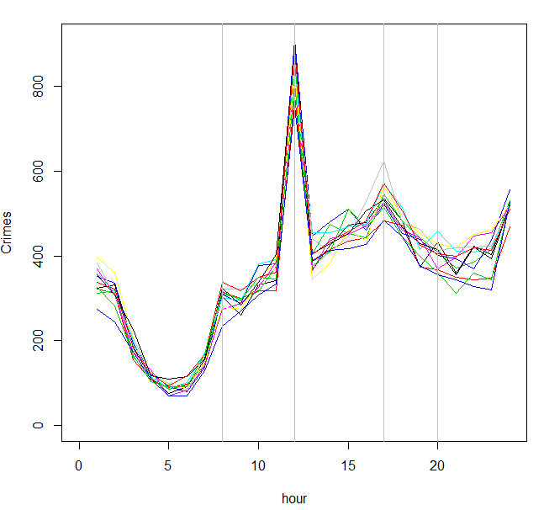

DISORDERLY, DRIVING UNDER THE INFLUENCE, DAMAGE, DISTURBANCE: hourly patterns

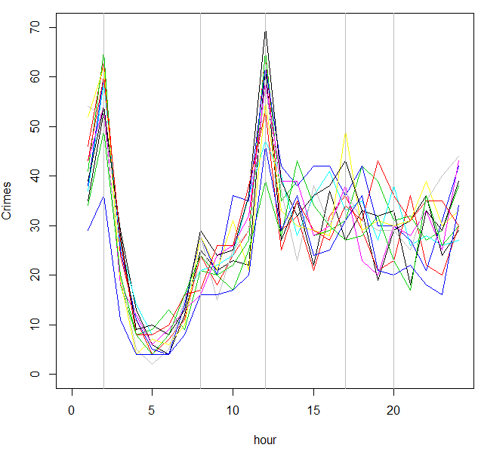

DISORDERLY, DRIVING UNDER THE INFLUENCE, DAMAGE, DISTURBANCE vs other crimes: monthly patterns

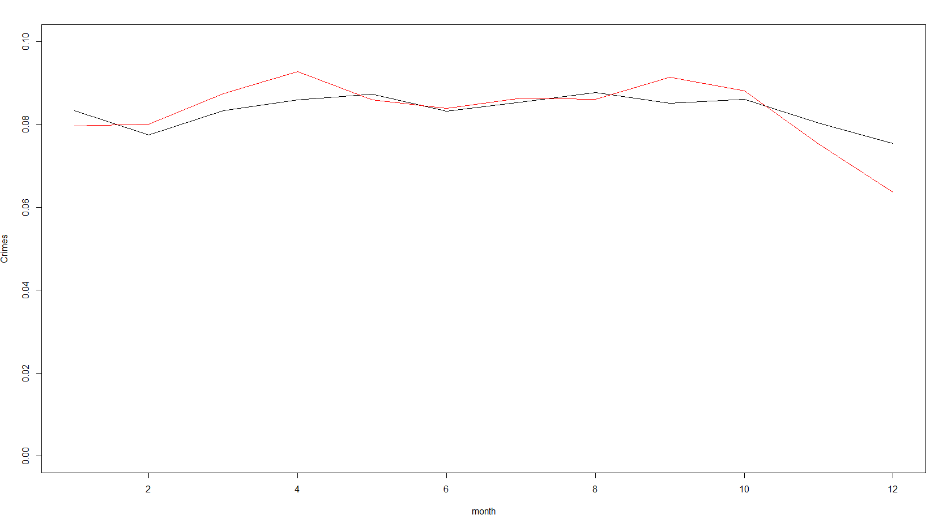

Spatial patterns

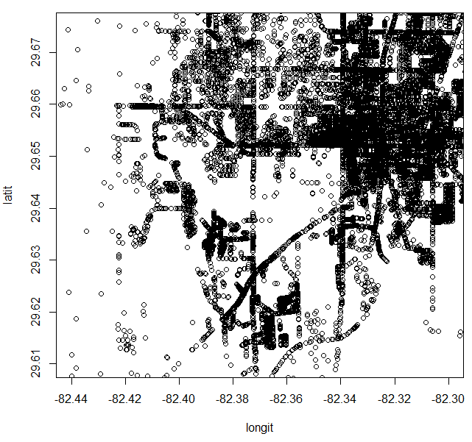

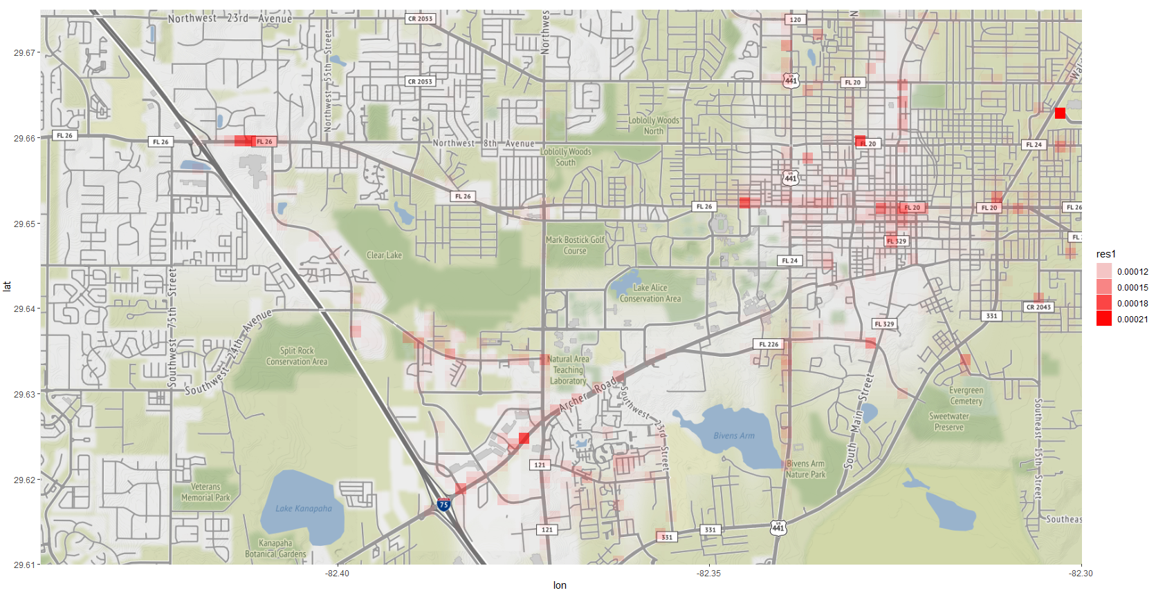

Future questions

- comparison of overall number of crimes (or temporal trends in certain crimes) around where you live vs your friends live or places you thought of living