# J586 Intermediate Interactive Multimedia

## Assignment: Interactive Infographic Review and Presentation

During this course you will be assigned a date when you will be responsible to choose a multimedia website or interactive and present it to the class. The goal of this assignment is to gain an understanding of what makes a good infographic and to become comfortable critiquing professional work. It is also important to have experience making presentations on creative work and this assignment will try to simulate making a critique of a competitor’s work in the creative corporate environment.

You should choose a piece of work that is more than a basic website but one that is a feature of interactive piece of a major website. Look for examples that are successful (award winning or received a lot of buzz at launch possibly) at presenting large amounts of data or visual information through creative ways. Discuss the things that are great but they do not have to be perfect nor will they be. Do some research into the technology behind the application. Contact the editors or producers and learn something from them.

## Requirements:

1. Review (50%)

You will submit a written review of the interactive (with link) that critiques (positive and negative) the design, use of media, use of data, creativity, interactivity and effectiveness. Your review is not limited to a traditional paper. Use good information presentation and be creative. Screen shots for demonstration purposes are expected and links to other professional reviews are helpful. Interviews of the producers receive a 10-point bonus.

1. Presentation (50%)

Make a 10-minute presentation and demonstration to the class that expresses the positive and negatives of the interactive. Your presentation should be professional, captivating and elicit dialog among the class. You can use any visual tools you find helpful but you should also demo the site showing the features and problems. Feel free to be creative and even assume the role of a developer or art director of a firm if it contributes to your presentation.

Your class peers will represent co-workers and respectfully but inquisitively ask questions that challenge or promote your opinion. You should respond professionally but with authority, as you are the expert on this topic.

## Grading: 100 pts

You will be graded on your professionalism and quality of your critique. Your ability to present the information well and to create a discussion among your peers is a major part of the grade. I expect this to be the type of pitch or critique I would see in a New York boardroom of a creative agency.

## Tips:

* Find a great piece
* Don’t wait till the last minute
* Contact the makers
* Research other views
* Dress professionally
* Don’t read the screen, present!
* Have fun wit it!

# 100% New Zealand

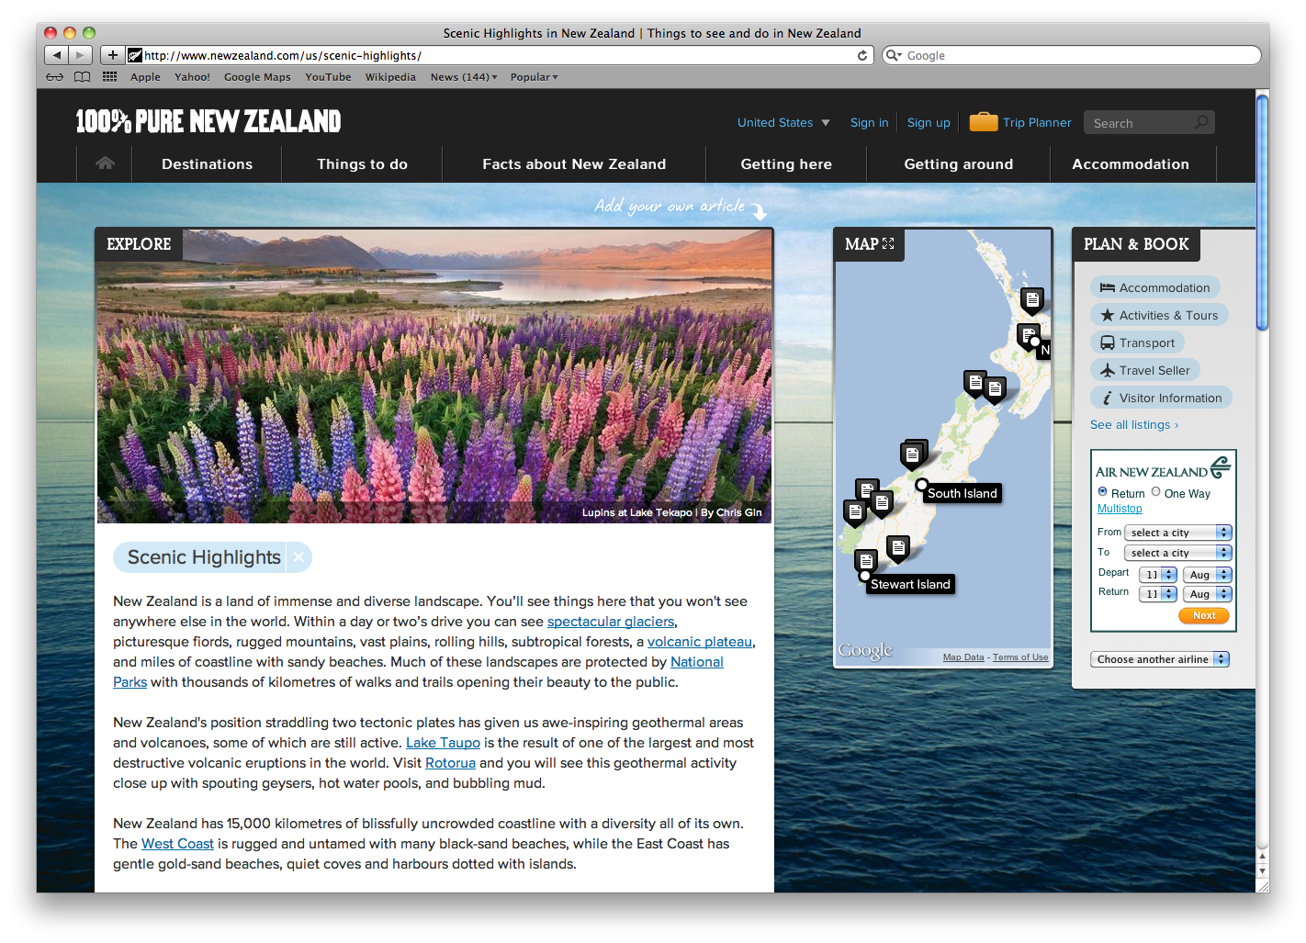

[100% New Zealand](http://www.newzealand.com/us) has changed the way travel destination sites are viewed. This site took a new approach to visual presentation and interactivity and incorporated many technical advances available in HTML5, CSS3 and JavaScript.

### Visual Presentation

Rather than ignoring the fact that users scroll, the designers have embraced it with this creative video-like experience that provides time-lapse scenes as the user scrolls. The images are large and eye-catching and scrolling down the page is not only pleasing but is also inviting. This effect took carful planning and a large budget to execute. [Here you can find out how it was created.](http://www.smashingmagazine.com/2012/03/08/behind-scenes-tourism-new-zealand/)

The usable tools such as trip planning and booking has been moved to the right side which is contrary to other travel destination sites in a way that provides more space to the visuals but still provides access to the tools.

The overall design has lots of elements that are overlapping but are separated with s slight stroke and drop shadow to provide depth and separation. It should be noted that on small monitors the photos become crowded by all of the extra elements around. Also, it seems the plan and book box could use equal padding to the right similar to the padding around the map box.

### Navigation

The top navigation is strong, easy to find, ready and understand. The rollovers provide a sub-navigation that is well spaced and easy to read. There is a top secondary nav that is in blue that provides access to tools and other features that could have been integrated into the main navigation to make it less confusing.

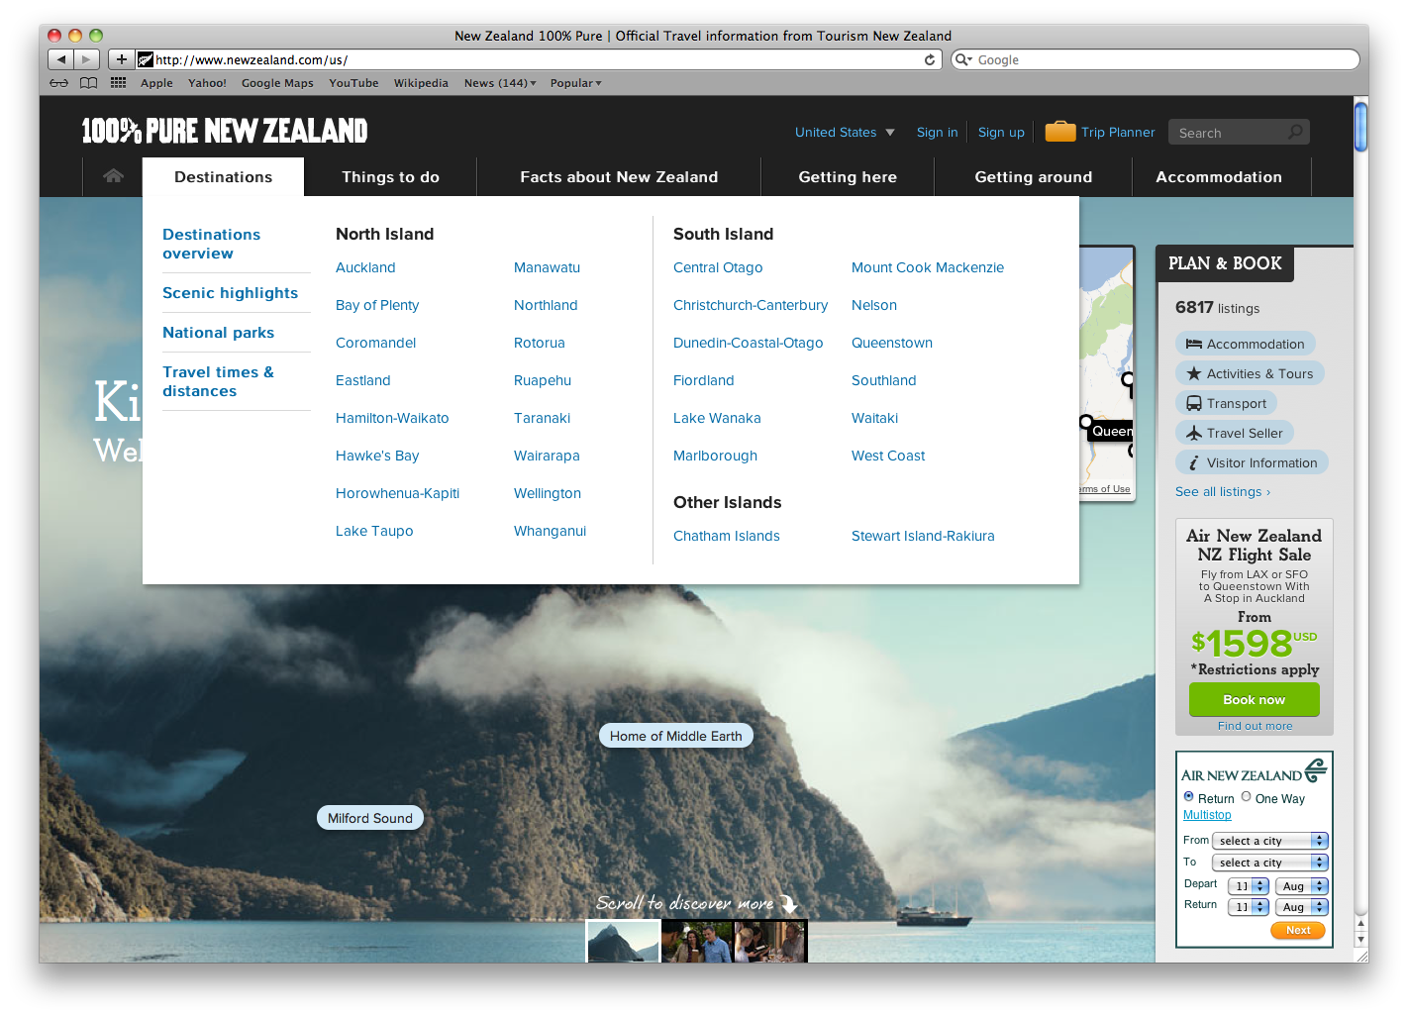

### Article page

[This page](http://www.newzealand.com/us/nature/) is presented on top of the scrolling background, which is visually appealing but renders the scrolling concept un-useable. This is ok as the focus of this page is the content the user wanted. The page has a nice photo across the top and the tag-like filter options are a nice element continued through out the design.

The map box changes to reflect the content, which is an ideal bonus to the material. It is difficult to find sharing options for the content.

### stking:Desktop:Screen shot 2012-08-08 at 10.49.23 AM.pngFeatures and Tools

The site has some nice features such as share your own travel article and a [trip planner](http://www.newzealand.com/us/manage/collection/), which is noted with the only orange icon on the page making it stand out. The tools are easy to use and integrate with Facebook.

### Summary

This site has redefined how users look at travel destination sites as well as created an excellent way to scroll the page while viewing beautiful photography. The site is effective in the goal of enticing users to visit and making it easy to make the next step of planning and booking travel.