**CSCE156 Homework 5 DESIGN DOCUMENT**

**Name:**

**Graded by: Ying Tan**

1. Draw a ER diagram of your design, including tables, primary keys, foreign keys, etc. (20 points)

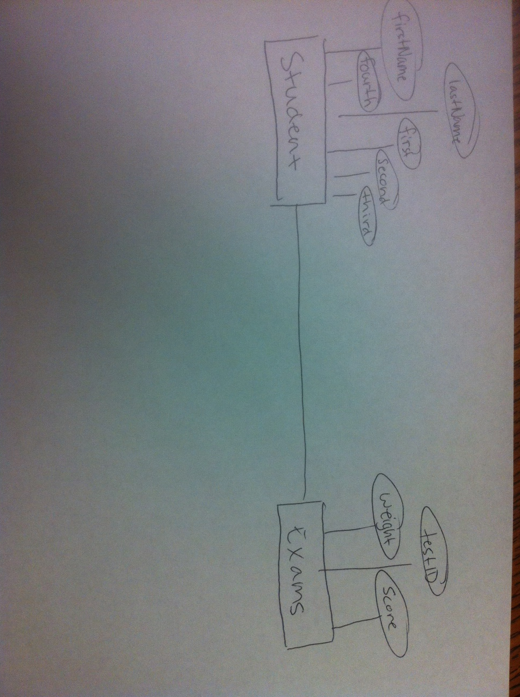

1. Describe the help received if any and indicate the specific segments (must be clear)

Received help with connecting to the mysql database and loading file into said database. I was struggling for some time using the LOAD DATA INFILE command

1. Describe any additional features that you may have incorporated (may earn extra points)