MSC Cover Page Template

*– Using the Maryland Case content as dummy text*

[Please replace all the greyed out text with your own content.]

**Title:**

* Kicker: Smarting over Smart Meters
* Question: Does Smart Grid Technology Have a Home in Maryland?
* Dek: BG&E is trying to roll-out smart meters across its service territory but the Maryland Public Service Commission is hesitant to approve the proposal.

**Authors**: Gianna Petito, Geoffrey Burmeister, Michael Moore, and Arman Golrokhian

**Summary:** Smart meters, an upgrade from the traditional analogue electric meters, have been heralded as a key step towards the elusive smart grid. They are designed to facilitate communication between end users and utility companies, to help individuals and communities save on electricity, to help utility companies cut operational costs, and to decrease the risk of costly and life-threatening blackouts during peak summer demands. They are typically considered a win-win-win for electric ratepayers, the utility company, and the environment. Yet in June 2010, the Maryland Public Service Commission (MPSC) hesitated over a proposal submitted by Baltimore Gas and Electric to roll out smart meters across its service territory and to institute a new electricity pricing plan that would rely on the meters. Commissioner Douglas Nazarian, Chair of the MPSC, needs to decide whether to approve or deny this proposal based on its economic business case, alongside a multitude of other arguments offered by the stakeholders. Facing a decision that could risk losing Maryland $200 million in federal funding, he carefully ponders the costs, benefits, and risks of the proposal.

**Table of Contents**:

1. Hunting in the Dark
2. Power to the People with Peaker Plants
3. Smart Grid Possibilities
4. Smart Energy Pricing
5. The Commission Deliberation
6. Time to Decide
7. Outcomes of the Order

**Consider:**

* Nazarian’s Household Demand for Electricity
* Peak Electricity Demand
* The Economics of Smart Energy Pricing

**Cover Image:**

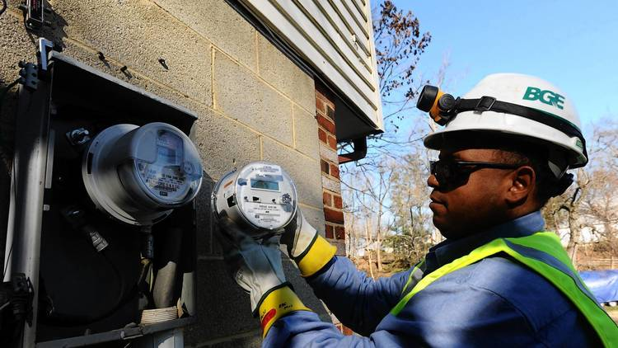

<http://www.baltimoresun.com/business/bs-bz-smart-meter-options-20130113-story.html>

Photo Credit: Algerina Perna, Baltimore Sun