E3ANALYSIS

A suite of Forms, Reports, and a MATLAB toolbox for exploring and analyzing data acquired with ELIZAN III or Human ELIZAN

Foreword
This manual describes how to explore and analyze data acquired with Elizan III or Human Elizan using a set of forms and reports from LibreOffice Base and a toolbox from MATLAB. The LibreOffice forms and reports are used to examine and modify basic information about the subjects (humans or rats). The MATLAB toolbox is used to analyze the data. The LibreOffice reports will then offer richer information after the data have been analyzed in MATLAB.
The analyses performed by the MATLAB toolbox might eventually be moved to Octave, or even to a language that can be triggered from within Base, eliminating the need for MATLAB. However, it is likely that anyone wishing to analyze these data will further interact with them in MATLAB, and therefore it makes sense to develop a MATLAB toolbox first.
The MATLAB toolbox offers two levels of sophistication depending on the requirements of the analysis. For simple feature extraction from the raw data and to perform pre-programmed analyses, the user may use the provided graphical user interface (GUI). To get the most out of the toolbox (i.e. to perform custom analyses) the user will have to write their own MATLAB code.
The toolbox has been written in such a way that only a minimal amount of coding will be required to create new features or new analysis procedures. Any further modifications will require the user to be familiar with object-oriented programming in MATLAB and database administration using the MySQL database server. Resources to learn more about each of these topics will be mentioned in the appropriate sections.
This manual begins with a chapter on setting up access to the raw data. Since the analyzed form of the data persist in a database, we then describe how to setup the analysis database in the second chapter. In the third chapter, we describe how to setup LibreOffice Base to interact with the analysis database including adding subject information and modifying subject parameters. In the 4th chapter we describe how to setup MATLAB to interact with the raw data and with the analysis database. Finally, in the 5th chapter, we provide more detailed information about the structure of the analysis database and the MATLAB code for more advanced users.
Administrator privileges are required to install and perform an initial configuration of MySQL, to install the MySQL Workbench, to install LibreOffice (note: OpenOffice >= 3.4 should also be sufficient), to install MATLAB, and to install some other tools if it is determined that you will need to compile binaries that the MATLAB toolbox depends on.

1Setting up Access to the Raw Data 4
1.1Determining the ideal data storage configuration 4
1.2Elizan data directory 4
1.3MySQL 5
1.4Installing and configuring MySQL 5
2Setting up the analysis database 10
2.1Add the E3Analysis database 10
3Setting up the forms and reports for LibreOffice Base 11
3.1Setting up access from Base to the MySQL service 11
3.2Test the Base connectivity to the MySQL service 11
3.3Using forms to modify how the MATLAB toolbox will work 11
3.4Using forms to enter information 13
4Setting up Matlab and the E3Analysis Toolbox 14
4.1MATLAB 14
4.2Installing MATLAB 14
4.3Installing the E3Analysis Toolbox and its dependencies 14
5Using the E3Analysis Toolbox 17
5.1Setting up access to the analysis database 17
5.2Launching the E3Analysis MATLAB toolbox 17
5.3Adding and configuring feature types 17
5.4Adding detail types 17
5.5Adding and configuring a subject 17
5.6Adding and configuring experiments 17
6Advanced Use of E3Analysis Toolbox 18
6.1Create novel feature types 18
6.2Create novel detail types 18
6.3Create new analyses 18

Setting up Access to the Raw Data
A note about file permissions if using an operating system other than Windows:
If the goal is to analyze human Elizan data, the directory must be accessible by the computer that will be used to perform the analysis. (Note that the raw data do not need to be accessible to the computer with the forms and reports, i.e. LibreOffice Base).
If we are analyzing Elizan III data (i.e. rat E3), then the data will be accessed through a MySQL database service. The service runs under a certain username. That username by default is 'mysql'. Either the user 'mysql' will need read and write permissions in the directory where the data will be stored or the MySQL service needs to be run with a different username that has access (by specifying --user=<alternate_user> when starting the service).
There are two different types of raw data that these tools work with: data from Elizan III (E3) and data from human Elizan. Human Elizan stores data in binary files which are relatively easy to access. E3 stores data in a MySQL database so we need access to a MySQL server where E3 data are stored. This is significantly more complicated than accessing binary files thus the majority of this chapter is devoted to accessing E3 data.

Determining the ideal data storage configuration
While it is possible to use these tools to interact with the data as they are acquired, it is highly recommended that we only interact with a backup copy of the raw data. The backup data (heretofore referred to as raw data) do not need to be stored on the computer we will use to interact with the raw data. The raw data should be stored on a remote computer if, and only if, the remote computer has very fast disk access and it has a very fast network connection to the computer(s) used for interacting with and analyzing the data. The ideal configuration can only be determined by benchmarking each possible configuration. In lieu of that, I will only mention that there are several bottlenecks to be aware of including the connectivity between the nodes and the disk access times.
The provided tools and the manual were written under the scenario that the raw data, the analyzed data, and the analysis were all on the same computer. The modular configuration has not been tested but it should work.

Elizan data directory
Determine where you will store the raw data. There should be ample storage space in case we are to add more raw data in the future. See the note about permissions if not using Windows (next page). If we are working with E3 data, write down the name of the data directory as it would be seen by the computer running the MySQL service. If we are working with Human Elizan data, write down the name of the directory as seen by the computer used for analysis. We will refer to this directory as 'datadir'.
Copy the raw data to the directory now. An Elizan III database is a folder with a name similar to 'ani-X-X' and within the folder will be 6+ files, 2 each of frm, MYD and MYI types. Copy the 'ani-X-X' folder itself into datadir.

MySQL
MySQL is a popular database management system (DBMS) and ample information surrounding its use is available online. MySQL Community Server (the free version) can be downloaded from the MySQL website (http://www.mysql.com/downloads/mysql/). Download the version appropriate for the computer that will be serving the raw data and, if distinct, the computer that will be serving the analyzed data.

Installing and configuring MySQL
If you are analyzing Human Elizan data, you can return to this section later when setting up the analysis computer. If you are analyzing E3 data, please proceed through the following steps now.
There are many many tutorials for installing and configuring MySQL available on the web. I will leave it to the reader to find basic instructions on installing MySQL for their particular platform. Note that the MySQL service providing the analyzed data must have InnoDB enabled and that, in the case of E3 raw data, the MySQL service providing the raw data must have MyISAM enabled. It is probably a good idea to enable both database formats during installation. I also usually use UTF8 instead of latin1 character set though I'm not sure that it matters. It would also be convenient if you selected the option to add the mysql binaries to the windows path. The installation typically ends with a prompt to start the service. Go ahead and start it.
The service, while running, is probably using the default data directory. We must tell it to use the datadir. Many MySQL options, including the datadir, are specified in an options file. Please see here for more information on where to find the options file depending on your operating system:
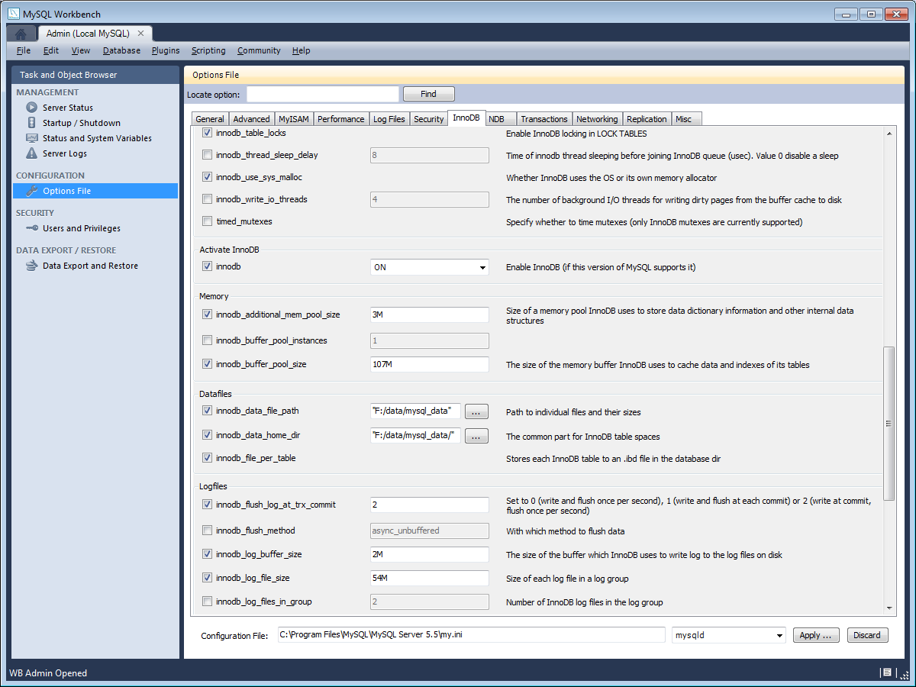Figure 1.4.1: InnoDB settings in MySQL Workbench
http://dev.mysql.com/doc/refman/5.1/en/option-files.html
I like to edit the options file using a GUI called MySQL Workbench. This GUI is available for all operating systems and is free. It can be downloaded from
http://dev.mysql.com/downloads/workbench/
In Windows, installation of the MySQL Workbench requires that a Visual C++ 2010 Redistributable package and .Net Framework Client Profile be installed. (Note: Do not install this if you are going to install a MATLAB compiler later). The Visual C++ package can be found here:
http://www.microsoft.com/download/en/details.aspx?id=8328
Though we only need the .Net Framework Client Profile for now, we might need the entire Framework at a later step if we need to compile some MATLAB binaries. Choose whether you need the client profile or the full developer framework and download it from here:
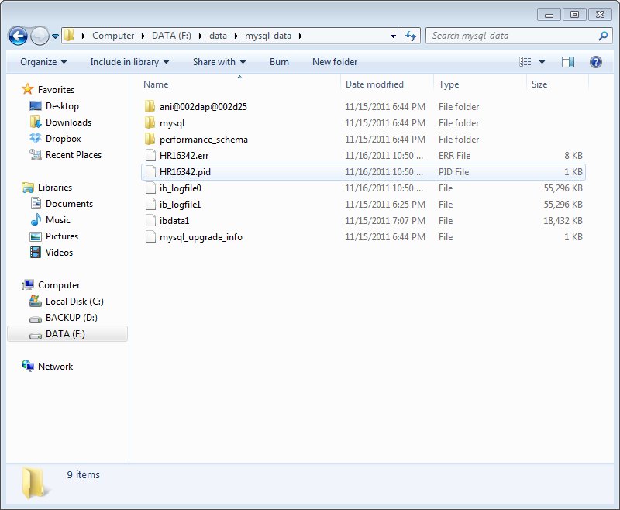Figure 1.4.2: Contents of mysql datadir after setup
http://www.microsoft.com/net/download
Start MySQL Workbench. In the rightmost column, under Server Administration, select the server (i.e. “Local MySQL”). This should launch the Admin interface. On the left, under Configuration, click on “Options File”. This may give you a few prompts to create an options file if one does not already exist.
The following settings are important Figure 1.4.1:
- Under the General tab
  - datadir=<datadir> (where <datadir> is the path we wrote down earlier)
- If this is the same MySQL service that will be used to store the analyzed data, then modify the following settings under the InnoDB tab
  - innodb=ON
  - innodb_file_per_table
  - innodb_data_home_dir=datadir
Apply the changes. Then on the left click on Startup/Shutdown under MANAGEMENT and stop the server. When it is stopped, start it again.
Now that the MySQL service is running and the data are loaded from the datadir, we should make sure the data are appropriately upgraded.
When the MySQL service is running, from the command line run mysql_upgrade. This might take some time depending on the size and number of databases in the data directory. [Open a Terminal window or a command prompt (Windows: Start -> Run -> cmd.exe; OSX: Use spotlight to find Terminal). Change to the directory where the MySQL binaries are installed (Windows: cd C:\Program Files\MySQL$version\MySQL\bin; OSX: cd /usr/local/mysql/bin). In that directory, type ‘mysql_upgrade -uroot -p<root_password>’ (or ‘./mysql_upgrade –uroot -p<your_password>’ in OSX). When complete, your data directory will probably look similar to the picture in Figure 1.4.2. Notice how the ani-ap-25 directory has been renamed to ani@002dap@002d25. This is because newer versions of MySQL do not allow hyphens in database or table names (hyphens are interpreted as subtractions).
Furthermore, we will create a mysql account called “e3ana” that only has read access to all e3data schemas and has unlimited access to a schema called 'e3analysis' which we will create later. To do this I use MySQL Workbench.
On the left click on 'Users and Privileges' below SECURITY. Click 'Add Account' at the bottom. Call the account something (I use e3ana) and give it an easy to remember password. Write this information down. If you are connecting locally, set the 'Limit connectivity to hosts' to 'localhost', otherwise set it to '%'. Click 'Apply'.
At the top, click 'Schema Privileges'. Under users click on the user (i.e. e3ana). On the right click on 'Add Entry...'. In the window that appears select 'Any Host (%)' and 'Schemas matching pattern or name' and type ani% in the accompanying box. Click OK. Highlight the entry then below check 'SELECT'.
Add another entry. Leave Host as Any Host. Set Schema to 'Schemas matching pattern or name' and type in e3analysis. Click OK. Then highlight the entry in the window above then below click 'Select “ALL”'. Save Changes.

Setting up the analysis database
Most of the steps required to set up the analysis database are outlined in Chapter 1.
If we are analyzing E3 data but the analyzed data will be on a separate MySQL server instance, or if we are analyzing Human Elizan data, then the MySQL service for analyzed data must be configured as outlined in Chapter 1 before proceeding with the following steps. If we are analyzing E3 data and the same MySQL server instance will be used for the analyzed data then the MySQL service does not need further adjustment with the exception of adding a database (schema).

Add the E3Analysis database
Look in the mysql_help folder for a file named something similar to e3analysis_v1.sql. Open a command prompt or terminal. Change to the directory with the mysql binaries (Windows: cd C:\Program Files\MySQL$version\MySQL\bin; OSX: cd /usr/local/mysql/bin) then type:
mysql -uroot -p<your_root_password> [-h host_name_if_not_local] < e3analysis_v1.sql
This should create a database (schema) named `e3analysis` and it should also create tables (relations) within the database. It will also populate some of the tables with some initial data.

Setting up the forms and reports for LibreOffice Base
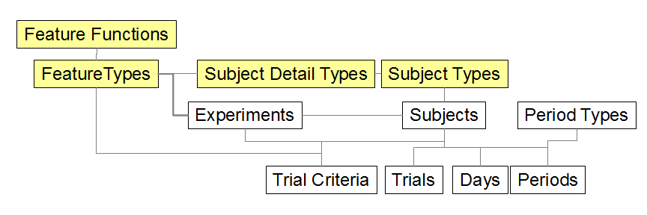Figure 3.3.1: Hierarchy of Forms. Boxes highlighted in yellow indicate forms that specify types of data. Data types must be defined before their child objects can be created. A vertical connection indicates a dependency, and a horizontal connection indicates objects that may have interactions but are not explicitly interdependent.
Note that the version of OpenOffice (3.0) that is installed by default from the Wadsworth ITG is not sufficient for our purposes. OpenOffice 3.0 does not come with MySQL access built-in. I use LibreOffice, which is nearly identical to OpenOffice, version 3.4. You may install either OpenOffice or LibreOffice, provided it is a sufficiently high version.

Setting up access from Base to the MySQL service
Download Connector/J from http://www.mysql.com/downloads/. Extract the archive somewhere and note the .jar file. (You may also use the .jar file that is included in the github repository)
Open LibreOffice. Go to the Options (Tools->Options or File->Preferences). Select Java under the main preferences. Select 'Class Path...' then 'Add Archive...”. Find the extracted .jar file. Quit LibreOffice.

Test the Base connectivity to the MySQL service
Open the ElizanDB.odb file provided with these tools.
Test out the database connection by clicking on 'Tables' on the left in the 'Database' panel. It will ask you for the password corresponding to e3ana. If you created the e3ana user as described in Chapter 1, then enter the corresponding password. If you used a different username, you will have to modify the Base file by going to Edit->Database->Properties.
If you authenticate correctly, you should then be able to see all of the tables that are part of the e3analysis schema by clicking on 'Tables' on the left panel of the window. Double click on the 'version' table, this should open a new window with a column named 'number' and then the version number below.

Using forms to modify how the MATLAB toolbox will work
The MATLAB toolbox has some pre-programmed functions to do basic calculations from the raw data. For example, there is a function to calculate the average absolute amplitude of a signal and there is a function to calculate the spectral amplitude of a signal. These functions can only be used to extract meaningful variables (e.g. the H-reflex) from the raw data when they are parameterized with meaningful information (e.g. the H-reflex channel, the start time, and the stop time).
Before we may parameterize these functions, we first have to allow for the existence of these parameters by specifying the type of parameter. This explicit requirement is an example of a data dependency. There are many such dependencies in this database. These dependencies exist to ensure the integrity of the data. Since it is impossible to create a type_A entry in the database when it depends on type_B but the type_B entry does not exist, then the information must be entered in a specific order when we wish to modify the E3Analysis toolbox features. See Figure 3.3.1.
When a table is very simple, it is not necessary to create a form for it and the data can be manipulated directly in the table view. For example, open the table for 'feature_function'. Several Feature Functions should be specified already. The function name expects there to be a function with that same name in MATLAB (more on this in Chapter 5).
Open the 'Feature Types' form. A feature type describes a variable to be extracted from the raw data. Here we can specify the name of the feature, a description for it, and we can select the function that will be used to calculate it. We can stop here if the function does not require any subject details. This is rare, however, so close this form and we will return to it after creating some Subject Detail Types.
Open the 'Subject Detail Types' Form. This form lists all of the Subject Detail Types including those from different experimental groups, from humans, from rats, etc, and therefore some detail types might not be relevant to you.
Examine the list and make sure we have some details named 'start_ms_h', 'stop_ms_h', and 'channel_h'.
It is important that the names of detail types created in this way conform to certain standards. Specifically, if a detail type is going to be used for a function, make sure the name of the detail type begins as indicated in the function description (e.g. for the H-reflex size feature, the detail type could be 'channel_h'). Close this form.
Now that these Detail Types have been created, we can go back to the Feature Type form. Edit the Feature Type so that its function knows which Subject Details to use. When finished, close this form.
Now open the Subject Types form. In here, enter a subject type. A subject type defines a collection of Subject Detail Types and therefore a new Subject Type should be created whenever the Types of Details about a subject change. For example, a rat that underwent H-reflex conditioning is of a different type than a rat that underwent H-reflex conditioning AND had its ECoG activity recorded.

Using forms to enter information
Now that some types have been specified, we can begin to setup our specific analysis.
Let's start by creating a subject. Open the Subjects form.

Setting up Matlab and the E3Analysis Toolbox

MATLAB
MATLAB is a commercial program from The Mathworks. It can be very expensive. There is a free alternative to MATLAB called ‘Octave’. Eventually I would like to get this toolbox working in Octave, and this shouldn’t be too difficult given the similarity of the two languages, but there are some differences that would prevent it from working in its current state.
MATLAB can be considered both a programming language and a development environment for scientific and engineering data analysis. In addition to the core MATLAB program, there are also many toolboxes (extra cost) from Mathworks for specific types of analysis. MATLAB is widely used in the scientific and engineering communities and as such it also has many freely available toolboxes programmed by other scientists and engineers.

Installing MATLAB
MATLAB has installation binaries for Windows, Linux, and OSX. The installation should be straightforward. Some toolboxes or MATLAB add-ons may be required depending on your specific demands.
- MATLAB compiler is required if you do not have access to a mym binary. Some binaries are included in the online repository.
- (I started with 0 toolboxes)

Installing the E3Analysis Toolbox and its dependencies
Let’s begin with the dependencies.
First is ‘mem’. mem is the maximum-entropy method of spectral estimation. This takes a signal (or signals) and parameters as its input and returns the spectral amplitude and frequencies as estimated by an autoregressive algorithm. This method is preferred over a Fourier transform when the data segment being analyzed is short. I have always received mem as a set of compiled binaries from someone in the BCI Lab at the Wadsworth Center. They are included with this toolbox in the mem folder. Newer versions may be available.
Second is ‘mym’. mym allows for low-level MySQL access. This is preferred over the MATLAB database toolbox because the database toolbox uses a Java bridge to connect to the MySQL server, and this Java bridge is slow and has memory constraints.
Some mym compiled binaries are included with this Toolbox. The Windows and OSX binaries rely on the presence of a linked library file. In Windows, this library file has to be present in the MATLAB search path. In OSX, this file has to be in the dynamic library path as specified by the command ('>>' denotes a MATLAB prompt)
>>getenv('DYLD_LIBRARY_PATH')
It has taken me a considerable amount of time to figure out how to compile these binaries for the different platforms so I will outline the basic procedure here in case it might help someone in the future. If the provided binaries work for you then you can skip this section.

- Make sure the MATLAB compiler is installed with MATLAB
- Install a compiler with C++ support chosen from:
http://www.mathworks.com/support/compilers/
- Be sure to choose the version of MATLAB that you have on the left. If using Windows SDK as the compiler, it is also necessary that you don't already have a Visual C++ Redistributable package installed that is newer than the one provided by the Windows SDK.
- In MATLAB, run >>mbuild -setup
  - Allow MATLAB to search for installed compilers. Select the C++ compiler that you just installed.
- Download and extract zlib (http://zlib.net/). Get the compiled dll version of the download.
- Locate the mysql_client source code headers (include) and libraries. If MySQL is installed on this computer, then the include and lib should already be installed.
- Download the mym source code (http://sourceforge.net/projects/mym/files/)
- Compile the source code
- Some example commands for compiling source code follow:
  - [Windows7 64-bit]
    - mex -I"C:\Program Files\MySQL\MySQL Server 5.5\include" -L"C:\Program Files\MySQL\MySQL Server 5.5\lib” -I"C:\Users\<username>\Downloads\zlib125-dll\include" -L"C:\Users\<username>\Downloads\zlib125-dll\lib" -lzdll -lmysqlclient "C:\Users\<username>\Downloads\mym_src_v1.36\mym.cpp" LINKFLAGS="$LINKFLAGS /NODEFAULTLIB:LIBCMT"
  - [Windows 7 32-bit]
    - The same as above but it probably does not require the extra link flags.
  - [Ubuntu]
    - mex -I/usr/include/mysql -I/usr/include -L/usr/lib/mysql -L/usr/lib -lz -lmysqlclient mym.cpp
  - [OSX 64-bit]
    - After running mex -setup, close MATLAB.
    - Open a terminal window and enter “sudo open -t ~/.matlab/R2011b/mexopts.sh”
    - In the maci64 section, change the line to read as follows: “MACOSX_DEPLOYMENT_TARGET='10.6' CC='gcc' CXX=g++”
    - mex -I[mysql include path] -L[mysql library path] -lmysqlclient -lz mym.cpp
    - you might also need the -lSystemStubs switch to avoid namespace clashes

Using the E3Analysis Toolbox

Setting up access to the analysis database
Open MATLAB and change the working directory to the matlab_toolbox directory. Open +E3\Mydb.m to edit the database connection parameters.

Launching the E3Analysis MATLAB toolbox
#Paths check
#Version check
#GUI

Adding and configuring feature types

Adding detail types

Adding and configuring a subject
#Add the animal
#Change the animal’s information
#Examine an animal’s features
#Specify the baseline period
#Specify trial exclusion criteria

Adding and configuring experiments
#Add animals
#Add and configure analyses

Advanced Use of E3Analysis Toolbox

Create novel feature types

Create novel detail types

Create new analyses

