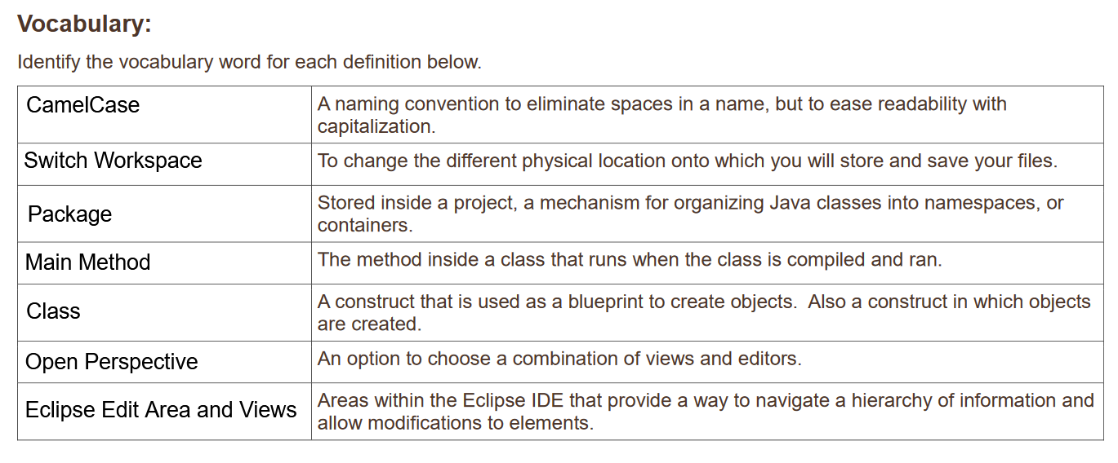2. The pseudo code for converting gallons to liters was described in the lesson. Write the code for the program. The program will convert a specific number of gallons to liters and then display the output.

**package** GallonsToLiters;

**public** **class** ConversionClass {

**public** **static** **void** main(String[] args) {

**double** Liters;

**double** Gallons = 8;

Liters = Gallons * 3.785;

System.***out***.println(Gallons + " Gallons = " + Liters + " Liters");

}//end method main

}//end class ConversionClass

3. Modify the code written in step 2 to prompt a user for the number of gallons to compute.

**package** GallonsToLiters;

**import** java.util.Scanner;

**public** **class** ConversionClass {

**public** **static** **void** main(String[] args) {

System.***out***.println("Enter number of gallons here");

Scanner scan = **new** Scanner(System.***in***);

**int** Gallons = scan.nextInt();

scan.close();

**double** Liters;

**double** Gallonsdouble = Gallons;

Liters = Gallonsdouble * 3.785;

System.***out***.println(Gallons + " Gallons = " + Liters + " Liters");

}//end method main

}//end class ConversionClass)

4. Describe three ways you can test the program that converts gallons to liters

By trying with in a whole number, a decimal, and a negative number.