**Exercise 1**

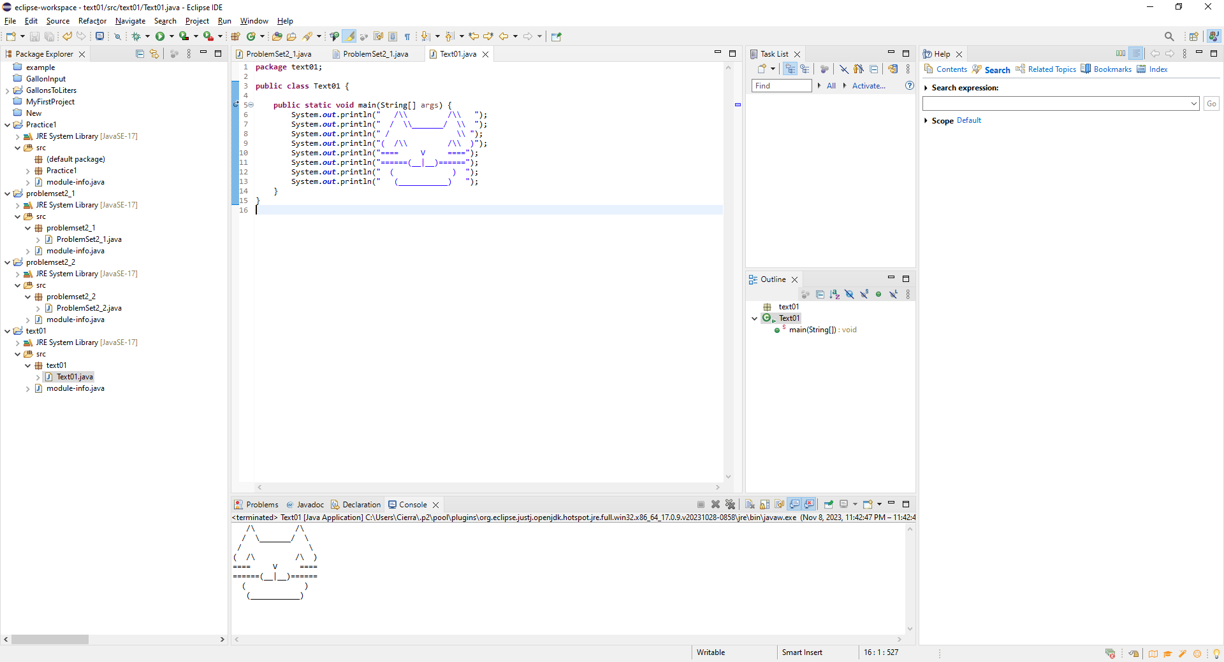

Cat for Problem 1

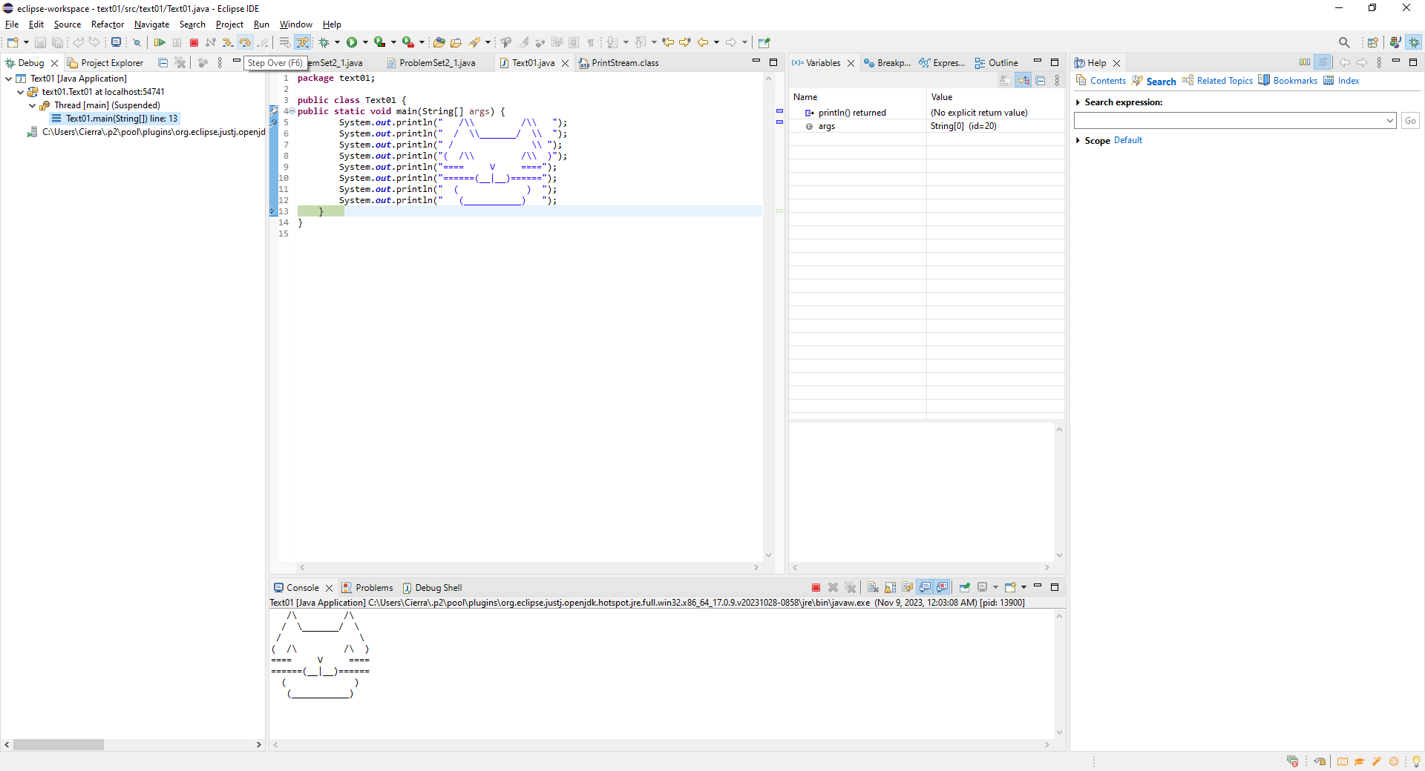

Cat showing up one line at a time through debug

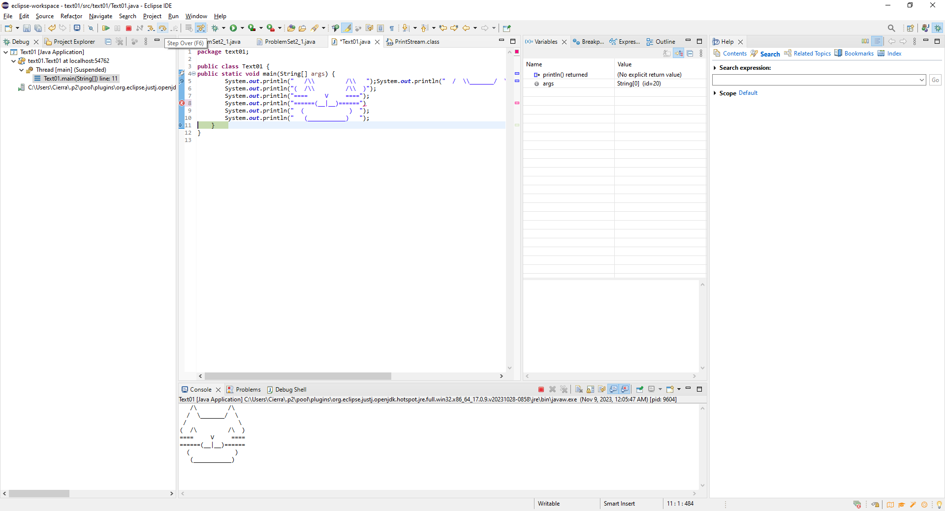

Moved 3 first print statements to line 5. Cat still showing up with that, and if I remove semicolon while debugging.

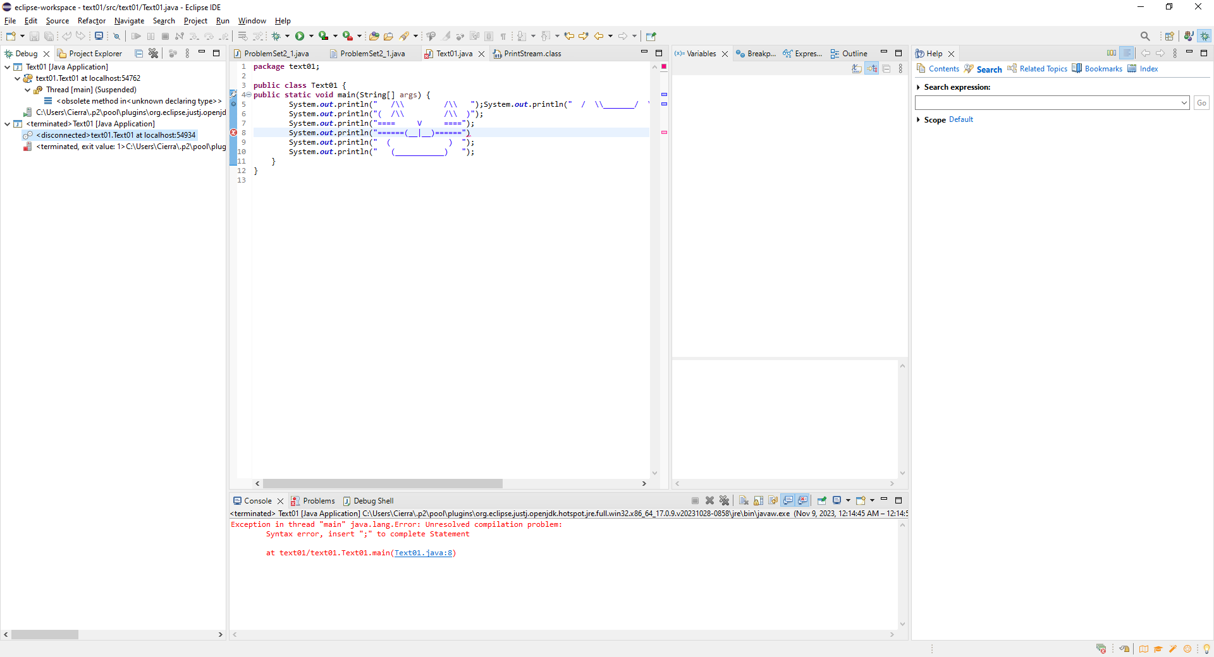

Program doesn’t run at all if I have the semicolon removed before running it through debugging.

**Exercise 2**

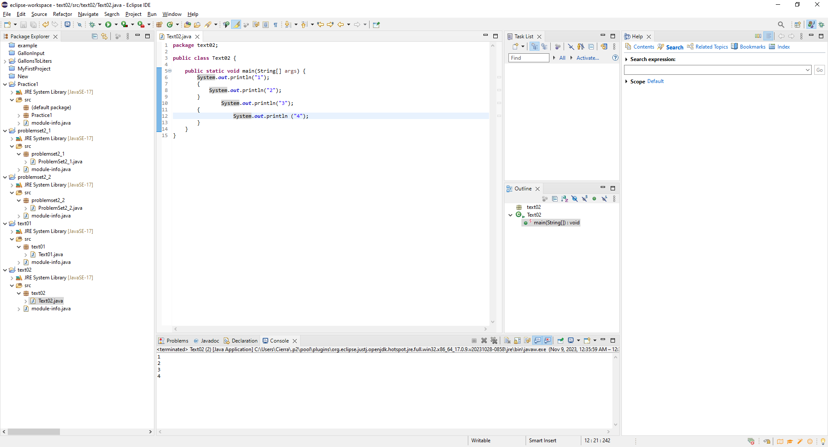

Fixed the program, and formatted it.

**Exersize 3**

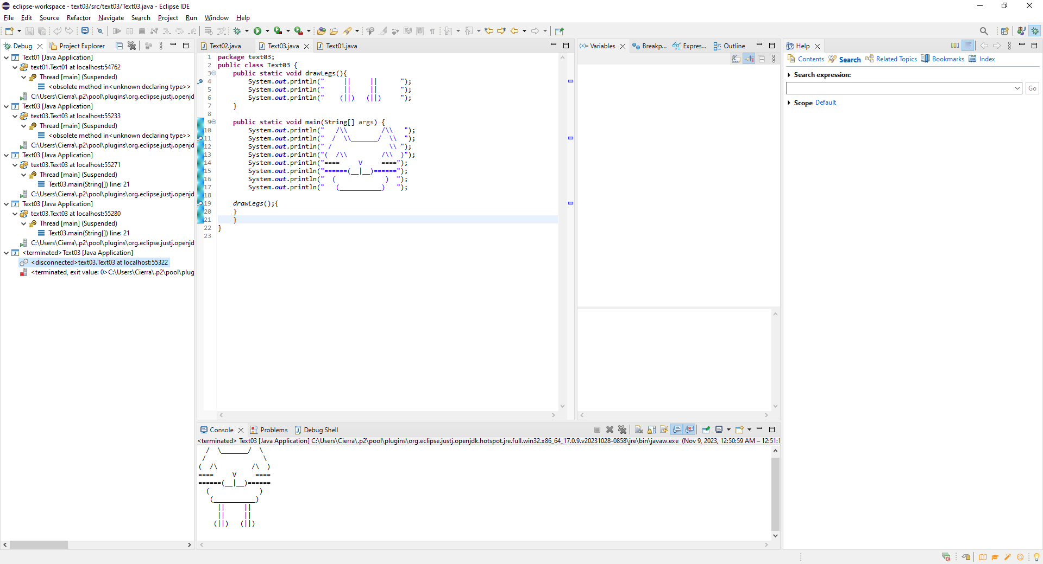

Putting a breakpoint in line 4 allows you to see the legs one at a time

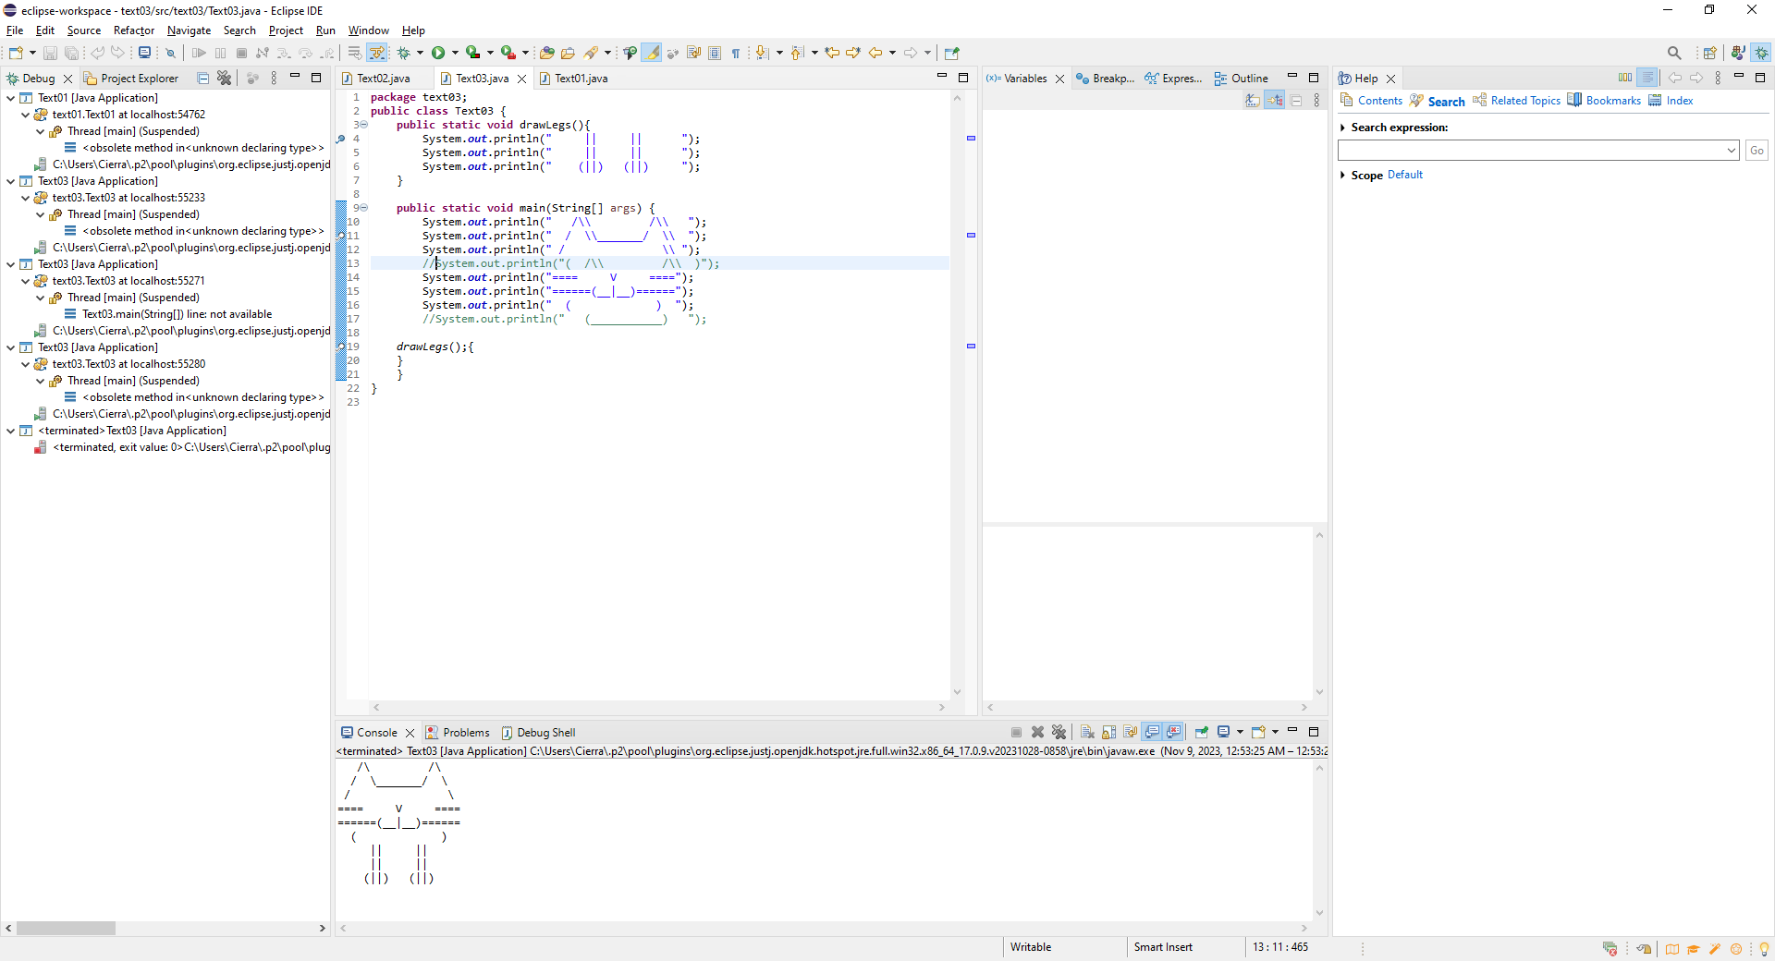

Commenting out lines causes them to be absent from the output.