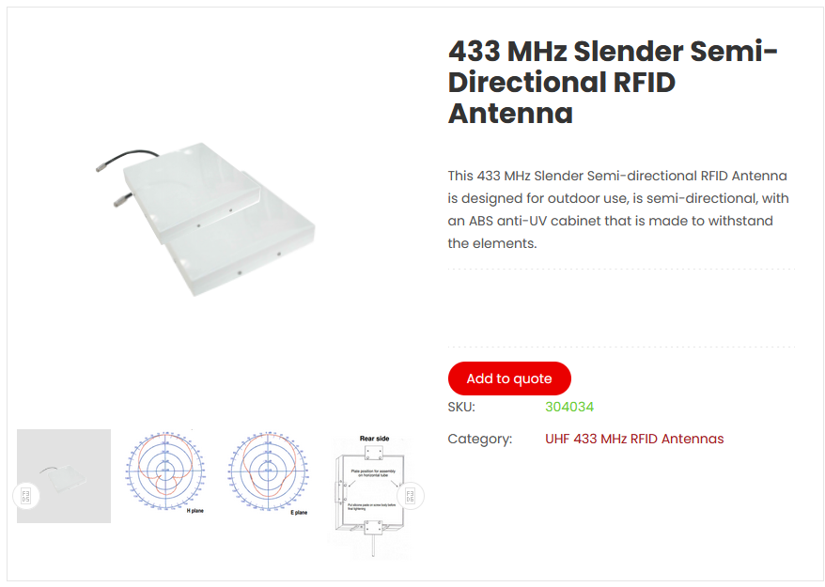

https://gaorfid.com/product/433-mhz-slender-rfid-antenna/

433 MHz Slender Semi-Directional RFID Antenna

This 433 MHz Slender Semi-directional RFID Antenna is designed for

outdoor use, is semi-directional, with an ABS anti-UV cabinet that is

made to withstand the elements.

SKU: 304034

Overview

This 433 MHz Slender Semi-directional RFID Antenna is designed for

outdoor use, is semi-directional, with an ABS anti-UV cabinet that is

made to withstand the elements.

Key Features

\* Outdoor Application

\* Semi directional

\* +8 dBi Gain

\* -15dB rear attenuation

\* ABS anti UV cabinet

Technical Specifications

Electrical Data

435 MHz radiation Effective electrical length 0.06?

Isotropic gain 8.0 dBi

Aperture angle @ -3dB E plane 2 x 38.2°

H plane 2 x 41.2°

First side lobe set E and H plane

Rear protection -15 dB

Average stray radiation E plane -20 dB

H plane -20 dB

Bandwidth Gain @ -1dB 425 to 445 MHz

Normal impedance 50 ?

Mechanical Data

Connector SMA

Overall length 300 x 300 x 50 mm

Mass 1.5 Kg

Effective wind load 0.11 m²

Approximate wind load (25 m/s – 55 mph) 4.1 daN

Approximate wind load (45 m/s – 100 mph) 13.3 daN