**To**: Tony Stark, CEO, Janzen Consulting Group

**From**: Colin Bradley, Junior Data Analysts, Janzen Consulting Group

**RE**: Relationship between video game genres and publishers

**Introduction**

In the past few decades, the video game industry has grown so much it has now become a multi-billion dollar industry. Within this industry there’s a wide variety of genres, and an even larger number of publishers. As expected, it is possible that in order to compete in this ever-changing market, some industries have decided that their best bet is to specialize in a few selected video game genres. By studying the relationship between publishers and genres, companies can determine what their competition is producing, which in turn will aid in creating an effective strategy to maintain and/or increase sales revenue.

As previously mentioned, specialization is a strategy that takes place in every industry, and the video game industry is no different. For this reason, we hypothesize that publishers prioritize specific genres for game releases. Essentially, this would mean that from what we can gather from our dataset, publishers have a preference for certain genres. Based on our findings, this relationship between genre of video games and publishers does exist.

For our analysis, we decided to use a subset of more than 16,500 video games sales data. More specifically, we decided to focus our efforts on four of the most popular video game publishers: Nintendo, Activision, Sony Computer Entertainment and Microsoft Game Studios. For genres, we narrowed it down to three of the top genres in the market that portray violent behavior: fighting, action and shooter.[1]

Our contingency table showed that Nintendo, Activision and Sony Computer Entertainment all favor the genre “Action” over “Fighting” and “Shooter.” This genre makes up 81.4%, 65.1% and 52.6% of their video game releases, respectively, within the bounds of our subset. Similarly, while Microsoft Game Studios may not prioritize “Action” games like the other publishers, they prioritize “Shooter” games, which constitute 52% of their game releases. The chi-squared analysis with an alpha of 0.05 revealed that our findings were of statistical significance, X2(6, 798) = 115.25. The p-value (p = 2.2e-16) is substantially smaller than the significance level; this allowed us to come to the conclusion that the dataset is statistically significant. The Cramer’s V effect size is 0.27, which confirms the association between publishers and genre. Given the small sample used in this study, we cannot generalize our findings to the entire population. However, our results do hold true to our hypothesis, which gave us some interesting insight regarding our sample.

Overall, the scope of our study was limited. We only looked at 3 out of 12 genres contained in the database, and 4 out of 579 publishers. For this reason, we cannot be sure that our results would be statistically significant if we had included the whole range of values. Furthermore, the data encompasses video games sales data all the way back to 1980, which raises the question of how relevant our findings are in today’s market. A more in-depth analysis would be needed in order to confidently answer this question.

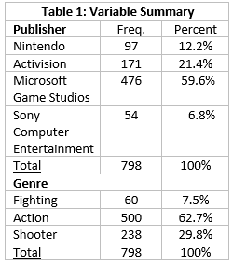

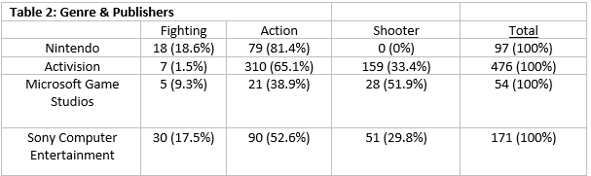

1. 2017, G. (2019). *U.S. most popular video game genres 2017 | Statista*. *Statista*. Retrieved 26 February 2019, from <https://www.statista.com/statistics/189592/breakdown-of-us-video-game-sales-2009-by-genre/>