1.Given the provided data, what are three conclusions we can draw about Kickstarter campaigns?

* A Kickstarter campaign is far more likely to succeed if the funding goes towards performance art (theater, film and video, and music).
* In general, the average campaign is more likely to succeed than it is to fail or be canceled, but journalism campaigns always fail.
* Successful Kickstarter campaigns are on a slow decline, while failed and canceled campaigns are remaining consistent

2. What are some limitations of this dataset?

* No reason given for cancelations. Look at this graph:

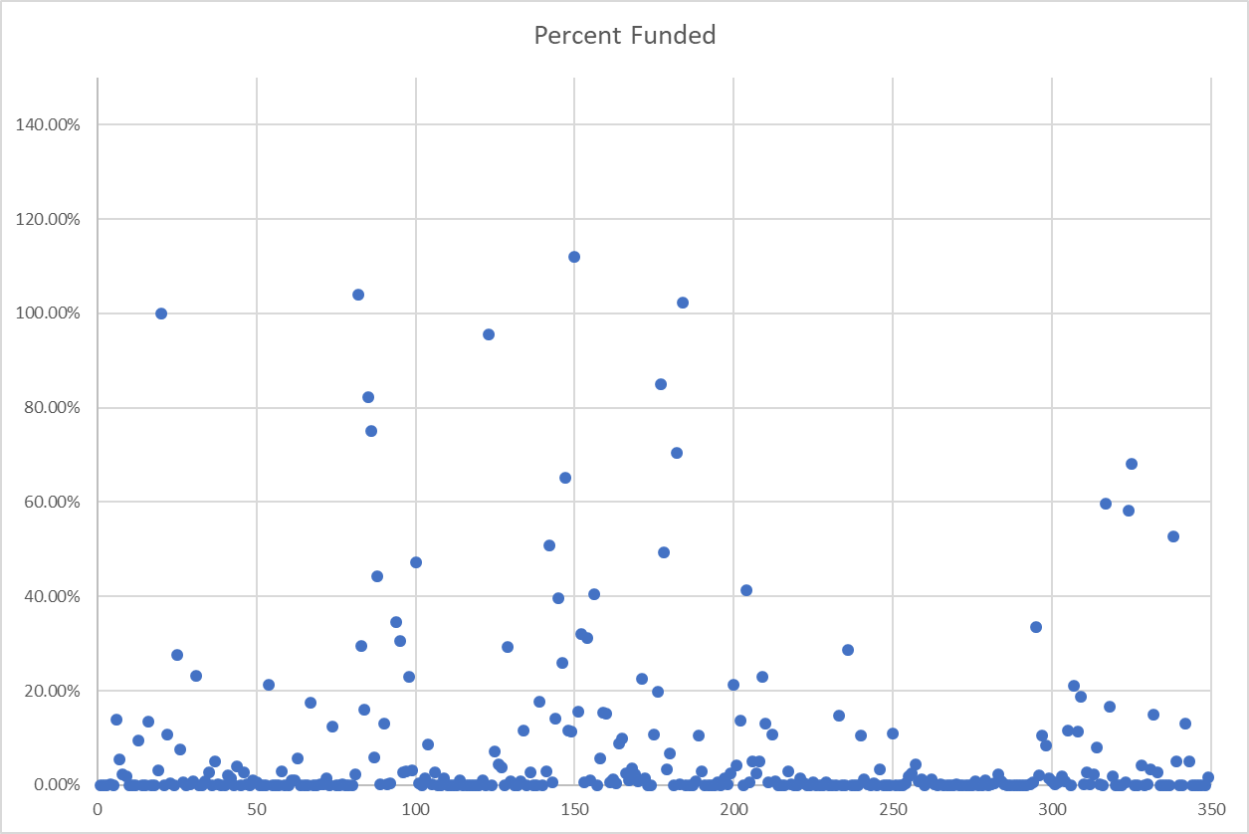



There were campaigns which reached their goal, but still canceled. There were also some campaigns which got very close to success, but still canceled

* I would like another date column. One which tells me the date 100% funded was achieved. Also, I’d like to know the date of cancellation

3. What are some other possible tables/or graphs that we could create?

\* We could make a graph showing the number of successful/live/failed/canceled by country

\* A graph showing category by country

\*A graph showing number successful/failed/live/canceled by currency

\*Graph showing size of goal in comparison to rate of success

Also, I think the graph below is below is interesting:

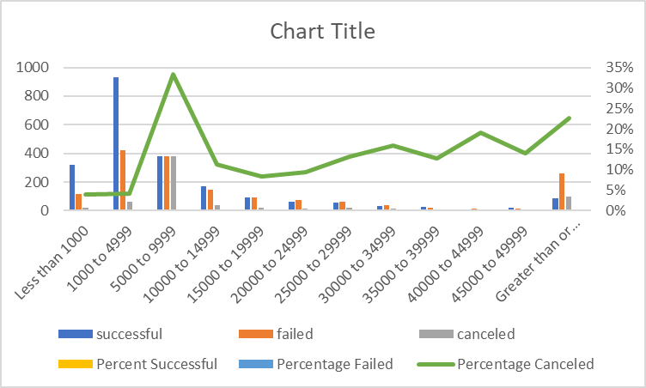

In the 5000-9999 category, the failure rate stayed remained pretty consistent, but the cancelation rate spiked and successes dropped drastically.