**Project Proposal: Games Database Website**

Group Members:

1. Christi Bragg: [cbragg3136@gmail.com](mailto:cbragg3136@gmail.com) | github: cbragg3136
2. Dustin Combs: [dccombs@gmail.com](mailto:dccombs@gmail.com) github: dustincombs
3. Lowell Vaughen: [wavaughen@gmail.com](mailto:wavaughen@gmail.com) github: lvaughen
4. Lydia Field: [lydia291@gmail.com](mailto:lydia291@gmail.com) | github: lydiapf
5. Shelly Nixon: [shellymnixon@gmail.com](mailto:shellymnixon@gmail.com) | github: shellymnixon
6. Rodrigo Reyes: rodrigoreyes96@gmail.com github: rodking96

Github Repository: <https://github.com/cbragg3136/Project-2_Gaming-Analysis.git>

**Introduction and Background:**

The goal of this project is the creation of a gaming information website for PC and Xbox games. Information will be generated by scraping [Xbox’s most played games](https://www.microsoft.com/en-us/store/most-played/games/xbox) by country and [Steam’s API](https://steamcommunity.com/dev) for PC games.

**The visualization will split between platform choice: PC vs. Xbox.**

* For Xbox, the website user will be able to select from a world map for a specific country to see the most popular games in that country as well as a trending of the per game rank in all listed countries.
  + The Xbox data online is limited to a webpage per market showing the top 50 games most popular games. We will scrap this information over several days to build up a database of performance for trending. Microsoft does not report outside of these markets online.
* For PC, the website user will be able to select top 100 games and individually see detailed information per game.

**Potential Visuals:**

Steam PC Games:

* + Creating a heatmap of the metascore & genre
  + World map of number of steam games sold per country/state
  + Bubble plot showing number of owners per game genre.
  + Word cloud of video game tags/genres

MS Xbox games:

World map showing countries with most popular data:

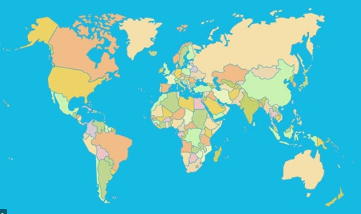

Select country - see the top 50 most popular games

Second visual: a list of games you can select - and it will show a trending of game popularity rank over time (line graph).

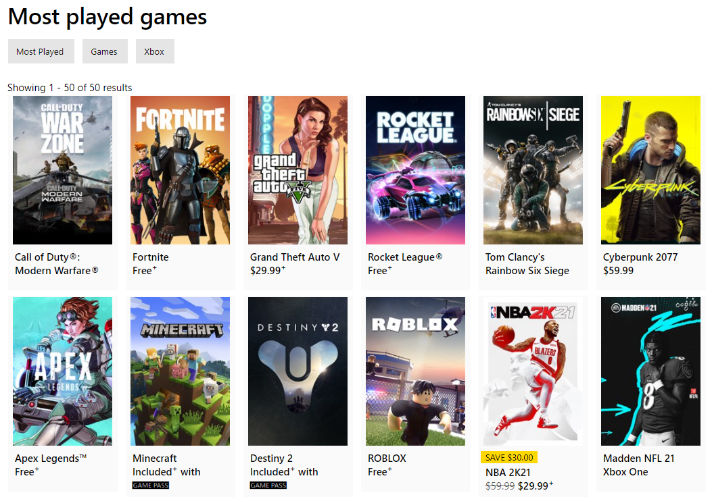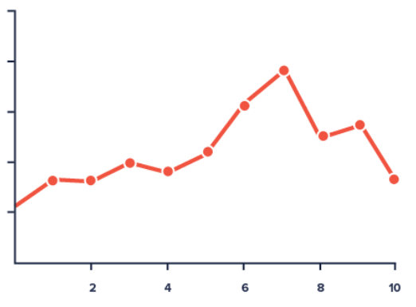

**Resources:**

* Ex. MS Xbox webpage for the US: <https://www.microsoft.com/en-us/store/most-played/games/xbox>
* [Steam’s API](https://steamcommunity.com/dev) for PC games.