**Physical Fundamentals of Remote Sensing (Hybrid) (GGS626, Fall 2023)**

**Mid-term (Total 200 points)**

**(Due 11:59PM, 10/31/2023)**

**Name: G #**

1. Please read and provide a summary of Chapter 7 (sections 7.1-7.4) from Liou's book. The focus of your summary should be on the fundamental principles and practical applications of remote sensing using both solar reflected bands (SRBs) and emitted bands. Your summary should be 2-3 pages in length (50 points).

2. Algorithm Design (70 points)

2.1 - Design your own algorithms for the detection of green grass, water clouds, and urban-residential areas using the reflectance data of water and ice clouds, sand, grass, soil, urban-residential areas, and water within the 0.4-2.5μm spectrum (refer to Fig. 1). Please take into consideration the interactions among these different materials and discuss the underlying physical principles.

2.2 - Which MODIS bands can be employed for detecting water vapor clouds, dust, and smoke? Please explain the major physical principles behind your chosen parameter (e.g., dust, wildfire, or smoke detection) over various surface types, such as deserts, grasslands, forests, oceans, and bare soil, among others.

2.3 - If you were to introduce two additional solar reflected bands in the 0.4-2.5μm spectrum for future instruments, which bands would you select and why? How would these enhancements improve the detection of your chosen targets, such as vegetation, dust, wildfires, and smoke, among others?

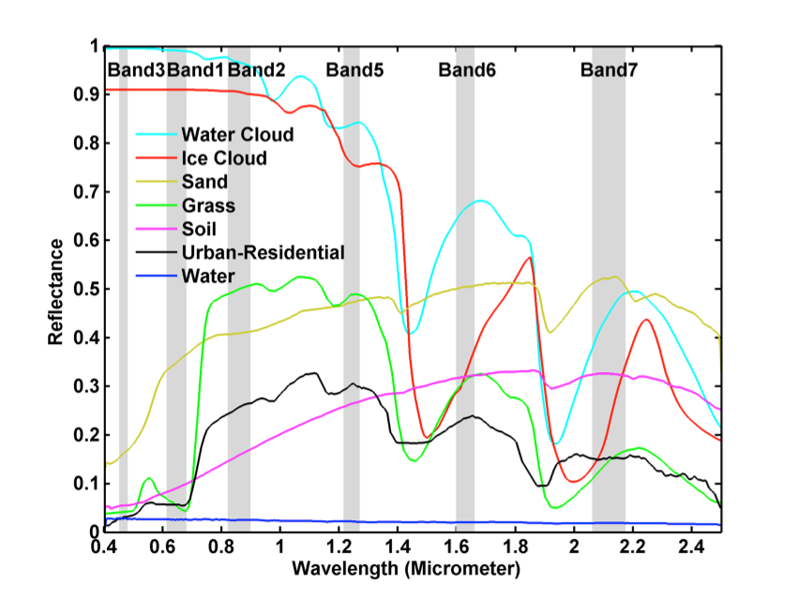

Figure 1. Reflectance of water and ice cloud, sand, grass, soil, urban-residential and water in 0.4-2.5μm spectrum.

3. Explain the methods currently employed to extract Sensor Data Records (SDRs) from Raw Data Records (RDRs) for Landsat, MODIS, or VIIRS sensors. These methods involve the transformation of Digital Numbers (DNs) into Radiance, which measures electromagnetic radiation, and then further conversion into Reflectance (SRBs) and Bright Temperature (TEBs). You are required to focus on a single sensor of your choice and provide a comprehensive discussion, which should span 1.5 to 2 pages and 50 points.

3.1 For Landsat, you can delve into the Landsat SDR algorithm, and the necessary information can be found in the provided links

(<https://yceo.yale.edu/how-convert-landsat-dns-top-atmosphere-toa-reflectance>)

(<https://yceo.yale.edu/how-convert-landsat-dns-brightness-temperature-using-envi-standard#:~:text=Using%20ENVI%20Standard%2C%20select%20from,and%20save%20the%20new%20file>).

3.2 For MODIS, please refer to Chapter 3 of the 'Earth Science Satellite Remote Sensing RS0103' document available on Blackboard. (50 points)

3.3 For VIIRS, you can utilize the 'VIIRS SDRs User’s Guide' provided by the LP DAAC. This guide will offer valuable insights into the process of obtaining SDRs from VIIRS sensors. (<https://lpdaac.usgs.gov/documents/134/VNP03_User_Guide_V1.2.pdf>)

Remember to provide detailed explanations of the retrieval processes specific to the two sensors you choose.

4. If Landsat-9 band 1 and 5 are not functional, which scientific products may be affected? How to generate these products with other band measurements (0.5-1 page, 30 points)?

(<https://www.usgs.gov/landsat-missions/landsat-9>)

(<http://estc.gmu.edu/homemain_files/03lgrs03-wang-proof.pdf>)