Gleise

Kennung | Adresse
s11 | 13
s12 | 12
S13 | 1
S14 | 15
S15 | 14
s16 | 11
s21 | 10
s22 | 8
s23 | 2
s24 | 6
s25 | 5
s26 | 4
25
9
1
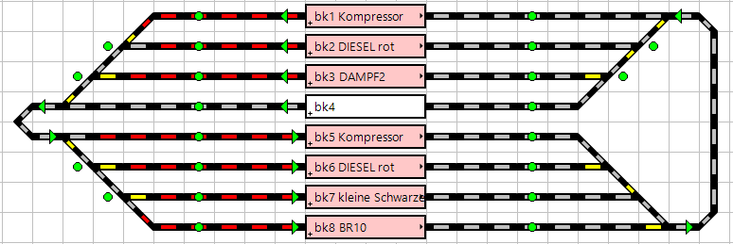
32
16
38
37
39
40
33
34
35
36
8
s11
s13
s11
s13
s11
s12
s14
s15
s16
33
34
35
36
37
38
s21
s23
s24
s26

