Please see my comments below:

For all the programs the times on the landing pages should be listed as follows:

* 1. Check-in & Breakfast – 6:30 AM
  2. Program 6:45 AM – 7:45 AM

Currently it is listed as:  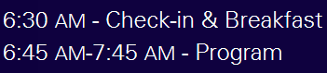

**Beyond Implantation: Make Your TAVR Program Grow and Endure**

1. When you hit register, it brings you to the correct page, but the tab says Sustained Potent P2Y12, which was a program last year, can we change it to Beyond Implantation: Make Your TAVR Program Grow and Endure

Currently it shows: cid:image002.png@01D3CA8B.D8517BC0

1. When you click register now it brings you to that security page where you have to click on the link to continue.  It only does it for this program, so maybe we want to look into that.