# Figures for ACS 2006-2010

**Distribution of assignment probabilities**

**Map showing the cluster assignment across Massachusetts census tracts**

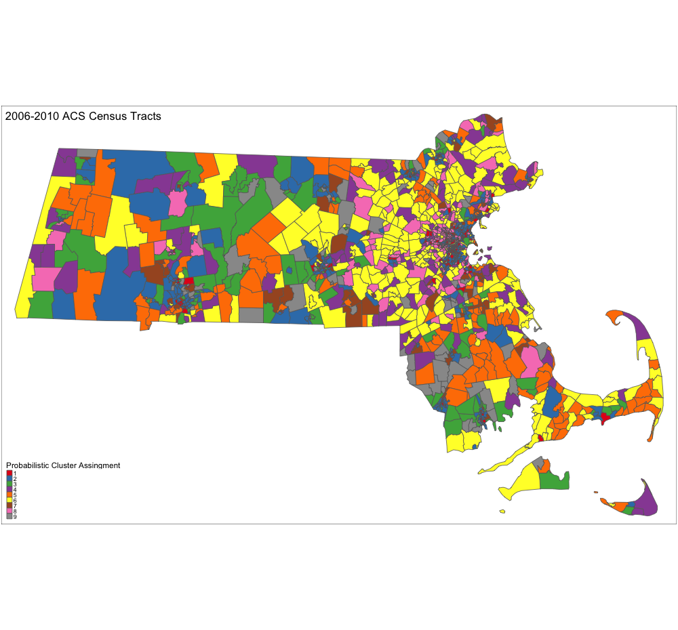

# Figures for ACS 2011-2015

**Distribution of assignment probabilities (original model output)**

**Distribution of assignment probabilities (re-labeled)**

# Figures for ACS 2015-2019

**Distribution of assignment probabilities (original model output)**

**Distribution of assignment probabilities (re-labeled)**

