**STUDENT NAME:  *Carl Broker***

**Lab1 Output**

Below is the screenshot of logged in homepage of the AWS management console.

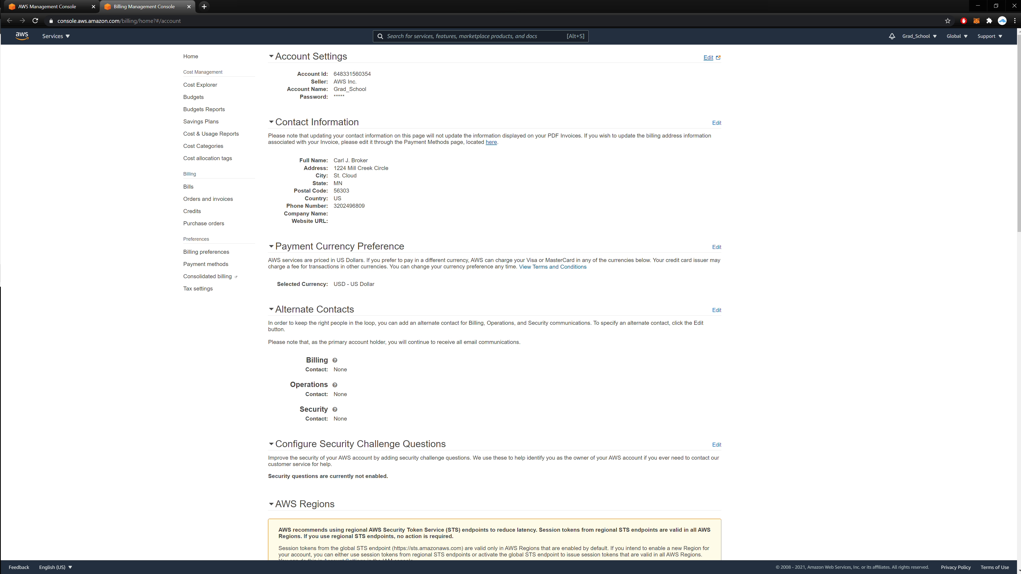

^ sorry for the 4k:

