**STUDENT NAME:  *Carl Broker***

**Lab2 Output**

2A) Below, place the screenshot from lab assignment 2A which demonstrates that you have successfully installed Virtual Box.

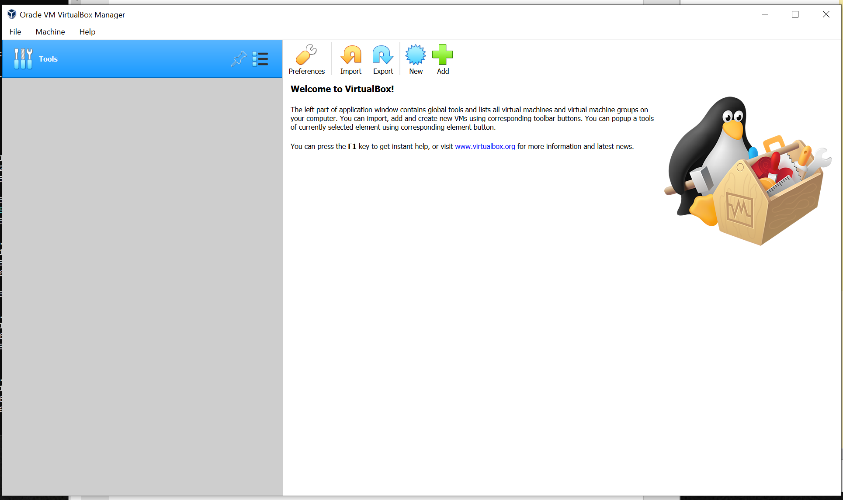

2B) Below, place the screenshot of lab assignment 2B indicating that you have successfully installed Ubuntu, running it on VirtualBox and hat you were able to log in.

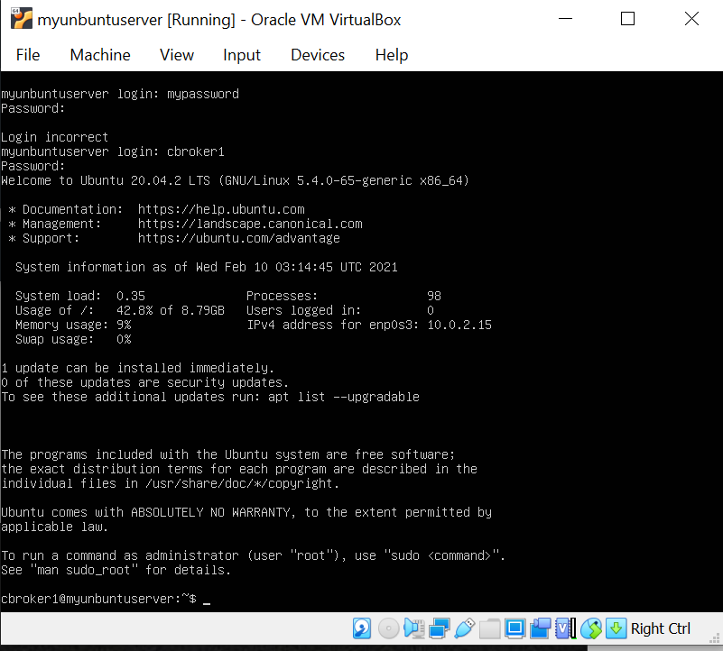

2C) Below, paste the screenshot of lab assignment 2C indicating that you have successfully ran the commands.

