**STUDENT NAME:  *Carl Broker***

**Lab4A Output**

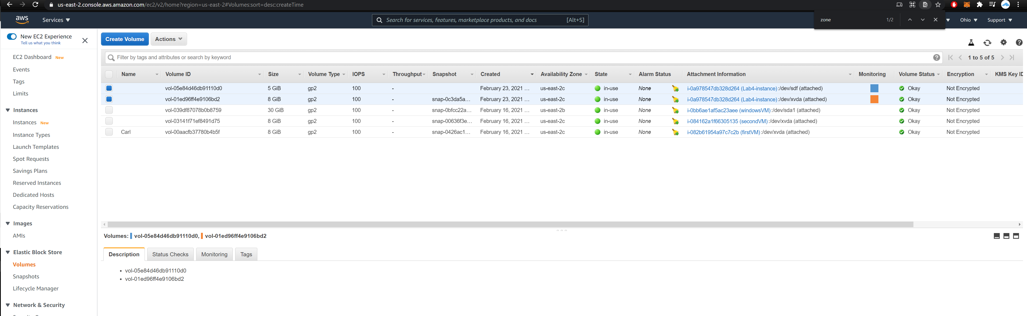

**Lab4B Output**

**Volumes:**

**Top volume in list is from lab.**

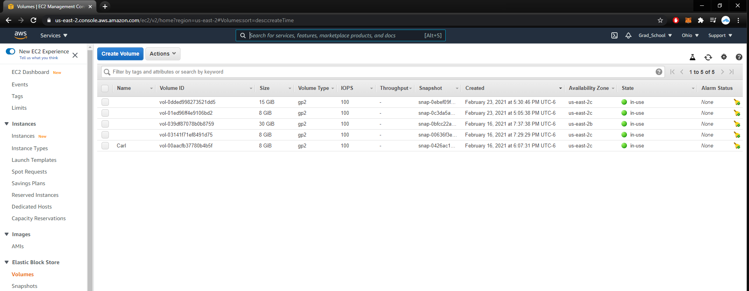

**Snapshot:**

**Highlighted one from lab.**

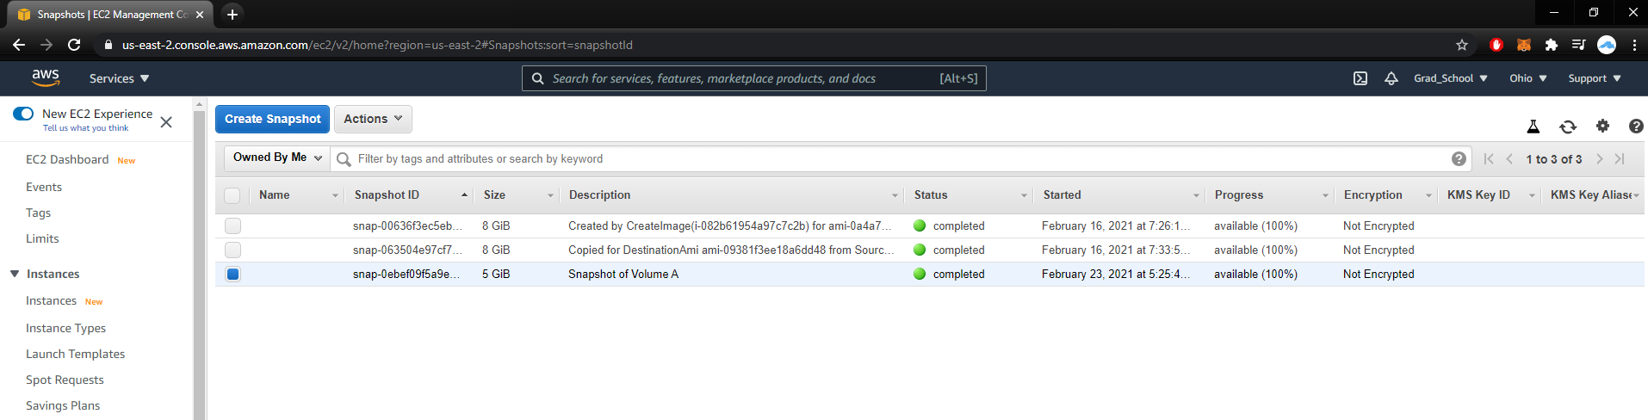

**Lab4C Output**

Encrypted Snapshot

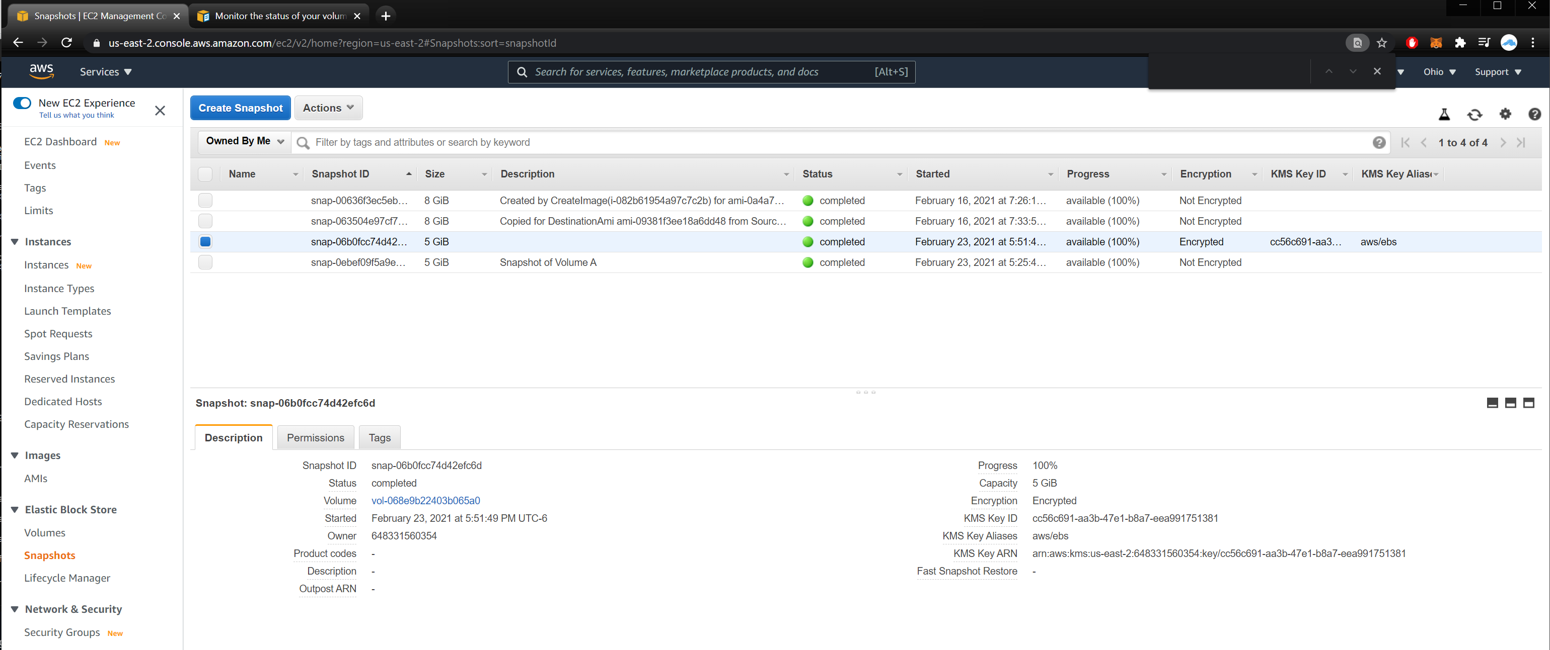

ALARM

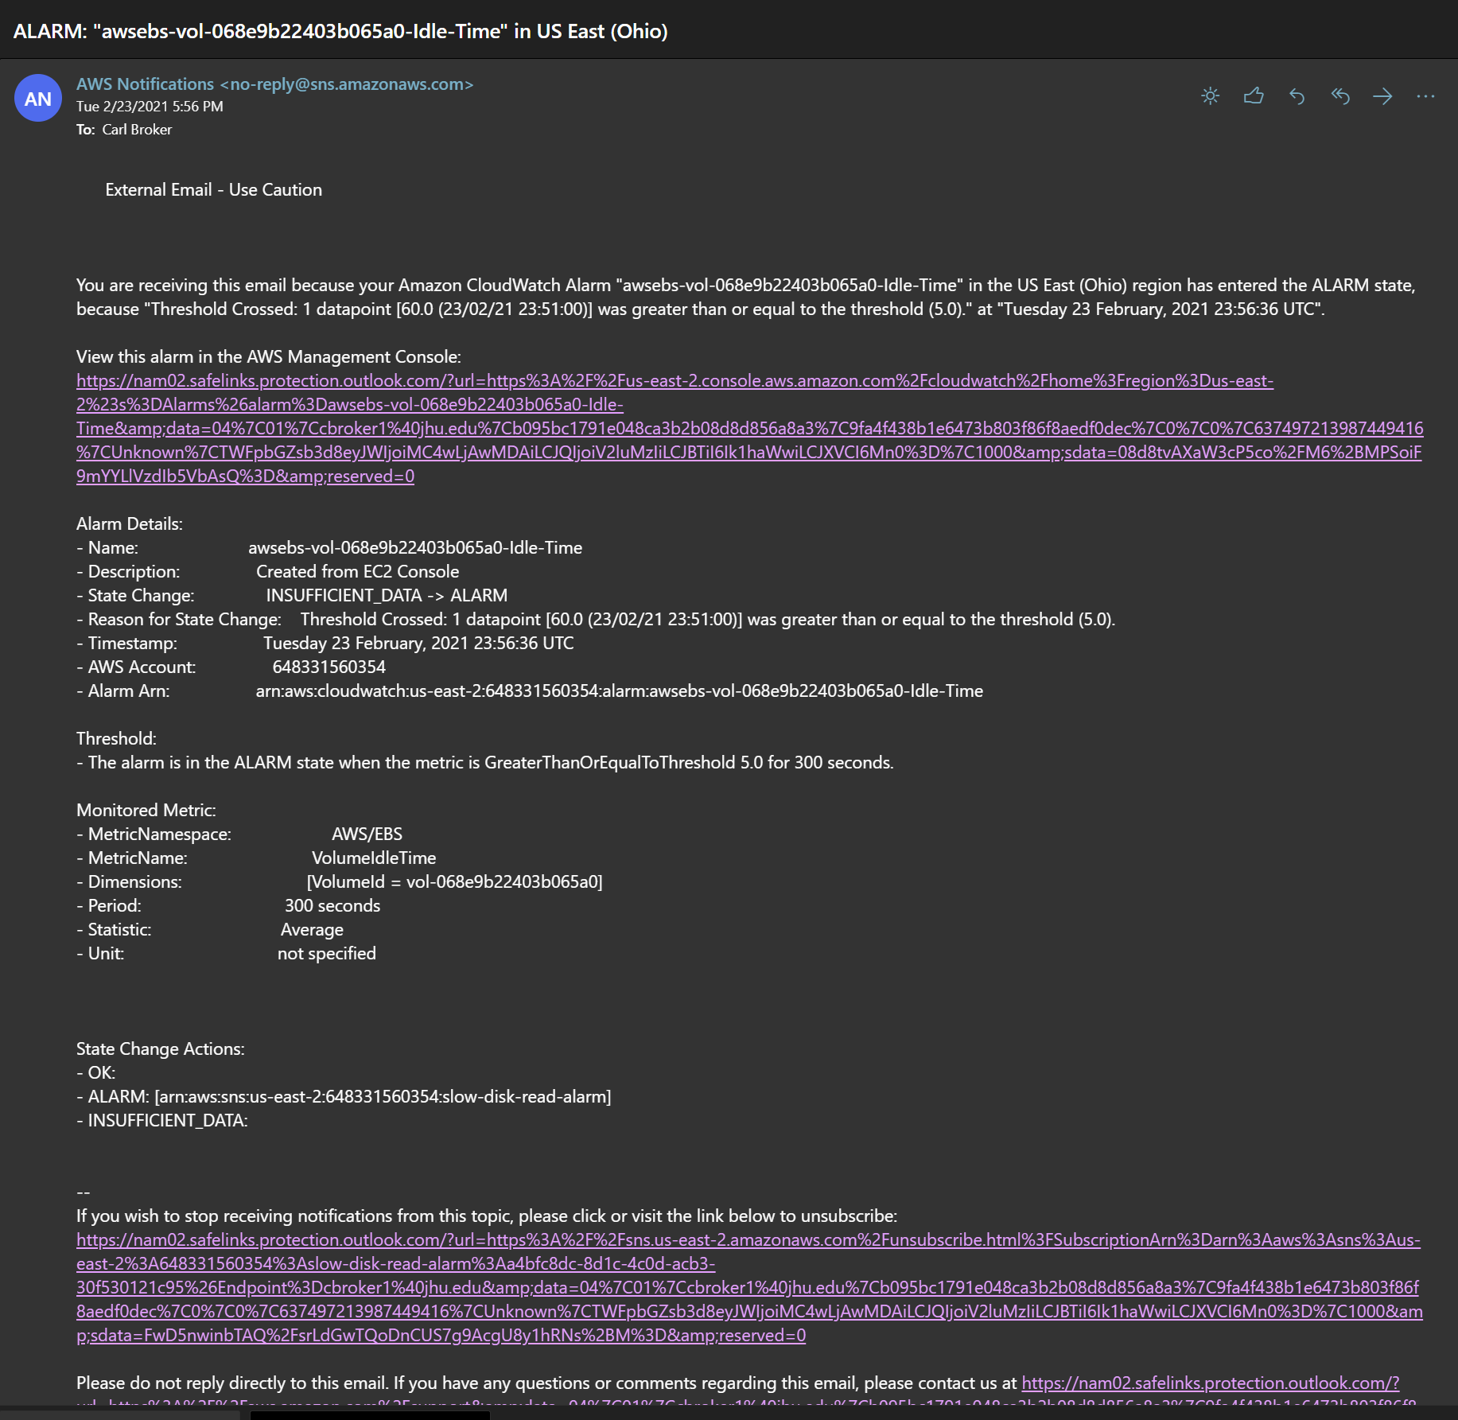

**Lab4D Output**

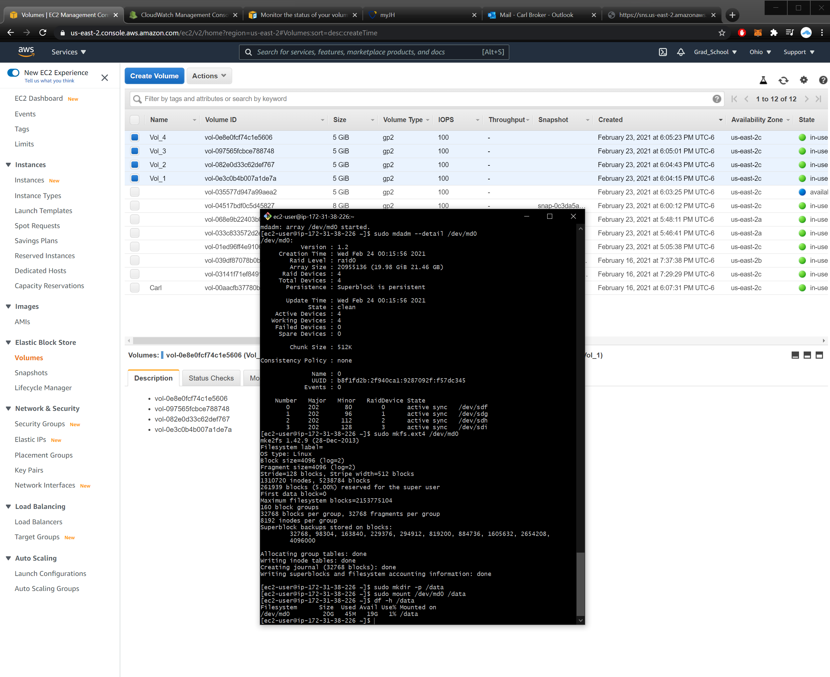

**Lab4E Output**

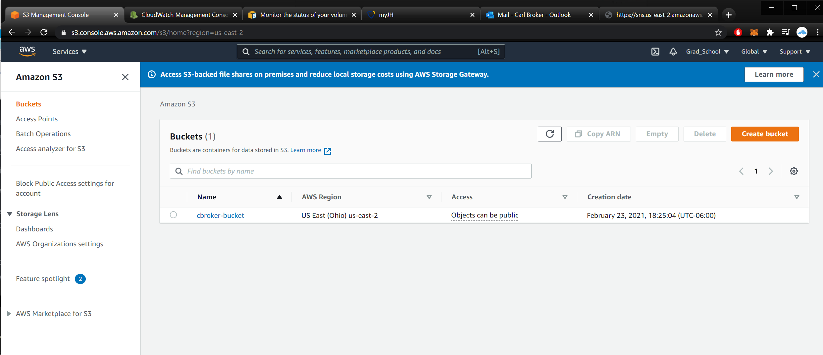

[**https://cbroker-bucket.s3.us-east-2.amazonaws.com/doge.jpg**](https://cbroker-bucket.s3.us-east-2.amazonaws.com/doge.jpg)

[**https://cbroker-bucket.s3.us-east-2.amazonaws.com/doge2.jpg**](https://cbroker-bucket.s3.us-east-2.amazonaws.com/doge2.jpg)

Provide one use case for each of the following S3 storage classes i.e. for which type of data would you use Standard, Standard Intelligent, Standard-IA and why? Take a look at this article too.

Standard – ex: mobile and gaming applications, big data analytics.

Why –

* low latency, high throughput performance,
* durable (11 9s),
* multiple availability zones

Standard Intelligent – ex: used for datasets with unknown storage access patterns, ie new applications, or data lakes.

Why –

* Automatic storage cost optimization, based on access patterns
* Durable (11 9s),
* Same performance as glacier

Standard-IA – ex: long-term storage data, backups, disaster recovery files.

Why -

* Durable (11 9s),
* Resilient against zone loss, due to multi-zone backups
* 99.9% available over a given year.

Ref: <https://aws.amazon.com/s3/storage-classes/>

**Lab4F Output**

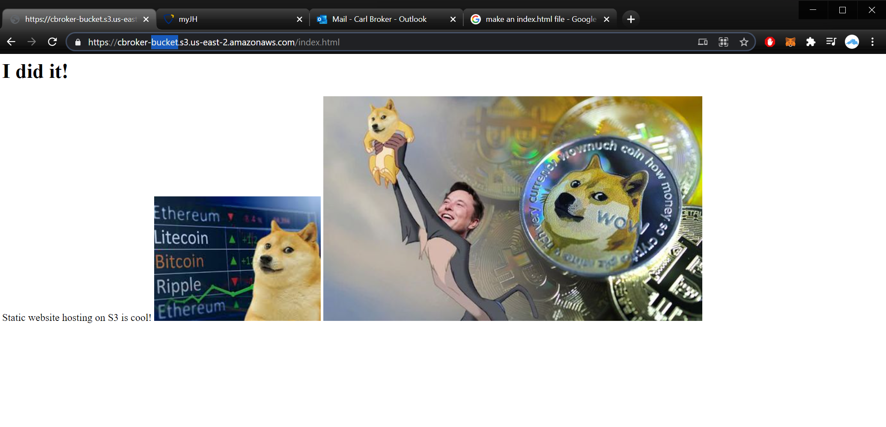

o How to create "sub-folders" in S3 bucket?

1. Start S3 Browser and select the bucket you want to work with.
2. Click Files -> Create New Folder. Click Files, Create New Folder.
3. Type the name for your new folder, and click Create new folder.

Ref: https://s3browser.com/how-to-create-virtual-folders.aspx

o Modify the index.html file on your laptop and upload it again. How can you view the two versions of the file?

1. Via versions tab:

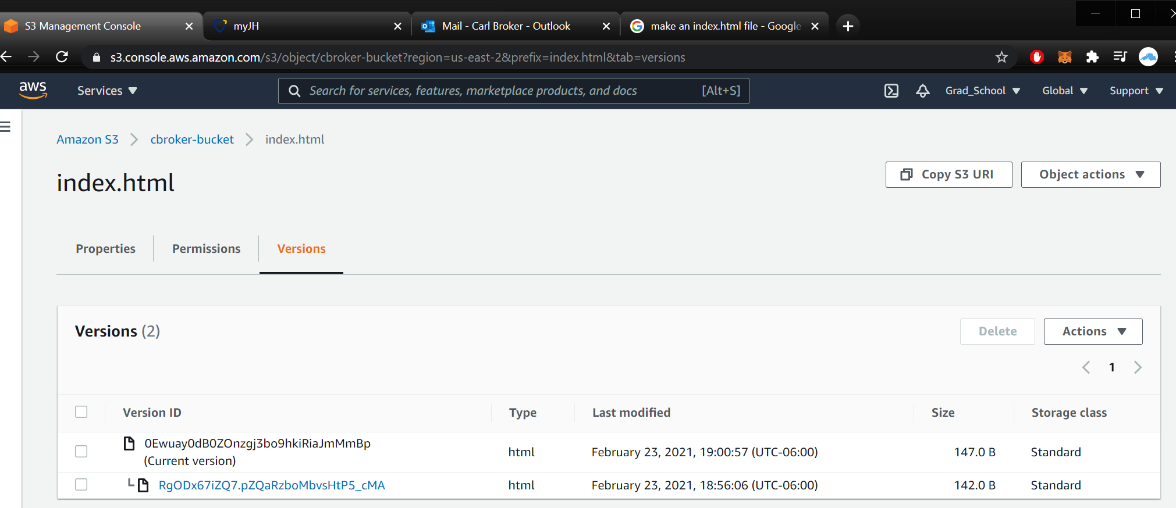

o How would you recover the old index.html that you overwrote?

1. Download the older version via this:
2. 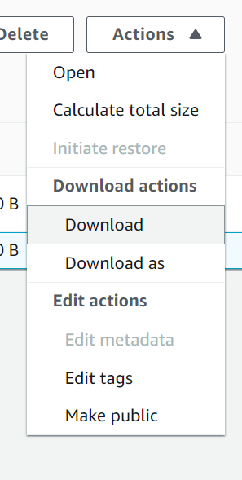

o What kind of files would you store on an S3 bucket? Make a list of use cases.

Use Cases:

1. Cloud applications,
2. Mobile/gaming applications,
3. Big data

Ref: <https://medium.com/appgambit/almost-everything-that-the-aws-s3-can-do-86aa61a13e12>

o When would you use S3 as opposed to EBS? List the pros and cons of each storage option.

You would use S3 for general storage, over EBS which is designed for EC2 instances.

S3 Pro: excellent support, api support, easy UI navigation, flexibility, cost-effective.

S3 Con: large file uploads, drop in speed, unable to rename bucket

EBS Pro: cost-effective storage for VMs, easy to backup, easy to create/destroy, fast provisioning

EBS Con: Learning curve (terminal), loose track of EBS if managing multiple drives