**STUDENT NAME:  *Carl Broker***

**Lab5A Output**

All of the below are 3/3. I assume that’s the amount of times I refreshed the page to verify the load balancer?

Unhealthy Hosts -

Healthy Hosts -

Average Latency -

Requests Count -

Surge Queue Length -

Spillover Count -

HTTP 5xxxs errors -

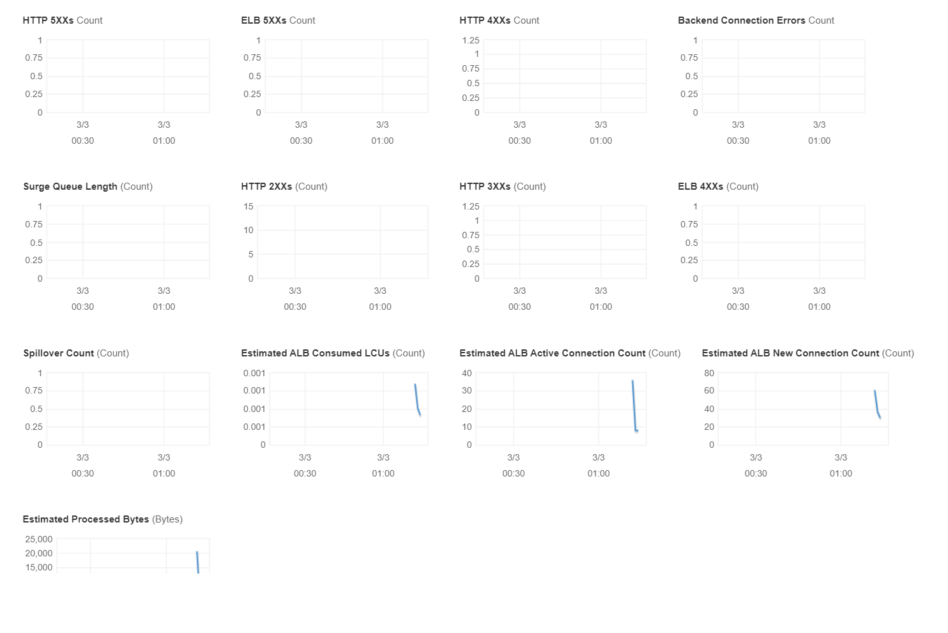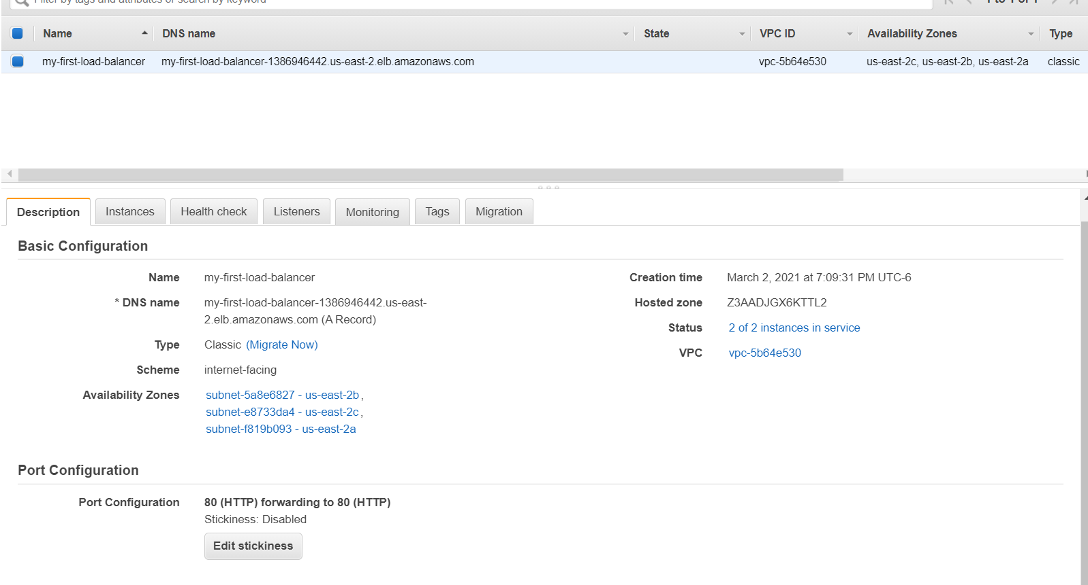

**Lab5B Output**

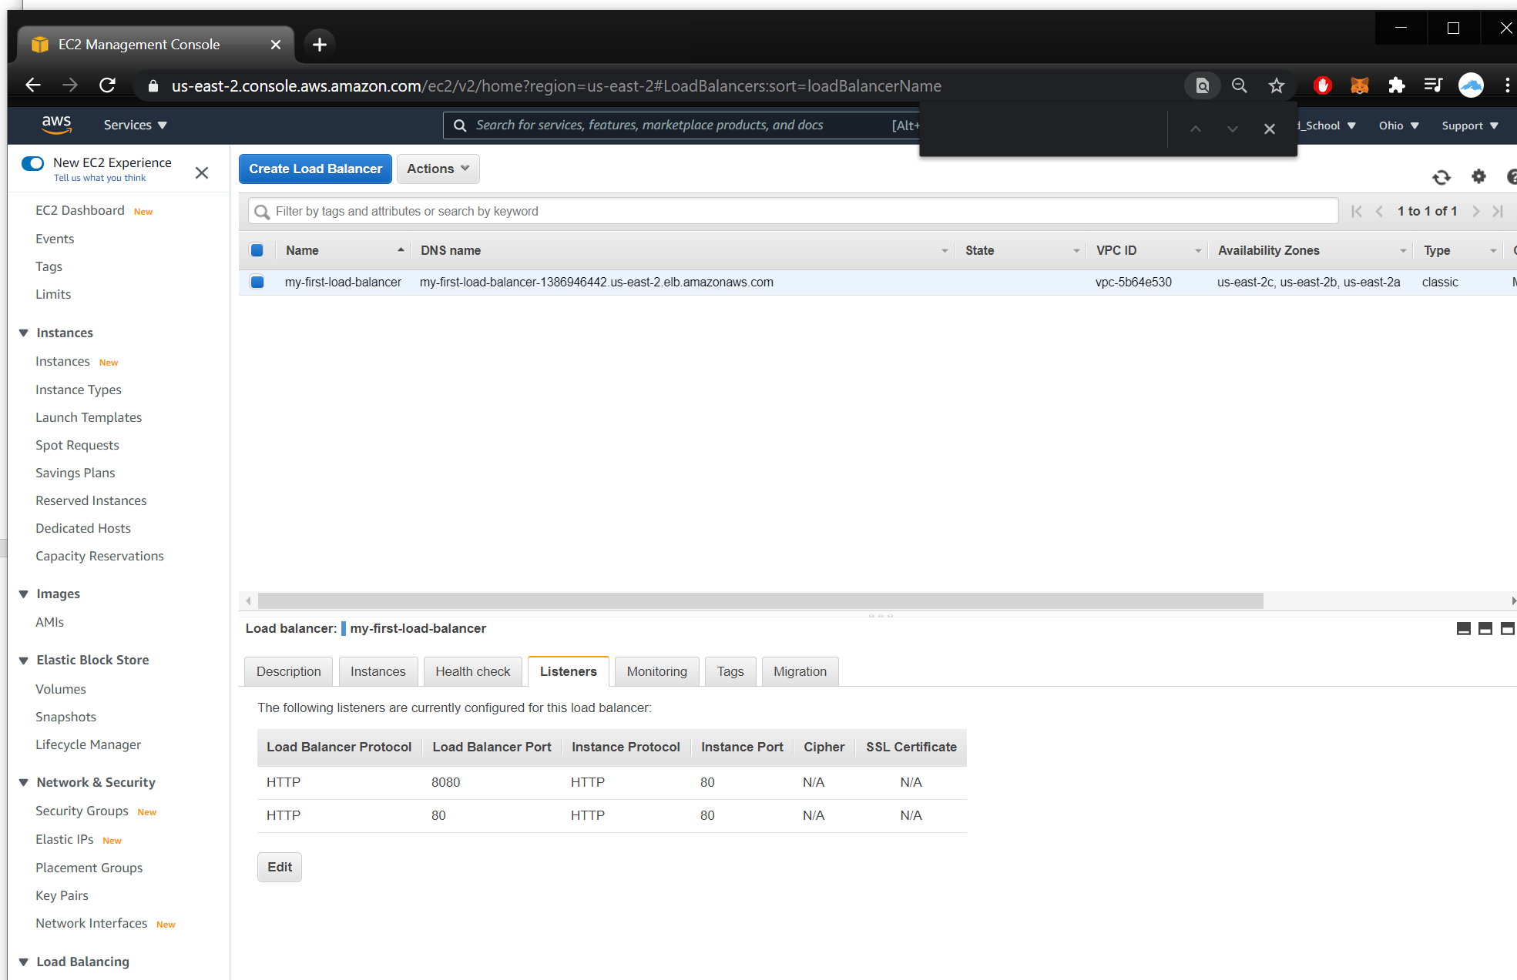

Change unhealth threshold check from 2 to 10: this changes the number of consecutive heath check failures before declaring an EC2 instance unhealthy.

Ref: AWS ? Icon in the ‘Configure Health Check’ screen.

How long did it take for the instance to change status to from InService to OutOf Service and back?

It took a couple minutes, 1) network traffic to execute the commands, 2) computations in the instances and 3) network traffic in health checks.

**Lab5C Output**

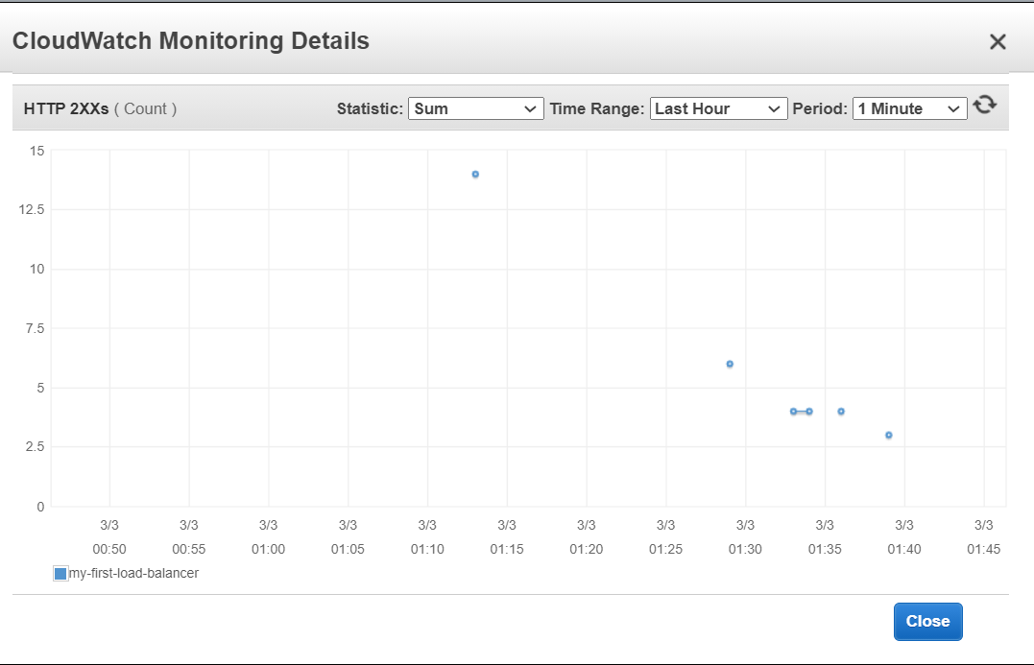

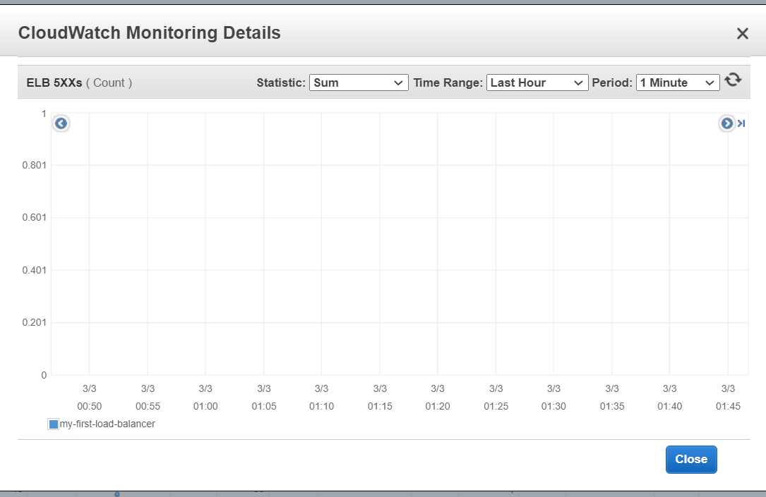

**Lab5D Output**

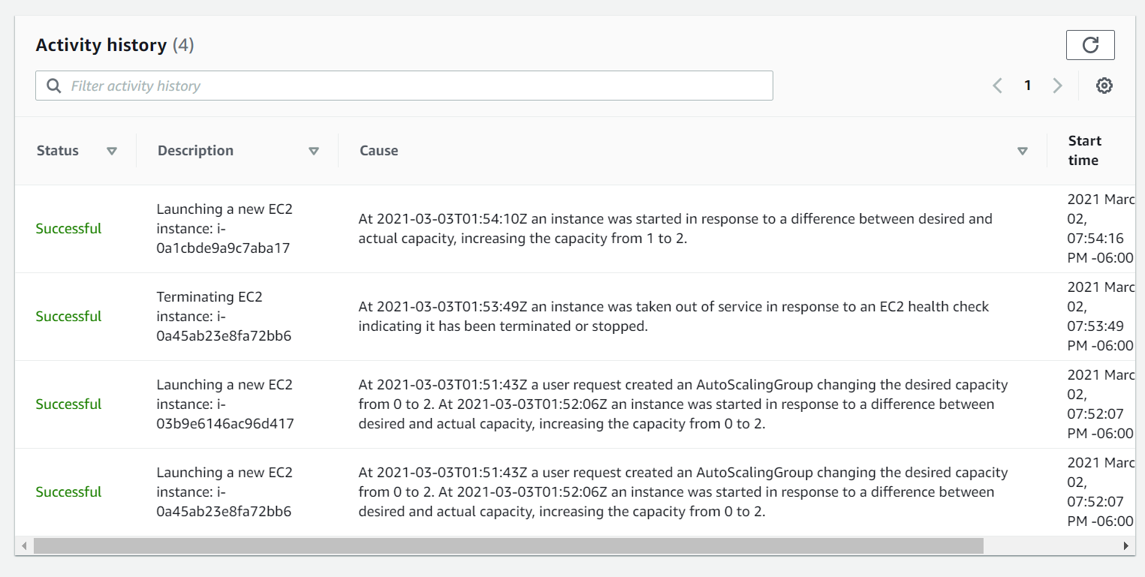

**Lab5E Output**

