**STUDENT NAME:  *Carl Broker***

**Lab6A Output**

**My VPC**

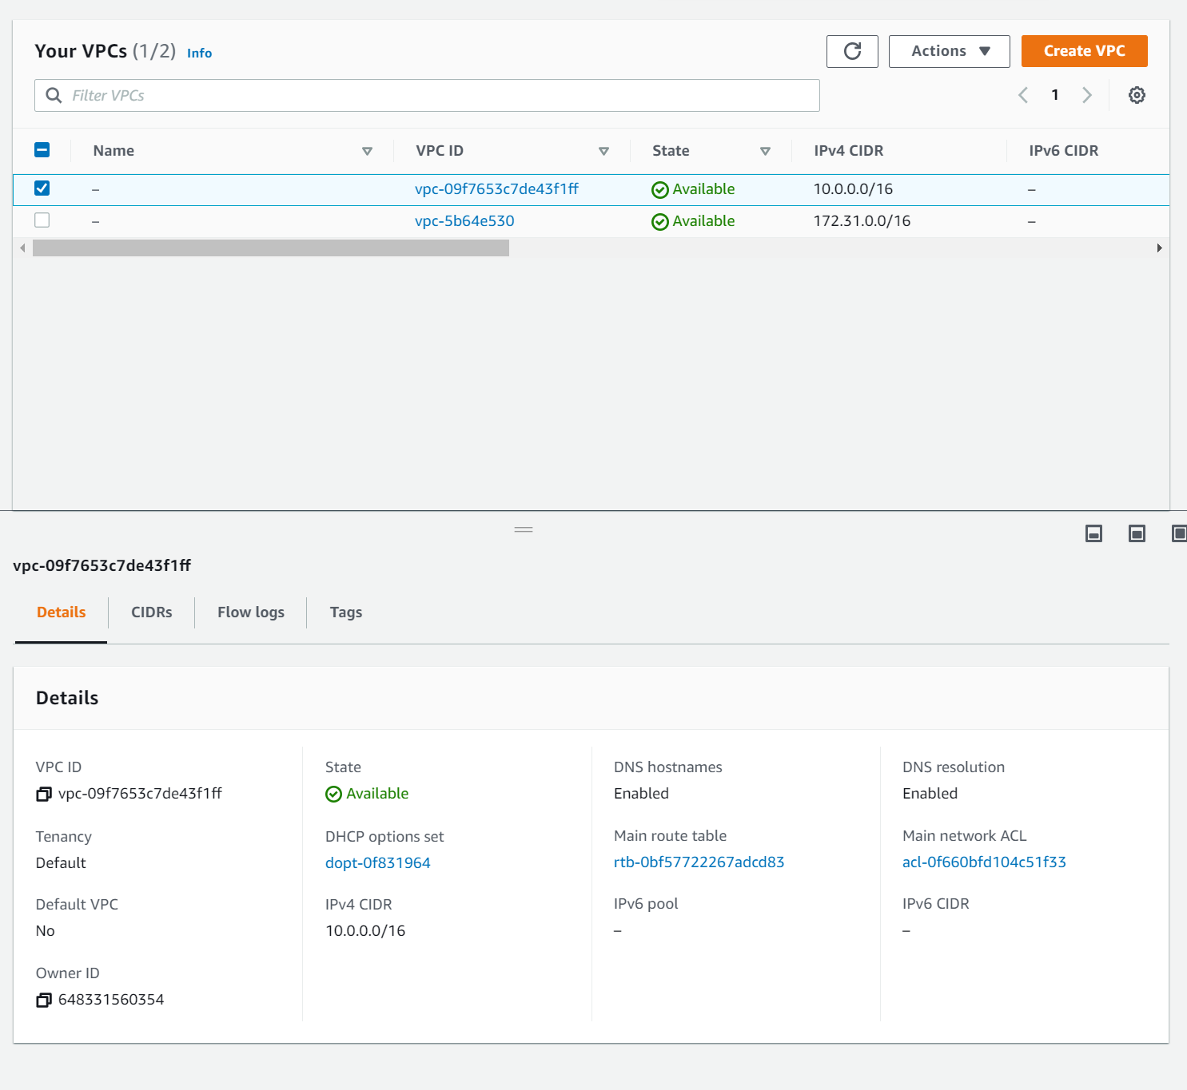

Subnets Pub

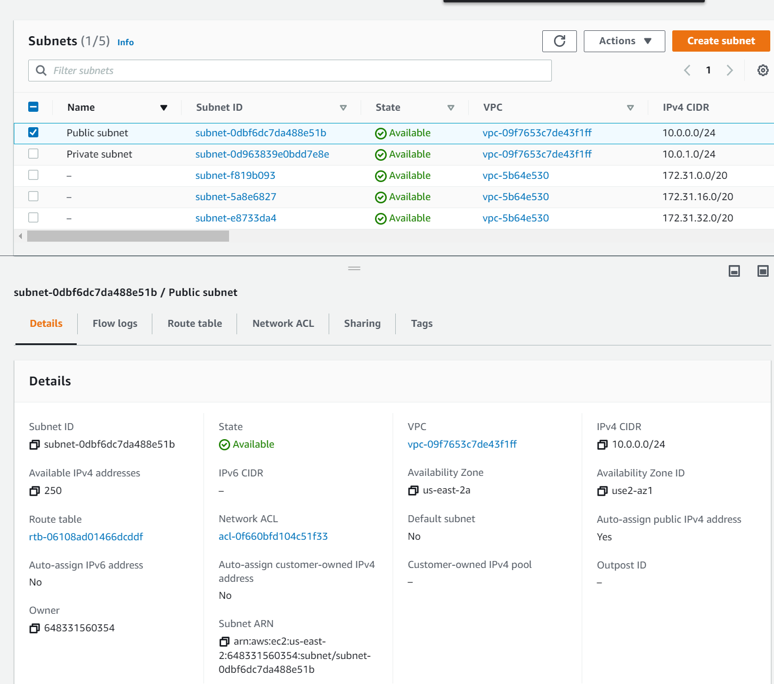

Subnet Priv

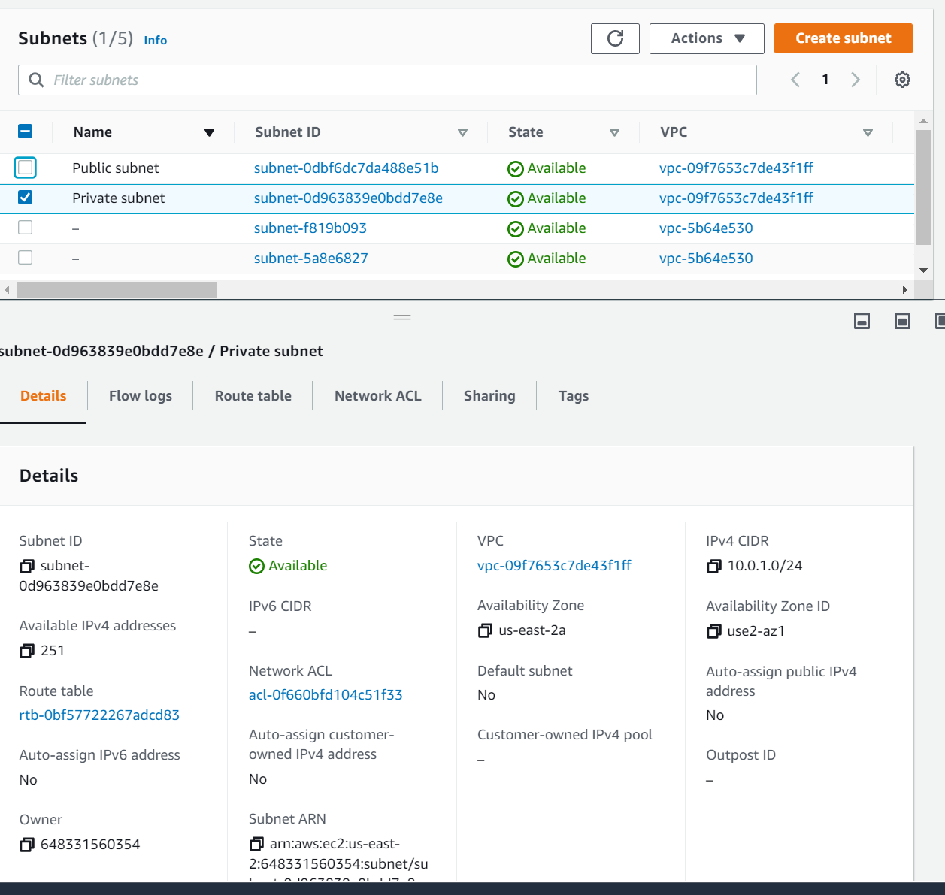

**Lab6B Output**

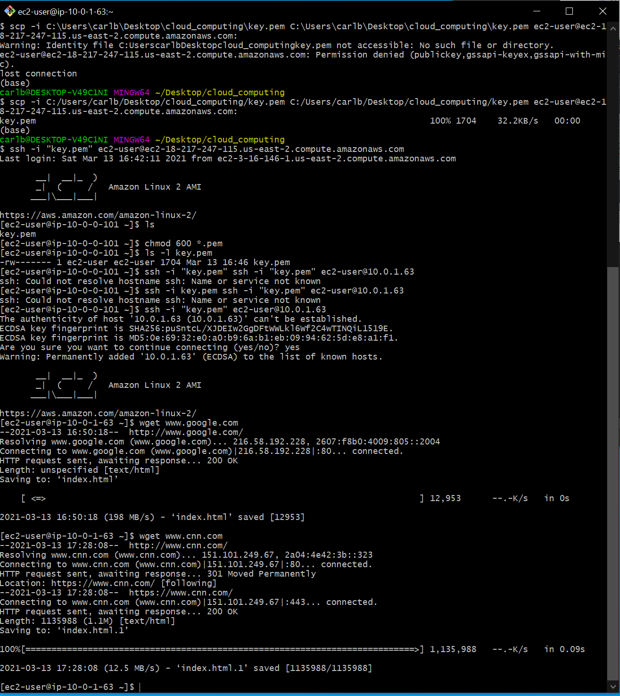

**Lab6C Output**

I really struggled with this section. I was fine, up till step 8, but then after that I got stuck.

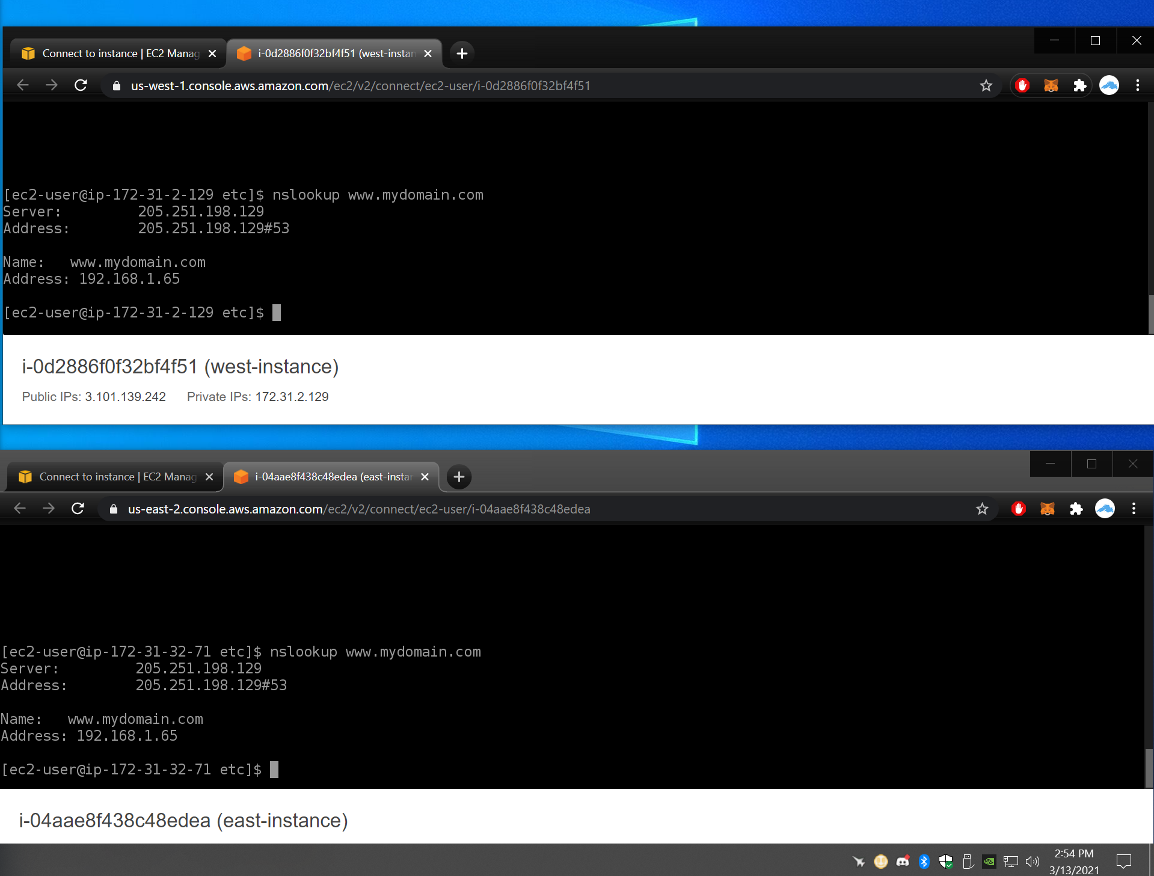

After deleting the “A” I tried to get my individual load balancers configured properly, with my instances. I tried for a couple hours and I just couldn’t get them going. (see attached image on the next page, specifically note the Status of each LB).

I will also include an image of each LB’s listener and instance SG.

(Load Balancer)

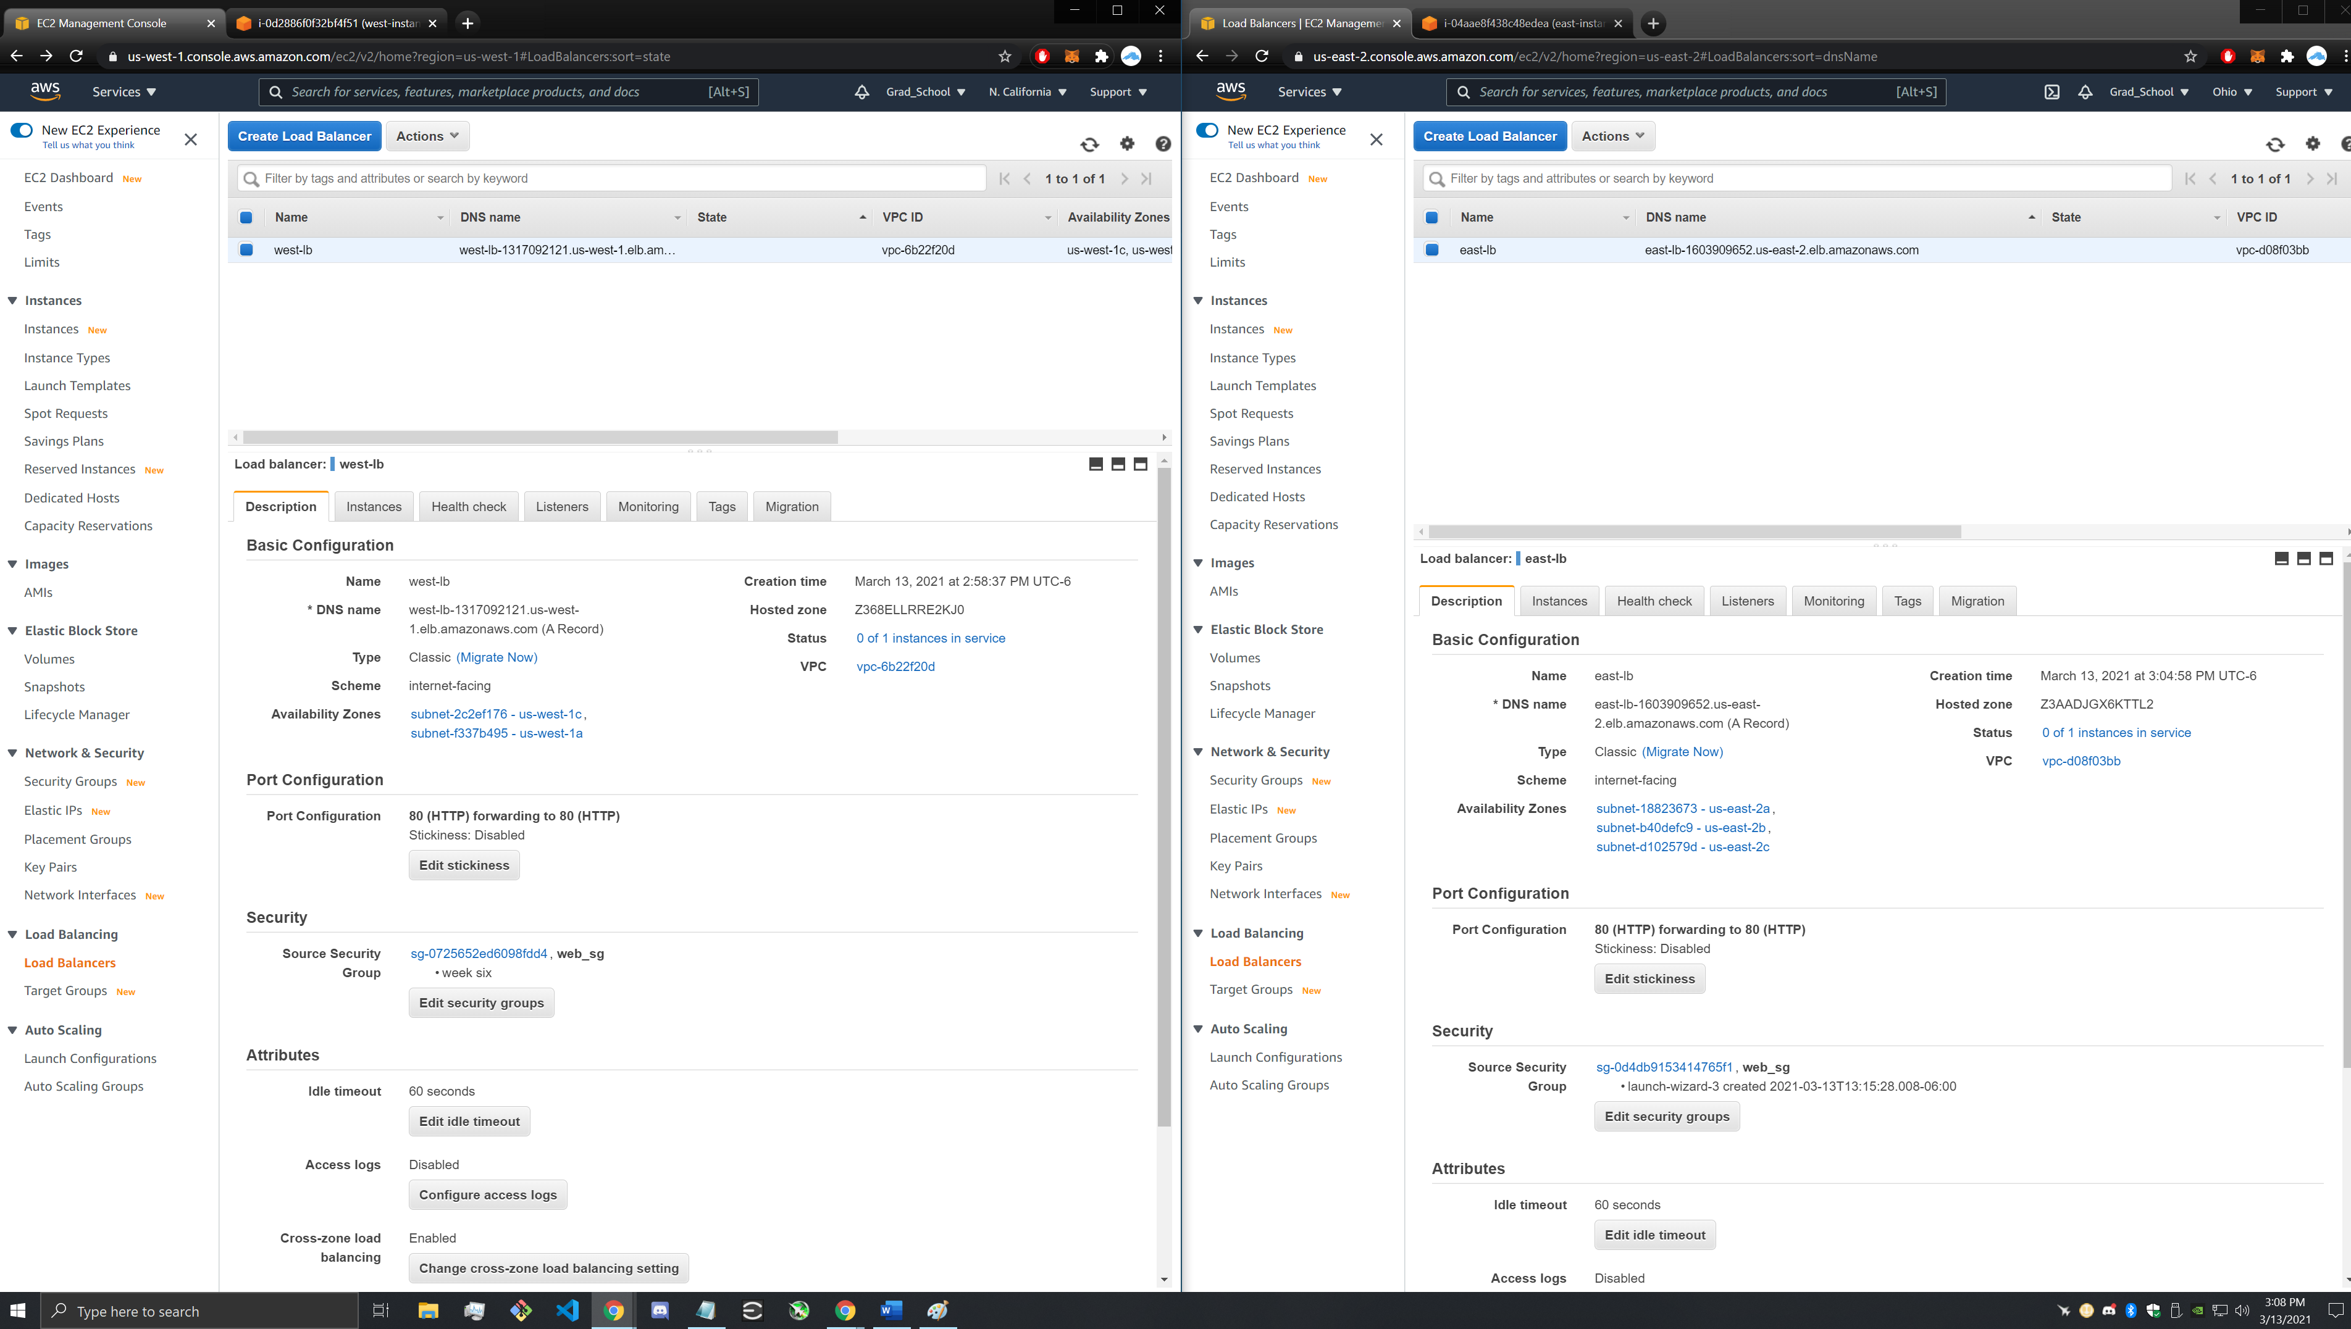

(Listener)

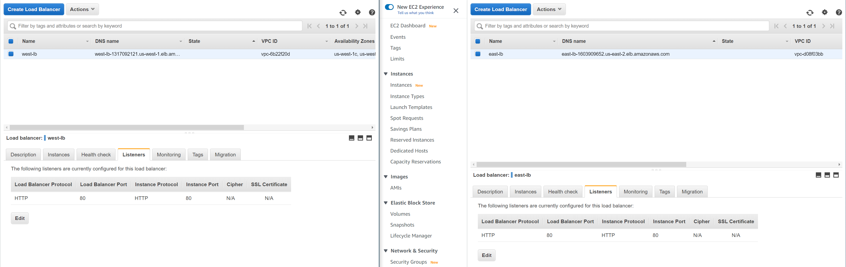

(Instance SGs)

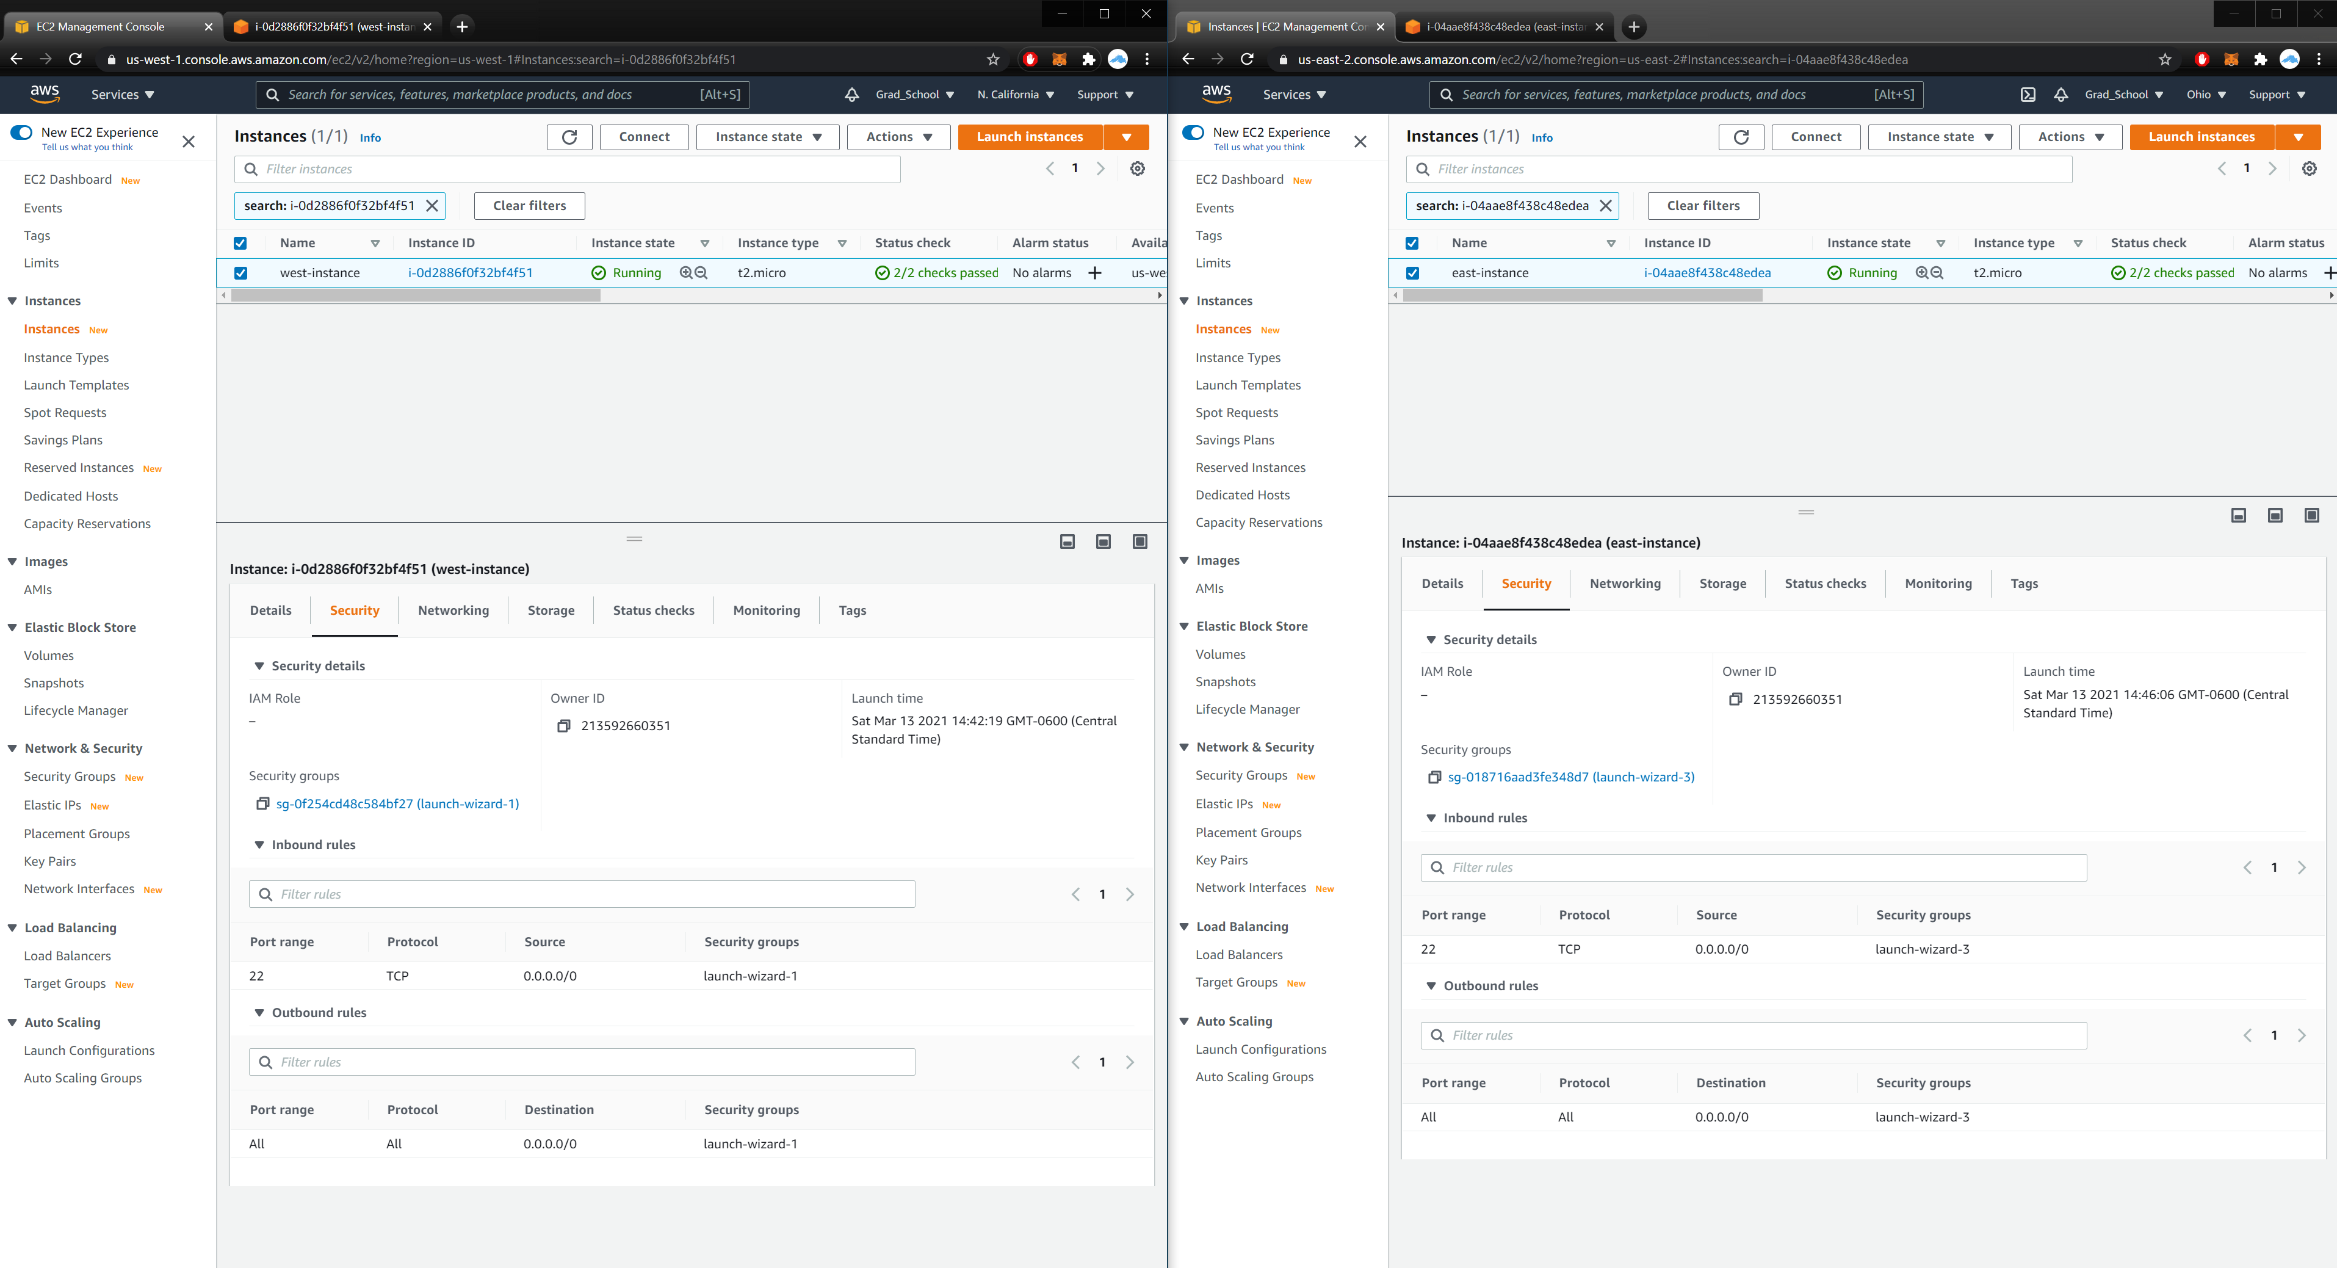

* What DNS concepts became clear after completing this lab?

Again, I really struggled with this, so to be honest it is all up in the air mixed around. What I did understand it that I need to take the time to review this section, and challenge myself to include these in my project.

* We looked at three routing policy of Route 53. Describe a policy of Route

53 you might use in your next project and why.

I’d imagine, if I’d get it working correctly, I’d use Route 53 to offer a service across the US for people to use, instead of it being locked onto one coast.

**Lab6D Output**

I forgot to take a screenshot yesterday, as a result scale is 24 hrs.

