Broker, Carl – Week 9

<https://youtu.be/zqPIQReAb2I>

Cost Estimate Page

<https://calculator.aws/#/estimate?id=87f5da9186701cf61738d9c2fdfbaa1918951a93>

Requirements:

1. The site should be Elastic - it should have the ability to perform well proportional to the EC2 resources allocated to it.

*I made elastic load balancers for each region, each of which spool-up a premade instance, as a result of my saved image and s3 bucket. These load balancers create a new instance when cpu usage >50% on an instance. A max of 4 instances will be available in each of the two regions.*

2. The application will use several EC2 instances spread across multiple AZs and Regions that are running WordPress with the same content. WordPress uses MySQL extensively - so we need to think about replicating the data from a primary database to one or more read replicas.

*In my design I made a read-replica, in the West region,* ***from*** *my master that’s in the East region.*

3. There should not be any SPOFs (Single point of failures) in the architecture.

*Following the design tutorial I ensure that there was no single point of failure.*

4. The site should serve media (videos, images) from a content delivery network or distribution.

*Word press is capable of handling videos and images.*

5. Setup Latency Based Routing in Route53

*In my last steps, I setup latency based routing to ensure that if one*

6. If you don't have a DNS domain you can use, we'll register one later. If you would like to use an existing domain, let the instructor know.

*I purchased a domain name from amazon – carlbroker.com*

7. The site should support zone apex (example.com and www.example.com) should point to the website.

*In my design I setup the record system to point to* [*www.carlbroker.com*](http://www.carlbroker.com) *in both regions.*

8. The site should use database replication and WordPress should be configured to read and write a "local" database i.e., WordPress should use the database in the current region.

*I designed the master database in the East, and the readable ‘local’ database in the West.*

9. The operational functions such as backup and monitoring must be automated.

*In configuring the database and systems, we included an automatic backup of the databases. The wordpress site also has backups.*

10. The client will modify the site on one WordPress server denoted "WordPress Master".

*Per the user profiles we designed, editors will be able to access the WordPress Master, make changes, and these changes will be reflected in the child instances.*

11. All the WordPress contents including the themes, plugins, uploaded content, configuration should all be propagated to other WordPress nodes that are started by AWS AutoScaling process within 15 minutes i.e., the customer expects to see all the changes made to master WordPress node to appear on all EC2 instances whether they are started manually or by AutoScale process.

*With the help of automated curl commands, we implemented a script to automatically update the other regions, from the master.*

12. Develop automated scripts / tools to copy data back and forth from S3 bucket periodically.

*A curl script was/is implemented to automatically send copies to the S3 bucket.*

13. In addition, all the WordPress content should be continuously backed up to S3.

*This was not completed, I think?*

14. Develop automated scripts / tools to copy data back and forth from S3 bucket periodically.

*Scripts were implemented to automatically send data to the S3 bucket automatically.*

15. Setup lifecycle policies on S3 buckets so that all data older than week are archived to Glacier for long-term storage and retention.

*This was optional, therefore not completed (to save on costs). However, for grading purposes, here is what I would have implemented. (see next page)*

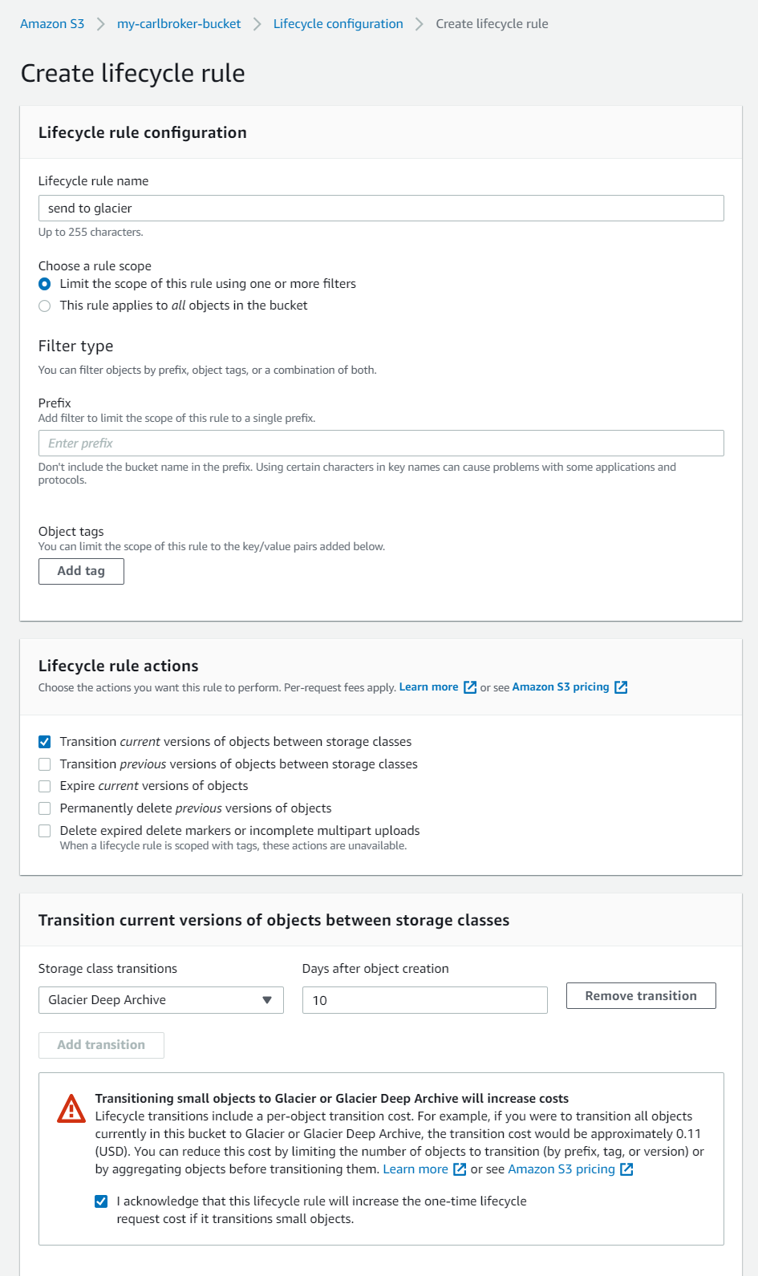

16. The customer is very security conscious. He would like you to expose as few services as possible to the Internet. All sensitive data processing and databases should be in a secure, private network.

*Per design I included multiple VPCs, including private and public. The public are the website and the private are the master wordpress instance and databases.*

17. Since this is a highly visible site that can receive several million visitors a day, the client wants to spend the least amount of time in bootstrapping the EC2 instances before they are put in service. So, a custom AMI (also called "Frozen Pizza") that has all the applications installed is recommended for AutoScaled instances. However, the instances need to retrieve the latest application data (WordPress content) from S3 backup before accepting traffic.

*Automated scripts to pull from S3 backup were implemented.*

18. Use tools like Creately, Powerpoint or Visio to draw your architecture. You can download the icons or Visio stencils at AWS Architecture Center.

*I did not deviate from the suggested tutorial, therefore did not create a new architecture.*

19. As cloud architects, we are also required to provide cost estimates or ballpark numbers. This number represents the approximate monthly cost the customer will pay every month in AWS fees. As architects, we are often asked to provide the highest availability for the lowest possible costs. There are several ways of estimating AWS costs, but the easiest way is to use AWS Calculator. So head over there and plug in the numbers for every component you are using in your architecture including EBS, EC2, ELB, and S3 etc. You may have to make certain assumptions for items you don't have the data - storage in S3, inbound and outbound data transfer costs and amount of data the ELBs will process and so on. Make reasonable guesses for these items and provide a cost estimate. Our clients can’t provide this data as well - typically we tack on 15-20% overhead to account for variable costs such as storage and bandwidth. If you need help figuring out the AWS Calculator, this quick 5-min video might help.

*Link is at top.*

20. When you are done with cost estimates, click on Estimate of your monthly bill tab and then Save and Share the link to get a URL for the page. You'll need this URL for the project submission.

*Link is at top.*