|  |  |  |
| --- | --- | --- |
|  | **Rochester Institute of Technology**  **Golisano College of Computing and Information Sciences**  **School of Interactive Games and Media**  **2145 Golisano Hall – (585) 475-7680** |  |

**Data Structures & Algorithms for Games & Simulation II**

**IGME 309, 2016-17 Spring**

**E10: Projections**

This is a teams of 2 ICE only one submission per team is required but you need to create a txt file at the root of the folder with the name of both partners. Feel free to work individually on this exercise as well.

For this in-class exercise you are asked to implement 5 different camera views by pressing F1 to F5, the actual values for the camera are entirely up to you but they should look like these:

F1:

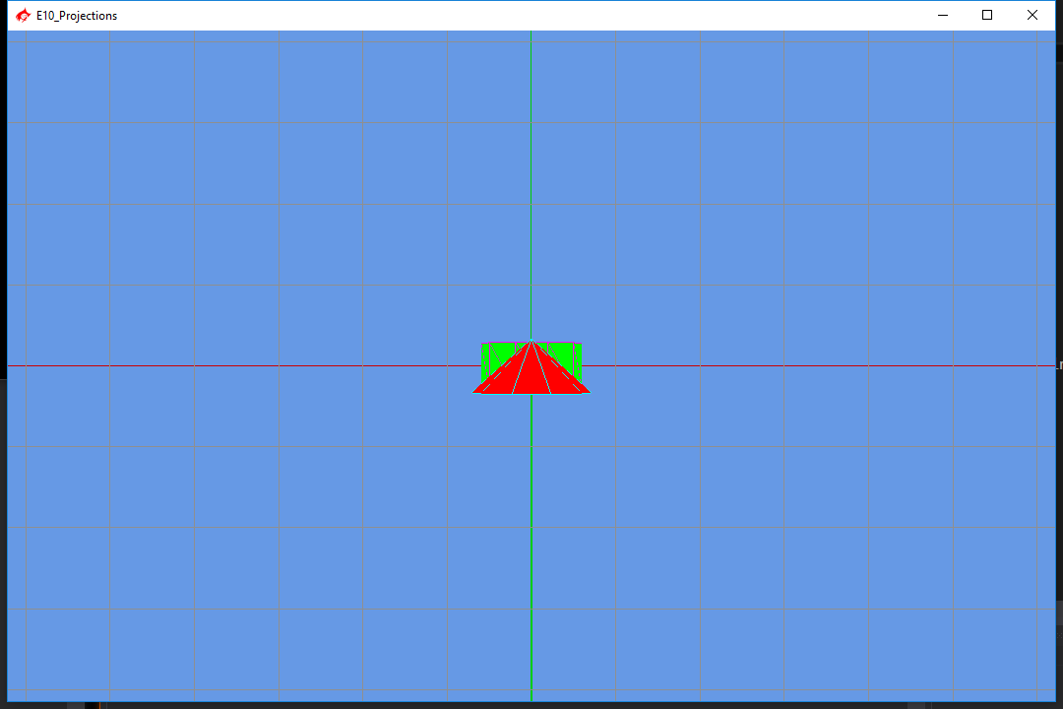

F2

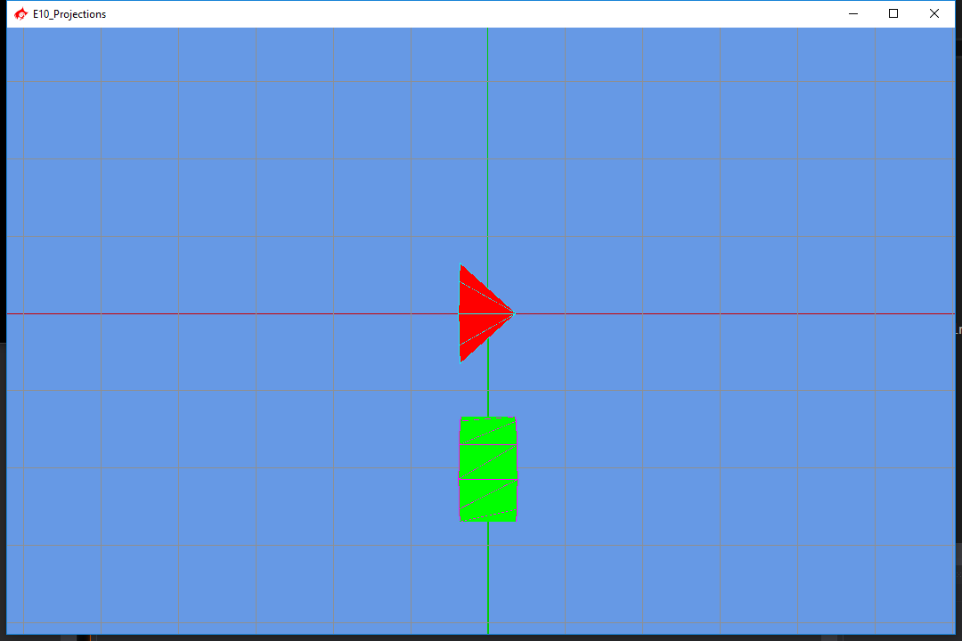

F3

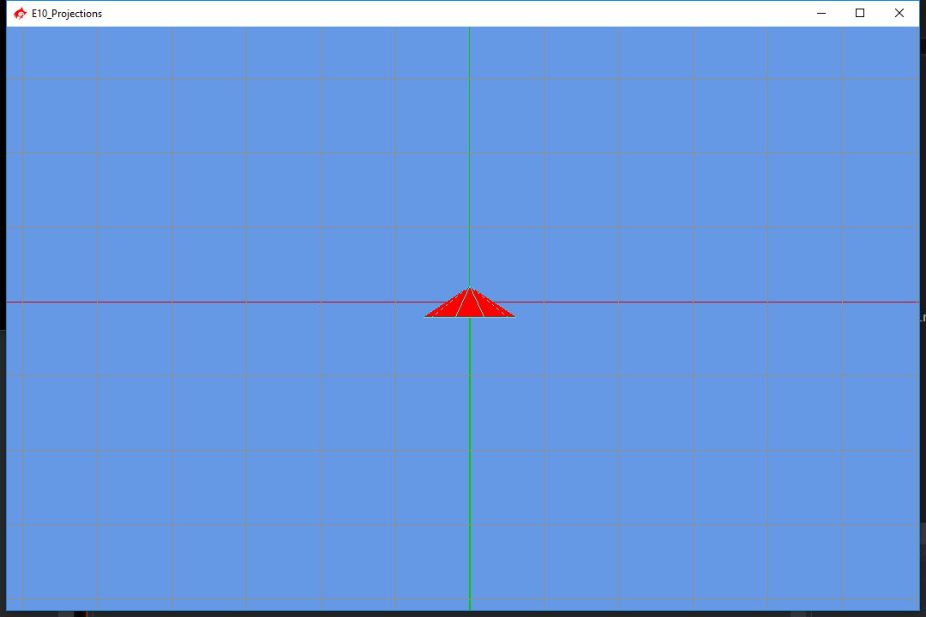

F4

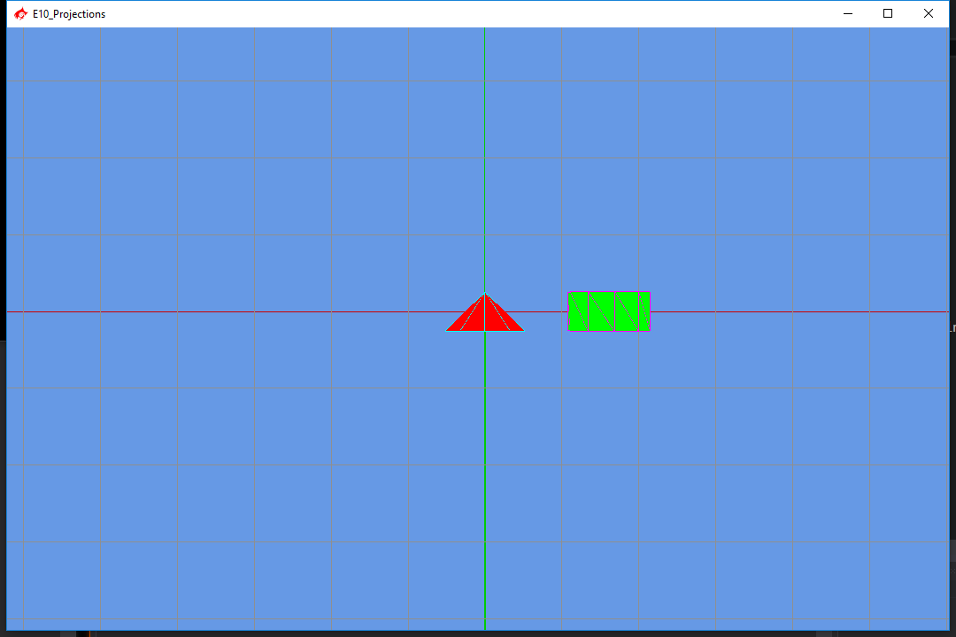

F5

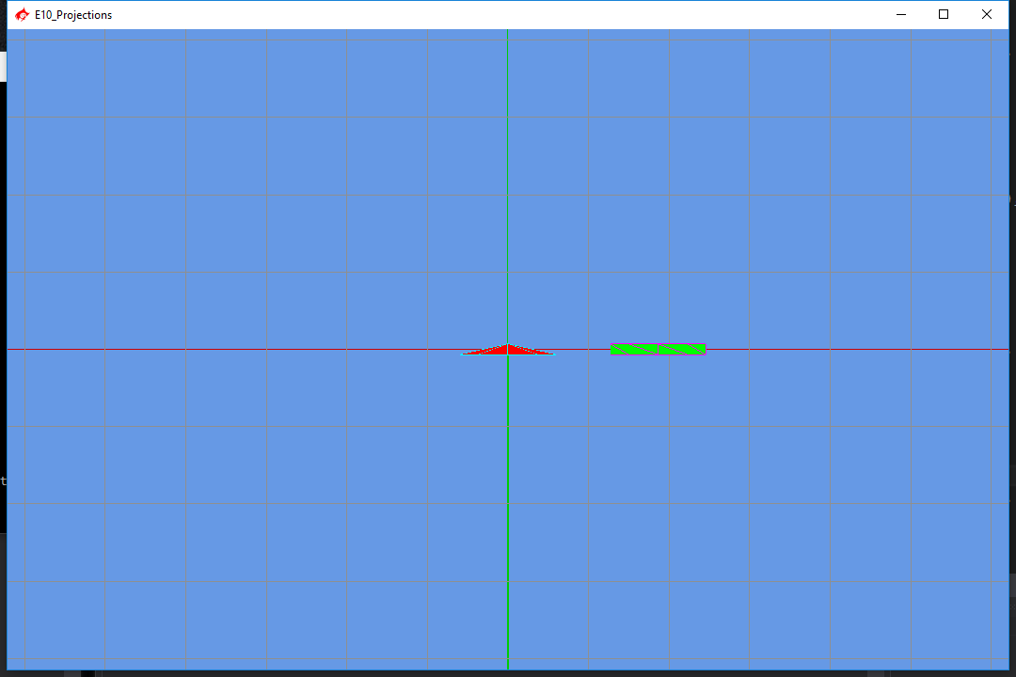

If you are using the provided code, all of it should go in the AppControllers.cpp;

There are only two matrices to modify in this ICE the m_m4Projection and the m_m4View, both of them are already connected in the AppClass.cpp. You just need to find some values for it.

Show the work to the TA or professor and explain what you did in order to avoid the Gimbal Lock.