|  |  |  |
| --- | --- | --- |
|  | **Rochester Institute of Technology**  **Golisano College of Computing and Information Sciences**  **School of Interactive Games and Media**  **2145 Golisano Hall – (585) 475-7680** |  |

**Data Structures & Algorithms for Games & Simulation II**

**IGME 309, 2016-17 Spring**

**E11: Sierpinski Triangle**

For this in-class exercise you are asked to generate a Sierpinski Triangle (in 2D to keep it simple) on to its 3th recursion (though you can come up with a method to create any iteration number).

Restrictions:

You can only call the graphics card once (implying that you need to use instance rendering)

You need to create at least 3 recursions (meaning you will have something like a set of 3 triforces)

Useful links:

<https://en.wikipedia.org/wiki/Sierpinski_triangle>

<http://ed.ted.com/lessons/the-mathematical-secrets-of-pascal-s-triangle-wajdi-mohamed-ratemi>

Starter code is provided and there are three particularly useful projects in the ReEngine repository; you are also allowed to start your solution out of a new project or based on an existing ICE, based on this or any other engine/framework.

Your solution should look like the tip of the following screenshot (the first 9 triangles) but if you make it programmatically you can make something like this:

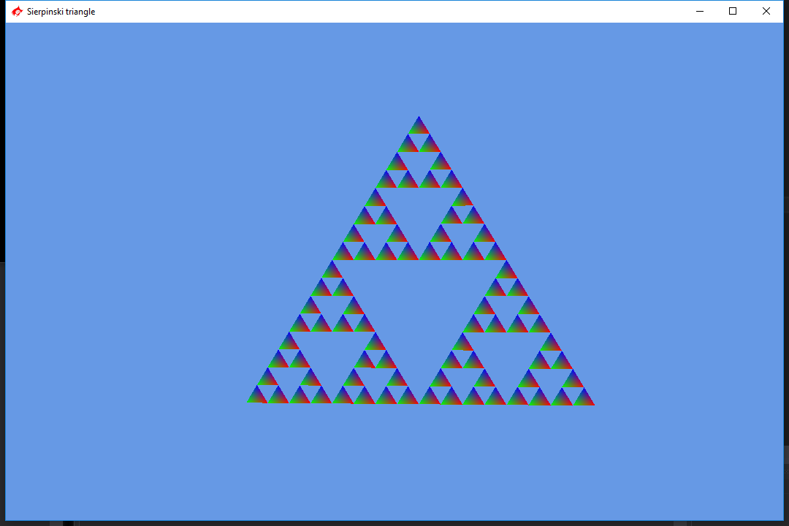

Show the work to the TA or professor and upload it to the designated dropbox. Your submission should only be the project folder that zipped should not be larger than 1mb. Do not forget to push to your repository.