# Appendix S5 Model Evaluation

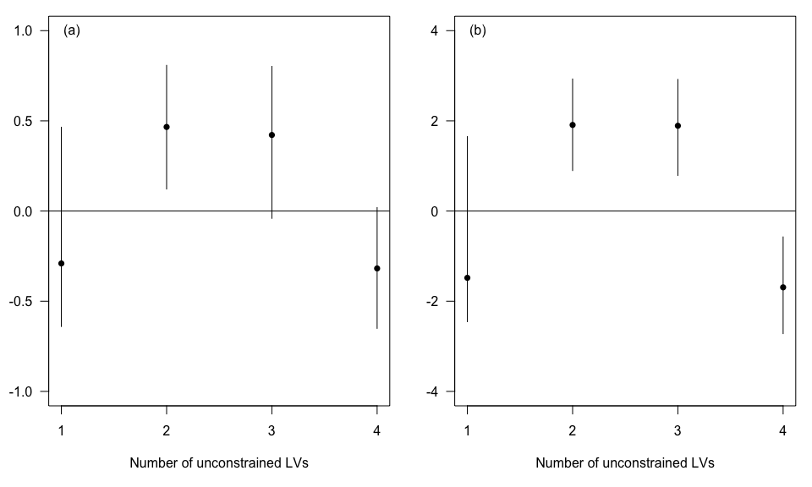

**Figure S1** Estimates for the effect of distance to log ponds (a) and high flow (b) on the constrained latent variable as a function of the number of unconstrained latent variables included in the model. Points show median estimate and bars show the 95% credibility interval.

**Table S2** Fit of the two latent variable model to each habitat type. r2 values are calculated on observed versus expected abundances. Slope values of 1 indicate now bias, <1 under-predictions and >1 over-prediction.

|  |  |  |  |
| --- | --- | --- | --- |
| Habitat | Mean abundance | r2 | Slope of expected on observed |
| Others | 0.84 | 0.19 | 0.11 |
| Other habitats | 1.86 | 0.44 | 0.32 |
| Rare corals | 2.65 | 0.20 | 0.18 |
| Acropora Tabular | 4.69 | 0.81 | 0.57 |
| Turf Algae | 4.90 | 0.37 | 0.25 |
| Macroalgae | 8.10 | 0.72 | 0.47 |
| Halimeda Algae | 11.31 | 0.96 | 0.47 |
| Algal assemblage | 12.61 | 0.96 | 0.57 |
| Submassive coral | 13.96 | 0.48 | 0.41 |
| Dead Coral | 17.39 | 0.80 | 0.74 |
| Other corals | 19.43 | 0.48 | 0.57 |
| Dead branching coral | 25.76 | 0.69 | 0.70 |
| Rock | 39.04 | 0.79 | 0.68 |
| Acropora Branching | 42.80 | 0.97 | 0.91 |
| Coral Massive | 51.12 | 0.82 | 0.85 |
| Coral Branching | 56.88 | 0.89 | 0.78 |
| Soft sediment | 61.67 | 0.94 | 0.81 |