# Tables

*Table 1* Comparison of candidate models using the predictive ordinate and the Watanabe-Akaike Information Criterion (WAIC). The Bayesian ordination includes only unconstrained latent variables. LV: number of unconstrained latent variables.

|  |  |  |  |
| --- | --- | --- | --- |
| Model |  | Log point-wise predictive density | Conditional WAIC |
| Bayesian ordination, 2 LVs |  | 10175 | 15621 |
| Constrained model, 1 LV |  | 8525 | 15679 |
| Constrained model, 2 LVs |  | 7962 | 12123 |
| Constrained model, 3 LVs |  | 7511 | 10093 |
| Constrained model, 4 LVs |  | 7939 | 8243 |

# Figures

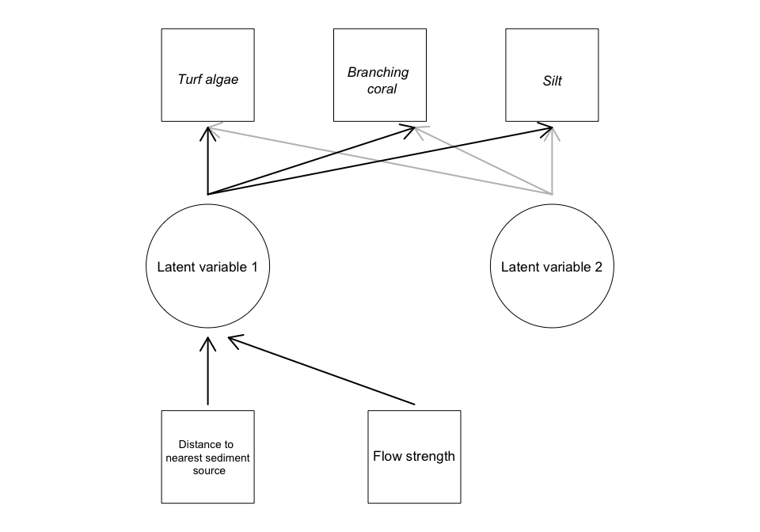

**Figure 1** Directed graph giving an example for the structure of our Bayesian latent variable model applied to coral reef habitats in Solomon Islands. Squares indicate measured variables, circles indicate latent variables, variables in italics also have error terms that are estimated from the data. Arrows indicate model effects, with gray and black arrows indicating the effects relating to different latent variables.

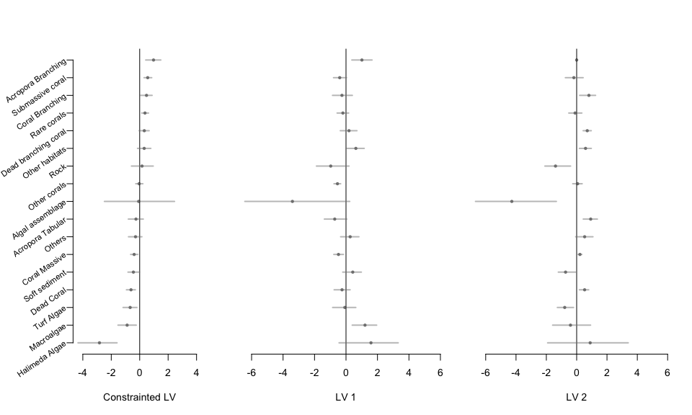

**Figure 2** Mean estimates and credible intervals (CIs) for loadings of each habitat category on the (a) constrained latent variable and (b-c) two unconstrained latent variables. Loading signs on the constrained latent variable (a) are fixed so that positive values indicate a habitat's cover increases farther from log-ponds.

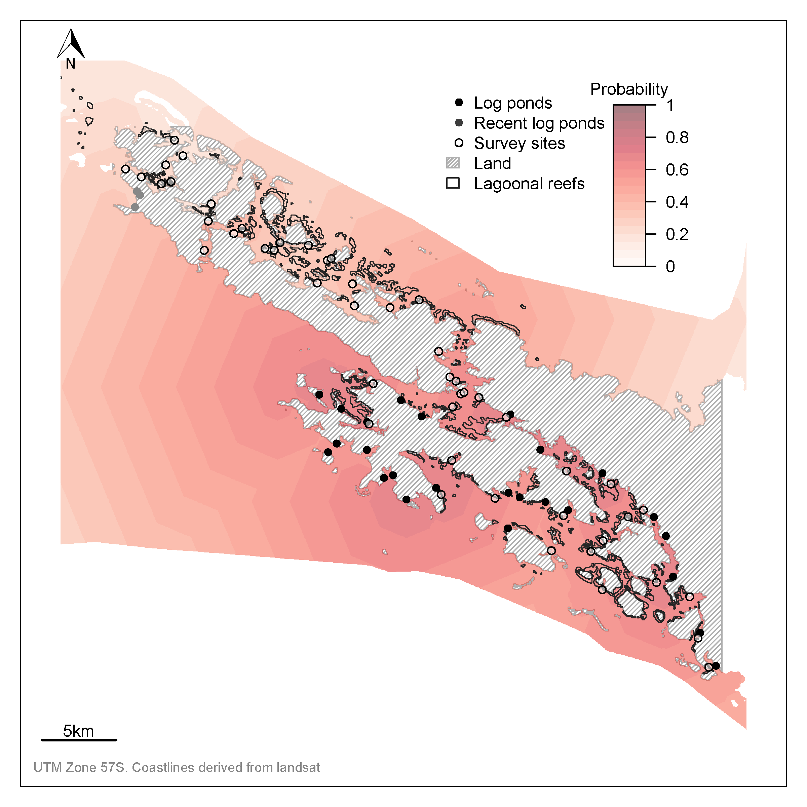

**Figure 3** Map of study region showing log ponds, survey sites and probabilities that a reef is degraded. The spatial field shows the probability that benthic communities are degraded. The probabilities are predicted to all ocean areas (not just lagoonal reefs) for visualization purposes. Note that uncertainty on the probability field is broad, but is not shown here for visualization purposes.

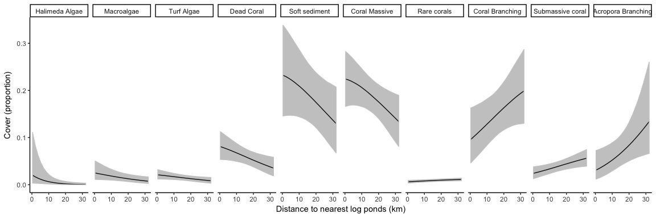

**Figure 4** Cover against distance to nearest log-ponds for habitats with a significant response to the latent variable for water quality. Significance was defined as 95% CIs not overlapping zero.