**Methods**

***Field Trials***

We deployed paired tacklebox gravid traps (Bioquip, Valencia, CA) at 3 separate locations for six weeks in Cullowhee, NC starting on June 15th, 2015 until July 23rd, 2015. Gravid traps were baited with either a white oak leaf infusion (n = 3) or a hay infusion (n = 3). White oak leaves were gathered from Western Carolina University while hay was obtained from a local feed supply store. White oak leaf infusions were created by grinding XXg of dried white oak leaves per liter of water and aging for 3 days in a 5 gallon bucket. Similarly, hay infusions were created by adding XXg of hay per liter of water and XXg of yeast then aging for 3 days in a 5 gallon bucket. Each gravid trap infusion type was paired and placed 3 feet apart. Gravid trap positions were rotated biweekly and during which all mosquitoes were collected. Additionally, grass and white oak leaf infusions were exchanged biweekly during mosquito collections and gravid trap position rotations. All mosquitoes were immediately transported to the WCU Vectorborne Infectious Disease Laboratory. All mosquito specimens were frozen and identified to species with Harrison et al. (2016) identification key on cold chain, then stored at -20oC. All male mosquito species collected during this study can be correctly identified based on characters listed in Harrison et al. (2016). Additionally, female mosquitoes were scored for present or absence of retained eggs and bloodmeals.

***Statistical Analysis***

We modeled the probability that a mosquito species would be attracted to hay or oak leaf infusions as a Poisson process. The lambda parameter (*λ*)for a Poisson process represents the expected number of events per unit of time. In this case, it represents the [unknown] expected number of mosquitoes collected in 1 sampling period. If we define the total number of individuals for a given mosquito species as *N* and the total sampling periods as *T* then:

The parameter *λ* can be estimated by a finite sample of *n* samples over *t* time periods and is expressed as the sample estimate (γ).

$$parmeter λ =\frac{N}{T} estimate γ=\frac{n}{t}$$

This can be further refined to represent the expected number of mosquitoes for a given species and infusion type as γoak and γgrass. Using the methodologies outlined in Gu *et al.* (2008) [formula 1; Wald test] we tested whether the γoak and γgrass differed significantly with a Poisson ratio test. Since our initial concern was whether oak infusion traps collected more mosquitoes than grass infusion traps, we chose to implement a one-way Poisson ratio test where *H*0 represents the null hypothesis that both γoak and γgrass are equal (null ratio = 1) and *H*1 represents the alternative that γoakis greater than the hay infusion γgrass:

All figures and statistical analysis were conducted in Python 3.9.4 with the Scipy (Virtanen *et al*. 2020), Numpy packages (Harris *et al*. 2020), and Matplotlib (Hunter 2007) packages. All data and Python code is available on GitHub (https://github.com/cbsither/WCU_Gravid_Trap_Study_2015.git).

**Results**

***Summary Statistics***

We collected 485 total female (n = 482) and male (n = 3) mosquitoes over during 12 trap sessions at 3 sites with 2 treatments per site yielding approximately 3,450 trap hours. A grand total of 36 samples were taken. Out of the 482 female mosquitoes, 385 were gravid (~79.4%) and no mosquitoes possessed retained bloodmeals. Table 1 summarizes the trap statistics by mosquito species and infusion type.

***Poisson Rates Test***

We focused on the most abundant species collected in our gravid traps: *Aedes japonicus*, *Aedes triseriatus*, and *Culex restuans*. All other species lacked enough observations and/or were not represented in all traps to draw any meaningful inferences about differences in γ estimates. Since the experimental design was balanced, i.e., an infusion type at each site, we treated each site as independent and site-specific effects or weather were not taken into account. Although, rainfall likely plays a role in the collect rates for each species, which in turn would impact the variance estimates. However, we lack the data to address these questions in this current study. We found that the oak infused gravid traps did not collect significantly more mosquitoes for any of the species we investigated (table 2). In fact, the collect rates were equivocal for *Culex restuans* and *Aedes japonicus* but significantly different in the opposite direction for *Aedes triseriatus* (*p* < 0.01) based on a post-hoc Poisson ratio test where *H*1: γoak / γgrass < 1 against *H*0: γoak / γgrass = 1.

Finally, we conducted a post-hoc power analysis to ensure that our sample size was large enough to draw inferences on whether significant differences existed between γ estimates. Here, samples represent the number of sampling intervals rather than the total number of mosquitoes collected. To elaborate, the lambda estimate (γ)is a homogenous rate, so rather than the number individual of mosquitoes (represented by γ) being collected in a sample it is the total number of samples (amount of times γ is estimated) that is important. In other words, the amount of time we collect data is more important than the total number of mosquitoes collected because γis thought of as a homogenous, stochastic process. We set the expected *α*=0.05(type I error), *β*=0.1(type II error), *d* (count ratio of both infusion types given a mosquito species), *R*=1 (null ratio), and *R’*=1.5 (expected γ ratio). *Aedes japonicus*, *Aedes triseriatus*, and *Culex restuans* required 31, 24, and 33 minimum samples, respectively. Thus, all samples met the minimum sample requirement based on the post-hoc power analysis (table 2). ~~The~~ *~~R’~~* ~~was arbitrarily set at 1.5 but could be modeled as a function of required effort to collect and deploy both systems.~~

**Discussion**

While there is likely a difference in γ for infusion types for each mosquito species, operationally it is not significant to use oak infusions over grass infusions because of the time intensive effort that in necessary for white oak leaf collections (leaf identification, man power, leaf aging, etc.) contrasted against easily obtaining a bag of hay from a local farmer. A more elaborate model would estimate the *R’* value from the time and money efforts required to employ different infusion strategies. A more general and robust approach would be to contextualize the problem in Bayesian decision theory which would give each lab the ability to fine tune a model based on different levels of resource availability (money, staff, time, space, etc.).

**References**

Harris, C. R., Millman, K. J., Van Der Walt, S. J., Gommers, R., Virtanen, P., Cournapeau, D., ... & Oliphant, T. E. (2020). Array programming with NumPy. *Nature*, *585*(7825), 357-362.

Virtanen, P., Gommers, R., Oliphant, T. E., Haberland, M., Reddy, T., Cournapeau, D., ... & Van Mulbregt, P. (2020). SciPy 1.0: fundamental algorithms for scientific computing in Python. *Nature methods*, *17*(3), 261-272.

Gu, K., Ng, H. K. T., Tang, M. L., & Schucany, W. R. (2008). Testing the ratio of two poisson

rates. *Biometrical Journal: Journal of Mathematical Methods in Biosciences*, *50*(2), 283-298.

Harrison, B. A., Byrd, B. D., Sither, C. B., & Whitt, P. B. (2016). *The mosquitoes of the Mid-Atlantic region: an identification guide*. Cullowhee, NC: Western Carolina University.

Hoaglin, D. C., & Tukey, J. W. (1985). Checking the shape of discrete distributions. *Exploring Data*

*Tables, Trends and Shapes*, 345-416.

Pearson, K. (1900). X. On the criterion that a given system of deviations from the probable in the case of

a correlated system of variables is such that it can be reasonably supposed to have arisen from

random sampling. *The London, Edinburgh, and Dublin Philosophical Magazine and Journal of*

*Science*, *50*(302), 157-175.

Team, R. C. (2013). R: A language and environment for statistical computing.

Reiter, P. (1983). A portable battery-powered trap for collecting gravid Culex mosquitoes. *Mosquito*

*News*, *43*(4), 496-498.

Trexler, J. D., Apperson, C. S., & Schal, C. (1998). Laboratory and field evaluations of oviposition

responses of Aedes albopictus and Aedes triseriatus (Diptera: Culicidae) to oak leaf

infusions. *Journal of Medical Entomology*, *35*(6), 967-976.

Hunter, J. D. (2007). Matplotlib: A 2D graphics environment. *Computing in science & engineering*, *9*(03), 90-95.

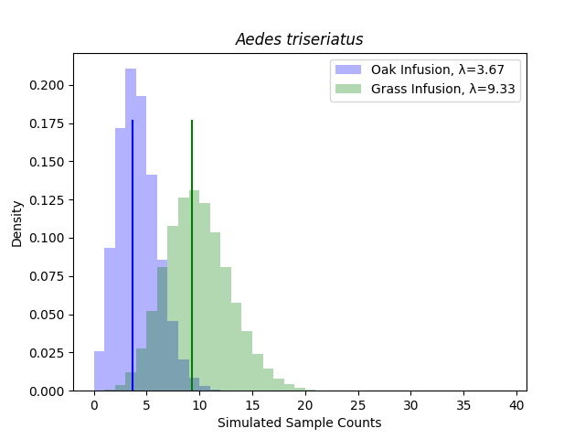

Figure 1: Simulated samples (n=1 000 000) using the *λ*oak and *λ*grass for *Aedes triseriatus*. A one-way Poisson ratio test showed no support for the alternative hypothesis that *λ*oak / *λ*grass  > 1. Conversely, grass infusions seem to be a more attractive ovipositioning queue for *Aedes triseriatus* in western North Carolina. The solid blue line represents *λ*oak = 3.67 and the solid green line is *λ*grass = 9.33.

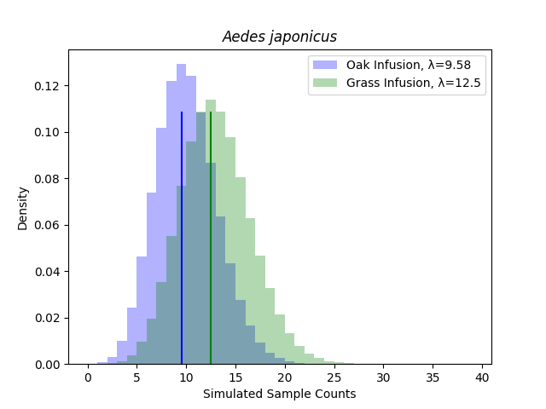

Figure 2: Simulated samples (n=1 000 000) using the *λ*oak and *λ*grass for *Aedes japonicus*. A one-way Poisson ratio test showed no support for the alternative hypothesis that *λ*oak / *λ*grass  > 1. The solid blue line represents *λ*oak = 9.58 and the solid green line is *λ*grass = 12.5.

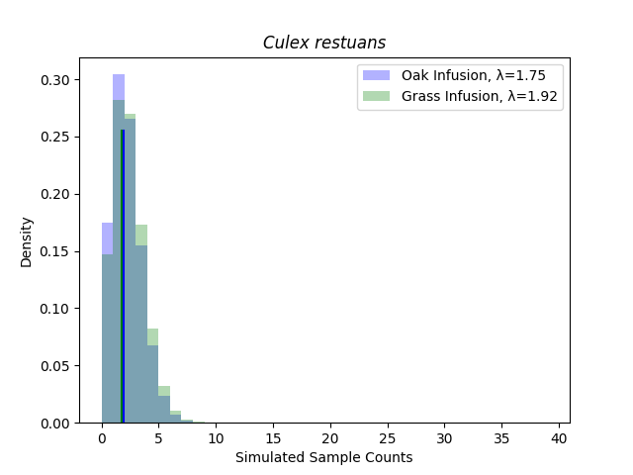

Figure 3: Simulated samples (n=1 000 000) using the *λ*oak and *λ*grass for *Aedes japonicus*. A one-way Poisson ratio test showed no support for the alternative hypothesis that *λ*oak / *λ*grass  > 1. The solid blue line represents *λ*oak = 1.75 and the solid green line is *λ*grass = 1.92.