

Southwestern Tires

Deliverable # 2

MIS 4720

Muyeedul Hoque

Caroline Mallory

Georgi Kardzhaliyski

Bing (Lily) Yang

Table of Contents

Executive Summary 3

Recommended System 4

Process Models 6

Context Diagram 6

Data Model 7

ERD Dictionary of Terms 7

System Architecture Design 13

Operational Requirements 13

Technical Environment Requirement 13

System Integration Requirements 13

Maintainability Requirements 13

Performance Requirements 13

Speed Requirements 13

Capacity Requirements 13

Availability and Reliability Requirements 13

Security Requirements 13

Access Control Requirements 13

Encryption and Authentication Requirements 14

Use Scenarios 15

Use Scenario: Time-Sensitive Basic Tire Purchase 15

Use Scenario: Not Time-Sensitive Tire Purchase 15

Use Scenario: Manager ordering needed tires – weekly order 15

Use Scenario: Manager ordering needed tires – emergency order 15

Use Scenario: New Inventory Check-in 15

Interface Structure Design 17

Comments and Explanations 18

Interface Standards Design 18

Use Scenario Influence 18

# Executive Summary

Southwestern Tires is a local tire distributor. They are interested in centralizing their inventory and sales system and automating some processes. Included in this system is information on which employees make sales and current inventory numbers of tires at each store. The proposed solution should be able to handle queries for inventory, create invoices when orders are needed, and create sales reports.

The current system exists on paper and in a very basic computer system. Typical data entry into the computer system is as followed:

Three types of information are stored in the system. Data from invoices, orders sent out, and payroll information are all stored in the system. Invoices and orders sent out are written on paper, and the receipts are all kept and stored until the main office secretary manually enters all the data, usually once a week. Payroll information is sent from each of the stores in the area to the main office on paper. This information is then entered into the computer. There are three different classes of employees, and only the salaried or hourly workers get paid from the main office. Others collect commissions from their store.   
The proposed system is decentralized, keeping track of tire inventory and sales for each store, in addition to payroll and managerial information. Each salesperson would be responsible for entering each of their sales into the system. This would guarantee that each sale is correctly documented, and accurate inventory information would be kept. (Each salesperson is paid on commission and is motivated to create accurate records.) Each manager would be responsible for managing inventory within their own store, and keeping track of storewide sales and profit information.

The information input by each store is also available to higher management. This would be used to create orders to supply the warehouse, and also to process orders from wholesalers.

## Recommended System

The current system at Southwestern Tires currently relies heavily on paperwork, an incredibly outdated computer system, and employees counting inventory. We would recommend replacing this entire system with something modern that integrates all facets of the business including finance management, point of sale (POS) endpoints, and multi-store inventory management. This solution can either be local hardware based, or Software as a Service (SaaS) based, both of which have their advantages and disadvantages. A local hardware based solution could be beneficial if Southwestern Tires wanted greater control over their system and had the time and money to have someone properly maintain it. A disadvantage would be that the cost to maintain the infrastructure would be high and prone to issues leading to business downtime. Going with the SaaS route, a company would likely see higher reliability as the system is automatically backed up and there is built-in redundancy to protect the system from failure as well as reduced maintenance costs. A potential disadvantage would be that is a subscription service and subscription as well as the cost per user may be greater than the cost of a hardware infrastructure with a dedicated employee in some cases.

In the case of Southwestern Tires, we believe that the SaaS model of the recommended system would be the proper choice.

POS software is ~$1800, with hardware closer to $2100 per station – this would be the same cost regardless of choice

* Pricing for QuickBooks enterprise solutions subscription is $100 per user per month – this needs to be compared to the costs of an employee’s salary which may need to be looked up.

Functional requirements

* The system will allow users to update inventory files quickly and easily at the time of a sale and incoming shipment.
* The system will provide timely updates of the inventory file when tires are transferred between stores.
* The system will record tire sales including store/salesman/date/tire code
* The system will allow users to check inventory file (of multiple stores) without the need of a “rack check”.
* The system will allow users to check the inventory of all stores to determine which tires to reorder.

Non-function requirements

* Operational
  + The system should be able to be accessed at all times.
  + The system should give out financial metrics and statistics that could help improve business and see where they’re losing money.
* Performance
  + The system should be able to support all the users connected at once without any delay.
  + The system should be able to update inventory changes as soon as a transaction is made.
  + The system should be able to provide real-time inventory numbers
  + The system should be able to provide low-inventory notifications automatically.
* Security
  + The system should have access controls put in place so that users can only access parts of the software they are supposed to see.
  + All POS stations should be able to be locked when a salesperson is not at it.
  + Each user should have their own individual account
* Cultural and Political
  + All customer information and sales information is protected in compliance with the Data Protection Act.
  + The system will be simple as to lower the learning curve so employees can focus on sales and not learning the software.
  + The system should have the company logo to brand all invoices.

## Process Models

### Context Diagram

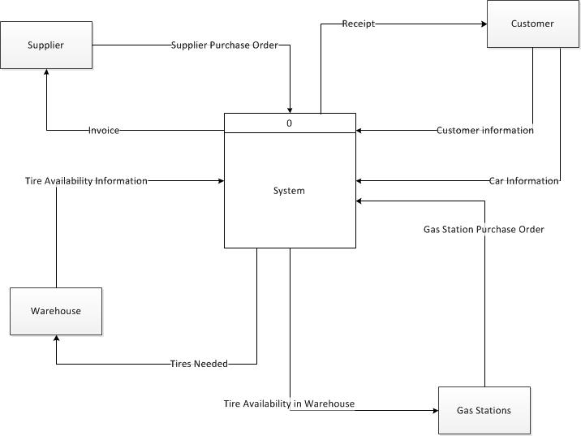

This updated version of the context diagram reflects a more accurate overview of the whole system. It shows how information flows between the system and its users. The previous version, though titled “Context Diagram” actually showed a level 1 or 2 data flow diagram.

### Data Model

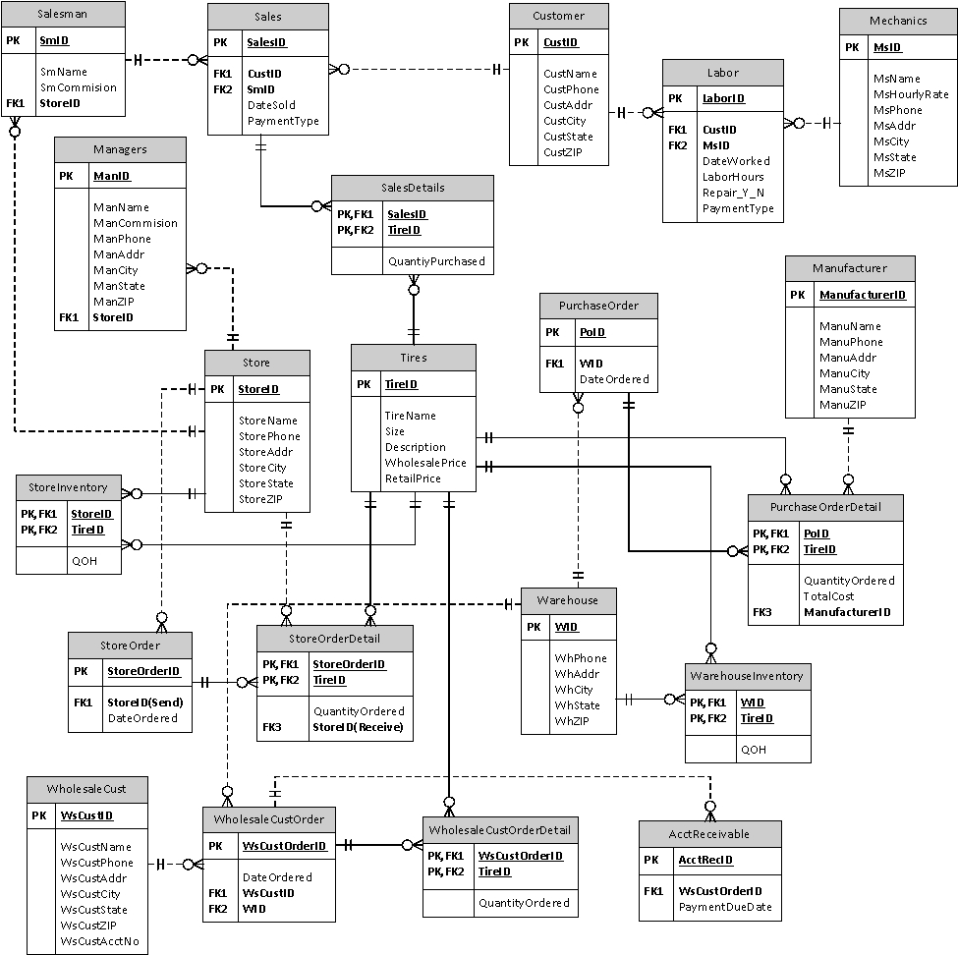

We updated the ERD because the ERD provided by the last group was focusing on the as-is system, not the to-be system. We can’t build our system according to the existing ERD so we revised it for better implementation.

### ERD Dictionary of Terms

**tblSalesman** – The Salesman table includes basic information about the salesman: **SmID** (primary key – unique for every salesman), SmName, SmCommision, *StoreID*.

The table consists of the list of salesman. It contains the salesman’s name, commission rate, and the store the salesman works for. The salesman table is linked with tblSales and tblStore so that which sales are placed by which salesman, and which store does which salesman work for could be easily tracked. The purpose of this table is to record a list of all salesman working for Southwestern Tires.

**tblManagers** – The Managers table includes basic information about the managers: **ManID** (primary key – unique for every manager), ManName, ManComission, ManPhone, ManAddr, ManCity, ManState, ManZIP, *StoreID*.

The table consists of the list of managers. It contains the manager’s name, commission rate, phone number, address, city, state, ZIP, and the store the manager works for. The manager table is linked with tblStore so that which store does which manager work for could be easily tracked. The purpose of this table is to record a list of all managers working for Southwestern Tires.

**tblMechanics** – The Mechanics table includes basic information about the mechanics: **MsID** (primary key – unique for every mechanic), MsName, MsHourlyRate, MsPhone, MsAddr, MsCity, MsState, MsZIP

The table consists of the list of mechanics. It contains the mechanic’s name, hourly rate, phone number, address, city, state, and ZIP. The mechanics table is linked with tblLabor so that which mechanic is involved in which labor order could be easily tracked. The purpose of this table is to record a list of all mechanics working for Southwestern Tires.

**tblCustomer** – The Customer table includes basic information about the customers: **CustID** (primary key – unique for every customer), CustName, CustPhone, CustAddr, CustCity, CustState, CustZIP.

The table consists of the list of customers. It contains the customer’s name, phone number, address, city, state, and ZIP. The customer table is linked with tblSales and tblLabor so that which customer is involved in which sales order and/or labor order could be easily tracked. The purpose of this table is to record a list of all customers that have visited Southwestern Tires.

**tblStore** – The Store table includes basic information about the store: **StoreID** (primary key – unique for every store), StoreName, StorePhone, StoreAddr, StoreCity, StoreState, StoreZIP.

The table consists of the list of stores. It contains the store’s name, phone number, address, city, state, and ZIP. The store table is linked with tblSalesman, tblManagers, tblStoreInventory, tblStoreOrder, tblStoreOrderDetial so that which store has which salesman and managers, which store has how many of each type of tires, which store are ordering tires from other store could be easily tracked. The purpose of this table is to record a list of all stores of Southwestern Tires.

**tblWarehouse** – The Warehouse table includes basic information about the warehouse: **WID** (primary key – unique for every warehouse), WhPhone, WhAddr, WhCity, WhState, WhZIP.

The table consists of the list of warehouses. It contains the warehouse’s phone number, address, city, state, and ZIP. The warehouse table is linked with tblWarehouseInventory, tblWholesaleCustOrder, and tblPurchaseOrder so that which warehouse has how many of each type of tires, which warehouse provide which wholesale customer with tires, and which warehouse ordered how many tires from manufacture could be easily tracked. The purpose of this table is to record a list of all warehouses of Southwesternern Tires.

**tblTires**– The Tires table includes basic information about the tires: **TireID** (primary key – unique for every tire), TireName, Size, Description, WholesalePrice, RetailPrice.

The table consists of the list of tires. It contains the tire’s name, size, description, wholesale price, and retail price. The tires table is linked with tblStoreInventory, tblWarehouseInventory, tblSalesDetails, tblStoreOrderDetail, tblPurchaseOrderDetail, tblWholesaleCustOrderDetail so that which tires are involved in which store inventory, warehouse inventory, sales order, store order, purchase order, and wholesale customer order could be easily tracked. The purpose of this table is to record a list of all tires Southwestern Tires sell.

**tblManufacturer** – The Manufacturer table includes basic information about the manufacturer: **ManufacturerID** (primary key – unique for every manufacturer), ManuName, ManuPhone, ManuAddr, ManuCity, ManuState, ManuZIP.

The table consists of the list of manufacturers. It contains the manufacturer’s name, phone number, address, city, state, and ZIP. The manufacturer table is linked with tblPurchaseOrderDetail so that which manufacturer is involved in which purchase order could be easily tracked. The purpose of this table is to record a list of all manufacturers.

**tblStoreInventory** – The Store Inventory table includes basic information about the store inventory: **StoreID, TireID** (primary keys – unique combination for every store inventory), QOH.

The table consists of the list of store inventory. It contains the StoreID, TireID, and quantity on hand. The store inventory table is linked with tblStore, and tblTires so that which store has how many of which tires could be easily tracked. The purpose of this table is to record a list of store inventory.

**tblWarehouseInventory** – The Warehouse Inventory table includes basic information about the warehouse inventory: **WID, TireID** (primary keys – unique combination for every warehouse inventory), QOH.

The table consists of the list of warehouse inventory. It contains the WID, TireID, and quantity on hand. The warehouse inventory table is linked with tblWarehouse, and tblTires so that which warehouse has how many of which tires could be easily tracked. The purpose of this table is to record a list of warehouse inventory.

**tblWholesaleCust** – The Wholesale Customer table includes basic information about the wholesale customers: **WsCustID** (primary key – unique for every wholesale customer), WsCustName, WsCustPhone, WsCustAddr, WsCustCity, WsCustState, WsCustZIP, WsCustAcctNo.

The table consists of the list of wholesale customers. It contains the wholesale customer’s name, phone number, address, city, state, ZIP, and account number. The wholesale customer table is linked with tblWholesaleCustOrder so that which customer placed which order could be easily tracked. The purpose of this table is to record a list of all wholesale customers that have business with Southwestern Tires.

**tblLabor** – The Labor table includes basic information about the labor order: **LaborID** (primary key – unique for every labor order), *MsID*, *CustID*, DateWorked, LaborHours, Repair_Y_N, PaymentType

The table consists of the list of labor orders. It contains the Mechanics ID, Customer ID, the date of work performed, the labor hours, if a repair is involved in this labor order and the payment type. The labor table is linked with tblCustomer, and tblMechanics so that which customer and mechanic are involved in the order could be easily tracked. The purpose of this table is to record a list of labor orders.

**tblSales** – The Sales table includes basic information about the sales order: **SalesID** (primary key – unique for every sales order), *CustID*, *SmID*, DateSold, PaymentType

The table consists of the list of sales orders. It contains the Customer ID, Salesman ID, the date of transaction, and the payment type. The sales table is linked with tblCustomer, tblSalesman, tblSalesDetails so that which customer and salesman are involved in the order and the detail of the order could be easily tracked. The purpose of this table is to record a list of sales orders.

**tblSalesDetails** – The Sales Details table includes detail information about the sales order: **SalesID, TireID** (primary keys – unique combination for every sales order details), QuantityPurchased.

The table consists of the list of sales order details. It contains the SalesID, the TireID, and the quantity of this type of tire purchased. The sales details table is linked with tblSales and tblTires so that which sales order involved which type of tire could be easily tracked. The purpose of this table is to record a list of sales order details.

**tblStoreOrder** – The Store Order table includes basic information about the store order: **StoreOrderID** (primary key – unique for every store order), *StoreID(Send)*, DateOrdered.

The table consists of the list of store orders. It contains the Store Order ID, sending Store ID, and the date ordered. The store order table is linked with tblStore and tblStoreOrderDetail so that which store placed the order and what detail is involved in this transaction could be easily tracked. The purpose of this table is to record a list of store orders.

**tblStoreOrderDetail** – The Store Order Detail table includes detail information about the store order: **StoreOrderID, TireID** (primary keys – unique combination for every store order detail), QuantityOrdered, *StoreID(Receive)*.

The table consists of the list of store order details. It contains the Store Order ID, Tire ID, the quantity ordered, and receiving Store ID. The store order detail table is linked with tblStoreOrder, tblStore, and tblTires so that which store is receiving the order and what tires are demanded could be easily tracked. The purpose of this table is to record a list of store orders.

**tblPurchaseOrder** – The Purchase Order table includes basic information about the purchase order: **PoID** (primary key – unique for every purchase order), *WID,* DateOrdered.

The table consists of the list of purchase orders. It contains the Purchase Order ID, warehouse ID, and the date ordered. The purchase order table is linked with tblWarehouse and tblPurchaseOrderDetail so that which warehouse placed the order and what detail is involved in this transaction could be easily tracked. The purpose of this table is to record a list of purchase orders.

**tblPurchaseOrderDetail** – The Purchase Order Detail table includes detail information about the purchase order: **PoID, TireID** (primary keys – unique combination for every purchase order detail), QuantityOrdered, TotalCost, *ManufacturerID*.

The table consists of the list of purchase order details. It contains the Purchase Order ID, Tire ID, the quantity ordered, the total cost, and the manufacturer ID. The purchase order detail table is linked with tblPurchaseOrder, tblTires, and tblManufacturer so that which manufacturer is supplying which type of tire in which purchase order could be easily tracked. The purpose of this table is to record a list of purchase order details.

**tblWholesaleCustOrder**– The Wholesale Customer Order table includes basic information about the wholesale customer order: **WsCustOrderID** (primary key – unique for every wholesale customer order), DateOrdered, *WsCustID, WID*.

The table consists of the list of wholesale customer orders. It contains the date ordered, wholesale customer ID, and warehouse ID. The wholesale customer order table is linked with tblWholesaleCustOrderDetail, tblWarehouse, tblWholesaleCust, and tblAcctReceivable so that which warehouse is supplying the tires for this order, what details are involved in this order, who is placing the order and the order total could be easily tracked. The purpose of this table is to record a list of wholesale customer orders.

**tblWholesaleCustOrderDetail** – The Wholesale Customer Order Details table includes detail information about the wholesale customer order: **WsCustOrderID, TireID** (primary keys – unique combination for every wholesale customer order details), QuantityPurchased.

The table consists of the list of wholesale customer order details. It contains the WscustOrderID, the TireID, and the quantity of this type of tire purchased. The wholesale customer order detail table is linked with tblWholesaleCustOrder and tblTires so that which wholesale customer order involved which type of tire could be easily tracked. The purpose of this table is to record a list of sales order details.

**tblAcctRecivable**– The Account Receivable table includes basic information about the account receivable: **AcctRecID** (primary key – unique for every account receivable), *WsCustOrderID,* PaymentDueDate.

The table consists of the list of account receivables. It contains the wholesale customer order ID and payment due date. The account receivable table is linked with tblWholesaleCustOrder so that which transaction is due by when could be easily tracked. The purpose of this table is to record a list of account receivables.

# System Architecture Design

## Operational Requirements

### Technical Environment Requirement

* This system is supported on a Windows operating system and created in Microsoft Access platform.
* System will work over a network connection.
* The system should be connected to a printer at each usage point or store.

### System Integration Requirements

* Database system will read information from each store and the warehouse about tire information (type, brand, ID number)
* The database system will maintain sales records
* System will be updated as sales are finalized to maintain accurate inventory records

### Maintainability Requirements

* The system has no current maintainability requirements
* The company should plan on hiring an IT consultant or employee to keep all databases and software up to date.

## Performance Requirements

### Speed Requirements

* Response time must be less than 4 seconds.
* Total system updates should happen at least twice per day to maintain most accurate records.

### Capacity Requirements

* There will be a max of 20 stores online at peak usage
* Each store can have up to 15 users logged in at once.

### Availability and Reliability Requirements

* The system should be available during operational hours.
* The system should have 99% uptime.

## Security Requirements

### Access Control Requirements

* Managers and salespeople can access accounts with username and password.
* No customers have access to the system.
* Salesmen cannot edit store information but they can view it.
* Managers can view and update store information.
* The system is not connected to the internet.

### Encryption and Authentication Requirements

* Customer information must be stored securely.
* Passwords are authenticated within the system.

# Use Scenarios

Use Scenario: Time-Sensitive Basic Tire PurchaseCustomer has tire type carried by SWT. Doesn’t have time to wait for tires to be delivered and installed.

1. Customer gives tire information to salesman (1.1).
2. Salesman looks up availability of tires and discovers they are not in the store’s warehouse, but are in the company’s (1.1).
3. Asks customer about waiting availability- can either wait for delivery or can pick new type of tire (1.1).
4. Customer chooses second type of tire, currently in stock, and can wait for them to be installed (1.1).
5. Tires are installed; there is no need for other repairs (1.1).
6. Customer pays (1.1).

Use Scenario: Not Time-Sensitive Tire PurchaseCustomer has tire type carried by SWT. Has time to wait for tires to be delivered and installed.

1. Customer gives tire information to salesman (1.1).
2. Salesman looks up availability of tires and discovers they are not in the store’s warehouse, but are in the company’s (1.1).
3. Asks customer about waiting availability- can either wait for delivery or can pick new type of tire (1.1).
4. Customer chooses first type of tire, can wait for them to be delivered and installed (1.1).
5. Tires are installed; need for further repair noted (1.1).
6. Customer alerted to repairs needed, cost of parts and repairs and offered choice to fix.
7. Customer chooses to have repairs completed, waits for further notification.
8. Customer pays (1.1).

Use Scenario: Manager ordering needed tires – weekly order  
Manager has historical use data and is performing weekly purchase order creation.

1. Manager checks current inventory against projected need for the week (1.2).
2. Creates invoice for difference (1.2).
3. Sends invoice to warehouse. Gets confirmation and projected delivery date (1.2).

Use Scenario: Manager ordering needed tires – emergency order  
Manager need for certain tire or tires for orders that are currently waiting in the store.

1. Manager checks availability of tire in warehouse and availability of truck (1.1).
2. Calls in order and checks delivery time (1.2).
3. Sends invoice to warehouse. Gets confirmation of delivery time (1.2).

Use Scenario: New Inventory Check-in  
Worker checks in tires to the warehouse’s inventory. There are several problems on the invoice and order.

1. Truck arrives at warehouse, and invoice is passed to worker in charge of unloading (2.1).
2. Invoice is checked against original order form. Incorrect numbers of tires from a certain brand are noticed on invoice. Worker notes discrepancy. (2.3)
3. Visual inspection of tires delivered starts. Numbers of tires ordered from two brands seem to have been mixed up. Discrepancy is noted. (2.2)
4. Correct parts of order are unloaded and scanned into system. (2.3)
5. Incorrect parts of order are written on invoice, and incorrect tires are sent back to manufacturer. (2.4)

# Interface Structure Design

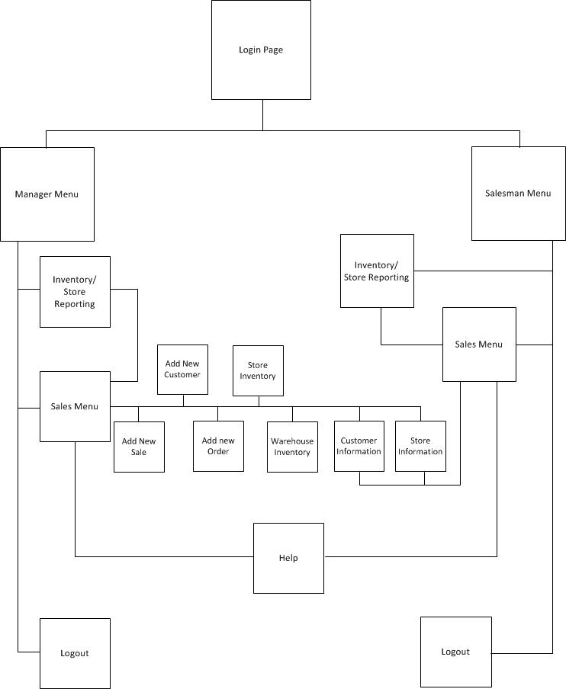

This interface creates and manages the databases necessary for Southwestern Tires to keep accurate inventory of tires, as well as number of sales. This organization allows managers to have greater access to and control of information in the system, while still allowing salesmen to input necessary data. Administrative information is classified under ‘management’ so the system is streamlined. The use

# Comments and Explanations

## Interface Standards Design

Interface standards for this project were created at the beginning of the design process. Font size and style was decided upon and implemented on all pages. Navigation buttons are located in the upper right hand corner of all pages. “Submit”, “Save”, and “Exit” type buttons are found at the bottom of the forms they relate to. Additionally, poka yokes have been added to forms to be completed by the employee. Only certain types of data ( numbers, letters, or symbols) can be entered in to certain fields. Additionally, if any changes are made to a form, the user can not leave that form until they have saved or cancelled the changes. Each page has a title indicative of the functions performed or available on that page, buttons are labeled according to their use. For more complicated or in depth actions, there are explanations next to the buttons that perform those operations.

## Use Scenario Influence

Our system mainly interacts with the users through menus and forms. Compared to a command language, menus do not require users to memorize commands, or need a background in computer languages. Instead, they allow users to retrieve information rather than recalling it each time they are using the system. Additionally, menus are easier to use and more convenient. They also minimize the need for typing and allow users to follow procedures. We designed our system keeping in mind the importance of helping the user establish and fulfill a logical progression through the system. With this in mind, we developed our prototype with the notion of low user familiarity with the system, or with computers in general. This means that new users should be able to use the system without much training. Our group aimed at minimizing the need for interpretations about metaphor in use in the system.

We designed our system for the managers and salesmen in Southwestern Tires. Managers will be using the system on a regular basis to update the inventory and check for the quality on hand. The primary requirement is to allow them to send tires to other stores when inventory is running low.

For the salesmen, our system allows them to view their sales, customers, information about the stores as tables, and modify them. We also identified that an important aspect of the system was to add new customers, sales orders, and labor orders. In addition, they can also print an invoice for the customers.

Our style guide consisted of grouping, ordering, consistency, error tolerance, and logical structure. We strived for consistency in the naming, grouping, color, placing of the company’s logo, and use of white space in the design of our system. We also considered providing help where needed and ability for the user to log out from the system. We avoided using long blocks of text, different fonts, and colors on each page. We also considered the problem of semantic distance and multitasking. We looked into minimizing the number of mouse clicks and amount of scrolling needed to navigate the page.

We designed the form fills to be short and easy to fill out. We aimed at helping absent minded or distracted users to complete a task and the layout. We used the same look on each form fill and emphasized the important objects on the screen through logical layout. We also reviewed Gestalt’s principle from the Human-Computer Literature and grouped similar items together. The items on the screen are grouped logically according to their relevance to the user’s task.

Throughout the design of our system, we also followed the 5 E’s in designing a system: Effectiveness, Efficiency, Engagement, Error Tolerance, and Ease of Use. Our system interacts with the users through the use of dialog boxes, form fill, instructing, conversing through rung queries and extracting information from the system, text boxes, and check boxes. The controls are visible and allow users to perform their task requirements. Buttons provide informative feedback through the use of message boxes and opening of the associated form after clicking. There is an icon accompanying buttons in the form fill and main pages to illustrate their functionality.