

Single Stage Random Numbers

User Guide

Revision 1 – May 5, 2017

**Purpose**

This program will generate an unduplicated quantity of random number for the user. The quantity of random numbers requested must be less than the size of the sampling frame.

**Input Screen**

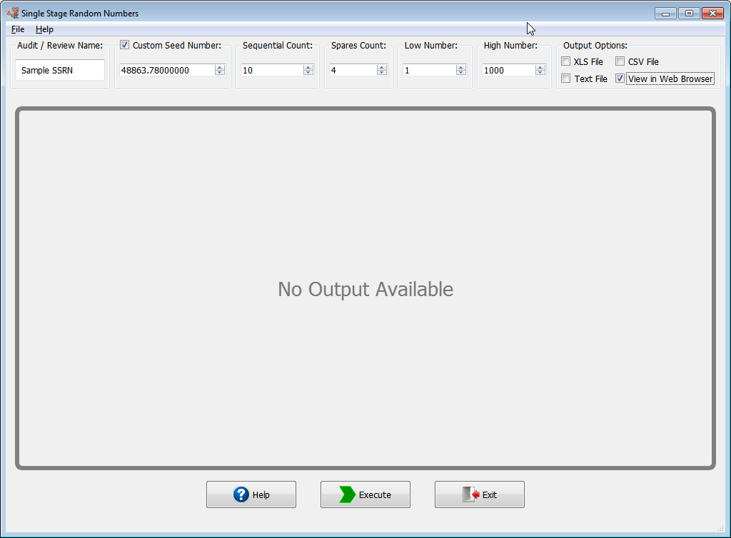

**NOTE:** This example is for illustrative purposes only. The sample size may not conform to the organization’s minimum sample size standards.

**Audit/Review Name**

This program allows the user to enter a brief description of the audit or purpose of the evaluation.

**Custom Seed Number**

The program allows a seed number to be entered by the user to start the random number generation. If no number is entered, then the program will use an algorithm to generate its own seed number. The seed number algorithm is based on the clock in the computer. If the computer clock is not functioning, the user should obtain and document a seed number from another source (e.g., a book of random numbers). The seed number will be printed as part of the output

**Sequential Order**

The quantity of random numbers to be generated in sequential order should be entered in this box. After the quantity indicated has been generated by the program, the random numbers will be sorted and the output will be arranged in ascending order to assist the user in retrieving the sample items. The order of selection will be printed with the random numbers. If the quantity desired is zero, then this box can be left blank or a “0” (zero) can be entered.

**Spares in Random Order**

The quantity of numbers to be generated in random order should be entered in this box. The random numbers will be displayed in the order selected. If the quantity desired is zero, then this box can be left blank or a “0” (zero) can be entered

**Entering the Sampling Frame**

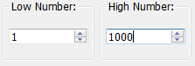

The low and high numbers in the sampling frame are the boundaries of the frame from which the user will be sampling. If the frame is a computer listing numbered 1 through 1,000 then the low entry will be 1 and the high entry will be 1,000. If the frame is a check register with checks numbered between 1,346 and 2,785, then the low will be 1,346 and the high will be 2,785.

**Validation Console**

This form provides a method of error/exception prevention by displaying up-to-date warning and error messages. Execution may continue when only warnings exist but will be blocked by errors until they are fixed. When neither errors nor warnings are detected the validation console is hidden.

**Menu / Keyboard Shortcuts**

|  |  |  |
| --- | --- | --- |
| Menu | Keyboard | Description |
| File -> New Window | **Alt + N** | **Create a new instance of the program** |
| File -> Recently Used | **Alt + R** | **Load previous successful runs** |
| File -> Execute | **Alt + E** | **Execute Function** |
| File -> Exit | **Alt + Q** | **Exit Program** |
| Help -> About | **Alt + A** | **Show “About” dialog** |
| Help -> Help Topics | **Alt + H** | **Show this help document** |

**Output Options**

The program supports four output types:

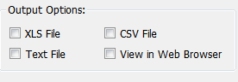

1. CSV (.csv extension) – Comma separated values
2. XLS (.xls extension) – Microsoft Excel 97+ output format
3. Text (.txt extension) – Evenly spaced readable text file
4. View in Web Browser (HTML) – Opens the output results into default web browser for viewing

If the user selects XLS, CSV or Text File then the “Save As” dialog will appear.

**Program Output**

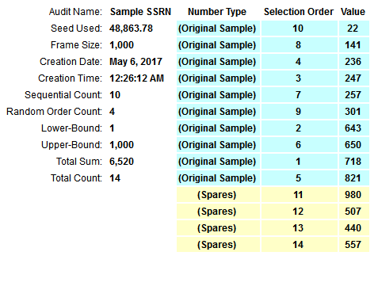

The program will generate output that labels the original sample and spare values (see above).