

Main Menu

User Guide

Revision 1 – May 6, 2017

**Purpose**

This program is used to launch internal and external user modules. It has been designed to support keyboard only functionality by utilizing the arrow keys and shortcuts keys to navigate and launch modules.

**Input Screen**

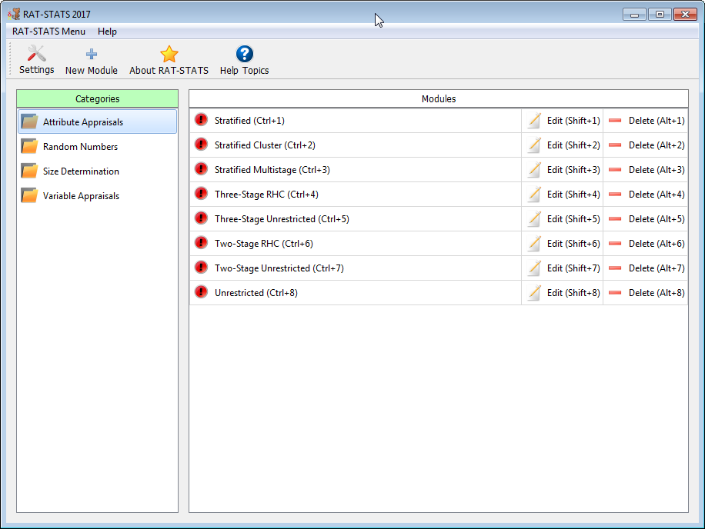

**Categories**

The categories feature is used to organize related modules. When no more modules exist for a particular category then it is automatically removed from the list. Uses may create new categories in the “New Module” dialog.

**Modules**

A module represents an internal/external program that can be launched by the user from the RAT-STATS main menu. The modules table showcases all modules that are defined and/or available for execution

**Settings**

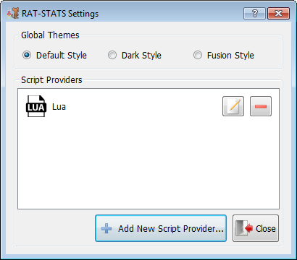

The settings dialog allows the user to change the graphical theme as well as add/edit script providers.

**New/Edit Script Provider**

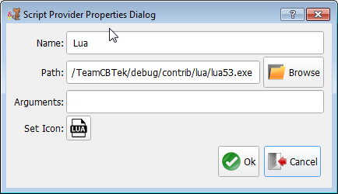

This dialog allows users to add additional scripting engines to RAT-STATS extending module support to custom scripts.

**New/Edit Module**

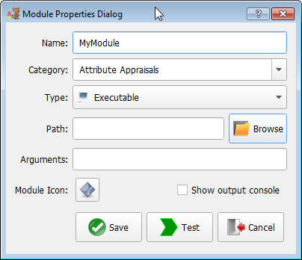

The New/Edit module dialog allows the user to extend RAT-STATS with additional modules/executables.

**Menu / Keyboard Shortcuts**

|  |  |  |
| --- | --- | --- |
| Menu | Keyboard | Description |
| File -> New Module | **Alt + N** | **Create a new module** |
| File -> Settings | **Alt + S** | **Load previous successful runs** |
| File -> Exit | **Alt + Q** | **Exit Program** |
| Help -> About | **Alt + A** | **Show “About” dialog** |
| Help -> Help Topics | **Alt + H** | **Show this help document** |