

Unrestricted Attribute Appraisal

User Guide

Revision 1 – May 5, 2017

**Purpose**

This program performs an attribute appraisal on data input by the user based on an unrestricted random sample. Attribute sampling is used to determine how frequently an event or type of transaction occurs in a given universe. This type of sampling usually requires a yes or no (true or false) evaluation of each sampling unit by the user. The results are usually reported as a percentage.

**Input Screen**

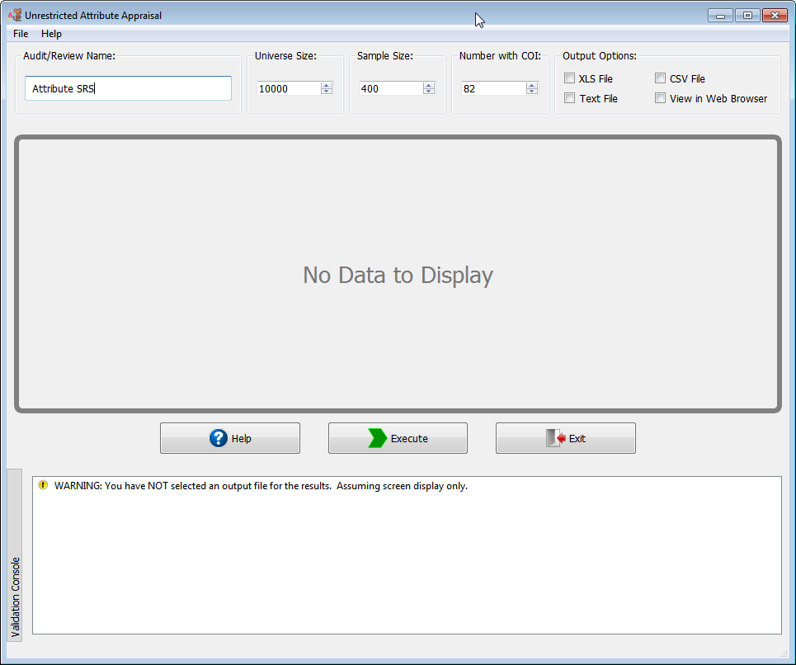

**NOTE:** This example is for illustrative purposes only. The sample size may not conform to the organization’s minimum sample size standards.

**Audit/Review Name**

This program allows the user to enter a brief description of the audit or purpose of the evaluation.

**Universe Size**

The universe size is the total number of items from which the sampled items were selected. The maximum size is 2,147,483,647.

**Sample Size**

The sample size is the quantity of items selected by the user from the universe.

**Number with COE (Characteristic of Interest)**

The user must establish evaluation criteria for all of the sample items. These criteria must be applied consistently to all items. The user needs to identify all sample items that have met the evaluation criteria (“characteristic of interest”). Depending on the purpose of the appraisal, the user would enter the number of items meeting or failing to meet the criteria. For example, if the user was looking at 100 documents to see if the documents had the proper approval signature, then the characteristic of interest would be the approval signature. If the evaluation of the sample showed that 88 documents out of 100 had the proper approval, the user would enter the response to the number of sample items with characteristic of interest as 88. The user could also enter 12 (i.e., 100 - 88) if the purpose of the appraisal was to estimate the percentage of the universe of documents did not have the approval signature. The program will also evaluate samples that have:

1. Zero occurrences of the evaluation criteria
2. All sample items meeting the evaluation criteria.

**Validation Console**

This form provides a method of error/exception prevention by displaying up-to-date warning and error messages. Execution may continue when only warnings exist but will be blocked by errors until they are fixed. When no errors nor warnings are detected the validation console is hidden.

**Menu / Keyboard Shortcuts**

|  |  |  |
| --- | --- | --- |
| Menu | Keyboard | Description |
| File -> New Window | **Alt + N** | **Create a new instance of the program** |
| File -> Recently Used | **Alt + R** | **Load previous successful runs** |
| File -> Execute | **Alt + E** | **Execute Function** |
| File -> Exit | **Alt + Q** | **Exit Program** |
| Help -> About | **Alt + A** | **Show “About” dialog** |
| Help -> Help Topics | **Alt + H** | **Show this help document** |

**Output Options**

The program supports four output types:

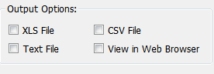

1. CSV (.csv extension) – Comma separated values
2. XLS (.xls extension) – Microsoft Excel 97+ output format
3. Text (.txt extension) – Evenly spaced readable text file
4. View in Web Browser (HTML) – Opens the output results into default web browser for viewing

If the user selects XLS, CSV or Text File then the “Save As” dialog will appear.

**Program Output**

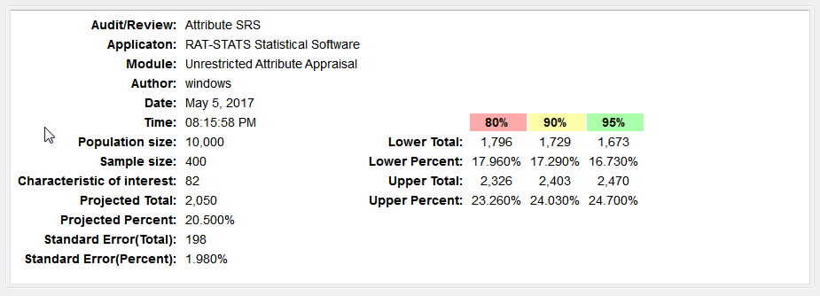

The program will reprint the data supplied by the user (universe size, sample size and number of sample items with the characteristic of interest) and also provide the appraisal results. The precision information is given at the two-sided 80%, 90%, and 95% confidence levels. The following information will also be displayed:

**Projected Total**: The proportion of sampled items with the characteristic of interest, multiplied by the universe size.

**Projected Percent:** The proportion of sample items with the characteristic of interest displayed as a percentage.

**Standard Error:** An estimate of the standard deviation of the point estimate for the proportion of sample items and the universe total having the characteristic of interest. This is a measure of the sample precision.

**Confidence Intervals (80%, 90%, or 95%):** The confidence that the actual proportion (or total number in the universe) will fall within the corresponding confidence interval of 80, 90 or 95 percent.

**Lower Limit (Total/Percent):**  The lower boundary of the confidence interval. The limit is shown as both a number and percentage of the universe. The confidence levels are 80%, 90%, and 95%.

**Upper Limit (Total/Percent):** The upper boundary of the confidence interval. The limit is shown as both a number and percentage of the universe. The confidence levels are 80%, 90%, and 95%.

In the event the sample contains zero items having the characteristic of interest, the user will see the following screen:

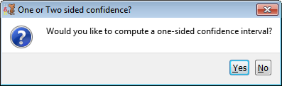

If the user responds with “Yes,” the program will only compute the upper limit and the lower limit will not be computed. If the user responds with “No,” the program will compute both the lower and upper limits.

In the event the number of sample items with the characteristic of interest is the same as the sample size, the user will also see the preceding screen. If the user responds with “Yes,” the program will only compute the lower limit and the upper limit will not be computed. If the user responds with “No,” the program will compute both the lower and upper limits.