

Unrestricted Variable Appraisal

User Guide

Revision 1 – May 5, 2017

**Purpose**

This program performs a variable appraisal on a data file previously created by the user based on information gathered from an unrestricted random sample. Variable sampling is used to estimate quantitative characteristics. For each sampling unit the user obtains one or more numeric pieces of information about an event or item. The user has the option of obtaining and appraising from one numeric piece of information per sample item (e.g., Examined amount) to as many as three pieces of information per sample item (i.e., Examined, Audited and Difference amounts). If the user decides to appraise all three pieces of information, only two of the pieces of data may be entered and the third will be calculated by the program. The variable appraisal program assumes that some variation exists between values. If no variation exists, then there is no need to run this appraisal program.

**Input Screen**

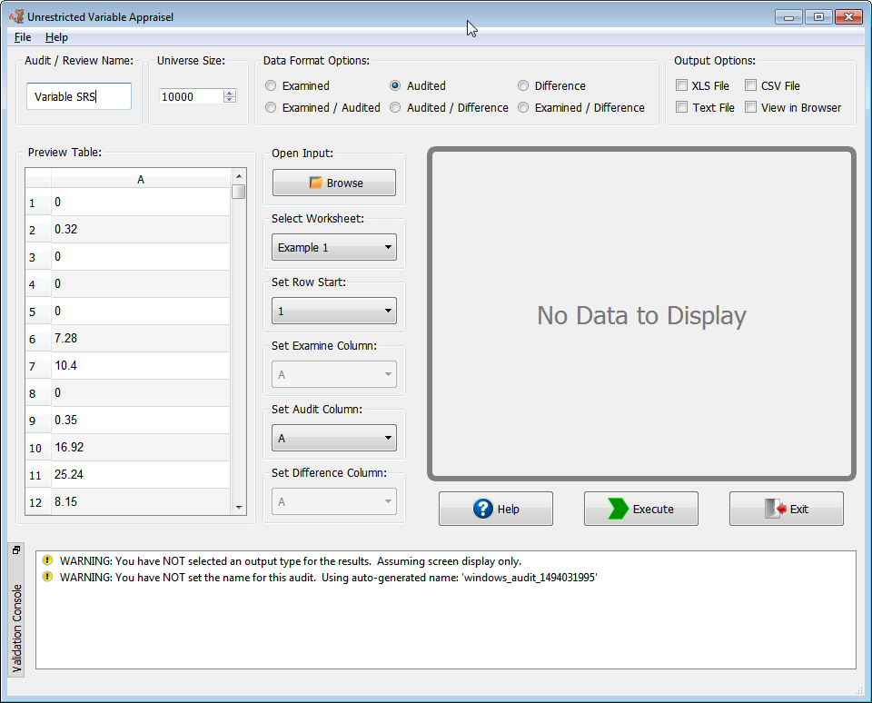

**NOTE:** This example is for illustrative purposes only. The sample size may not conform to the organization’s minimum sample size standards.

**Audit/Review Name**

This program allows the user to enter a brief description of the audit or purpose of the evaluation.

**Universe Size**

The universe size is the total number of items from which the sampled items were selected. This number will be used in estimating universe parameters. The maximum size is 2,147,483,647.

**Format of Input File**

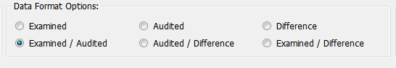

Prior to executing this program, the user must create a data file that contains certain identifyingdata and one or two pieces of information for each sample unit selected. Each data line consistsof a line number for that sampling unit followed by the first piece of information (a numericvalue) the user wants to appraise (i.e., examined, audited, or difference value). If two or morepieces of information will be appraised and the examined amount is one of the values, then theexamined amount must be the first piece of data entered for each sampling unit. If only theaudited and difference amounts are being appraised, then the audited amount must be the firstpiece of data entered. The second piece of information may be the numeric difference betweenthe examined value and the amount accepted by the user or the audited amount if the examinedamount was the first piece of data entered.

**Supported Input Formats**

|  |  |
| --- | --- |
| Description | Extension |
| Microsoft Excel 97 – 2003 file format | .xls |
| Microsoft Excel 2007 and higher file format | .xlsx |
| Data Interchange file format | .dif |
| Comma separated values file format | .csv |
| Space/tab separated values file format | .ssv, .txt or .dat |

**Specify Input File**

Click on the “Browse” button under the “Open Input” group. This will show a “File Open” dialog box to select input file.

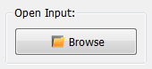

After loading a file the read-only preview table will be populated. You can use the Set Row Start and Set (Audit, Examine, Difference) Column drop –downs to select the proper data ranges. In the example below the “Examined / Difference” data format type is selected which causes the “Set Audit Column” drop-down to be disabled. After row and columns are selected, the function is ready to be executed.

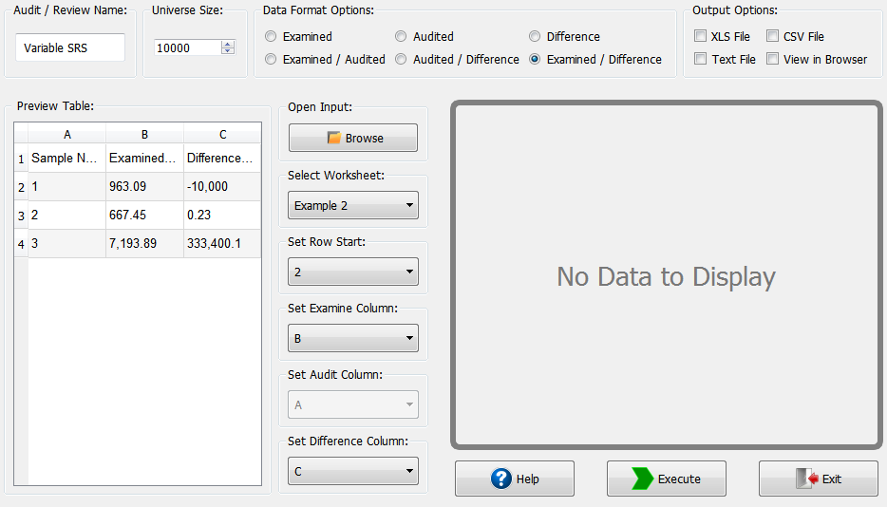

**Validation Console**

This form provides a method of error/exception prevention by displaying up-to-date warning and error messages. Execution may continue when only warnings exist but will be blocked by errors until they are fixed. When neither errors nor warnings are detected the validation console is hidden.

**Menu / Keyboard Shortcuts**

|  |  |  |
| --- | --- | --- |
| Menu | Keyboard | Description |
| File -> New Window | Alt + N | Create a new instance of the program |
| File -> Recently Used | Alt + R | Load previous successful runs |
| File -> Import Input Sheet | Alt + I | Loads file dialog to select input data |
| File -> Execute | Alt + E | Execute Function |
| File -> Exit | Alt + Q | Exit Program |
| Help -> About | Alt + A | Show “About” dialog |
| Help -> Help Topics | Alt + H | Show this help document |

**Output Options**

The program supports four output types (If the user selects XLS, CSV or Text File then the “Save As” dialog will appear):

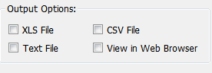

1. CSV (.csv extension) – Comma separated values
2. XLS (.xls extension) – Microsoft Excel 97+ output format
3. Text (.txt extension) – Evenly spaced readable text file
4. View in Web Browser (HTML) – Opens the output results into default web browser for viewing

**Program Output**

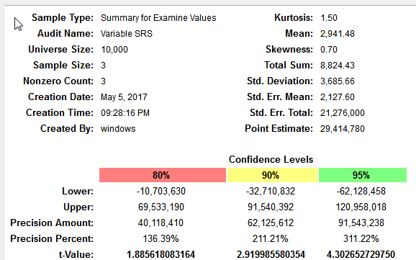

For the examined, adjusted, and difference sections of the output, the following pieces of information will be displayed. The precision information is given at the two-sided 80%, 90%, and 95% confidence levels.

(**NOTE**: The output format structure will be the same regardless of output option selected)

**Mean:** The average value for the sample items appraised. It is obtained by summing the items in the sample and dividing the result by the number of items in the sample

**Universe:** The quantity of the items from which the sample was drawn. The results of the sample will be projected to the universe using this value.

**Standard Deviation:** A measurement of the variation of the sample items about the average value (mean).

**Standard Error (Mean):** A measurement of the variation of the estimated universe means with respect to all possible estimated means for this universe and sample size.

**Standard Error (Total):** A measurement of the variation of the estimated universe total with respect to all possible estimated totals for this universe and sample size.

**Kurtosis:** A measure of the peakedness or flatness of the frequency distribution of the sample values.

**Point Estimate:** A single estimate for the universe total based on the sample mean multiplied by the universe size.

**Skewness:** A measure of the symmetry of the frequency distribution of the sample items. Accounting universes are usually right-skewed (majority of items have a low value while a few items have a high value)

**Confidence Level:** The confidence (80%, 90%, 95%) associated with the ability of the corresponding interval to contain the true mean (or universe total).

**Precision Amount:** A measurement of the closeness of the sample estimate of the universe total and the corresponding unknown universe value. The precision amount is calculated by multiplying the standard error by the universe size and multiplying the result by the appropriate factor (“t” value) corresponding to the desired confidence level.

**Precision Percentage:** The result of dividing the precision amount by the point estimate and stating the result as a percentage.

**t-Value Used:** The t- percentile value used to construct the confidence interval.

**Lower Limit (Total/Percent):**  The lower boundary of the confidence interval. The limit is shown as both a number and percentage of the universe. The confidence levels are 80%, 90%, and 95%.

**Upper Limit (Total/Percent):** The upper boundary of the confidence interval. The limit is shown as both a number and percentage of the universe. The confidence levels are 80%, 90%, and 95%.