GitLab Ingestion — Architecture (EMBER-38)
Elijah Tabor · Jira: EMBER-38 · Updated September 30, 2026 · drop-first, epic EMBER-20
Documentation only; no code in this change. Canonical copy: docs/ingestion/gitlab.md on the Ember repo. GitLab facts checked against docs.gitlab.com on 2026-09-23.

Proposed architecture
Same shape as the GitHub, Jira and Slack workers: a thin receiver that never calls GitLab, a separate backfill that does, and both emitting EMBER-39 intake unchanged.
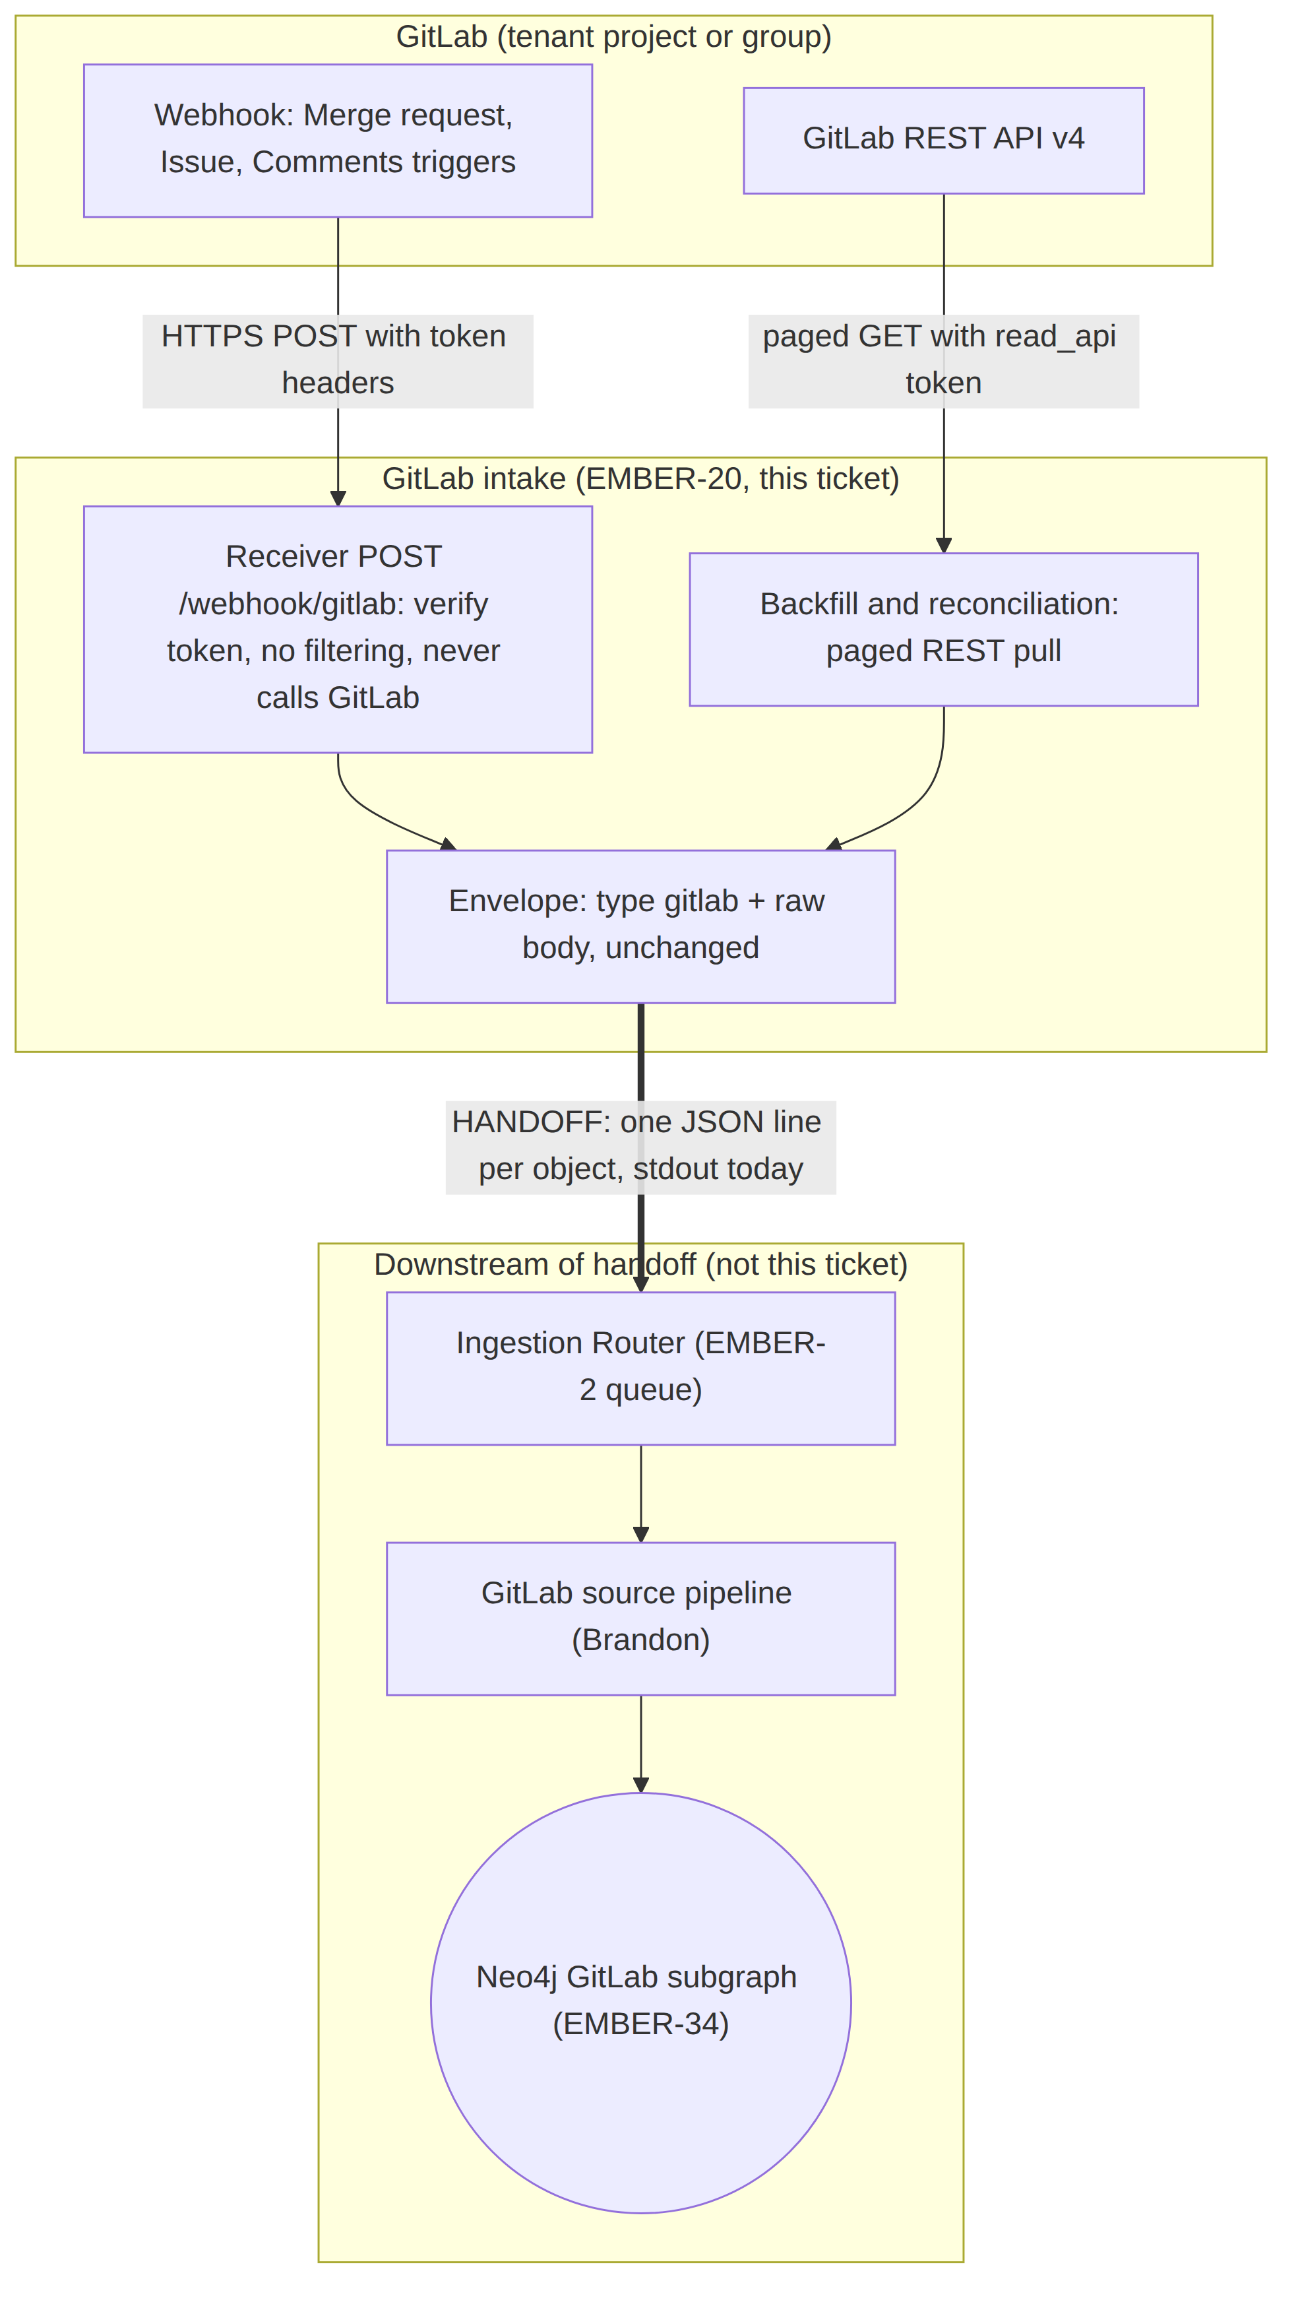
Figure 1. GitLab intake and its handoff to the ingestion pipeline. Mermaid source: EMBER-38_GitLab_Architecture.mmd
Component | Does | Holds a token?
Receiver (services/gitlab-ingestion, POST /webhook/gitlab) | Verifies the signing or secret token, wraps the body, emits one line, answers 2xx | Webhook secret only
Backfill / reconciliation | Onboarding history and scheduled re-pulls, one envelope per REST object | API token
Envelope | {"type":"gitlab","body":...} per the EMBER-39 contract. Body unchanged. | No
Registering the webhook URL and secret on the customer's project or group is onboarding, owned by the CLI and web app (EMBER-11 / EMBER-12). The public HTTPS URL is the same hosting need as the other receivers.

Handoff to the pipeline
Handoff point | Intake provides | Pipeline is responsible for
Where data is handed over | One {type:"gitlab", body} JSON line per object. Stdout today, the router's queue (EMBER-2) later. | Routing type: "gitlab" to the GitLab source pipeline
Identifying each object | Webhooks: object_kind (merge_request, issue, work_item, note). Backfill: raw REST objects, which have no object_kind field. | Classifying both. services/pipeline/ontology/sources.py _gitlab keys on object_kind only, so it misses REST objects and work_item. Follow-up for Brandon (EMBER-34).
Duplicates | The same MR or comment can arrive from a webhook, a retry and a reconciliation run | Idempotent upsert on the stable IDs in Data shapes (Requirements doc)
Edits and reversals | Every update re-sent in full, with changes on MR updates | Superseding, not overwriting, a reversed decision
People | user / author with username. Email may be [REDACTED]. | Resolving people by username first (the key in docs/graph-schema.md), email second
Noise | Nothing filtered at intake | Filtering and decision detection

Mermaid source
Same diagram as Figure 1, for Excalidraw (Mermaid to Excalidraw) or any Mermaid renderer. Also in docs/ingestion/gitlab/architecture.mmd.
flowchart TD
subgraph GL["GitLab (tenant project or group)"]
WH["Webhook: Merge request, Issue, Comments triggers"]
API["GitLab REST API v4"]
end

subgraph AD["GitLab intake (EMBER-20, this ticket)"]
RCV["Receiver POST /webhook/gitlab: verify token, no filtering, never calls GitLab"]
BF["Backfill and reconciliation: paged REST pull"]
ENV["Envelope: type gitlab + raw body, unchanged"]
end

subgraph CORE["Downstream of handoff (not this ticket)"]
ROUTER["Ingestion Router (EMBER-2 queue)"]
PIPE["GitLab source pipeline (Brandon)"]
GRAPH(("Neo4j GitLab subgraph (EMBER-34)"))
end

WH -->|"HTTPS POST with token headers"| RCV
API -->|"paged GET with read_api token"| BF
RCV --> ENV
BF --> ENV
ENV ==>|"HANDOFF: one JSON line per object, stdout today"| ROUTER
ROUTER --> PIPE
PIPE --> GRAPH

