Chilean needle grass impact network analysis

Chris Buddenhagen

24/02/2022

## Introduction

Here we focus on the farm to farm spread of Chilean needle grass (CNG) in the Hawkes Bay. We provide data and suggest some methods for modeling its spread. Distribution data for CNG was sourced from Hawkes Bay Regional Council and should be presented confidentially, though the data set is large the methods to collect it appear to be ad-hoc. Estimates of the eco-climatic range of CNG in New Zealand were sourced for current and future climates from Shona Lamoureaux (Bourdôt et al. 2012).

CNG was introduced in 1962 to a Waipawa farm in the Hawkes Bay region owned by a “Mr Hornblow” after cultivation and seeding using seed sent from the South Island (Connor, Edgar, and Bourdôt 1993). I have yet to identify the specific location though. The rate of local spread being estimated at approximately 120-140 metres per year, since seed has no major features for long distance dispersal other than being able to penetrate animal hides and furs, and survive at low numbers <3% after passage through Angus steer guts (Gardener, Whalley, and Sindel 2003). Longer distance dispersal is believed to be primarily human mediated, via farm equipment, hay, and farm to farm movement of livestock. Once the plant colonizes riverbeds, it can spread downstream, and has infested most of the lower reaches of the Tukituki and Waipawa Rivers. Another farm in Puketapu was planted with contaminated seed in 1976 (both cases from seed provided from Marlborough farms). Now approximately 135 farms are infested.

We use Impact Network Analysis to model spread (Garrett 2021), an attractive feature is that it can account for the interacting influence of management measures and environmental suitability for establishment.

## Methods

Farm location data was sourced from Agribase (Sanson 2000) for the Hawkes Bay Region, where CNG is targeted in the [Hawkes Bay Regional Council’s Pest Plan](https://www.hbrc.govt.nz/environment/pest-control/biosecurity/regional-pest-management-plan/). Since farms in the database contain multiple land parcels, farms with the same farm ID were merged. Then only sheep and and beef farms selected. An ecoclimatic index for CNG of >5 was also used to further reduce the number of farms to be used in an adjacency matrix

## Reading layer `HB_wgs84' from data source   
## `C:\Users\buddenhagenc\OneDrive - AgResearch\Documents\GitHub\CNG_INA\CNG_INA\Inputs\HB_wgs84.shp'   
## using driver `ESRI Shapefile'  
## Simple feature collection with 5984 features and 86 fields  
## Geometry type: MULTIPOLYGON  
## Dimension: XY  
## Bounding box: xmin: 175.2125 ymin: -40.43835 xmax: 178.0017 ymax: -38.23417  
## Geodetic CRS: WGS 84

## [1] "HBAY"

## [1] "sf" "data.frame"

## [1] "175.2125314" "-40.4383482" "178.0016744" "-38.2341672"

## Reading layer `NZ_fine_scale_fishnet_join' from data source   
## `C:\Users\buddenhagenc\OneDrive - AgResearch\Documents\GitHub\CNG_INA\CNG_INA\Inputs\NZ_fine_scale_fishnet_join.shp'   
## using driver `ESRI Shapefile'  
## Simple feature collection with 12593 features and 10 fields  
## Geometry type: POLYGON  
## Dimension: XY  
## Bounding box: xmin: 166.425 ymin: -47.325 xmax: 178.575 ymax: -34.375  
## Geodetic CRS: WGS 84

## Coordinate Reference System:  
## User input: GEOGCRS["WGS 84",  
## DATUM["World Geodetic System 1984",  
## ELLIPSOID["WGS 84",6378137,298.257223563,  
## LENGTHUNIT["metre",1]],  
## ID["EPSG",6326]],  
## PRIMEM["Greenwich",0,  
## ANGLEUNIT["degree",0.0174532925199433],  
## ID["EPSG",8901]],  
## CS[ellipsoidal,2],  
## AXIS["longitude",east,  
## ORDER[1],  
## ANGLEUNIT["degree",0.0174532925199433,  
## ID["EPSG",9122]]],  
## AXIS["latitude",north,  
## ORDER[2],  
## ANGLEUNIT["degree",0.0174532925199433,  
## ID["EPSG",9122]]],  
## USAGE[  
## SCOPE["unknown"],  
## AREA["World."],  
## BBOX[-90,-180,90,180]]]   
## wkt:  
## GEOGCRS["WGS 84",  
## DATUM["World Geodetic System 1984",  
## ELLIPSOID["WGS 84",6378137,298.257223563,  
## LENGTHUNIT["metre",1]],  
## ID["EPSG",6326]],  
## PRIMEM["Greenwich",0,  
## ANGLEUNIT["degree",0.0174532925199433],  
## ID["EPSG",8901]],  
## CS[ellipsoidal,2],  
## AXIS["longitude",east,  
## ORDER[1],  
## ANGLEUNIT["degree",0.0174532925199433,  
## ID["EPSG",9122]]],  
## AXIS["latitude",north,  
## ORDER[2],  
## ANGLEUNIT["degree",0.0174532925199433,  
## ID["EPSG",9122]]],  
## USAGE[  
## SCOPE["unknown"],  
## AREA["World."],  
## BBOX[-90,-180,90,180]]]

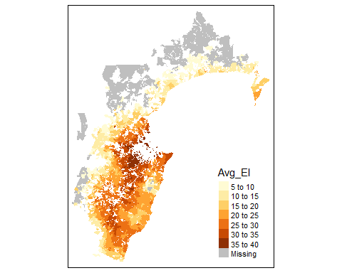

Ecoclimatic index values (>5) for sheep and beef farms in Hawkes Bay.

The next thing is to get information about CNG point locations on farms, or near farms.

## [1] "sf" "tbl_df" "tbl" "data.frame"

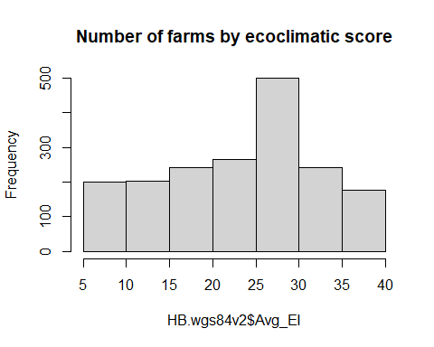

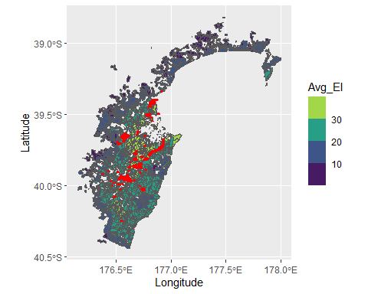

Chilean needle grass records (red points) overlayed on farms with the corresponding ecoclimatic index.

The next step is to make a distance matrix, using polygons. Centroids would be simpler but using them to estimate farm to farm distances does not address farms that share a boundary. The goal is to use a dispersal kernel that takes into account farm distances a the boundary.

#gDistance seems to require this other format  
For_distance <-as_Spatial(HB.wgs84v2)  
For_distance <-spTransform(For_distance, CRS("+proj=utm +zone=60 +south +datum=WGS84 +units=m +no_defs"))  
  
#summary(For_distance)  
  
# #distance matrix all farms  
Farm_Dist_Mat_HB<-gDistance(For_distance, byid = TRUE)  
#row.names(Farm_Dist_Mat_HB)  
  
farm_ids<-HB.wgs84v2$farm_id  
  
rownames(Farm_Dist_Mat_HB) <- farm_ids  
colnames(Farm_Dist_Mat_HB) <- farm_ids  
dist_mat_farm<-as.matrix(Farm_Dist_Mat_HB)  
saveRDS(dist_mat_farm, "Inputs/dist_mat_farm.rds")  
#write.csv(Farm_Dist_Mat_HB, "Inputs/dist_mat_farm.csv")

### Dispersal kernel

This graphs a negative exponential dispersal kernel but such that dispersal near 0 is not 100%. Instead we set it at 1/20 based on the idea that seed dispersal between adjacent farms is not zero (but once every 20 years). The plant produces seed once per year and is mainly dispersed within farm by farmer equipment, grazing animals moving on wool or hooves (gut passage is not proven). Between farms dispersal is mainly from livestock movement, hay or possibly silage and historically from contaminated seed (rare now). Then we set up the adjacency matrix based on the probability of dispersal based on distance between nodes/farms.

d<-seq(from=0.5, to=2000, by=0.5)  
lmda=0.01  
thresh=1/20  
NegExp <- thresh*exp(-lmda * d)  
dispersal<-tibble(distance=d, Probability=NegExp)  
#probability of dispersal at 1500m  
dispersal[3000,]

## # A tibble: 1 x 2  
## distance Probability  
## <dbl> <dbl>  
## 1 1500 0.0000000153

#probability of dispersal at 159m  
dispersal[300,]

## # A tibble: 1 x 2  
## distance Probability  
## <dbl> <dbl>  
## 1 150 0.0112

ggplot(data=dispersal, aes(x=d, y=NegExp))+  
 geom_line()+  
 scale_y_continuous(trans = "sqrt",   
 # breaks=c(0.000000001,0.00001, 0.001, 0.01, 0.05)  
 )+  
 xlab("distance in meters")+  
 ylab("Probability of dispersal")

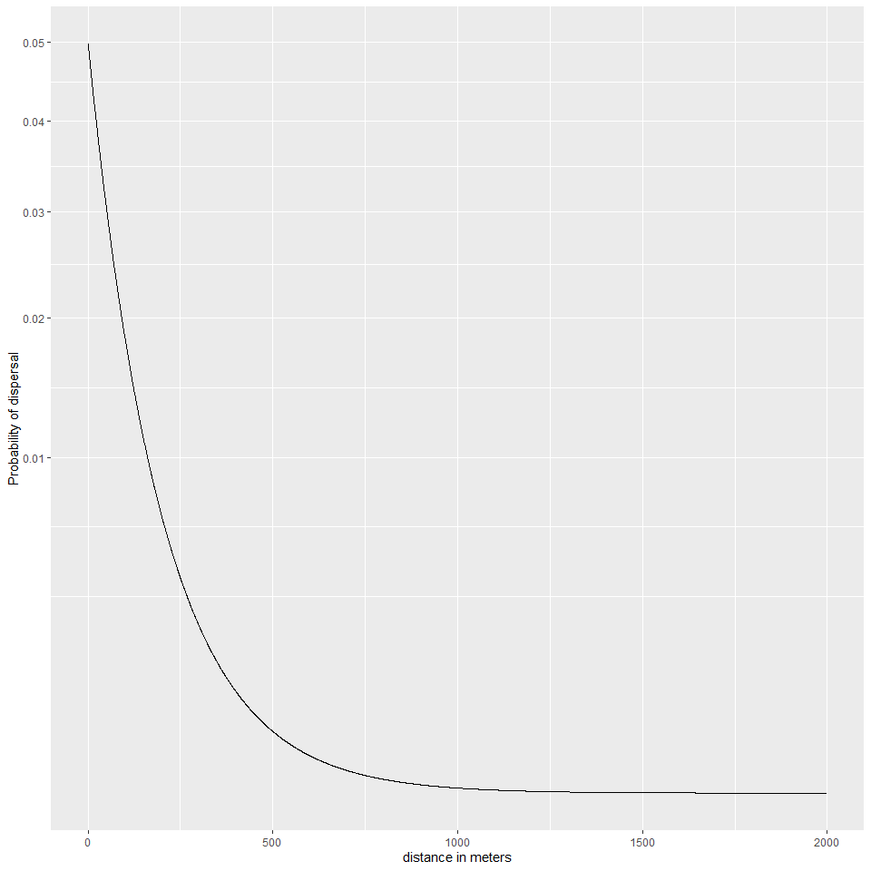

Dispersal kernel negative exponential

Then we set up the adjacency matrix based on the probability of dispersal based on distance between nodes/farms.

#set all zero distances to a small distance because zeros are a problem for negative exponential formula  
  
dist_mat_farm[dist_mat_farm==0]<-0.01  
   
 farm2farm_probs <- thresh * exp(-lmda * dist_mat_farm)  
#set diagonal to 1   
diag(farm2farm_probs)<-1  
  
saveRDS(farm2farm_probs, "Inputs/farm2farm_probs.rds")

The next step is to set up a INA scenario analysis. With the probability of establishment being penalized by 20% at an Avg_EI of 6 and not at all for an average EI of 40. The management adoption rate could vary between 20 and 80% in increments of 10. Management effectiveness could have a mean of 1/14 and sd of 0.1 - since the seed bank lasts 7 years, and getting rid of it is difficult.

## References

Bourdôt, Graeme W., Shona L. Lamoureaux, Michael S. Watt, Lucy K. Manning, and Darren J. Kriticos. 2012. “The Potential Global Distribution of the Invasive Weed Nassella Neesiana Under Current and Future Climates.” *Biological Invasions* 14 (8): 1545–56. <https://doi.org/10.1007/s10530-010-9905-6>.

Connor, H. E., E. Edgar, and G. W. Bourdôt. 1993. “Ecology and Distribution of Naturalised Species of *Stipa* in New Zealand.” *New Zealand Journal of Agricultural Research* 36 (3): 301–7. <https://doi.org/10.1080/00288233.1993.10417727>.

Gardener, M. R., R. D. B. Whalley, and B. M. Sindel. 2003. “Ecology of Nassella Neesiana, Chilean Needle Grass, in Pastures on the Northern Tablelands of New South Wales. I. Seed Production and Dispersal.” *Australian Journal of Agricultural Research* 54 (6): 613. <https://doi.org/10.1071/AR01075>.

Garrett, Karen A. 2021. “Impact Network Analysis and the Ina r Package: Decision Support for Regional Management Interventions.” *Methods in Ecology and Evolution* 12 (9): 1634–47. <https://doi.org/10.1111/2041-210X.13655>.

Sanson, R. L. 2000. “The New Zealand Veterinary Association Epidemiology and Animal Health Management Branch Seminar.” In, 61–64. Wallaceville, Upper Hutt: Massey University.