**Components and Tools**[**¶**](https://clouddocs.f5.com/training/community/waf/html/class4/labinfo/labinfo.html#components-and-tools)

Linux Client (Client01):

* Web Attack Tools:
* [Burp Suite Community Edition](https://portswigger.net/burp) - HTTP Request Manipulation
* [iMacros](https://imacros.net/) - Web Scraping (Install iMacros manually via Add-Ons in Firefox browser
* [ab (Apache Bench)](https://httpd.apache.org/docs/2.4/programs/ab.html) - HTTP Load Testing

Kali Client (Kali-BaDOS):

* [ab (Apache Bench)](https://httpd.apache.org/docs/2.4/programs/ab.html) - HTTP Load Testing

Linux Server (Server01):

* [WebGoat 8](https://github.com/WebGoat/WebGoat/wiki) - deliberately insecure application

LAMP Server (LAMPv4):

* [Hackazon](https://github.com/rapid7/hackazon) - deliberately insecure application

BIG-IP (bigip01):

* Local Traffic Manager
* Application Security Manager / Advanced WAF

# Lab Topology[¶](https://clouddocs.f5.com/training/community/waf/html/class4/labinfo/labinfo.html#lab-topology)

#####Need topology description#####

The following table lists VLANS, IP Addresses and Credentials for all components:

| **COMPONENT** | **MGMTNET IP** | **CLIENTNET IP** | **SERVERNET IP** | **CREDENTIALS** |
| --- | --- | --- | --- | --- |
| Linux Client (client01) | 10.1.1.51 | 10.1.10.51 | N/A | rdp-f5student: f5DEMOs4u!  https-f5student: f5DEMOs4u! |
| Bigip (bigip01) | 10.1.1.245 | 10.1.10.245 | 10.1.20.245 | https - admin:password ssh - f5student:password |
| Linux Server (server01) | 10.1.1.252 | N/A | 10.1.20.252 | ssh - f5student:password |
| Kali (Kali-BaDOS) | 10.1.1.245 | 10.1.10.100 / 10.1.10.200 | N/A | ssh - f5student:password |
| Linux Server (LAMPv4) | 10.1.1.250 | N/A | 10.1.20.250 | N/A |

A graphical representation of the lab:

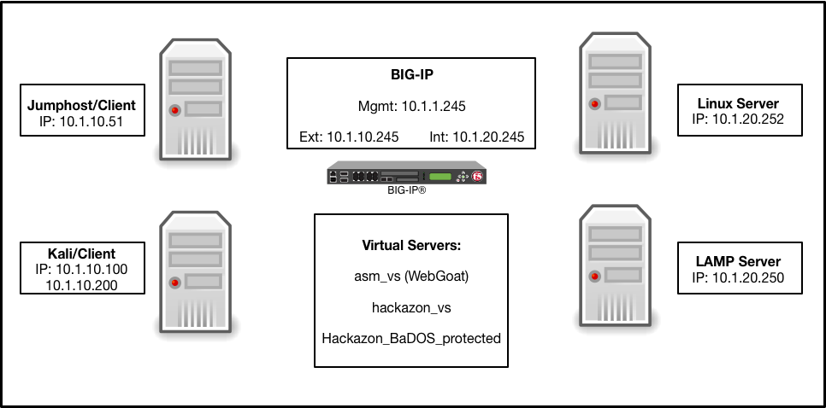

## Client Setup

Client Addresses:

Internal Primary 10.1.10.20

Internal Seondary Address ??? 10.1.1.51

Mngmt vlan 10.1.1.20

RDP Mngmt (redundant?) 10.1.2.20

Apache Bench SRC IP adddresses:

SRC_ADDR1=10.1.10.51

SRC_ADDR2=10.1.10.52

SRC_ADDR3=10.1.10.53

Target VS_ADDR=10.1.10.61

## XFCE Tab fix

 had a similar issue running XFCE4 over VNC and the workaround for me was to edit the ~/.config/xfce4/xfconf/xfce-perchannel-xml/xfce4-keyboard-shortcuts.xml file to unset the following mapping

< <property name="&lt;Super&gt;Tab" type="string" value="switch_window_key"/>

---

> <property name="&lt;Super&gt;Tab" type="string" value="empty"/>

<https://devcentral.f5.com/articles/deploy-big-ip-ve-in-aws-24727>

ssh to big-ip:

modify auth password admin

## AWS Cert upload

<https://docs.aws.amazon.com/cli/latest/reference/iam/upload-server-certificate.html>

aws iam upload-server-certificate --server-certificate-name myServerCertificate --certificate-body file://public_key_cert_file.pem --private-key file://my_private_key.pem --certificate-chain file://my_certificate_chain_file.pem

## Read ME

<https://github.com/F5Networks/f5-aws-cloudformation/tree/master/supported/standalone/3nic/existing-stack/byol>