|  |
| --- |
|  |
| NC BookStack |
| A UMass Lowell Textbook Search Tool |

|  |
| --- |
| Burbine, Warren, Chau |

# PROJECT GOAL

The goal of this project it to provide an application that allows UMass Lowell(UML) students to buy, sell or trade used textbooks with each other.

# MAJOR FEATURES/CAPABILITIES

Our application will have three main capabilities. The first will be to allow users to search for textbooks that are being used at UML. The second is to allow each user to create a list of textbooks that they are willing to sell or trade; along with a list of textbooks that they are looking to buy. The third is to give users the power to make contact with each other to set up a meeting to trade or purchase textbooks from one another.

These capabilities would be facilitated by several features. Users will be able to register a personal account where they will create a username and password. After the account is created the user will be able to sign in and build a profile.

The main components of this profile will be two lists. The first list is a list of textbooks the user is interested in acquiring. The second list is a list of textbooks that the user is interested in selling or trading for. This account will allow for the updating of personal information and current books they have/are looking for. Once this is done the user will be prompted for any extra information (i.e. desired textbook quality or selling price). After all this the user will then confirm that the information is correct and we will add their information to an appropriate list.

Users will be able to contact other users with offers for textbooks. From there the user can agree to a meeting point along with a date and time for the transaction. Users will also be able to post reviews about other users, this score will be displayed to anyone viewing the profile.

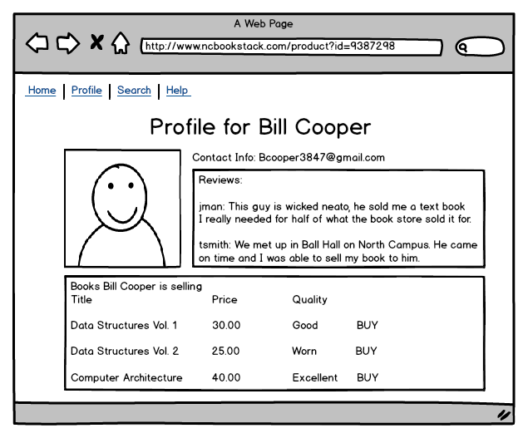

Users will be able to search for textbooks being offered by other users by class or name. If the book is found in our database details of the textbook will be displayed along with a list of users that currently selling the book. If the book is not found a message will be displayed that the textbook is not in our database or that no user is currently selling it.

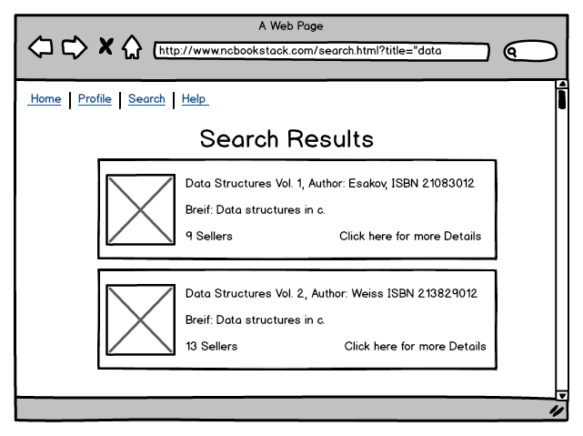

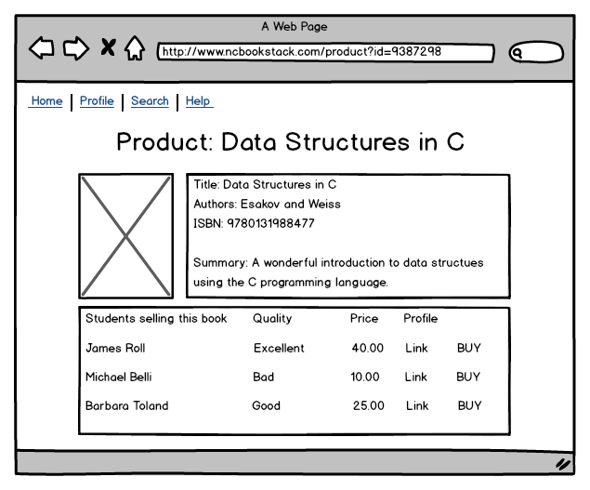

Some other features we hope implement are a pricing tool and Google maps tool. The pricing tool will suggest a price on each side of the transaction based on book quality, edition and whether its trade or just a purchase. The maps tool will give the user a display of suggested meeting spots. We also hope to integrate in an Amazon tool. Though it is a far off goal, the Amazon tool will allow the user to search for a textbook on Amazon if it isn’t being sold on our application.

# SOFTWARE COMPONENTS

Primarily, we will be using HTML, CSS, JavaScript, jQuery, and jQuery UI for all web pages and front end interaction. We will be making all components from scratch, but we will be using existing sites such as Amazon and other online bookstores as models for what our application may look like.

We will be using JavaScript, jQuery, PHP, and MySQL to create methods for our application to read and store data. We will be using code from previous assignments to create these methods, which will require minimal set up and modification to suit the needs of this project.

We will also be using a Amazon API and a Google Maps API for added integration. We do not have any models at the time of writing this. Anything made will be made from scratch or based off of existing examples we find online.

# INTENDED USERS

The main audience of our application will be the students of UML North Campus. We hope in the future to add South Campus classes to our database, but at the moment it seems a bit out of reach.

# POSSIBLE ISSUES

One issue that we foresee is the finding and implementation of a good Amazon API. We plan on using Amazon as a data source for our application. That said we want to avoid individually finding each book we need on Amazon and manually entering in its information into our system, an API should help us with this. However, at the time of writing this we have not tested any of the APIs we have found thus far.

Another issue that may arise is the implantation of our user profile system. We are looking to do a lot with this: unique usernames, password protection, user reviews, and updating profiles with new books the user needs/has. These are just the issues we can think of right now, there may be more.

Finally, creating a robust, stable and consistent search tool may become an issue. We dealt with the implantation of search tools in GUI 1, but nothing as complex as we are trying to build in this project. The tool we have in mind will be parsing much more data that will be far more complex then what we have had to deal with in the past; we may end up running into some issues with stability and consistency.

# PRELIMINARY SCHEDULE

|  |  |  |  |
| --- | --- | --- | --- |
| Task | Description | Date | Done By |
| Book Database | Build a database of books for North Campus classes. | Feb. 11 | Everyone |
| User Profiles | Give users the ability to create a profile for our application. Will require a user to login with a username/password and enter in personal "book data". | Feb. 18 | Chris Burbine |
| Search Tool | Create a manual search function where users can search for the books they need. | Feb. 21 | Everyone |
| Alpha Build | Finalize our core features. Test application thoroughly for any issues. | Feb. 24 | Everyone |
| User Reviews | Give users the ability to review other users. | Mar. 11 | Thuan Chau |
| Pricing Tool | Create a tool that will inform users on how to proceed with a transaction. | Mar. 18 | Chris Burbine |
| Meeting Tool | Create a tool using Google Maps to suggest meeting points for trades. All of our suggested locations will be on campus grounds. | Mar. 25 | Nick Warren |
| Beta Build | Finalize additional features make sure they do not break what we already have. Test new features thoroughly. | Apr. 2 | Everyone |
| Additional Features | The implantation of South Campus class books, South/East suggested meeting spots, Amazon purchase option and implementation for other UMass college campuses fall into here. | TBA | TBA |
| Final Build | Finalize any other additional features. Polish application as much as possible before end of semester. | Apr. 23 | Everyone |

# THE FINAL PRODUCT

We will consider this project to be completed when we have at least finished the user review section. The meeting and pricing tools are not entirely necessary they are simply nice features to have. The meeting and pricing tools will be considered top-tier priority when we have finished the user review section, but can be dropped if we run out of time. As for the South Campus class books, South/East suggested meeting spots, implementation for other UMass college campuses and integration with the Amazon store they are rather far off goals at the moment.