Curricula DB Schema

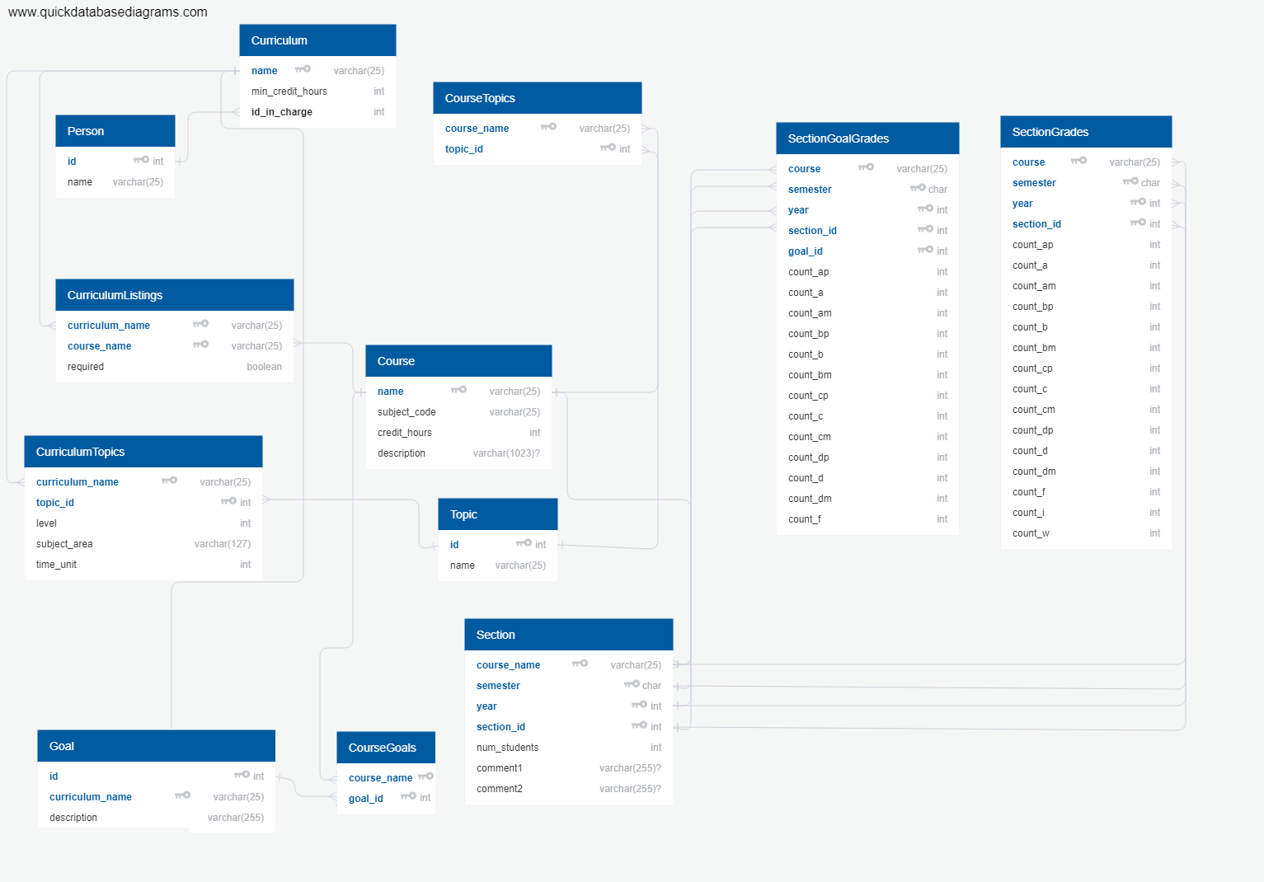(Colin Burdine, Jake Berns, Hunter Michalk)