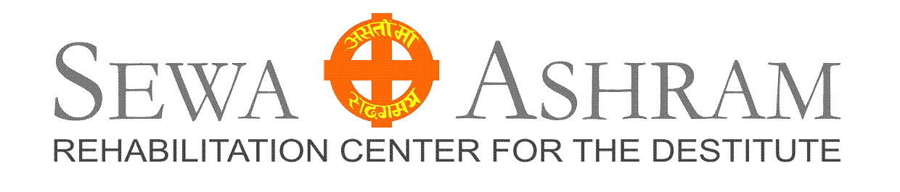
Volunteer Application

Name:

Address:

Email / Phone:

Age / Gender :

Please answer the following questions. Feel free to express your own uniqueness in doing so.

- How did you hear about Sewa Ashram?

- What is your professional background?

3. Have you lived or worked in a developing country before?

- The majority of mankind lives in poverty.
What do you think about this and what would you like to do?

5. What are your motives, why do you want to come and help the poor?

6. Do you have any experience working with poor/destitute people?

7. What do you think could you learn from the poor?

8. What is your spiritual / religious background?

9. What are your skills / qualities?

10. In which ways could you help?

□ Patient Care  □ Medical Support  □ Nurse  □ Physiotherapist  □ Research  □ Writing  □ Filming  □ Journalism  □ Sports/Games/Recreation | □ Kids house  □ Arts / Workshops  □ Administration  □ Vocational Trainer  □ General Maintenance  □ Cooking  □ Advocate  □ IT- Work  □ Electrical | □ Car Mechanic  □ Teacher  □ Public Relations  □ Exhibitions  □ Gardening / Farming  □ Alternative Energy / Medicine  □ Ambulance Patrol  □ Web-designer  □ Pharmacy
□ Construction | □ Accounting | □ Whatever is needed…

11. When would you like to come and for how long? (4 months minimum)

Please email this application to office@delhihouse.de and attach a passport picture.

