US HEADQUARTERS

525 Almanor Avenue, 4th Floor

Sunnyvale, CA 94085

+1-650-963-9828 Phone

+1-650-968-2997 Fax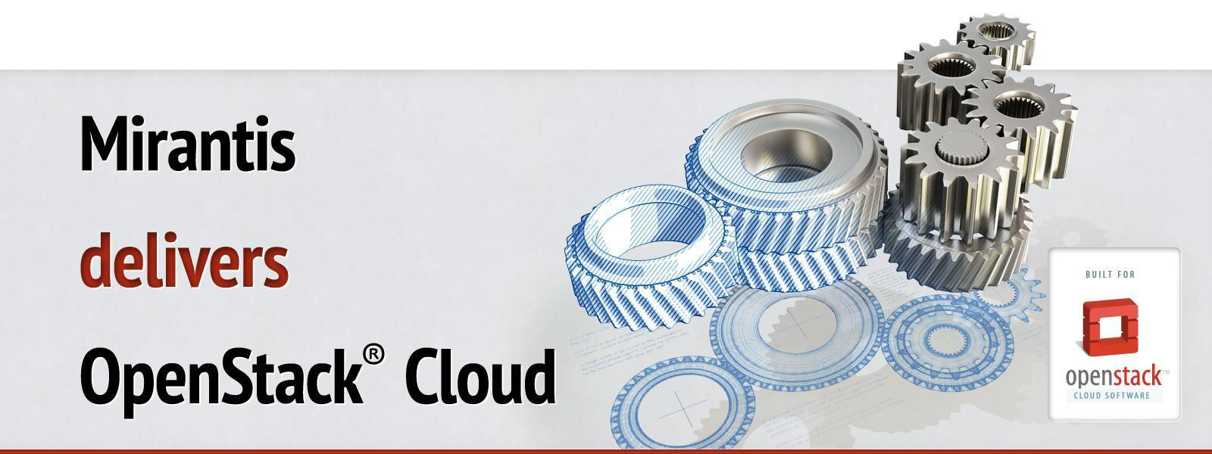

Run book for OpenStack

Deployment guide

Cluster CUSTOMER ENV

OpenStack RELEASE

*Version 1*

*DATE*

*Author(s) <AUTHORS>*

Table of contents

Document purpose

Key terms, acronyms and abbreviations

Introduction

Types of Nodes

Architecture

Network Layout

Nodes

Access Information

Fuel Master Node Installation

Post installation customization

OpenStack Environment Deployment

Creation of environment:

Network settings:

Environment settings:

Nodes network allocation:

Controller nodes HDD allocation:

Compute nodes HDD allocation:

Storage nodes HDD allocation:

Pre Deployment Customization

Adding and Removing Compute & Storage Nodes

Post Deployment Customization

[Extensions implemented in OpenStack to define the provider network]

[Creating provider networks within OpenStack]

Cloud Verification Test Results

Cli and Web UI verification results