# Architecture

ENV environment build on top of VMs, that hosted on 5 hardware nodes. Each node is Supermicro server with:

* Intel(R) Xeon(R) CPU E5-2650 v2 @ 2.60GHz
* 256G Ram
* 12x4Tb disk without RAID

Logically this looks like scheme below:

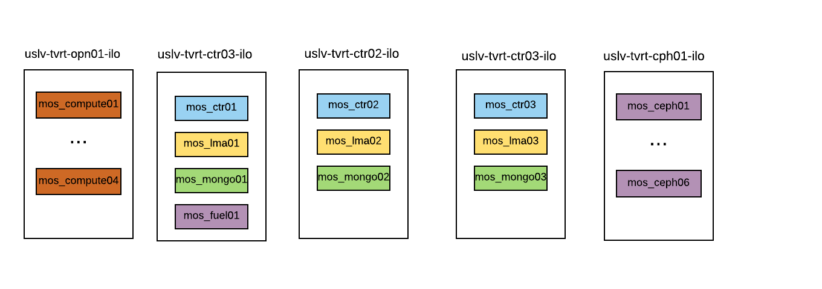

# Prepare hardware nodes:

All 5 servers were provisioned manually, using remote console. Ubuntu 14.04 was installed.

These are steps that were done in order to run VMs on top of hardware:

* Setup networking(adapt IPs per node)

|  |
| --- |
| # REPLACE |

* Install KVM, using [this](https://help.ubuntu.com/community/KVM/Installation) guide.
* Create LVM(adapt commands per server)

|  |
| --- |
| # REPLACE |

* Create VM disks and define libvirt-xml VMs (adapt per server)

|  |
| --- |
| # REPLACE |