*Chas Busenburg, Xianliang Dai, Brandon Patterson, Jacob Rendall*

*Ball State University | 2000 West University Ave. Muncie, IN 47304*

*IntroNet*

User’s Manual

Introduction 3

Hardware/System Software Requirements 3

Overview 3

IntroNet 3

Subsystems 3

Languages and Tool 3

Databases 3

Interfaces 3

Installing IntroNet 4

Procedure 4

Frequently Encountered Problems 4

Using IntroNet 5

User Registration 5

User Login 6

Navigation Sidebar 7

Navigation Topbar 7

User Profile 8

Event Creation Wizard 9

One-to-One 10

Preference Form 11

One-to-Many 12

Events Owned Dashboard 13

Event Details 13

Manage Attendees 14

Schedules 15

Event Timer 15

Events Attending Dashboard 16

Event Details 17

Event Attendees 17

Preferences 18

Schedule 18

# 

# Introduction

## Hardware/System Software Requirements

The hardware requirements for IntroNet are based from the Meteor platform, on which IntroNet was built. Meteor supports OS X, Windows, and Linux.

Detailed requirements can be found at [Meteor Install](https://www.meteor.com/install).

## Overview

IntroNet is a system intended to ease the creation and management of networking events. It’s core functionality allows users to create and register for events as well as automatic schedule generation, based on individual user preferences.

# IntroNet

## Subsystems

Subsystems are virtually non-existent in Meteor. Packages desired to be added for more functionality are addressed with Meteor at <https://atmospherejs.com/>.

## Languages and Tool

IntroNet has been built on the Meteor Platform. The system is built primarily on JavaScript, using Node.js, Express, and the Blaze templating format.

More information on Meteor can be found at [Meteor.com](http://guide.meteor.com/).

## Databases

InroNet uses a NoSQL database called MongoDB on the server. A MiniMongo cache is used locally for Collections. More information about MongoDB can be found at <https://www.mongodb.com>.

## Interfaces

The interfaces are similar to subsystems. These are handled completely by Meteor, and are typically of little importance.

# Installing IntroNet

## Procedure

1. Install Meteor locally on the machine that will be hosting the website. Installation instructions can be found at [Meteor Install](https://www.meteor.com/install).
2. In a command window/terminal, navigate to the IntroNet source folder.
3. Execute the “meteor” command (no quotes).
4. Meteor will install necessary updates and launch the project.
5. By default, meteor hosts on localhost:3000

## Frequently Encountered Problems

Browsers – Chrome is the only *officially* supported browser. Many other browsers may also work as intended, but no guarantees are made outside of chrome.

In Windows, if the meteor updates aren’t working, make sure that you’ve responded to any system permission prompts. If this does not work, try running meteor from an elevated command prompt (right-click, run as administrator).

# Using IntroNet

## User Registration

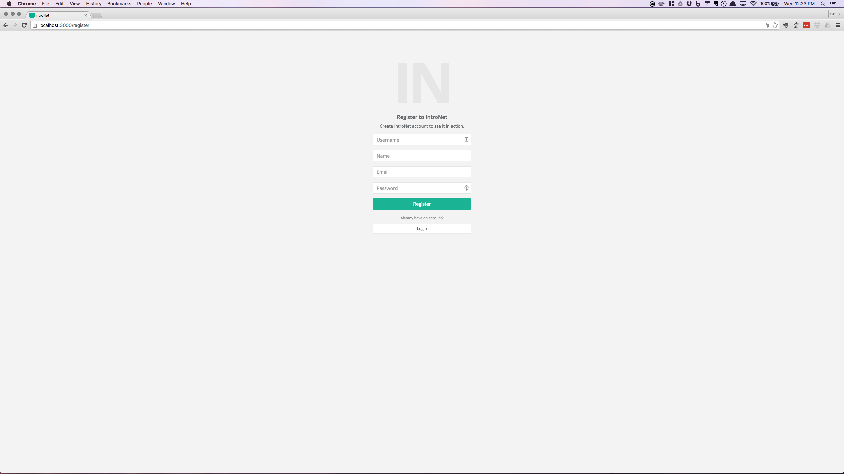

**Username**: The name of the total user profile, that a user wishes to be referenced by.

**Name**: User’s name

**Email**: Email address to be associated with this account

**Password**: password string to be used for encryption and secure login

**Register Button**: Press to create and submit all information from above.

**Login Button**: Redirects to login page.

## User Login

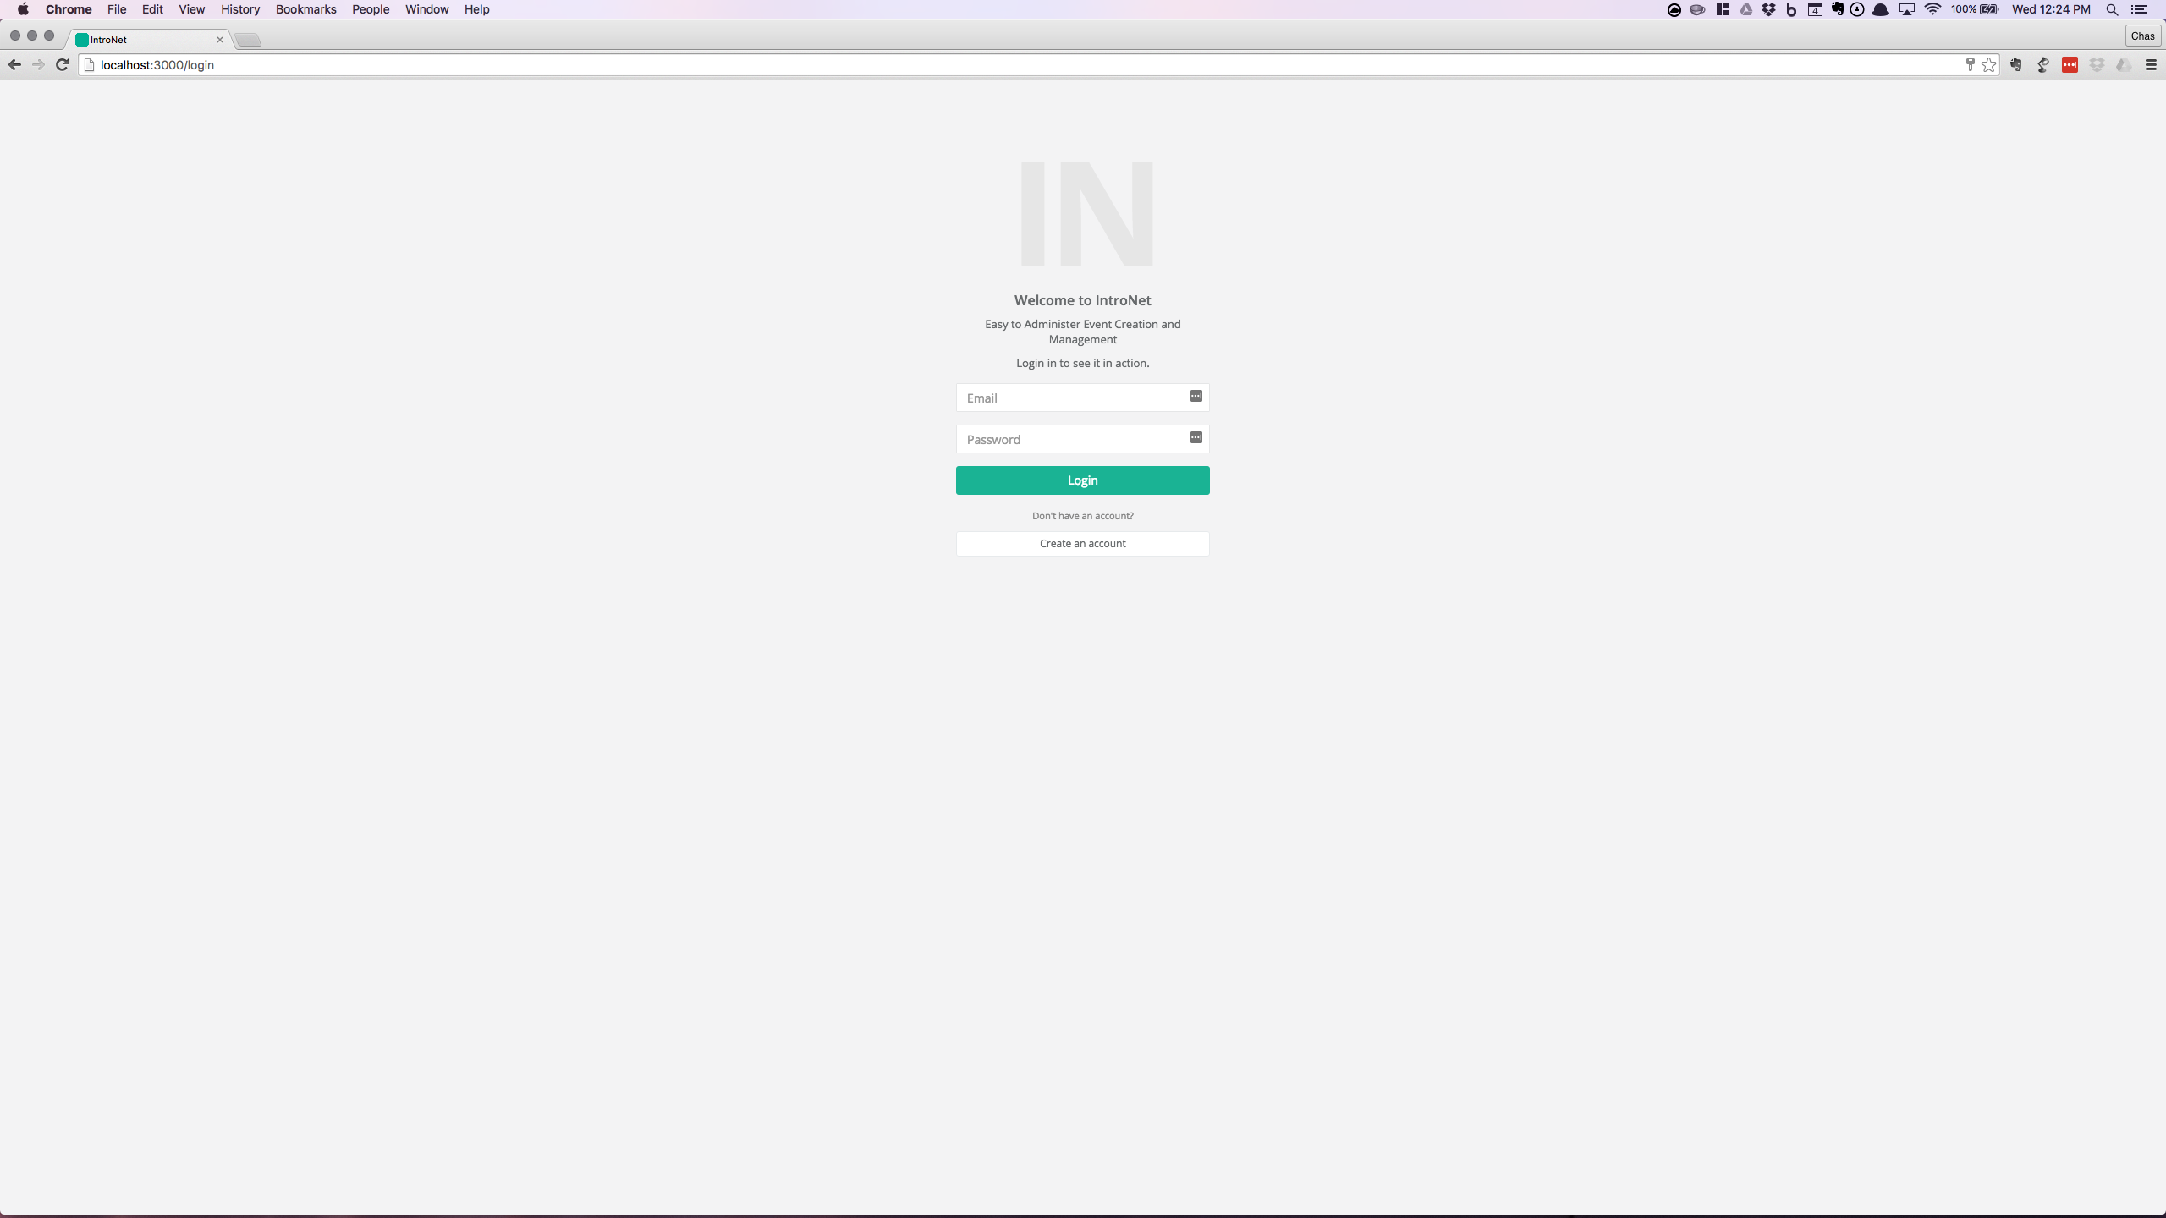

**Email:** The email that the user gave to the system during user creation.

**Password:** The Password associated with the account given during user creation.

**Login Button:** Validates credentials and logs in.

**Create an Account Button:**  Redirects to the user creation page.

## Navigation Sidebar

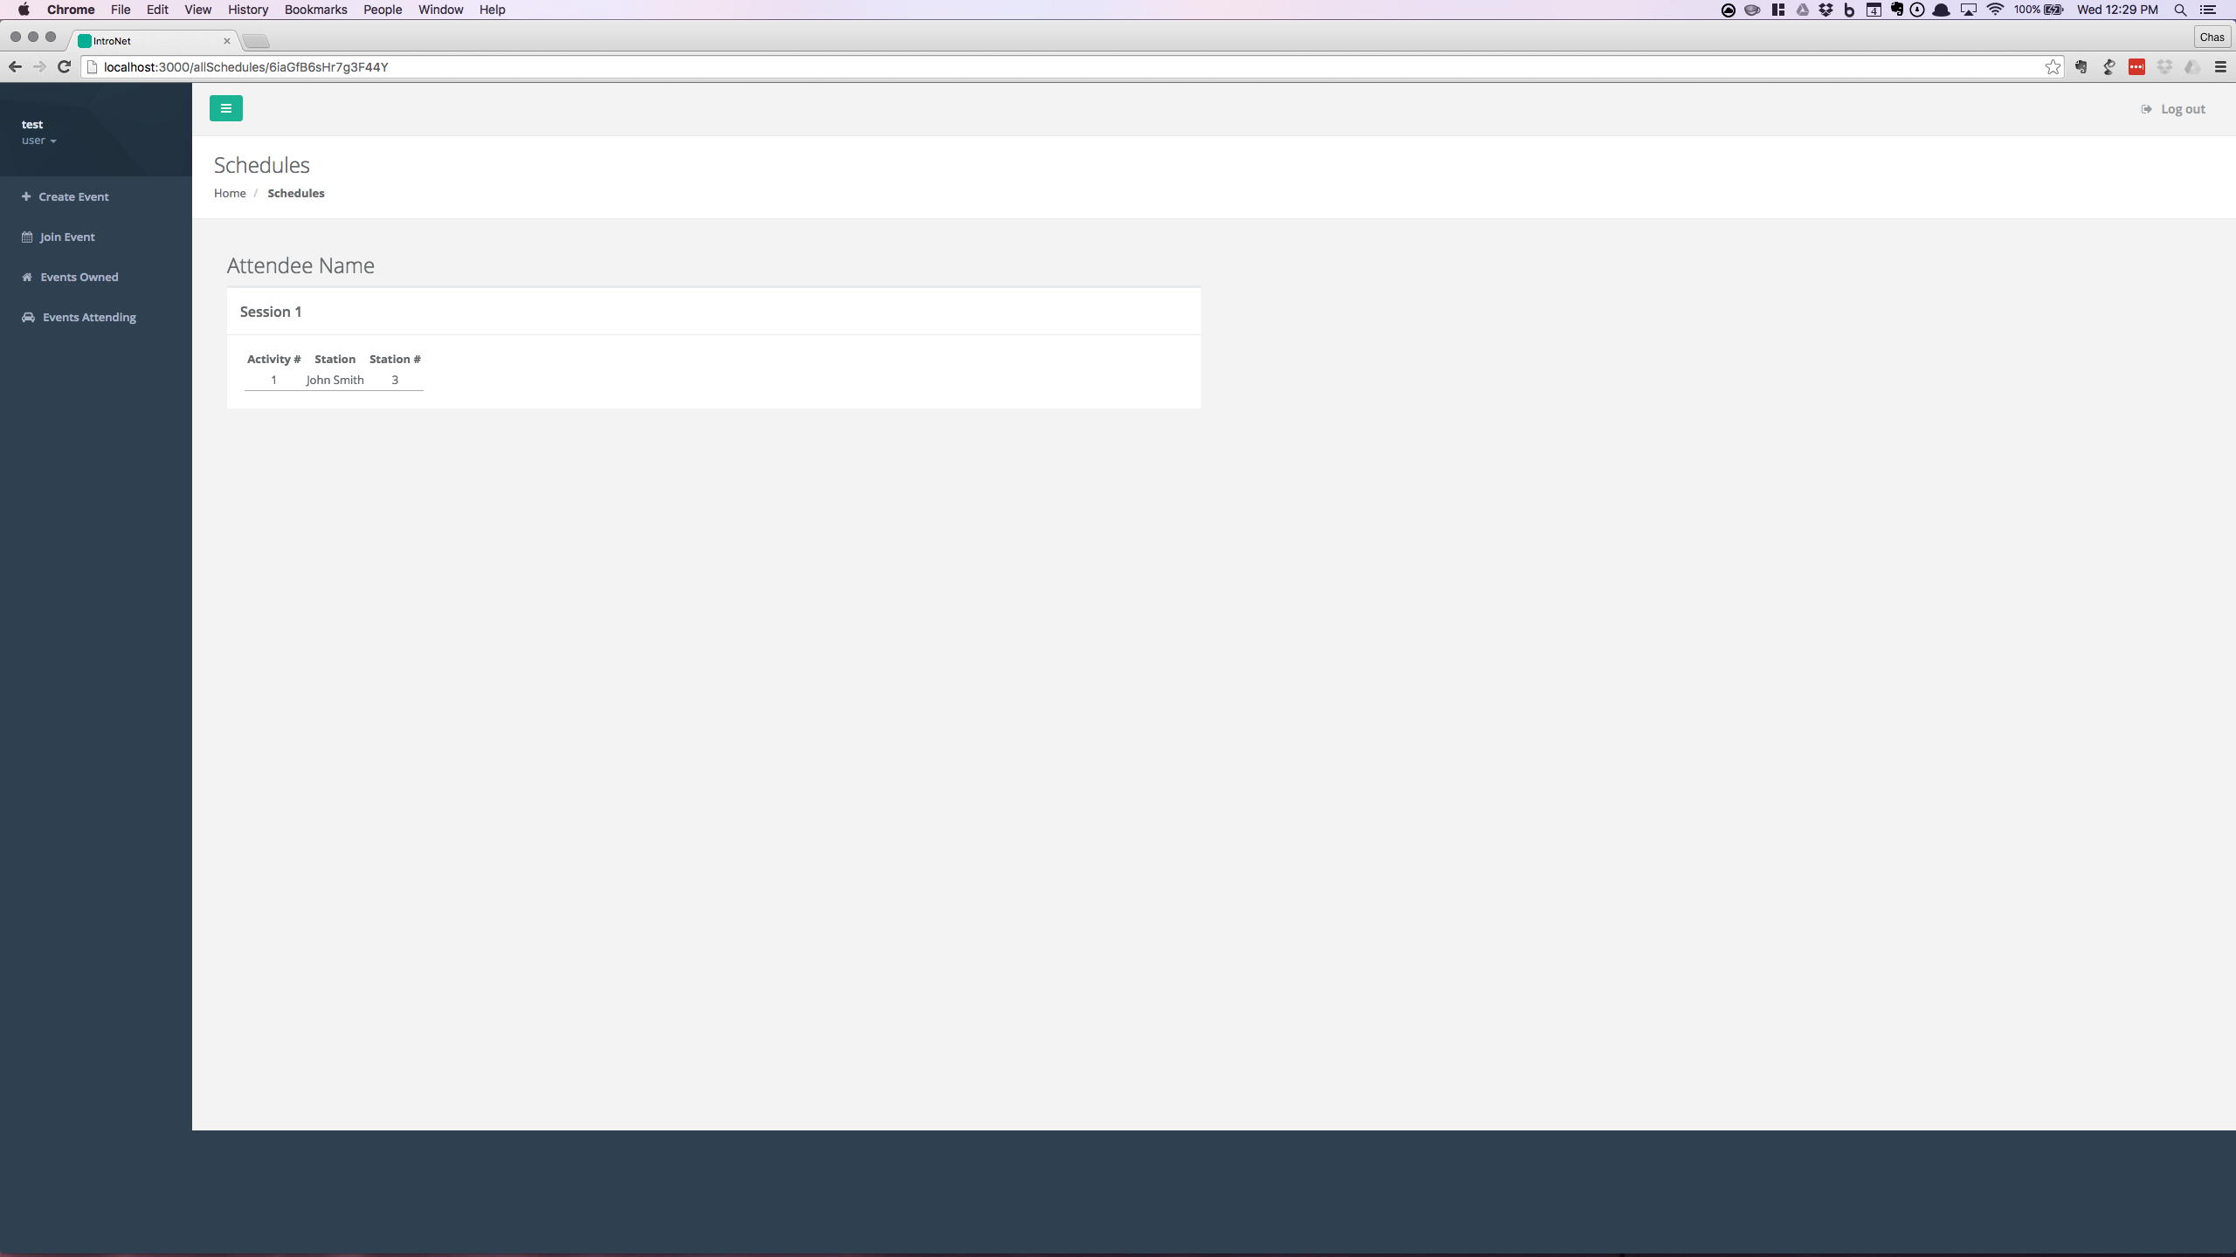

**test:** Current user’s username displayed.

**user:** user dropdown pane.

**Create Event:** Redirects to event creation wizard.

**Join Event:** Redirects to join event wizard.

**Events Owned:** Redirects to User’s Owned Event Dashboard.

Note: This will not be visible until a user has created an event.

**Events Attending:** Redirects to User’s Events Attending Dashboard

Note: This will not be visible until a user has registered for an event.

## Navigation Topbar



**Green Button:** Toggles the Navigation Sidebar visibility.

**Log out/Log in:** Depending on user’s login state will display a redirect to log out, or log in.

## User Profile

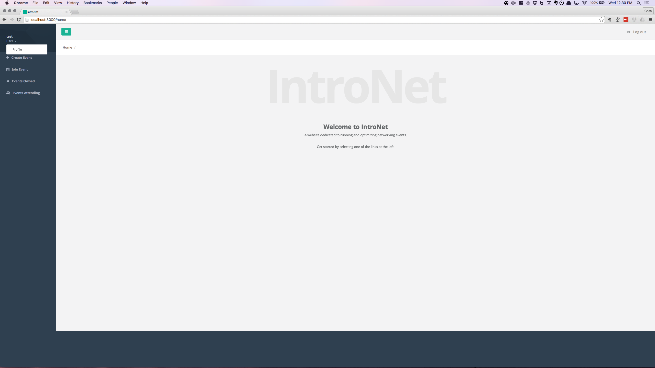

**Profile Button:** Access a user profile through the user dropdown pane.

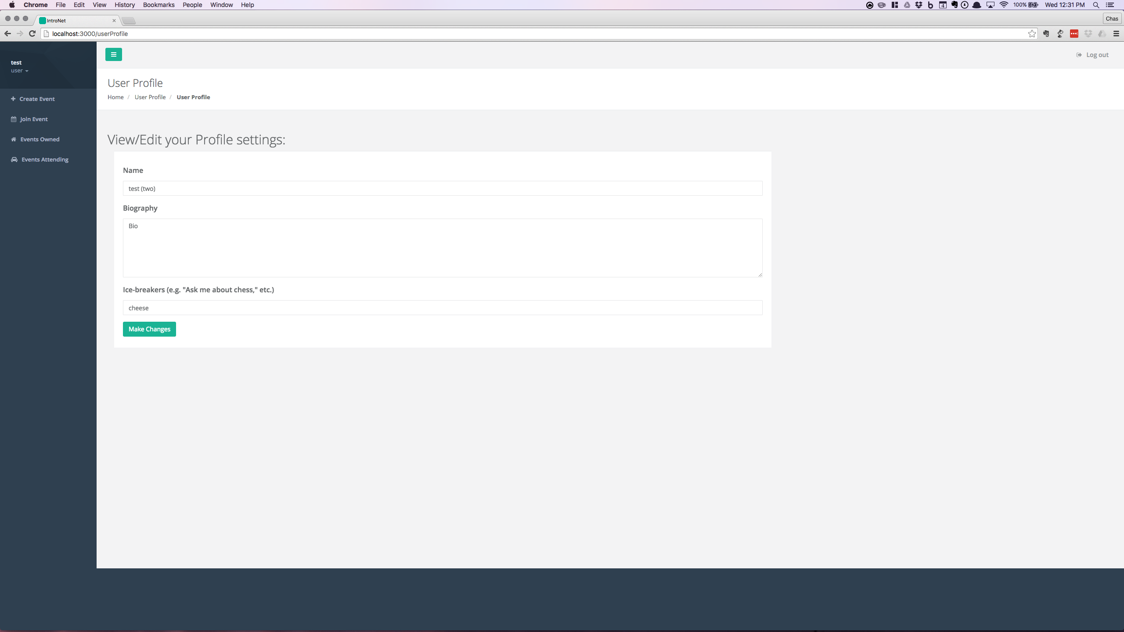

**Name:** Name for the user.

**Biography:** A description that the user can input to explain who they are.

**Ice-breakers:** Suggested conversation topics that the user can input.

Note: All of this information will be publicly displayed for any attended event.

**Make Changes Button:** Save any profile changes.

## Event Creation Wizard

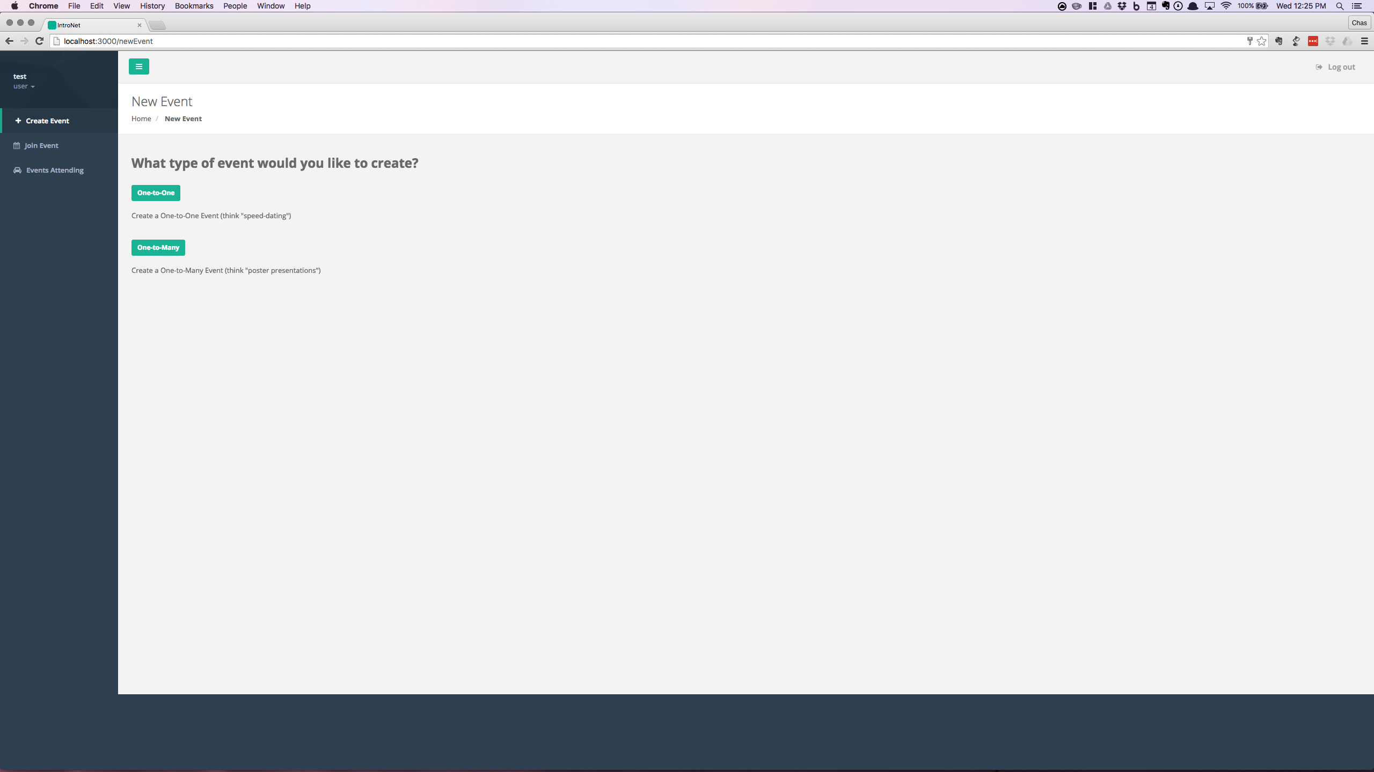

**One-to-One Button:** Navigates to One-to-One event creation form.

**One-to-Many Button:** Navigates to One-to-Many event creation form.

### One-to-One

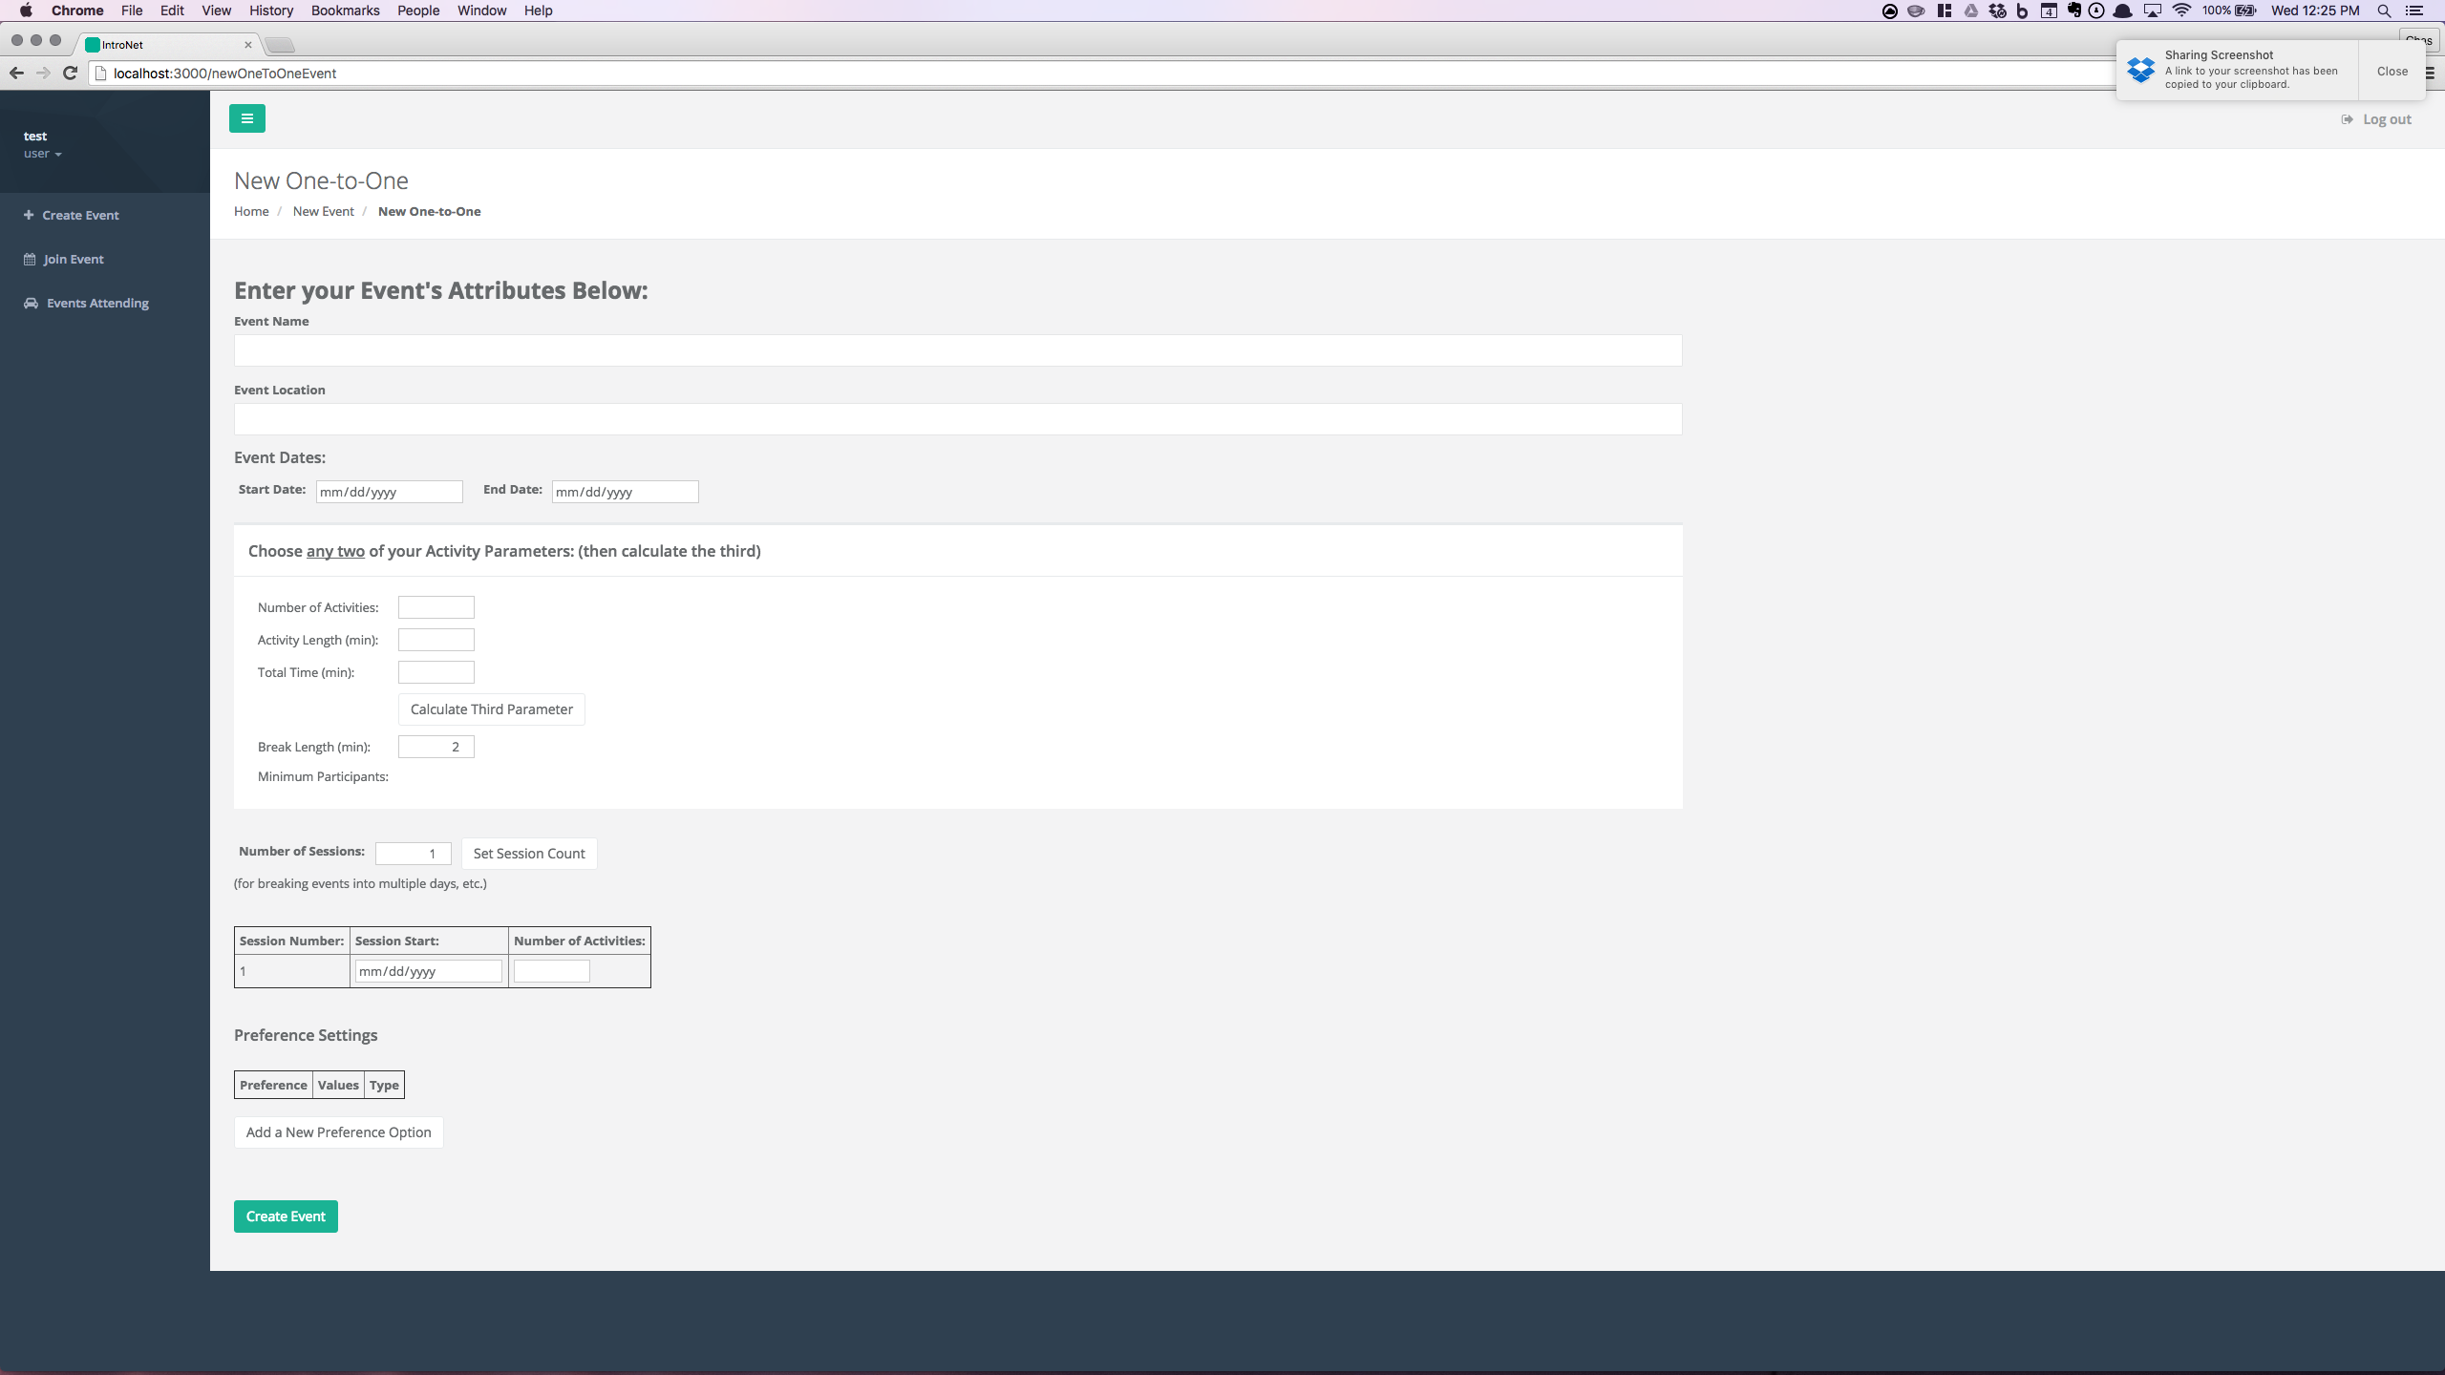

**Event Name:** Name given by the user for the event.

**Event Location:** Location for where the event will be taking place.

**Event Dates:** Enter the start and end dates. A calendar will appear by clicking on the right side of either box.

**Number of Activities:** The number of individual meetings during the event.

**Activity Length:** The length of each individual meeting.

**Total Time:** The time needed for the event to run to completion.

**Calculate Third Parameter Button:** Calculates the third parameter when given two of the following parameters: Number of Activities, Activity Length, or Total Time.

**Break Length:** The time between each activity.

**Minimum Participants:**  The number of people needed to generate a schedule.

**Number of Sessions:** The number of groups of activities. For instance, meetings split over two days.

**Add a New Preference Option Button:** Brings up the preference form.

**Create Event Button:** Creates a new event with the above parameters.

### Preference Form

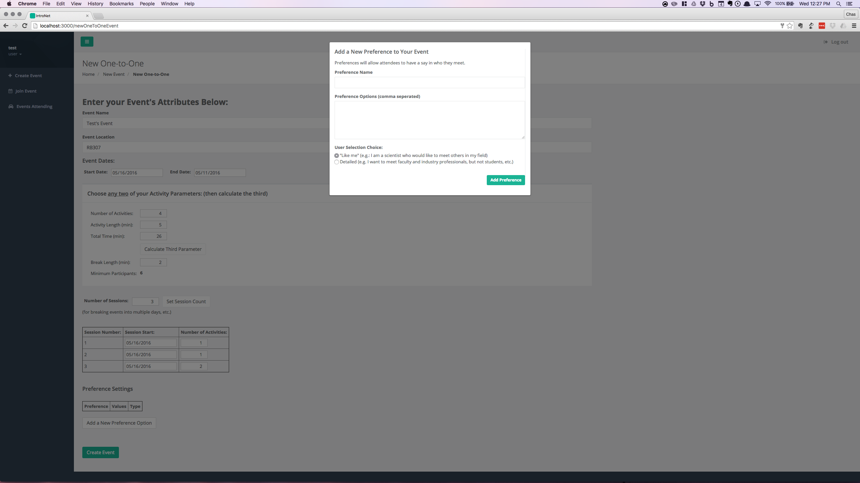

**Preference Name:** Name of the new Preference

**Preference Options:** The choices a user is given for a user category

**User Selection Choice:** The type of selection users are given when choosing their preferences

**Add Preference:** Adds the new preference to the event

Preferences are often confusing to new users. These are used during scheduling to match attendees with other attendees they would like to meet.

An Example: A networking event between a school and industry professionals might have a preference like the following

Name: “Occupation”

Preference Options: “Student,Professor,Professional”

The “Like me” and “Detailed selection option determines the freedom of selection during event registration. “Detailed” selection allows to specify their preference for *each* category individually. “Like me” selection allows a user to specify their preferences only for users in the same category and users in a different category, which is more restricted than the “Detailed” option.

### One-to-Many

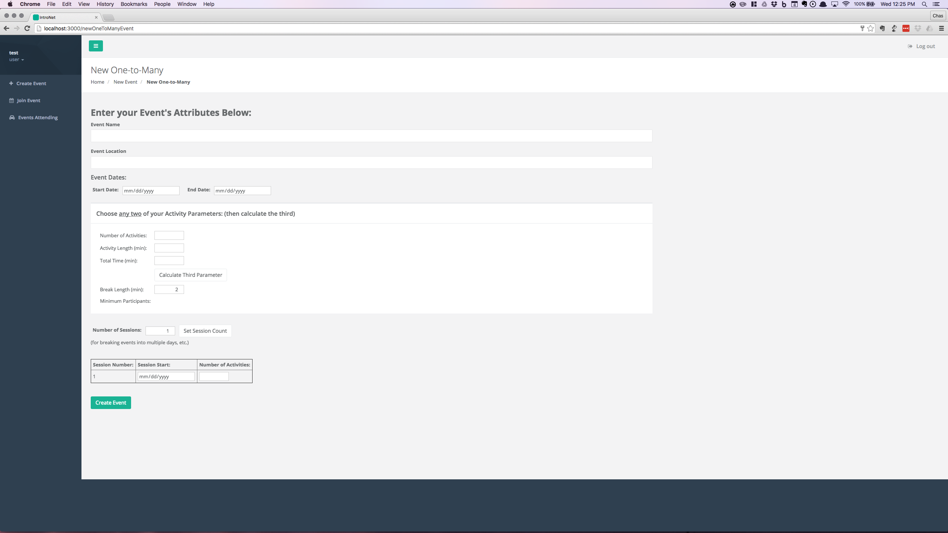

**Event Name:** Name given by the user for the event.

**Event Location:** Location for where the event will be taking place.

**Event Dates:** Enter the start and end dates. A calendar will appear by clicking on the right side of either box.

**Number of Activities:** The number of individual meetings during the event.

**Activity Length:** The length of each individual meeting.

**Total Time:** The time needed for the event to run to completion.

**Calculate Third Parameter Button:** Calculates the third parameter when given two of the following parameters: Number of Activities, Activity Length, or Total Time.

**Break Length:** The time between each activity.

**Minimum Participants:**  The number of people and posters needed.

**Number of Sessions:** The number of groups of activities. For instance, meetings split over two days.

**Create Event Button:** Creates a new event with the above parameters.

## Events Owned Dashboard

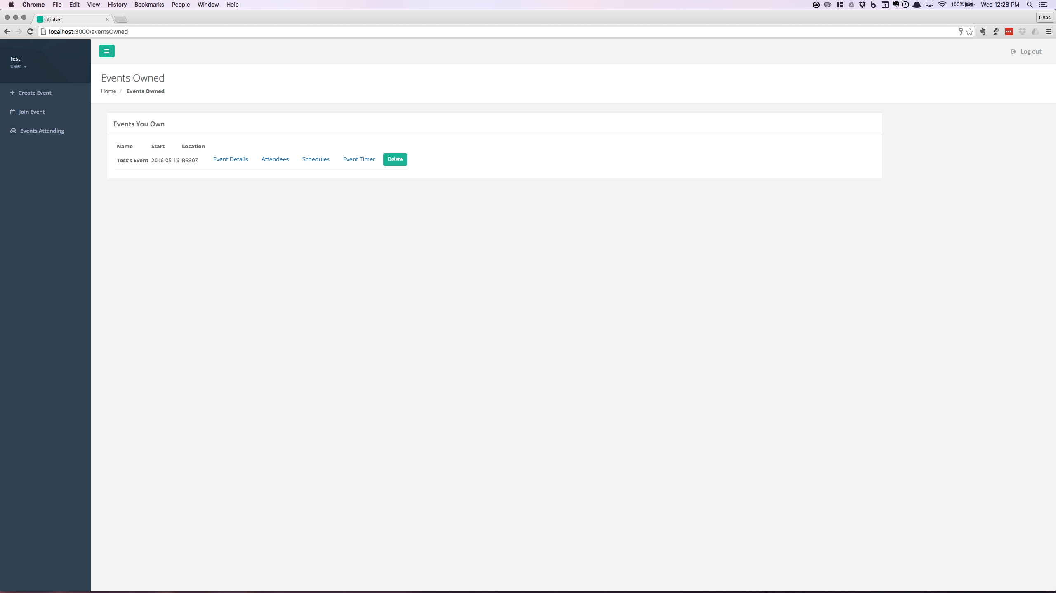

**Name:** The name given for an event.

**Start:** The start date for an event.

**Location:** The location for an event.

**Event Details:** Redirects to the details page for the event.

**Attendees:** Redirects to the list of attendees for the event.

**Schedules:** Redirects to the list of all schedules for the event.

**Event Timer:** Redirects to the timer for the event.

**Delete Button:** Completely removes the event (CANNOT BE UNDONE).

### Event Details

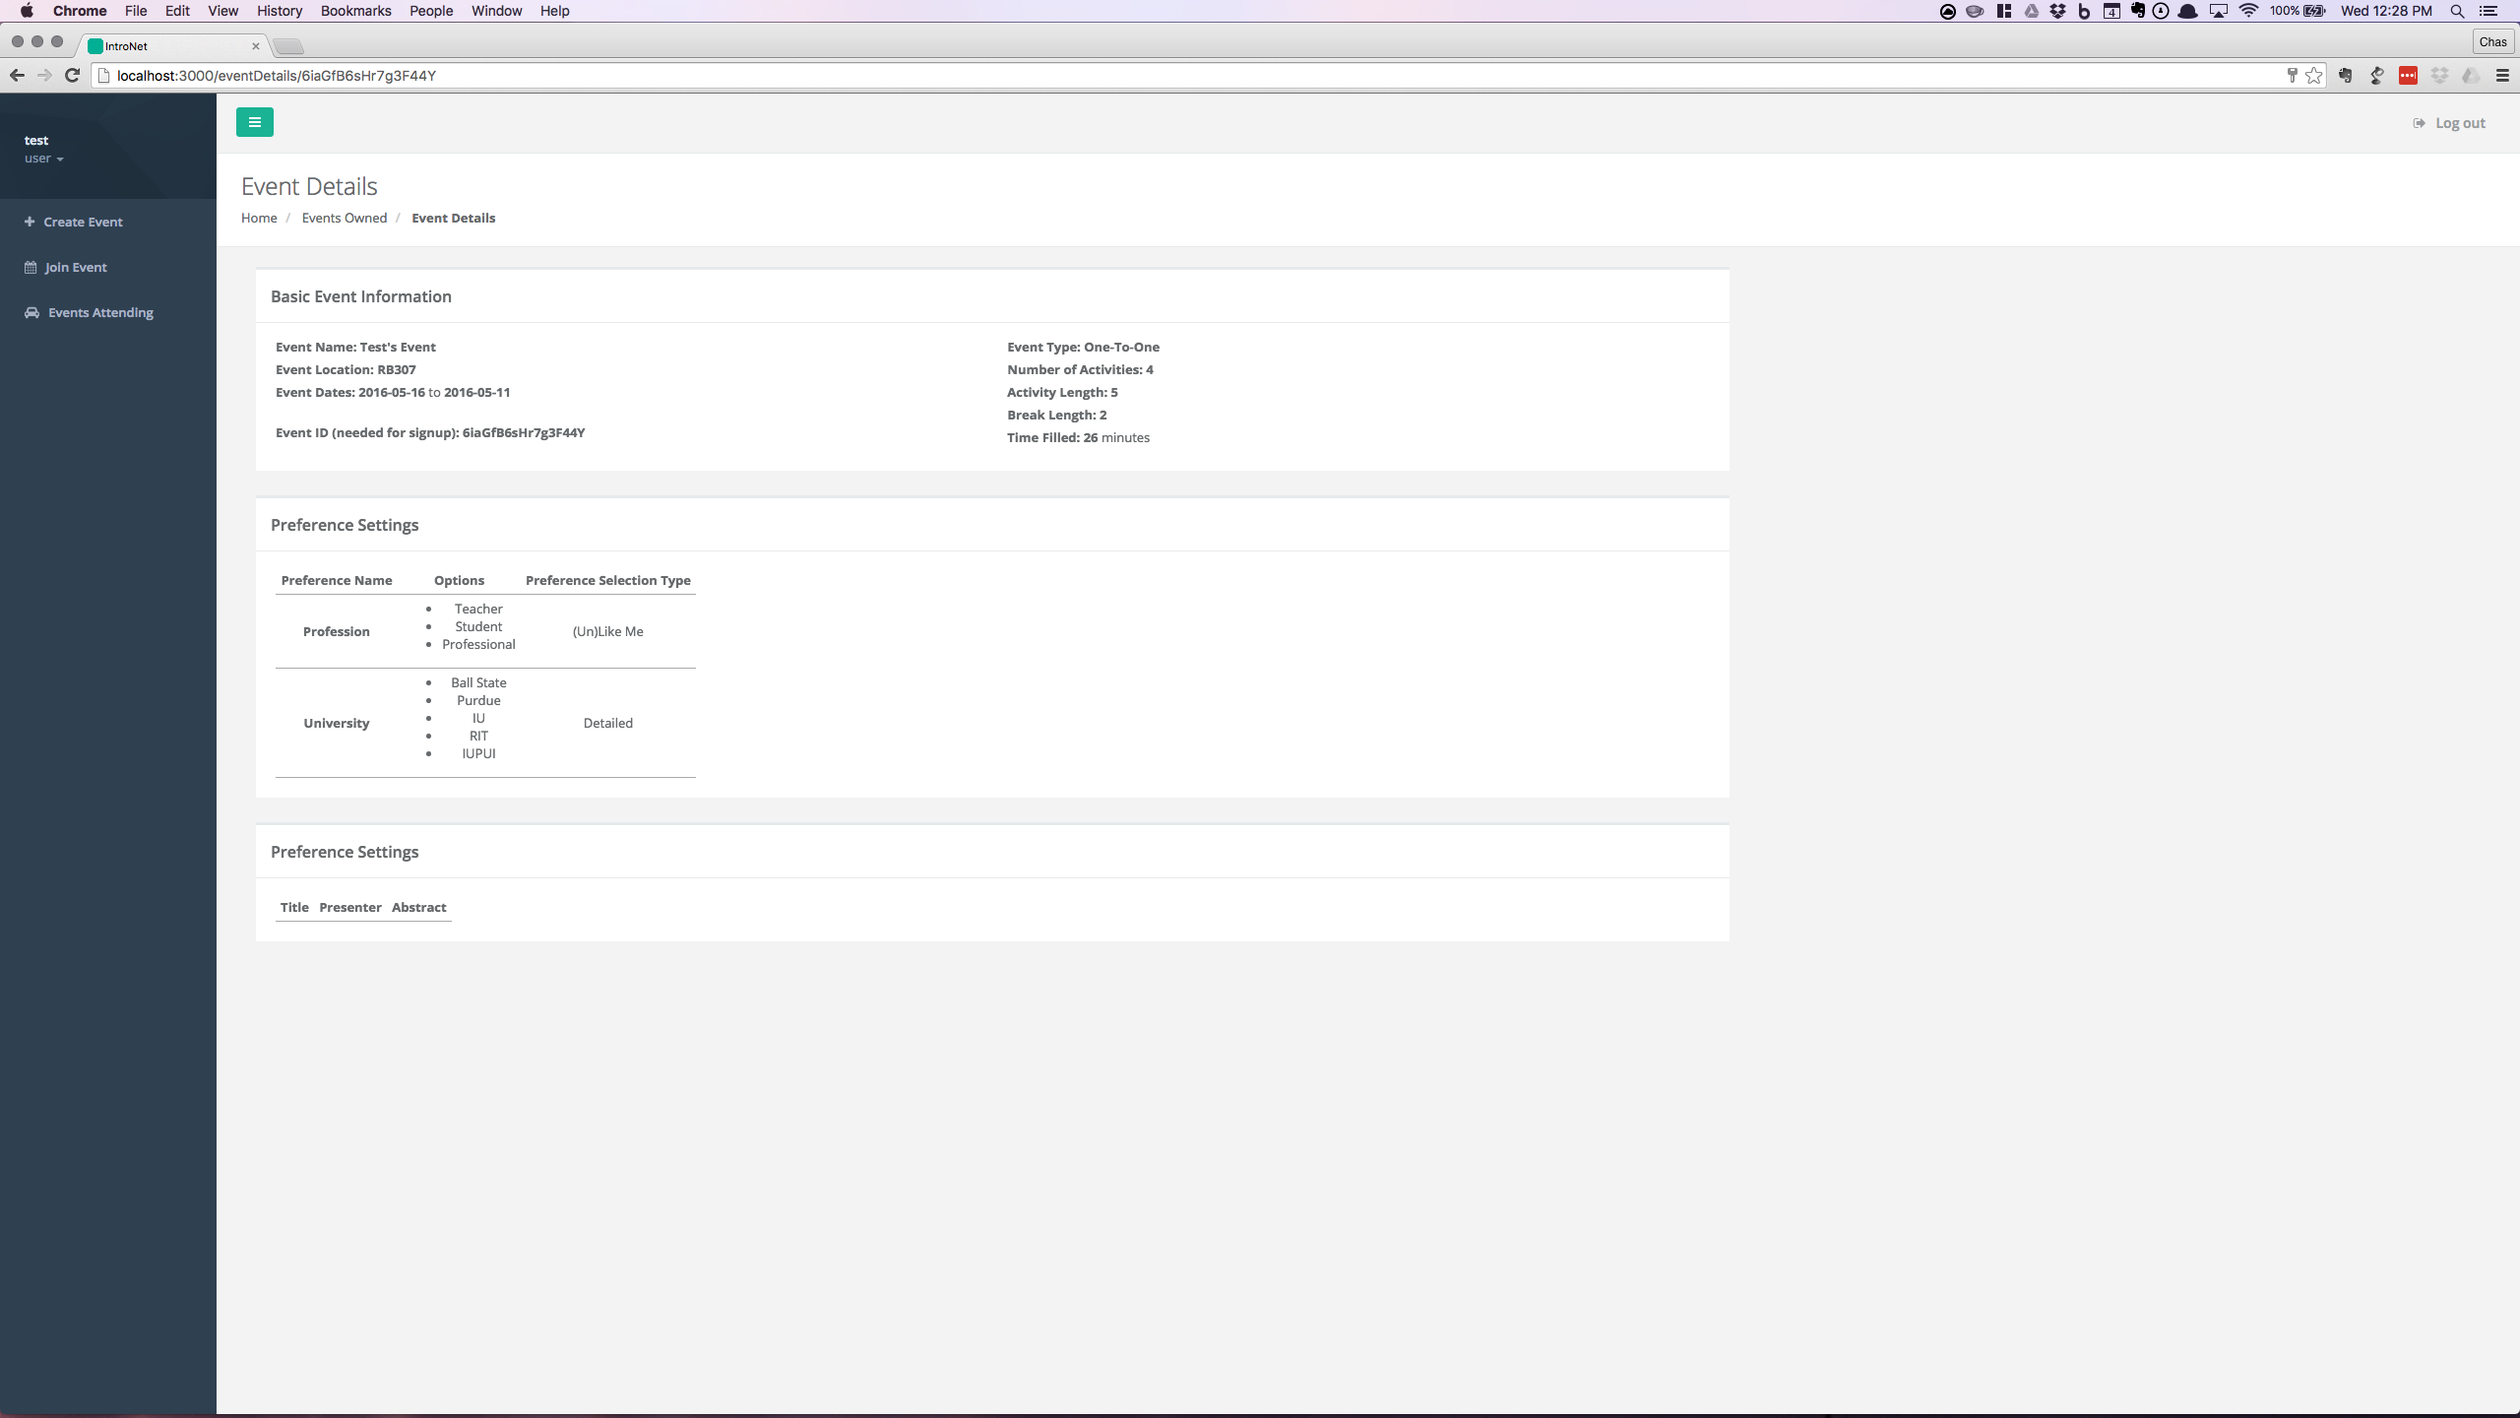

**Event ID:** ID for the event to be distributed to any user in order to attend an event.

Note: All the other information is gathered during the event creation process.

### Manage Attendees

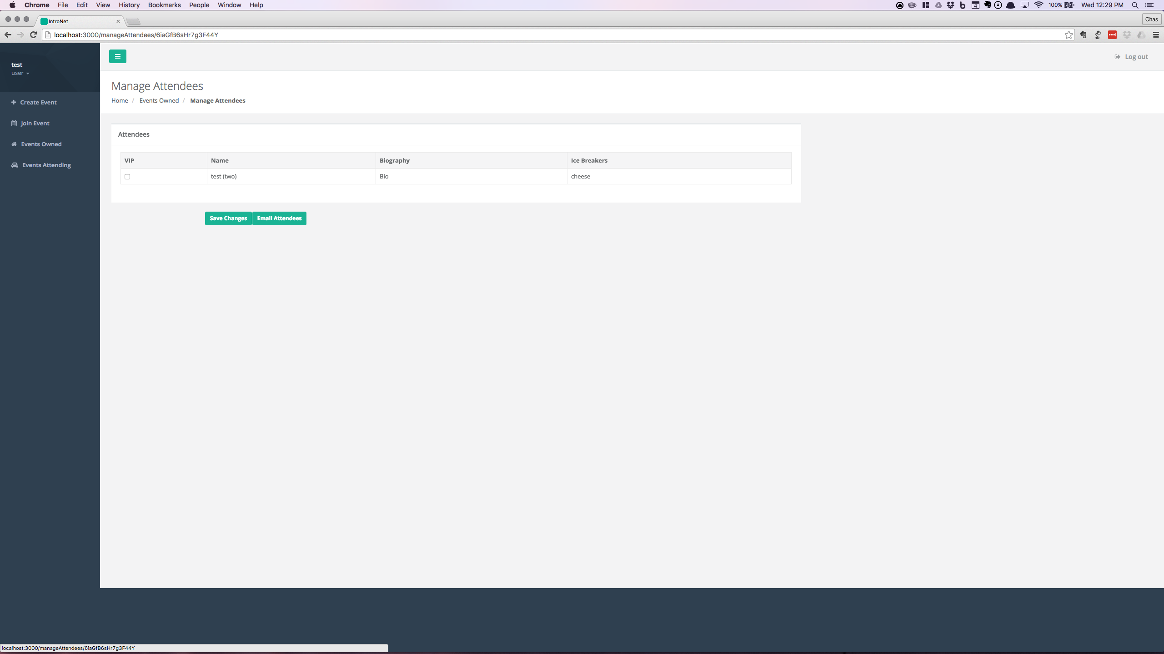

**VIP Check Box:** Marks a user for preferential scheduling.

**Save Changes Button:** Saves the changes made by the event creator.

**Email Attendees:** Send out emails to all registered attendees.

Note: The Name, Biography, and Ice Breakers is gathered from the user profile for each user attending the event.

### Schedules



A set of tables to display the schedules for each session and attendee.

**Activity #:** The ID for the activity.

**Station:** The person or poster that the user is matched with.

**Station #:** The table or poster ID.

### Event Timer

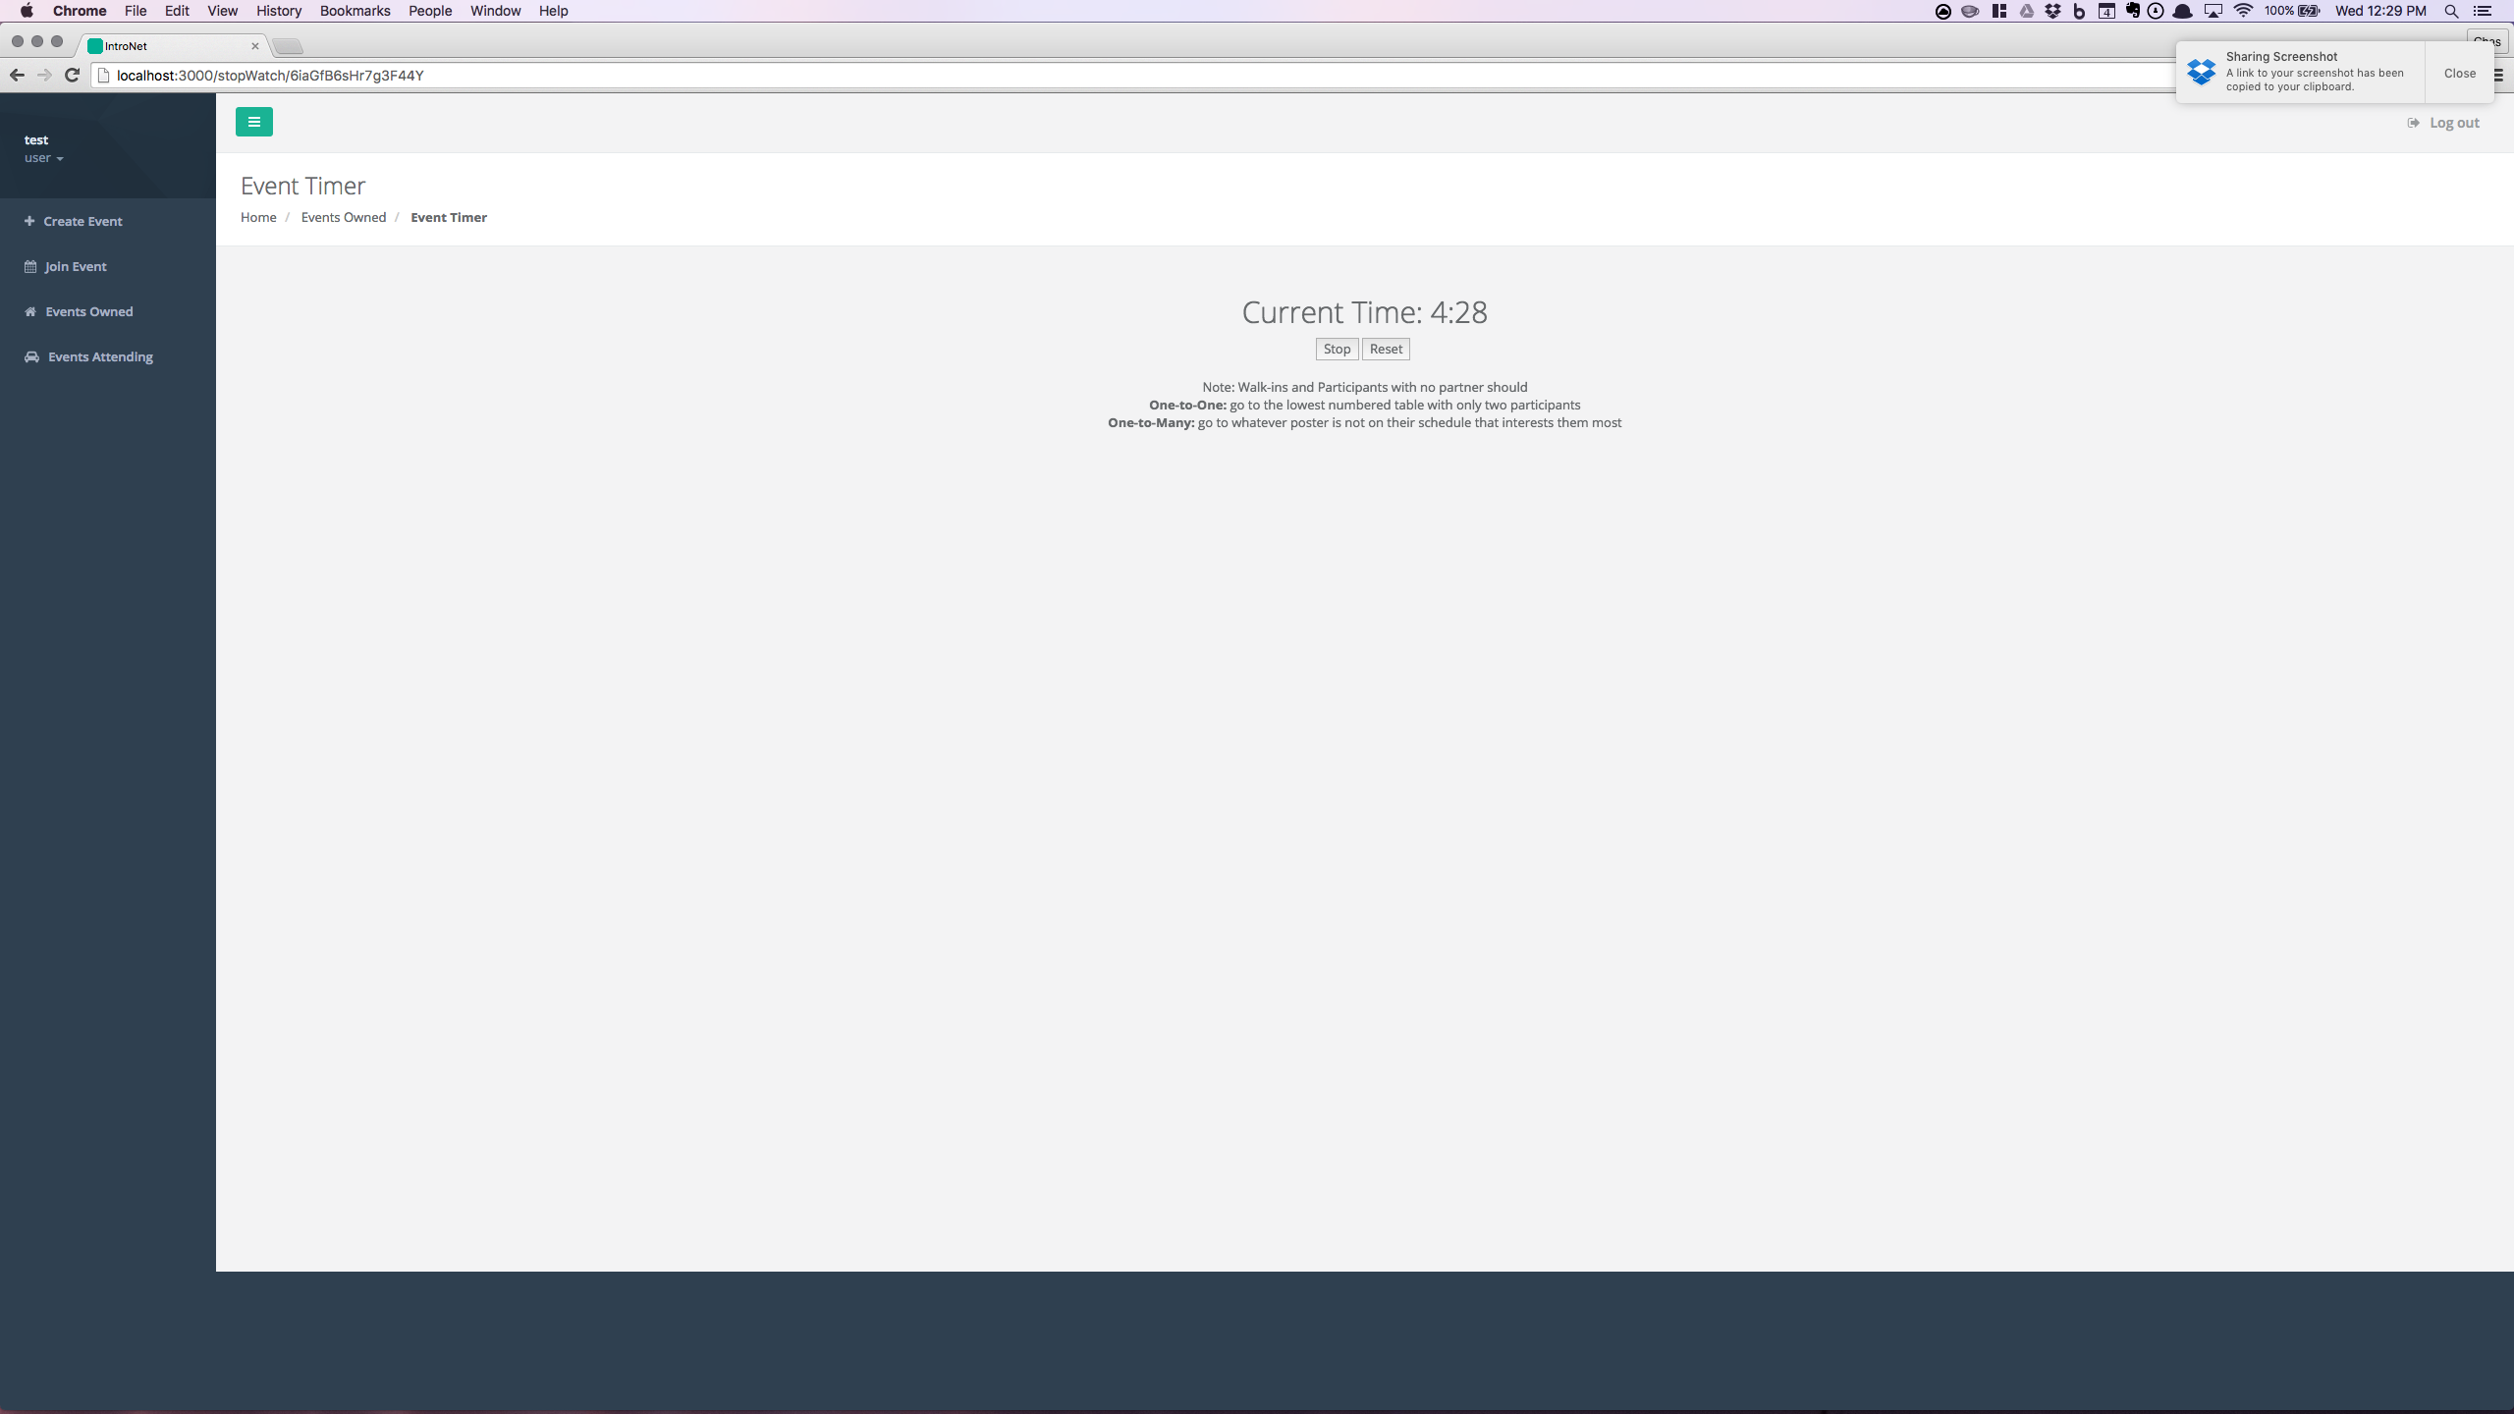

**Current Time Display:** Shows the time remaining for the activity.

**Stop Button:** Halts the timer.

**Reset Button:** Starts a new countdown.

Note: The messages should be followed in special cases.

## Events Attending Dashboard

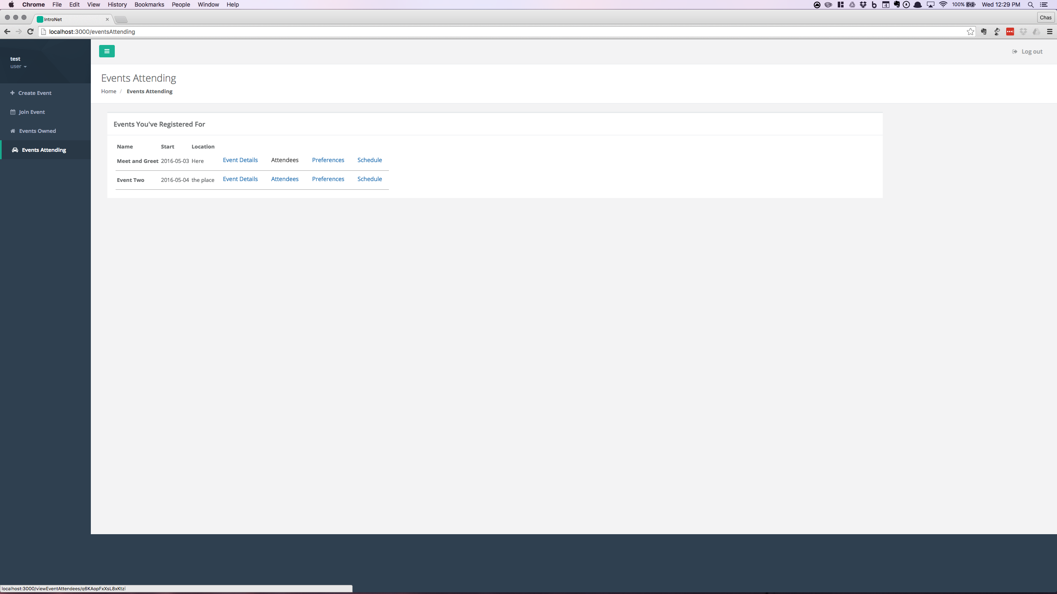

**Name:** The name given for an event.

**Start:** The start date for an event.

**Location:** The location for an event.

**Event Details:** Redirects to the details page for the event.

**Attendees:** Redirects to the list of attendees for the event.

**Preferences:** Redirects to the user’s prefences.

**Schedule:** Redirects to the user’s schedule for the event.

**Delete Button:** Completely removes the event (CANNOT BE UNDONE).

### Event Details

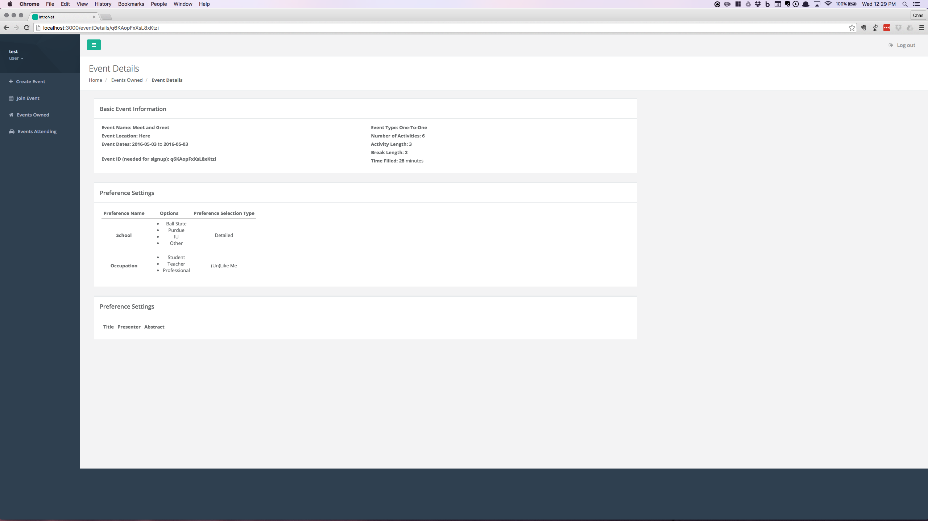

**Event ID:** ID for the event to be distributed to any user in order to attend an event.

Note: All the other information is gathered during the event creation process.

### Event Attendees

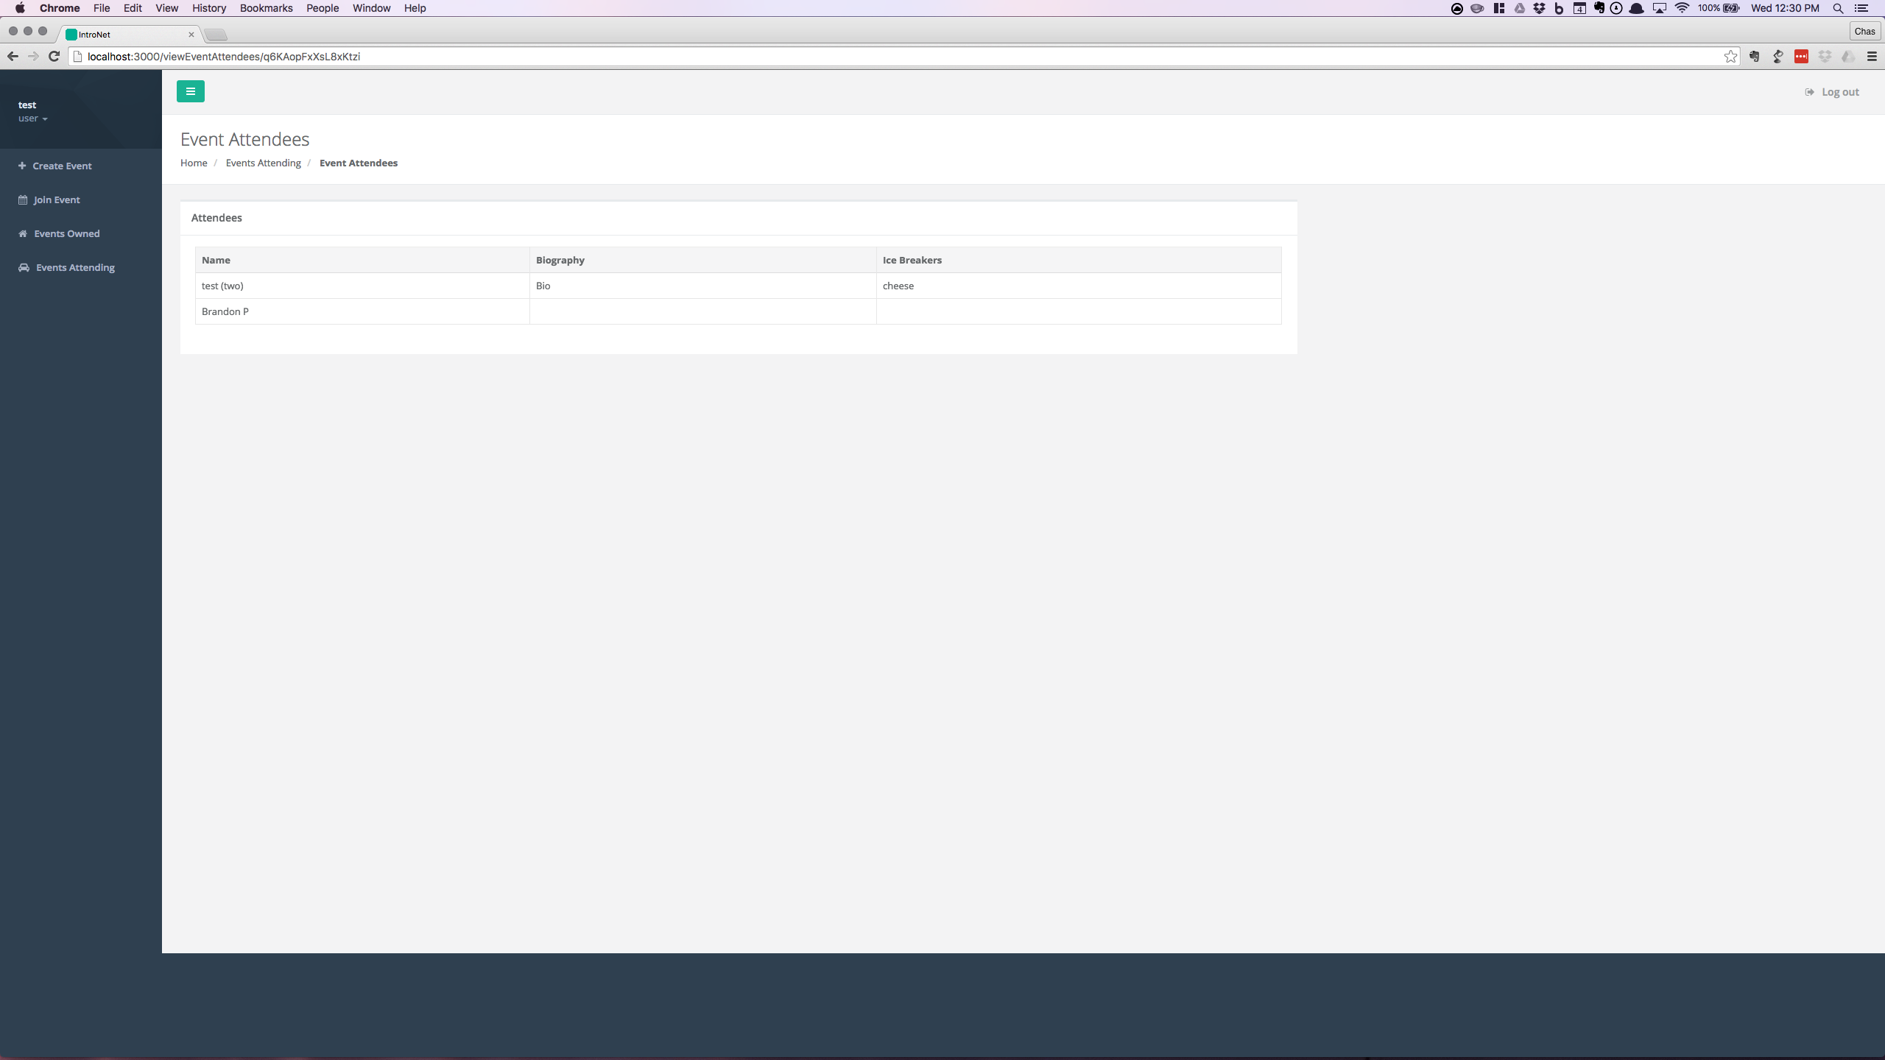

**VIP Check Box:** Marks a user for preferential scheduling.

**Save Changes Button:** Saves the changes made by the event creator.

**Email Attendees:** Send out emails to all registered attendees.

Note: The Name, Biography, and Ice Breakers is gathered from the user profile for each user attending the event.

### Preferences

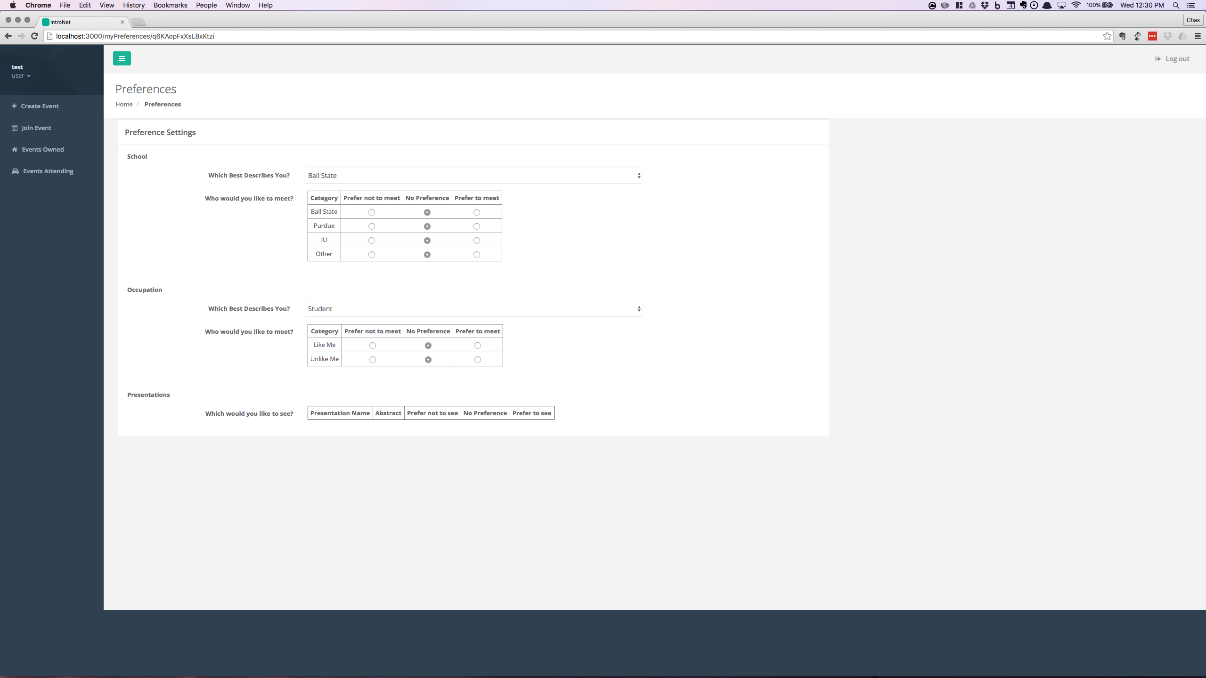

**Preference Name:** Name of the Preference

*Example:* School (Detailed Preference), Occupation (“Like Me” Preference)

**Preference Options:** The choices a user makes for each preference

*Example:* Ball State, Student

**User Selection Choice:** The selections users make for each preference

*Example:* Category table with specific attributes.

### Schedule

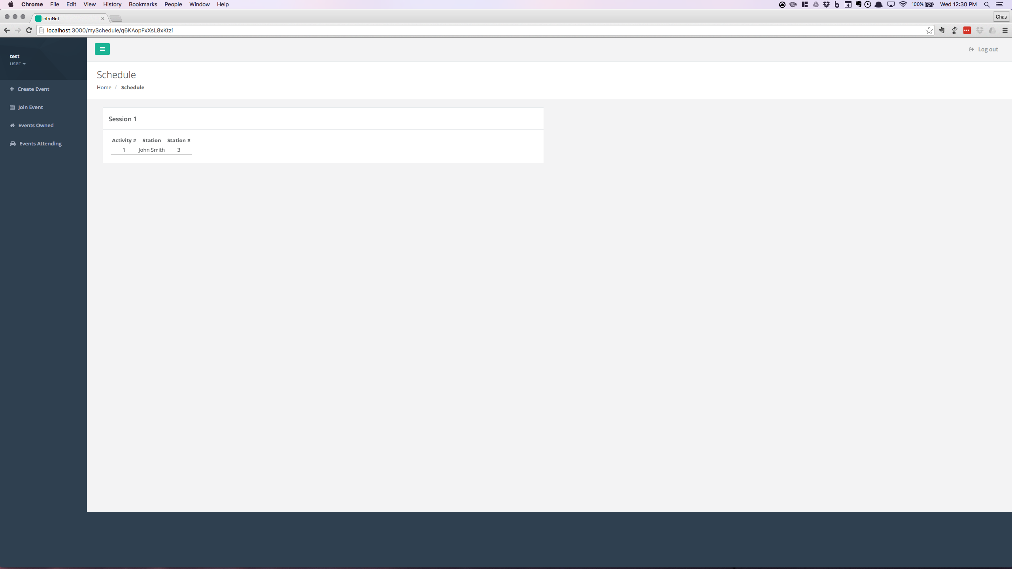

A set of tables to display the schedules for each session for a user.

**Activity #:** The ID for the activity.

**Station:** The person or poster that the user is matched with.

**Station #:** The table or poster ID.