Gettin’ groovy with Bookdown

C Wall

11/25/2020

###Git up! BookDowwwwwn!

For the advanced Markdown-ers, you can also write and code a manuscript in markdown that can be exported to Word, with references embedded. Markdown magic! [R markdown: Publsihing workflows and manuscript.](https://danovando.github.io/publications-with-rmarkdown/presentations/pubs-with-rmarkdown)

I’ve found this does not work for html–which is fine–but the pdf and word outputs seem to flow quite well. Make sure to load the package bookdown and set the options for output at the top of the Markdown script as I have above– with  
output:  
bookdown::word_document2: default  
bookdown::pdf_document2: default  
bookdown::html_document2: default

Let’s try to embed a figure in the document we are making now. If I wanted the reference to the figure to go chronological in the code (1 to the nth) and I name the code chunk accordingly, we can ‘call the chunk’ using a reference!

This uses the package bookdown and this approach is called cross referencing. It works by typing \@ref(ref-type:chunk-name), which produces a linked number to the referenced object. Let’s try one, here using *ref-type* = “fig” and the *code chunk name* = “test-fig”. **Note** the code chunk name must not have spaces. Let’s start a new page and call the code chunk

**Chlorophyll?! More like bore-o-phyll! (Fig.1).**

data<-read.csv("data/coral_data.csv")  
hist(data$chla, col="seagreen", freq=F, main="Chlorophylls in coral symbionts", ylab="density",  
 xlab=expression(paste("Chlorophyll", ~italic("a"+"c"[2]), ~(mu*g~cm^-2), sep="")))  
par(new=T)  
lines(density(data$chla),lwd=3,col="mediumseagreen")

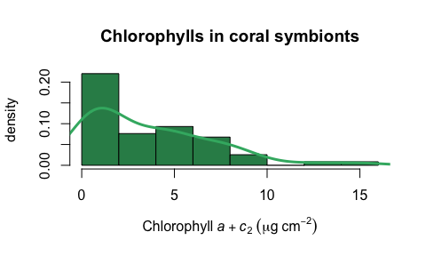

Figure 1: Chlorophyll *a* boxplot

Notice the text updates to show *Figure 1* and the code chunk (displayed above) produced the figure and adds the *Figrue 1* tot he caption, despite the fact that I did not directly name it Figure 1 using fig.cap. This is great because now R will reference these figures chronologically and link the # to the code chunk name. If a reviewer says, “I think this should be moved to the supplement and have a new Figure 1,” we can do that easily. It would require moving the order of chunks around, but that is doable.

Let’s try… making another figure, this one will be figure 2–as per reviewer requests

*We have appeased the reviewer with this fatted calf and a blood offering. We hope this new data with satiate the appetite of the reviewer*. Please see (Fig.2), which is awesome, and chlorophyll data now in the supplement. 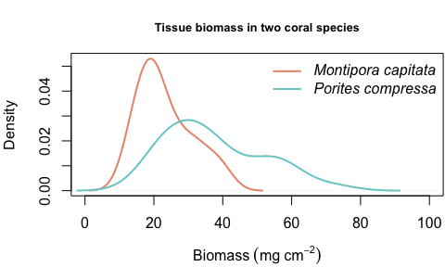

# Supplementary material

Here is the chlorophyll data in a new section, with numbers restarted. We accomplished this by using the header information in the top of the script. (Fig.3). 

If you knitted this for the first time, looked at the output, and said "Holy SH*T!"… I did too!  
What is also great is that this will export your figures into a bookdown figure folder that