**Fundamental of Discontinuity Detection**

In segmentation, input is image and output is attributes extracted from images. It subdivides an image into constituent region or object. Segmentation algorithms are based on the 1 or 2 basic properties of intensity value: discontinuity & similarity. Discontinuity approach is to partition image based on abrupt changes in intensities (edges). Similarity approach is to partition the image based on similar regions according to predefined criteria.

**Fundamentals**

Let R represent the entire region occupied by an image. Image segmentation partition R into n sub regions $R_{1},R_{2},…,R_{n},$ such that there should not be any common among different segment (partition).

Properties of Segmentation

1. $R_{i}\bigcap{ }R_{j}= ϕ$ for all i & j, i ≠ j.

$\bigcup_{i=1}^{n}{R_{i}= }R.$

**Types of Discontinuity Detection**

1. Point Detection
2. Line Detection
3. Edge Detection

The detection is based on the convoluting the image with a spatial mask. The general 3×3 mask is $$\begin{matrix}w_{0} & w_{1} & w_{2} \\ w_{3} & w_{4} & w_{5} \\ w_{6} & w_{7} & w_{8}\end{matrix}$$

The Response of the mask at any point p (x, y) in the image is

$$R_{x,y}= \sum_{i=0}{z_{i}w_{i} }$$

Where i = 0, 1 …, 8, $z_{i}$ is gray-level image i position intensity value and $w_{i}$ is mask (weight) value.

**1. Point Detection**

Point detection should be based on the second derivative. This is implies using Laplacian and use for the image sharpening. The sharpening of the image is implemented by the mask

|  |  |  |
| --- | --- | --- |
| -1 | -1 | -1 |
| -1 | 8 | -1 |
| -1 | -1 | -1 |

If point at location p (x, y) on which the mask is centered if the absolute value of the R(x, y) of that location is greater than or equals to the threshold value than output image on that location g(x, y) is labeled with 1 otherwise it is 0 in the case of binary image.

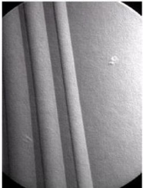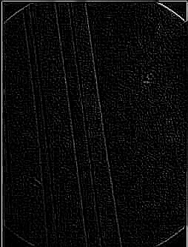

*Figure 1.1 Original image Figure 1.2 After apply the mask Figure 1.3 After apply threshold*

**2. Line Detection**

The line detection can expect second derivative to result in a stronger response and to produce thinner lines than first derivative. Thus we can use the same Laplacian mask for line detection but the negative values can be handled by taking absolute values of the Laplacian image and it’s doubles the thickness of the lines. Therefore, the use positive values of the Laplacian give the result in thinner lines.

The detection of point is not isotropic (rotating image and then apply filter), so its response is independent of direction. Therefore, to getting the direction of the lines is done by the four directions of 3 × 3 Laplacian mask: Horizontal, Vertical, and two diagonal(±45 degree).

|  |  |  |  |  |  |  |  |  |  |  |  |  |  |  |
| --- | --- | --- | --- | --- | --- | --- | --- | --- | --- | --- | --- | --- | --- | --- |
| -1 | -1 | -1 |  | 2 | -1 | -1 |  | -1 | 2 | -1 |  | -1 | -1 | 2 |
| 2 | 2 | 2 | -1 | 2 | -1 | -1 | 2 | -1 | -1 | 2 | -1 |
| -1 | -1 | -1 | -1 | -1 | 2 | -1 | 2 | -1 | 2 | -1 | -1 |

*Horizontal +45 Vertical -45*

The Response of the mask at any point p (x, y) in the image is

$$R_{x,y}= \sum_{i=0}{z_{i}w_{i} }$$

It gives the four response of the four mask .Let $R_{1},R_{2},R_{3 }and R_{4}$ response of the mask .Suppose that an image is filtered with four mask then final response value of the mask will be

$$R_{x,y}=max⁡(\left|R_{1}\right|,\left|R_{2}\right|,\left|R_{3}\right|,|R_{4}|)$$

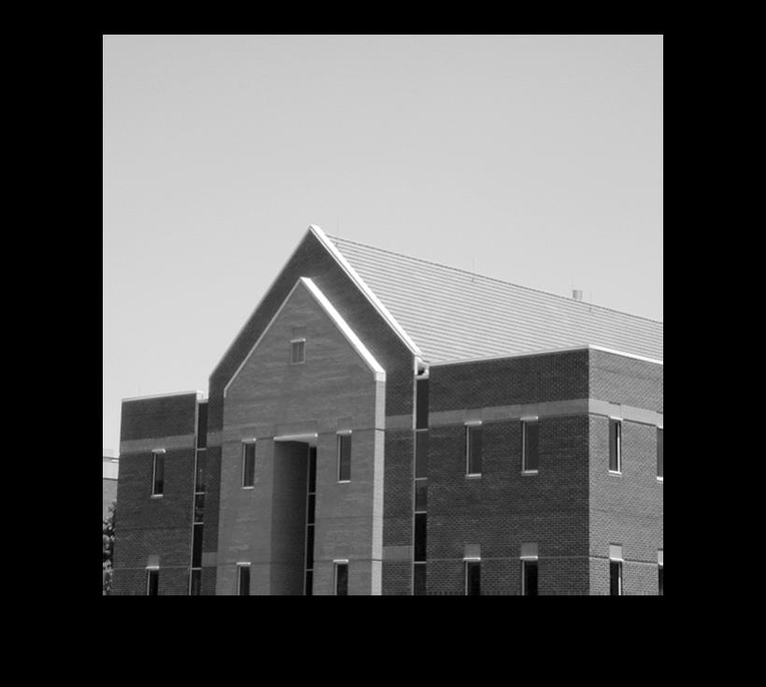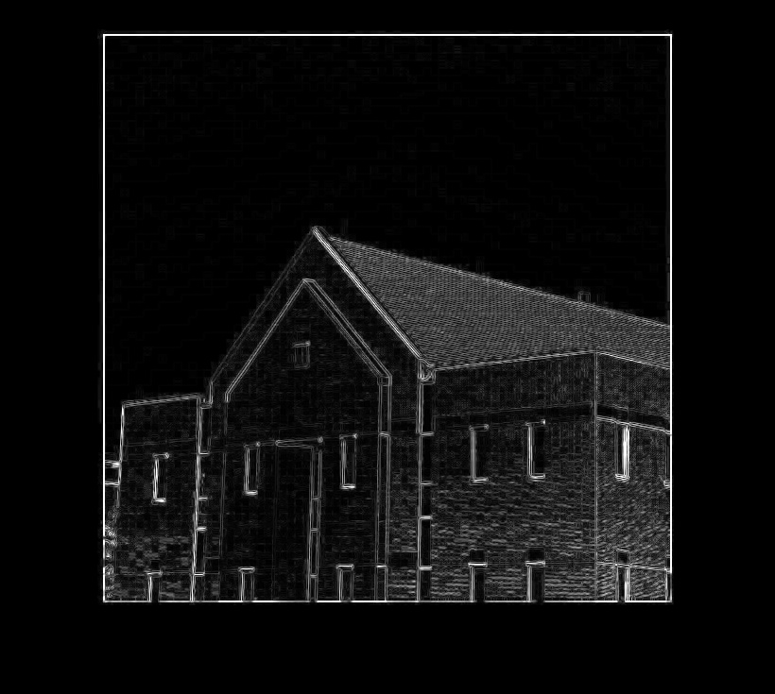

*Figure 2.1 Original Image Figure 2.2 Filtered Image by four Laplacian mask*

**3. Edge Detection**

Edge detection is the approach used most frequently for partition images based on local changes in intensity. There are several models of edges. Edges models are classified according to their intensity profiles.

**Classification of Edges**

1. Step Edges: The image intensity abruptly changes from one value to one side of the discontinuity to a different value on the opposite side.
2. Roof Edges: A ridge edge where the intensity change is not instantaneous but occur over a finite distance (generated usually by the intersection of surfaces).
3. Ramp Edges: A step edge where the intensity change is not instantaneous but occurs over a finite distance.

**3.1 Basic Edge Detection**

**1. Gradient Operator:**

A gradient is 2-D vector that point to the direction in which the image intensity grows fastest.

The gradient operator $∇$ is given by

$$∇ = \left({\frac{δ}{δx} \atop \frac{δ}{δy}}\right)$$

If the operator $∇$ is applied to the function *f*  then ,

$$∇f = \left({\frac{δf}{δx} \atop \frac{δf}{δy}}\right)$$

The Gradient is a vector which has a certain magnitude and direction. The magnitude of the gradient is usually approximated by

$$mag\left(∇f\right)≈\left|M_{x}\right|+|M_{y}|$$

By gradient operator include the Roberts, Sobel, Canny, Prewitt methods are implemented.

|  |  |  |  |  |
| --- | --- | --- | --- | --- |
| -1 | 0 |  | -1 | 1 |
| 1 | 0 | 0 | 0 |

*X Direction Y Direction*

|  |  |  |
| --- | --- | --- |
| $$z_{1}$$ | $$Z_{2}$$ | $$Z_{3}$$ |
| $$z_{4}$$ | $$z_{5}$$ | $$z_{6}$$ |
| $$z_{7}$$ | $$z_{8}$$ | $$z_{9}$$ |

**A. Roberts Edge Detection**

The Robert operator is based on implementing the diagonal difference. It is also called as th*e Roberts cross-gradient* operator.

$$\frac{δf}{δx}=(z_{9}- z_{5})$$

$$\frac{δf}{δy}=(z_{8}- z_{6})$$

The Magnitude of the Roberts can be implemented by following mask.

|  |  |  |  |  |
| --- | --- | --- | --- | --- |
| -1 | 0 |  | 0 | -1 |
| 0 | -1 | 1 | 0 |

*X Direction Y Direction*

**B. Prewitt Edge Detection**

Prewitt kernel is based on the idea of central difference. The Prewitt edge detector is the much better than the Roberts edge detector. The partial derivatives can be computed by

$$\frac{δf}{δx}=\left(z_{7}+ z_{8}+z_{9}\right)-(z_{1}+z_{2}+z_{3})$$

$$\frac{δf}{δy}=\left(z_{3}+z_{6}+z_{9}\right)-(z_{1}+z_{4}+z_{7})$$

The Magnitude of the Prewitt can be implemented by following mask.

|  |  |  |  |  |  |  |
| --- | --- | --- | --- | --- | --- | --- |
| -1 | -1 | -1 |  | -1 | 0 | 1 |
| 0 | 0 | 0 | -1 | 0 | 1 |
| 1 | 1 | 1 | -1 | 0 | 1 |

*X Direction Y Direction*

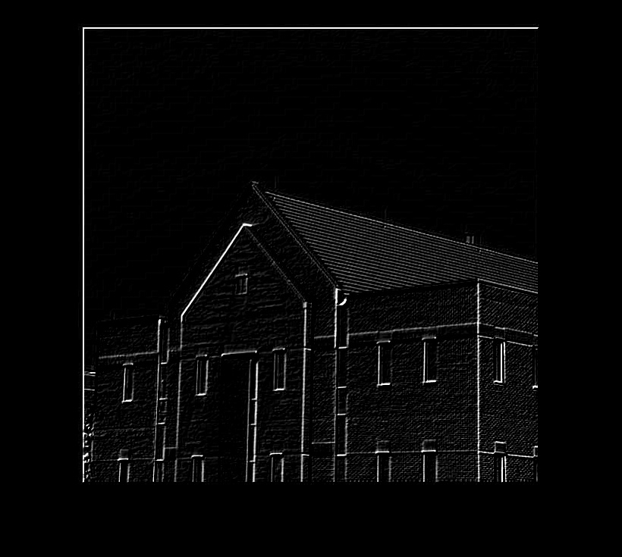

*Figure 3.B.1 Original Image Figure 3.B.2 Prewitt Kernel filter*

**C. Sobel Edge Detection**

Sobel gives the greater weight to the central pixel when averaging. Sobel Kernels can be thought of as 3 × 3 approximations to first derivative of Gaussian Kernal.

$$\frac{δf}{δx}=\left(z_{7}+ {2z}_{8}+z_{9}\right)-(z_{1}+{2z}_{2}+z_{3})$$

$$\frac{δf}{δy}=\left(z_{3}+2z_{6}+z_{9}\right)-(z_{1}+{2z}_{4}+z_{7})$$

The Magnitude of the Prewitt can be implemented by following mask.

|  |  |  |  |  |  |  |
| --- | --- | --- | --- | --- | --- | --- |
| -1 | -2 | -1 |  | -1 | 0 | 1 |
| 0 | 0 | 0 | -2 | 0 | 2 |
| 1 | 2 | 1 | -1 | 0 | 1 |

*X Direction Y Direction*

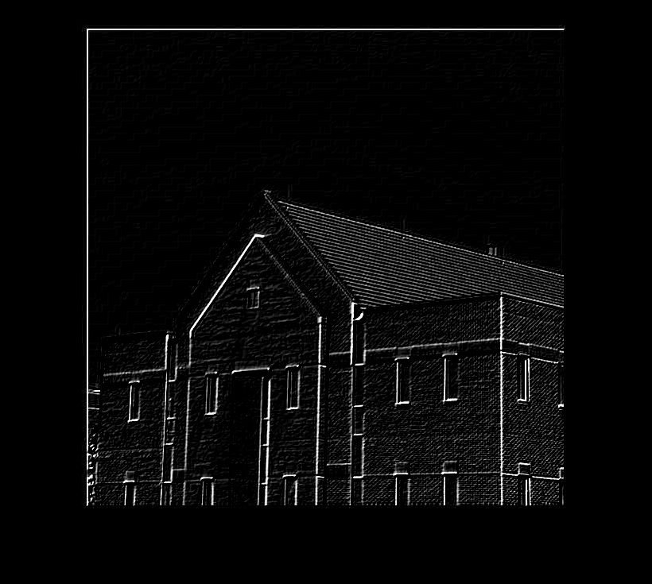

*Figure 3.B.1 Original Image Figure 3.B.2 Sobel Kernel filter*