SCENERIO 1-Successful Login
Login using username and password
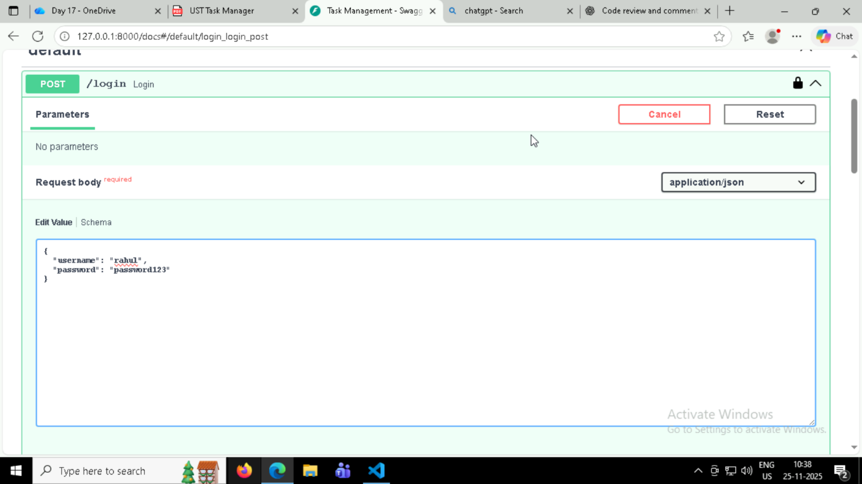

Token Generated if username and password are valid
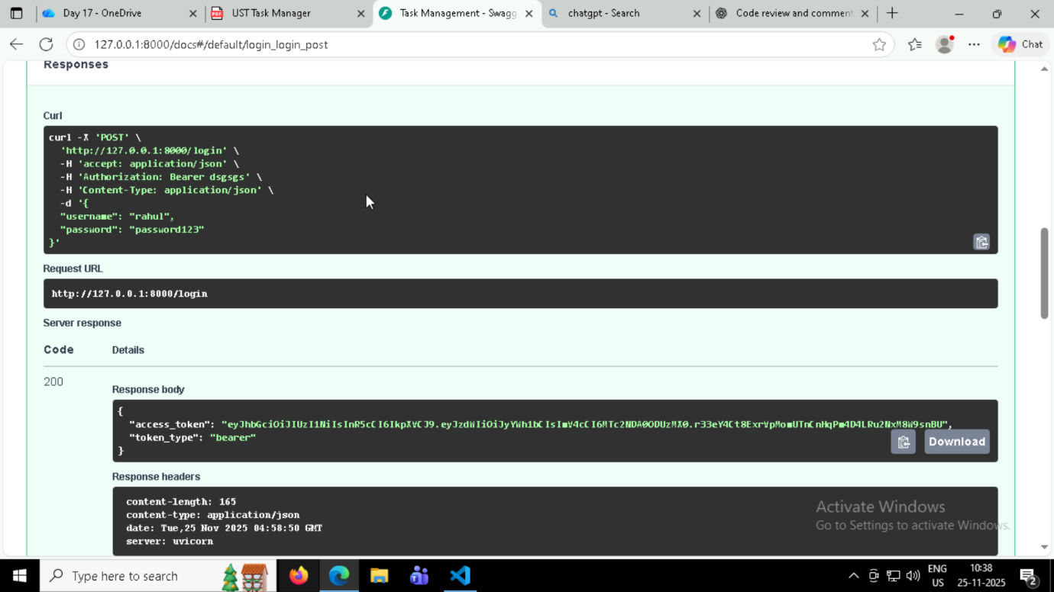

Authorizing using Token
Login successfull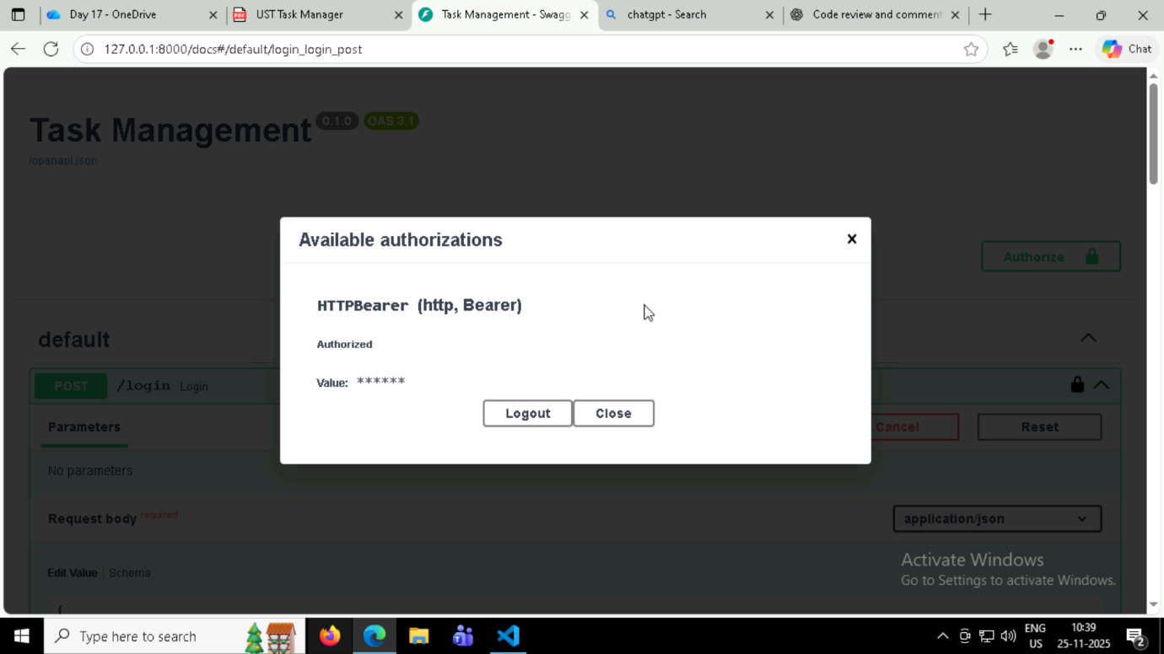

SCENERIO 2 –Login Failure

Invalid password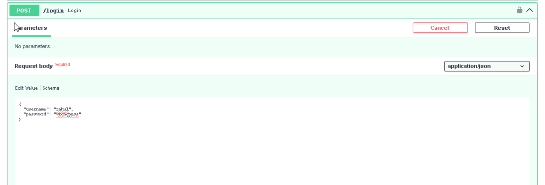

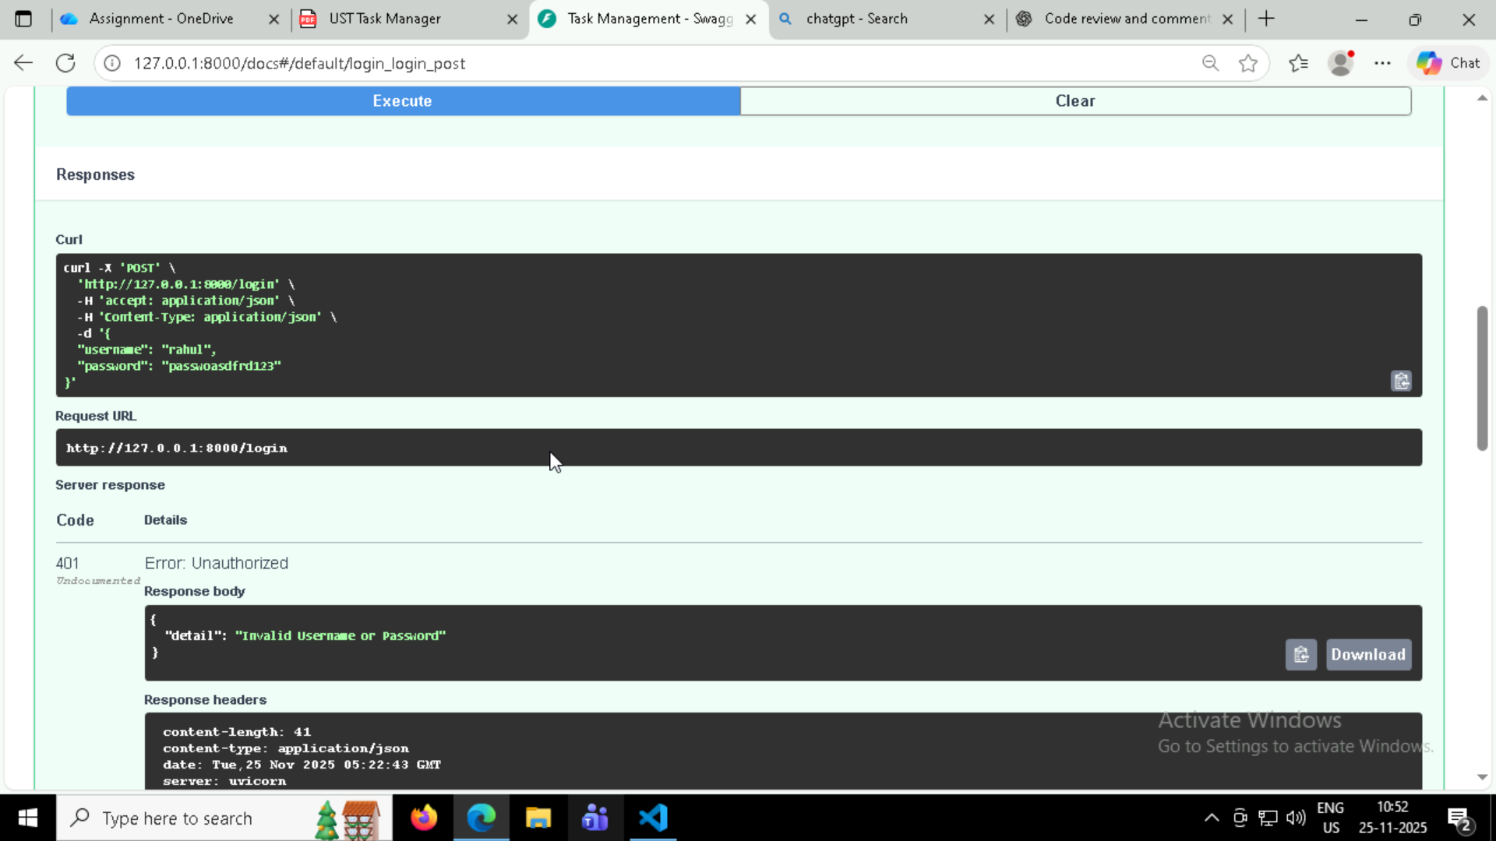

SCENARIO 3- Create Task

Creating new task -Request
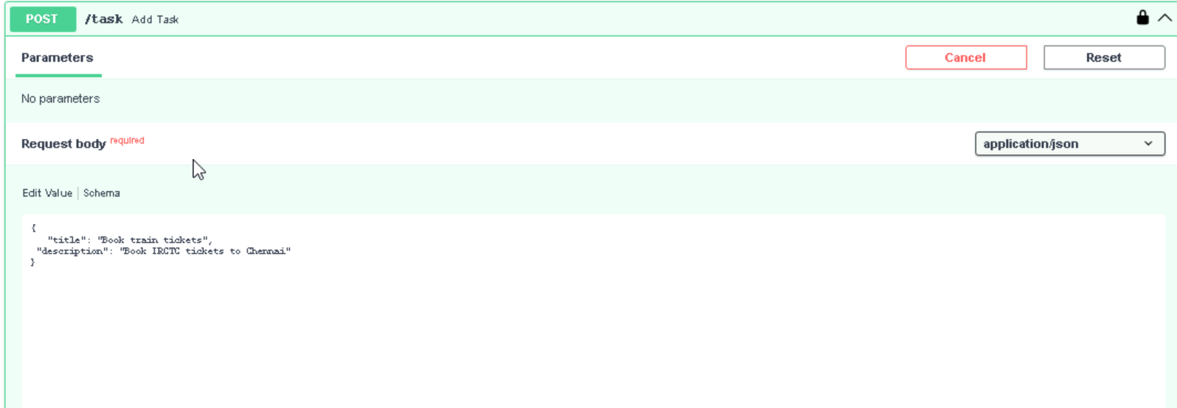

Response -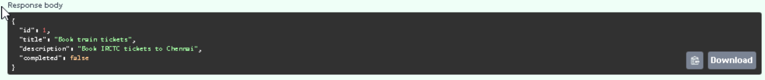

SCENARIO 4-Create Task with Missing Title

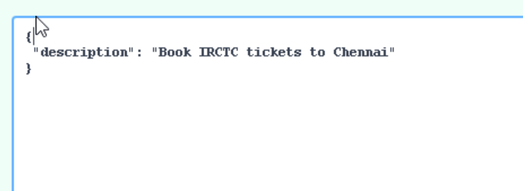

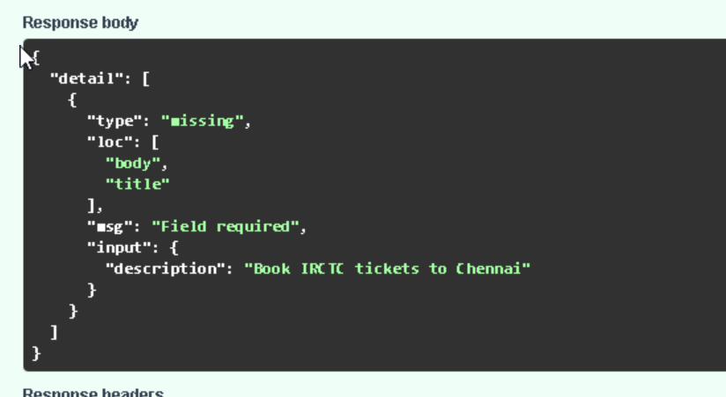

SCENARIO 5 -Update Task
Request to update task using id -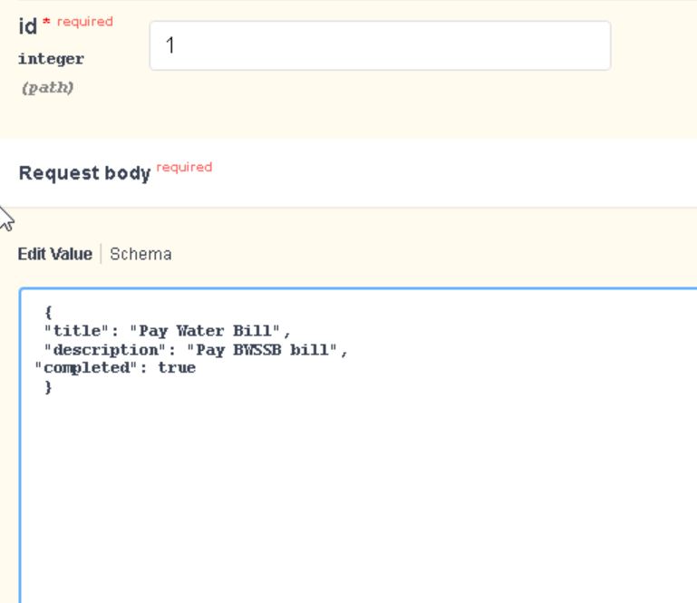

Response –
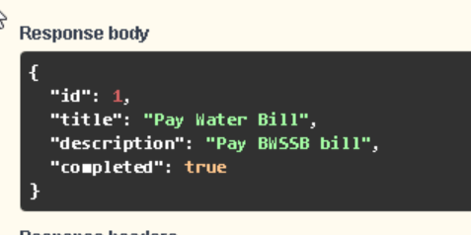

SCENARIO 6-Get Non-Existing Task
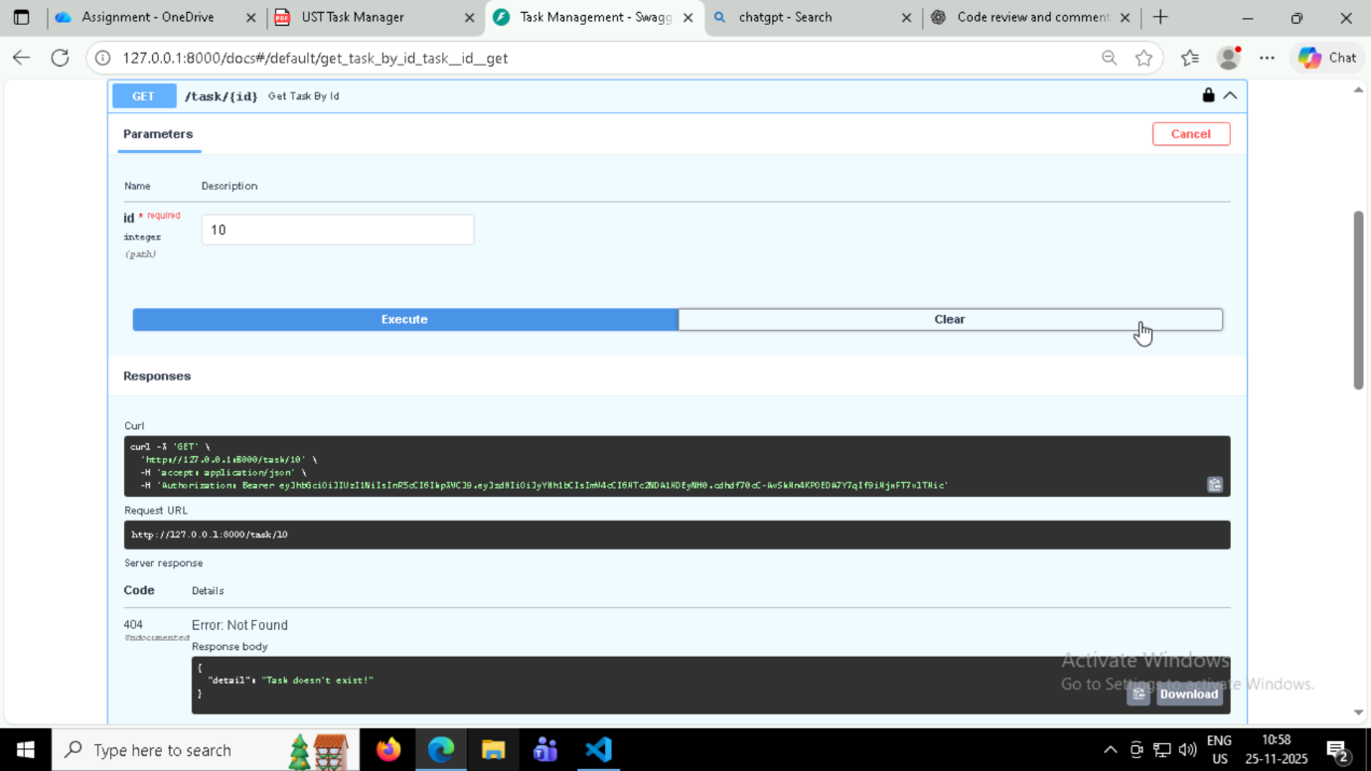

SCENARIO 7-Delete Non-Existing Task
