**Kickstarter Market Analysis**

**Background**

Kickstarter is a massively successful crowdfunding platform that has been used to raise over $2 Billion Dollars. Despite this achievement, not every project results in a positive outcome. Only one-third of the nearly 300,000 crowdfunding projects launched on Kickstarter can boost of successful funding.

The premise of Kickstarter is that a project must meet or exceed their initial funding goals to retain the crowdsourced monetary funding.

**Objectives**

A database containing over 4,000 past projects would be organized and analyzed to better understand the market trends behind successfully funded Kickstarter campaigns.

**Conclusions**

Overall, out of a total of 4,064 completed Kickstarter campaigns, over half were successful (53.8%), while a little over one-third failed (37.6%) in raising or exceeding their initial funding goals. Another portion of projects were canceled (8.6%) before reaching the end of the funding process. In analyzing launched date outcomes successful campaigns comes to a peak around May before experiencing a decline into the month of December. Throughout the year, the data showed a noticeable gap in successful and failed campaigns until outcomes narrow down in September and finally intersect in December. The number of failed projects surpass the number of successful projects during the month of December. Maybe looking farther into the correlation data for percent funded between the highest and lowest counts for the state of success might give more insight to whether or not there is a lack of crowdfunding success in the last month of the year. Regardless, it would be safer for perspective campaigners to avoid a December launch date for their respective crowdfunding endeavors on Kickstarter.

An additional pivot line chart for launch date outcomes with the exclusion of the most popular category, theater (33.8%), would shift the peak of successful campaigns towards January through March, allowing for the data to be analyzed without being biased towards the largest industry in the dataset.

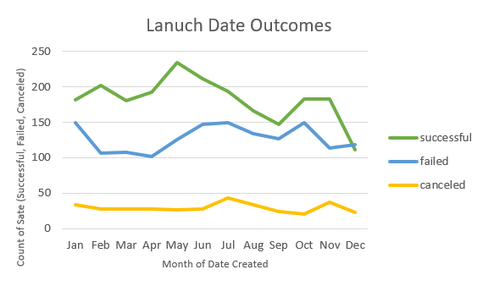

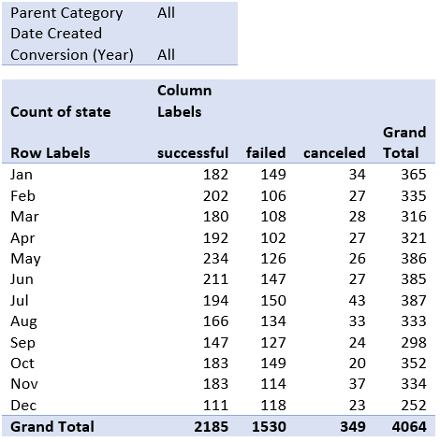

After visualizing the data for assigned Kickstarter project categories in a stacked column pivot chart, it seems that the demographic breakdown for industries with the most project funding submissions are theater (33.9%), music (17.0%), technology (14.6%), and film & video (12.6%). Food, games, photography, and publishing are less represented in dataset at (4.7%, 5.3%, 5.3%, and 5.7%) respectively. Journalism (0.6%) is the industry with the least project submissions at only 24 campaigns, all of which were canceled. While the population size of the given dataset is likely too small to test for statistical significance, regardless, inferring that journalism campaigns would have a tougher time reviving funding on Kickstarter would not be entirely unreasonable.

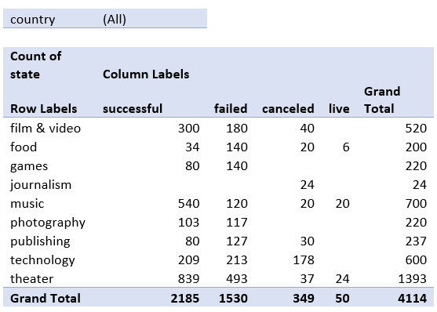

While not statistically significant due to the small sample size provided, a farther industry demographic breakdown into subcategories highlights that classical music, documentary, electronic music, metal, pop, radio & podcasts, rock, shorts, tabletop games, and television are the subcategories that resulted in a 100% successful funding rate. Alternatively, animation, children’s books, drama, gadgets, jazz, mobile games, nature, people, restaurants, and video games resulted in a 100% failure rate. A line graph comparing 100% successful or 100% failed campaigns with their respective initial funding goals might allow for more insights to be made. However, filtering the by categories, one can still safely state that entertainment related Kickstarter campaigns (especially plays) receive more submissions and funding engagement than food related Kickstarter campaigns. Food trucks (0 successful, 120 failed, 20 canceled, and 140 total), restaurants (0 successful, 20 failed, 0 canceled, and 20 total), small batch (34 successful, 0 failed, 0 canceled, 6 live, and 40 total).

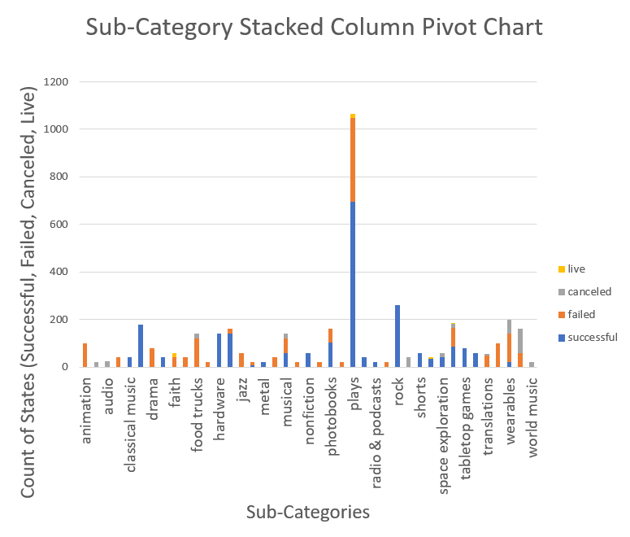

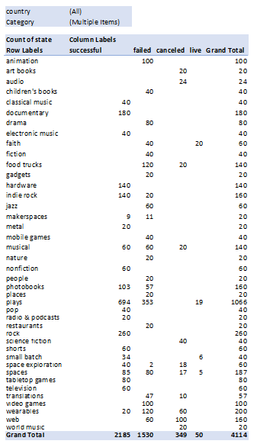

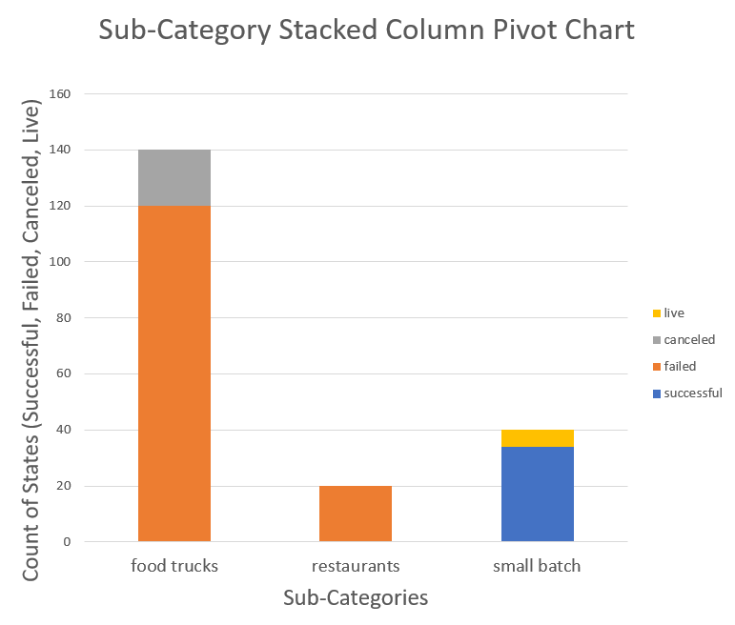

**Limitations**

The dataset is relatively small and not statistically significant, relevant, or representative of the various categories and sub-categories for the broad range of Kickstarter campaigns launched to date. From the background information provided, one-third of the 300,000 project launched experienced a positive outcome, while more than half of the 4114 selected sample projects (53.8%) were successfully funded. A larger sample size might allow for better insights to be derived. Farther testing of the current dataset for statistical significance between successful and failed campaigns might also help in making a more decisive conclusions and drawing more relevant insights.

Removal of more ambitious initial funding goals from the current dataset might also help against biasing the overall analysis of the various Kickstarter campaigns.

A farther look into successfully funded Kickstarter campaigns to see the resulting project, product, and businesses might also be insightful in understanding successful project trends.

**Possible Tables/Graphs**

As previously state, a line graph comparing 100% successful or 100% failed campaigns with their respective initial funding goals might allow for more insights to be made in regards to weather initial funding goals (barrier to entry) make Kickstarter a more relevant funding option for some project categories over others.

A column chart breaking down funding pledged per day might also be insightful in gaining understanding for the kind of traction that would result in a successful Kickstarter campaign.

**Statistical Analysis**

While the mean is usually a good measure of central tendency, in these particular datasets (both successful and failed outcomes) the existence of outliers makes the median more useful as a representative summary.

The variance for successful outcomes is 712,841, while the variance for failed outcomes is 3,773. Which is reasonable to conclude that there are more variability among successful outcomes than failed outcomes.