**Hypothesis**

Rubisco (Ribulose-1,5-bisphosphate carboxylase/oxygenase) is an abundant but inefficient protein involved in the Calvin Cycle, in the last step of glycolysis and should be able to be isolated by solubility, charge, polarity, and size through the combination of the four different protein isolation techniques: ammonium sulfate precipitation, ion-exchange chromatography, SDS-Page, and Western Blot.

**Results**

**Table 1. Absorbance Spectral Analysis Data**

The wavelength ranging from 200 to 400 (nm) and absorbance data for Rubisco protein samples were obtained via absorbance spectral analysis of ion exchange column chromatography fractions and ammonium sulfate precipitation. 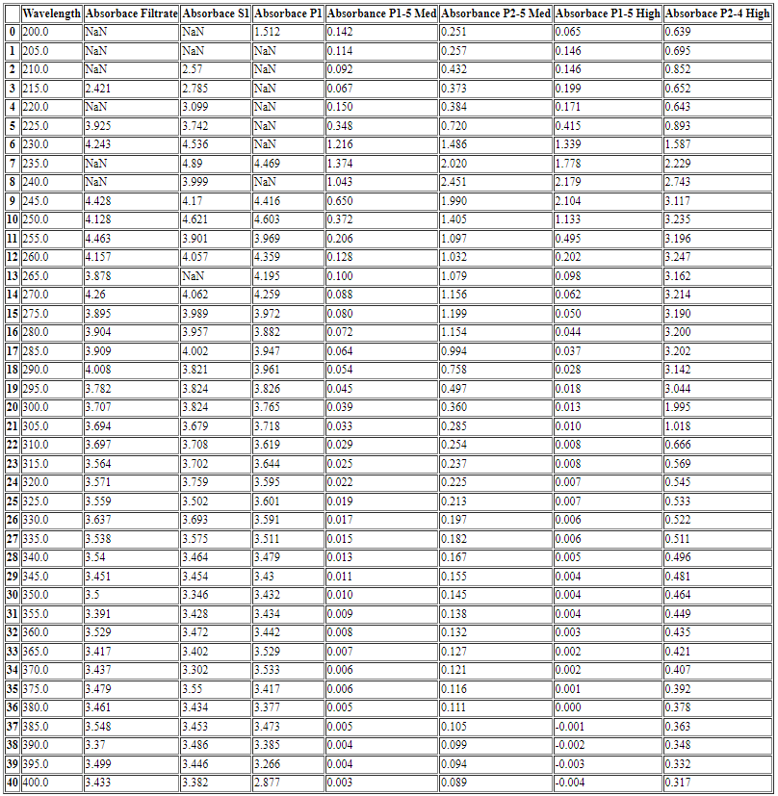

**Figure 1. Spectrum Analysis of Purified RuBisCo Protein**

Ion exchange column chromatography fractions of pellets (P1) and (P2) were subjected to low, medium, and high salt washes containing a mixture of Buffer A (10 mM Tris, pH 8.0, containing 3 mM EDTA) and varying concentration of NaCl (50 mM, 200 mM, and 500 mM respectively). Absorbance at 280 nm is a possible indicator of the presence of protein, Rubisco. The lack of a peak at 280 nm for P1 medium salt fraction and P1 high salt fraction might be an indication of absence of the protein in those fractions.

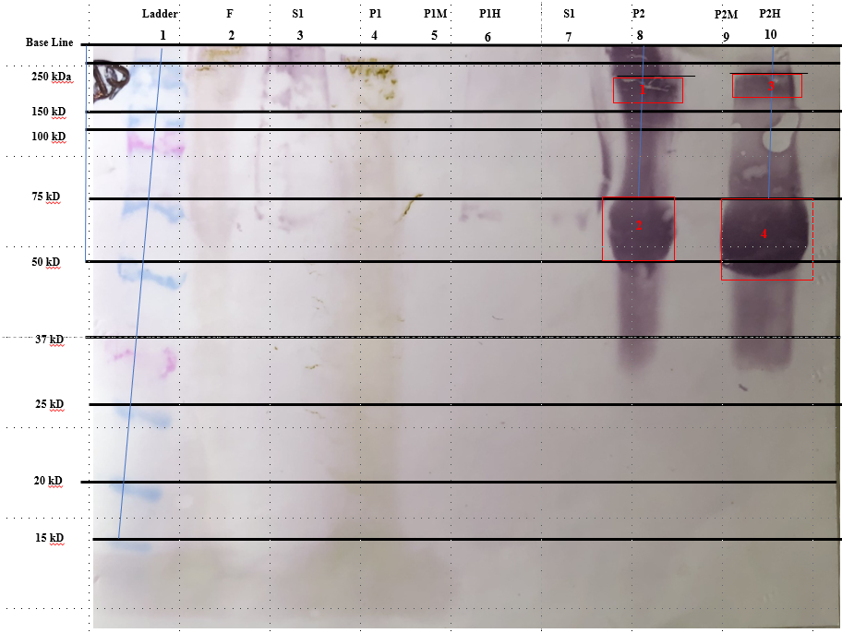

**Figure 2. Western Blot Membrane**

Only four bands are clearly visible on the Western Blot membrane. The first set of bands are located in well 8 containing sample (P2) with the top of the bands corresponding to the distance of 0.838 cm and 4.267 cm respectively. The second set of bands are located in well 10, containing sample (P2H), the high salt fraction of sample (P2). The distance of the (P2H) bands are 0.762 cm and 4.267 pm respectively. The filtrate (F), first supernatant (S1), first pellet (P1) samples should have had bands corresponding to Rubisco protein in the approximate range of 55 kDa, but the protein was likely degraded. The visible are also unlikely to be RuBisCo protein, as they did not travel to the 55 kDa in distance, corresponding to the size of the large subunit of RuBisCo and a possible indicator of its presence.

**Table 2. SDS-Page Analysis**

The migration distance (cm) of standard protein from molecular ladder as the y-axis values and the log10 of molecular weight (kDa) as the x-axis values obtained from SDS-Page analysis and used to generate a standard curve and equation used in calculation of the molecular weight of protein bands on western blot membrane.

|  |  |  |
| --- | --- | --- |
| **SDS-Page Analysis** | | |
| **Migration Distance (cm)** | **Molecular Weight (kDa)** | **Log of Molecular Weight (kDa)** |
| 0.635 | 250 | 2.397940009 |
| 1.8542 | 150 | 2.176091259 |
| 2.54 | 100 | 2 |
| 4.2418 | 75 | 1.875061263 |
| 5.9944 | 50 | 1.698970004 |
| 8.128 | 37 | 1.568201724 |
| 10.0076 | 25 | 1.397940009 |
| 12.2174 | 20 | 1.301029996 |
| 13.7668 | 15 | 1.176091259 |
| NaN | 10 | 1 |

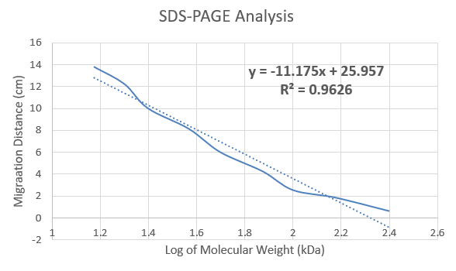

**Figure 3. Standard Curve**

The standard curve generated from the measurement of distance migrated (cm) for each protein standard in the molecular ladder and graphed against the log of the corresponding molecular weights (kDa) resulted in the standard curve equation of y = -11.175x + 25.957.

**Table 3. Tabular Data for Migration Distance (cm) and Molecular Size (kDa) Calculated**

A total of four protein bands were observed on the western blot membrane, measured for distance, and resulted in protein sizes of 194 kDa, 87 kDa, 178 kDa, 87 kDa which are unlikely to be protein, RuBisCo ~55 kDa.

|  |  |  |  |  |
| --- | --- | --- | --- | --- |
| **Calculated Molecular Weights for Observed Protein Bands** | | | | |
| **Band #** | **Well #** | **Sample/Fraction** | **Migration Distance (cm)** | **Calculated Molecular Weight (kDa)** |
| 1 | 8 | P2 | 0.3882 | 194 |
| 2 | 8 | P2 | 4.2672 | 87 |
| 3 | 10 | P2H | 0.762 | 178 |
| 4 | 10 | P2H | 4.2672 | 87 |

**Calculations**

|  |
| --- |
|  |

**Results Conclusion**

According the results of the absorbance spectrum analysis, protein, RuBisCo, is suspected to be contained within Filtrate, S1, P1, and P1M (Med Salt) samples, which are the fractions with peaks at 280 nm wavelength commonly associated with the large subunit of RuBisCo. However, western blot membrane results did not correspond to this finding. The wells associated with the aforementioned fractions were likely degraded.

**Discussion**

**Ammonium sulfate**

Crude RuBisCo protein sourced from 50 grams of de-ribbed spinach leaves were homogenized in 200 ml Buffer I (0.01 M K-PO4 buffer, pH 7.5, containing 0.3 mM EDTA, and 30 grams/L of polyvinylpolypyrrolidone). Homogenate were filtered through two layers of Miracloth, resulting in the filtrate (F) sample. Ammonium sulfate was used in an attempt to isolate protein RuBisCo from the filtrate solution via the difference in solubility. Ammonium sulfate manipulate the solubility of the filtrate solution, precipitating the proteins into a pellet (P1) after 37% concentration and pellet (P2) after 50% concentration. In theory all of the proteins, including RuBisCo, should have precipitated into the pellet (P1).

**Ion-Exchange Chromatography**

Ion-exchange chromatography was conducted in an attempt to farther separate the proteins content via their net negative charge, where fractions are collected and highest protein contents at 280 nm for each low, medium, and high salt fraction were retained and used in absorbance spectra analysis.

**Western Blot**